Course: INTERNET PROGRAMMING
Code: CSA4303
Name: Kumaran M
Reg.No: 192525022
LAB EXPERIMENTS

Ex-06:
Aim:
To design and develop an Online Cake Ordering System that allows users to search, filter, customize, and order cakes online, while enabling the admin to manage products, orders, and delivery status.
Algorithm:
- Start the program.
- Provide student registration and login facilities.
- Allow users to search and filter cakes by category, flavor, and price.
- Display cake details, descriptions, images, and prices.
- Allow users to add cakes to the cart and enter shipping details.
- Place orders and display order history and shipping status.
- Allow the admin to manage cake products, images, orders, and delivery status.
- Display the order details and stop the program.

Code:
body {
margin: 0;
font-family: Arial, sans-serif;
background: #fff5f7;
color: #333;
}
header {
background: #9b2454;
color: white;
text-align: center;
padding: 20px;
}
nav a {
color: white;
text-decoration: none;
margin: 10px;
font-weight: bold;
}
nav a:hover {
color: #ffd5e5;
}
.hero {
background: #f3a6c2;
color: #641638;
text-align: center;
padding: 45px 15px;
}
.container {
width: 85%;
max-width: 950px;
margin: 25px auto;
padding: 25px;
background: white;
border-radius: 10px;
box-shadow: 0 3px 10px #00000012;
}
h2 {
color: #9b2454;
}
form {
display: flex;
flex-direction: column;
gap: 10px;
}
label {
font-weight: bold;
}
input, select, textarea {
width: 100%;
box-sizing: border-box;
padding: 12px;
border: 1px solid #ddd;
border-radius: 5px;
}
button, .btn {
display: inline-block;
background: #c13c70;
color: white;
padding: 12px;
border: none;
border-radius: 5px;
text-decoration: none;
text-align: center;
cursor: pointer;
}
button:hover, .btn:hover {
background: #8b1949;
}
.cake-list {
display: grid;
grid-template-columns: repeat(2, 1fr);
gap: 20px;
}
.cake-card {
text-align: center;
background: #fff8fa;
border: 1px solid #f2d5e0;
padding: 20px;
border-radius: 10px;
}
.cake-image {
font-size: 65px;
background: #ffe5ef;
padding: 20px;
border-radius: 8px;
}
.cake-card h3 {
color: #9b2454;
}
.cake-card p {
line-height: 1.5;
}
.price {
color: #c13c70;
font-size: 20px;
font-weight: bold;
}
footer {
background: #9b2454;
color: white;
text-align: center;
padding: 20px;
}
@media (max-width: 600px) {
header h1 {
font-size: 23px;
}
nav a {
display: inline-block;
margin: 6px;
font-size: 13px;
}
.container {
width: 90%;
padding: 18px;
box-sizing: border-box;
}
.cake-list {
grid-template-columns: 1fr;
}
}

Output:
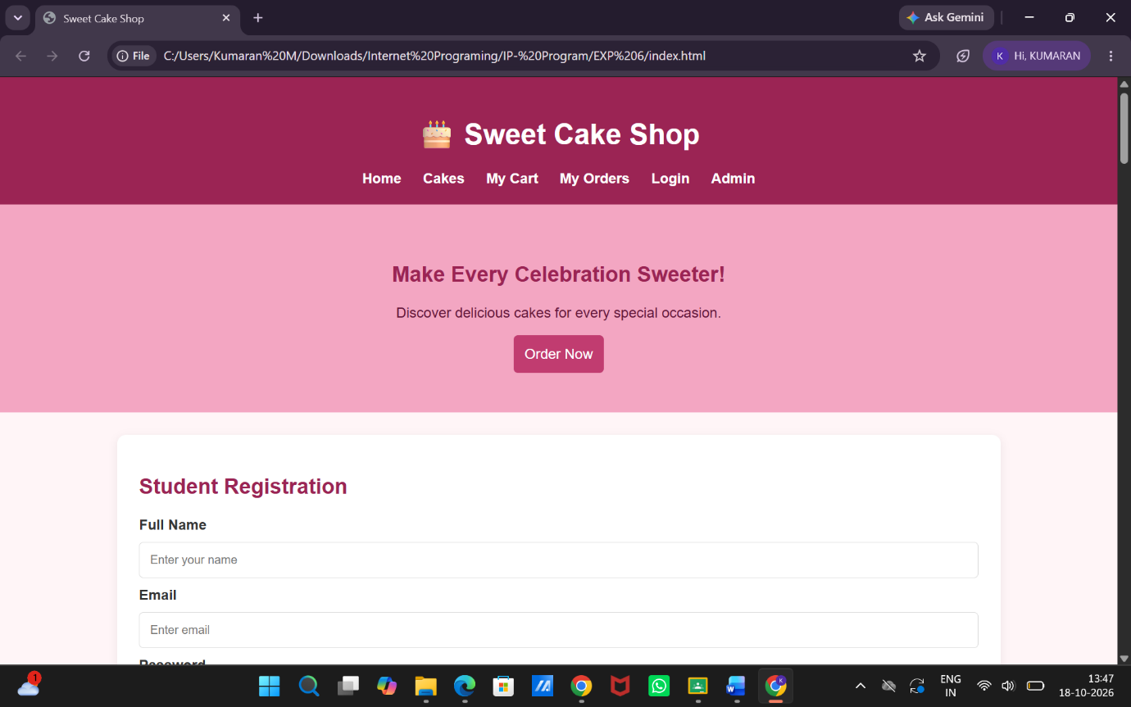

Result:
Thus, the Online Cake Ordering System was developed successfully with cake searching, filtering, cart management, order placement, shipping details, and admin management features.

