Course: INTERNET PROGRAMMING
Code: CSA4303
Name: Kumaran M
Reg.No: 192525022
LAB EXPERIMENTS

Ex-07:
Aim:
To design and develop an Online Beauty Parlour Appointment Booking System that allows customers to select beauty services, book, reschedule, or cancel appointments, and enables salon staff to manage schedules, payments, and customer feedback.
Algorithm:
- Start the program.
- Provide customer registration, login, and profile management.
- Display beauty services, stylist details, and available appointment slots.
- Allow customers to select services, a stylist, and a preferred date and time.
- Confirm appointments and manage full payments or deposits.
- Allow customers to view, reschedule, or cancel appointments.
- Enable salon staff to manage reservations, schedules, and customer feedback.
- Display appointment details and stop the program.

Code:
```css
* {
margin: 0;
padding: 0;
box-sizing: border-box;
}
body {
font-family: Arial, sans-serif;
background: #fff5f8;
color: #333;
line-height: 1.6;
}
header {
background: #c2185b;
color: white;
padding: 20px;
text-align: center;
}
nav {
margin-top: 10px;
}
nav a {
color: white;
text-decoration: none;
margin: 8px;
font-weight: bold;
}
section {
padding: 35px 20px;
text-align: center;
}
h2 {
color: #c2185b;
margin-bottom: 20px;
}
.container {
display: flex;
justify-content: center;
flex-wrap: wrap;
gap: 20px;
}
.card {
background: white;
width: 230px;
padding: 20px;
border-radius: 10px;
box-shadow: 0 2px 8px #ddd;
}
.card h3 {
color: #c2185b;
margin-bottom: 10px;
}
form {
background: white;
max-width: 450px;
margin: auto;
padding: 25px;
border-radius: 10px;
box-shadow: 0 2px 8px #ddd;
}
input, select, textarea, button {
width: 100%;
padding: 12px;
margin: 8px 0;
border: 1px solid #ccc;
border-radius: 5px;
}
textarea {
min-height: 100px;
resize: vertical;
}
button, .btn {
background: #c2185b;
color: white;
border: none;
cursor: pointer;
padding: 12px 18px;
border-radius: 5px;
text-decoration: none;
display: inline-block;
}
button:hover, .btn:hover {
background: #880e4f;
}
#home {
background: #fce4ec;
padding: 70px 20px;
}
#calendarList, #myAppointments, #adminAppointments,
#feedbackList {
max-width: 700px;
margin: 15px auto;
}
.appointment {
background: white;
padding: 15px;
margin: 10px 0;
border-radius: 8px;
box-shadow: 0 2px 6px #ddd;
}
footer {
background: #880e4f;
color: white;
text-align: center;
padding: 18px;
}

@media (max-width: 600px) {
nav a {
display: inline-block;
margin: 5px;
}
.card {
width: 100%;
}
}
```

Output:
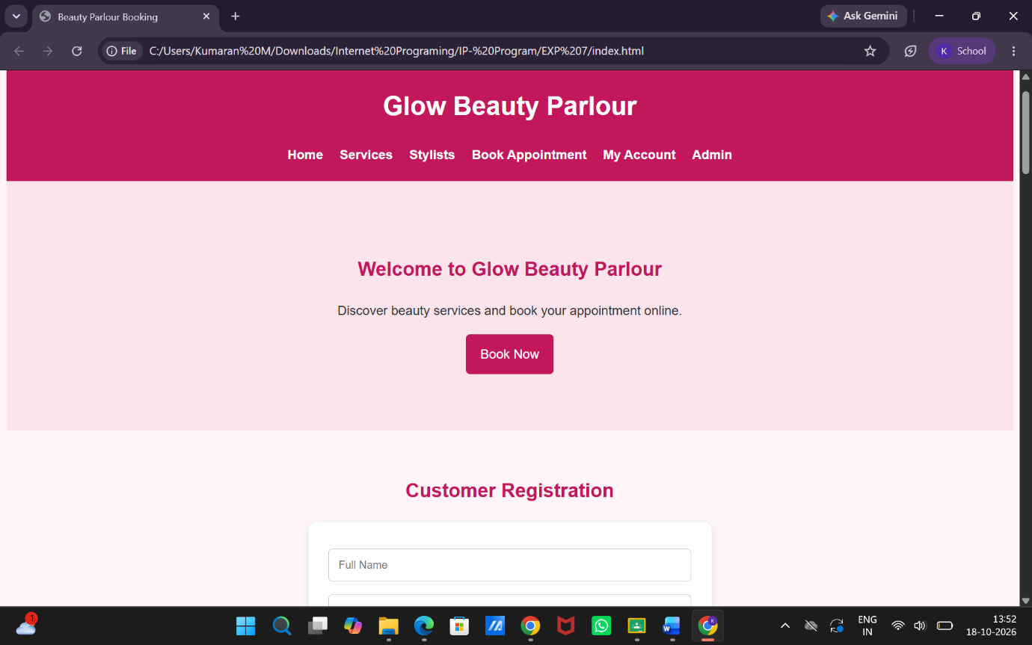

Result:
Thus, the Online Beauty Parlour Appointment Booking System was developed successfully with service selection, appointment scheduling, reservation management, payment facilities, and customer feedback features.

