Course: INTERNET PROGRAMMING
Code: CSA4303
Name: Kumaran M
Reg.No: 192525022
LAB EXPERIMENTS

Ex-08:
Aim:
To design and develop an Online Hospital Appointment Booking System that allows patients to search hospitals and doctors, book and manage appointments, and enables administrators to manage doctors, appointments, and patient feedback.
Algorithm:
- Start the program.
- Provide patient and hospital registration and login facilities.
- Allow patients to search hospitals and doctors by location and specialty.
- Display available doctors and appointment time slots.
- Allow patients to book appointments and submit check-in forms.
- Enable patients to view appointment status, history, and doctor reviews.
- Allow the admin to manage doctors, appointments, ratings, and statistics.
- Display appointment details and stop the program.

Code:
* {
margin: 0;
padding: 0;
box-sizing: border-box;
}
body {
font-family: Arial, sans-serif;
background: #f2f7fa;
color: #333;
}
header {
background: #087f8c;
color: white;
padding: 20px;
text-align: center;
}
nav {
margin-top: 15px;
}
nav a {
color: white;
text-decoration: none;
margin: 8px;
display: inline-block;
}
.hero {
text-align: center;
padding: 60px 20px;
background: #d8f3f4;
}
.hero h2 {
color: #087f8c;
margin-bottom: 15px;
}
.hero p {
margin-bottom: 25px;
}
.btn, button {
background: #087f8c;
color: white;
padding: 12px 18px;
border: none;
border-radius: 5px;
cursor: pointer;
text-decoration: none;
}
.container {
background: white;
max-width: 900px;
margin: 25px auto;
padding: 25px;
border-radius: 8px;
box-shadow: 0 2px 8px #0001;
}
h2 {
color: #087f8c;
margin-bottom: 20px;
}
input, select {
display: block;
width: 100%;
padding: 12px;
margin: 12px 0;
border: 1px solid #ccc;
border-radius: 5px;
}
.cards {
display: grid;
grid-template-columns: repeat(auto-fit, minmax(200px, 1fr));
gap: 15px;
margin-top: 20px;
}
.card {
padding: 18px;
border: 1px solid #ddd;
border-radius: 6px;
background: #f9ffff;
}
.card h3 {
color: #087f8c;
margin-bottom: 10px;
}
.card button {
margin-top: 12px;
}
#appointmentList p {
padding: 12px;
margin: 8px 0;
background: #e9f7f7;
border-radius: 5px;
}
footer {
background: #087f8c;
color: white;
text-align: center;
padding: 18px;
margin-top: 30px;
}
@media (max-width: 600px) {
nav a {
margin: 6px;
}
.container {
margin: 15px;
padding: 18px;
}
.hero {
padding: 40px 15px;
}
}

Output:
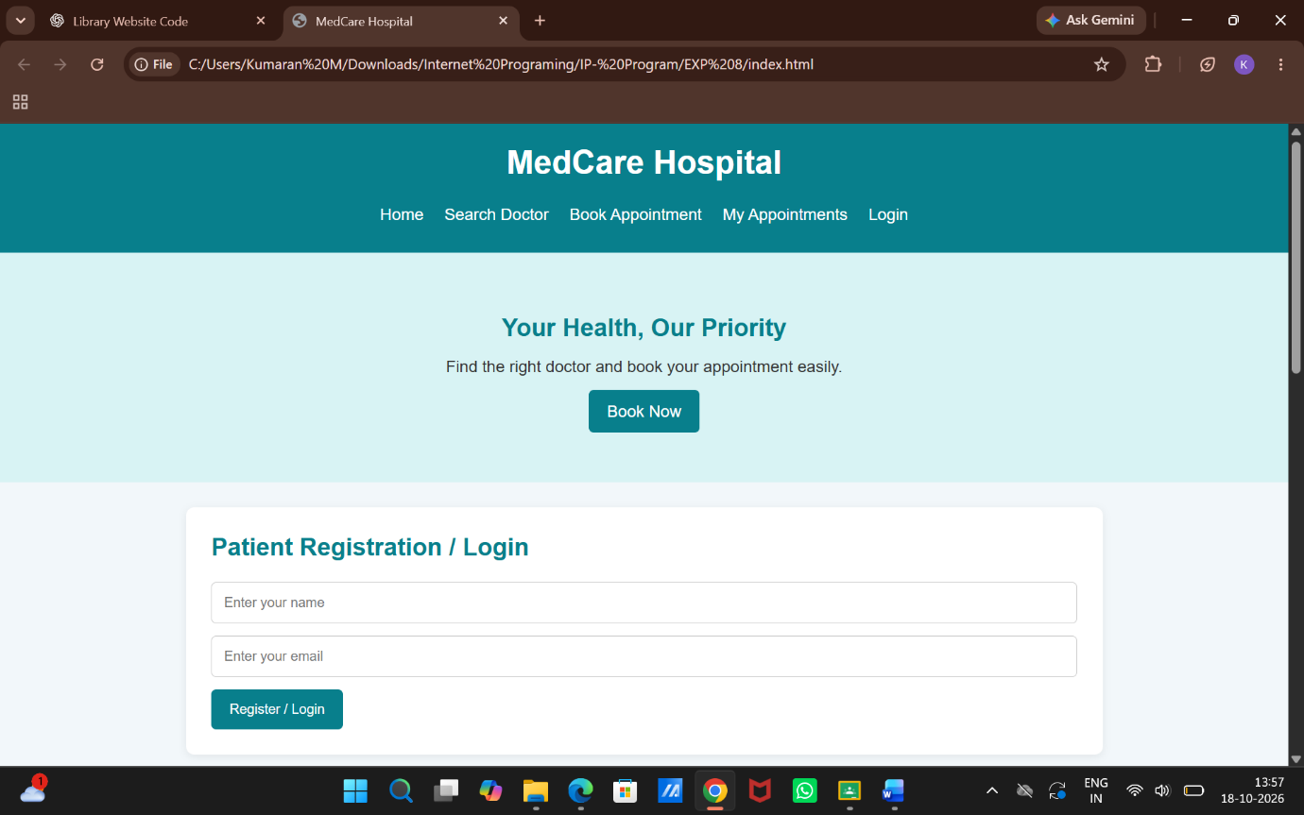

Result:
Thus, the Online Hospital Appointment Booking System was developed successfully with hospital searching, doctor selection, appointment booking, appointment management, and feedback facilities.

