Course: INTERNET PROGRAMMING
Code: CSA4303
Name: Kumaran M
Reg.No: 192525022
LAB EXPERIMENTS

Ex-09:
Aim:
To design and develop an Online Gadget Shopping System that allows customers to browse, search, and purchase electronic products, manage shopping carts, track orders, and enables administrators to manage products and customer details.
Algorithm:
- Start the program.
- Provide user registration and login facilities.
- Display gadget categories, subcategories, and product details.
- Allow users to search products and check availability.
- Enable users to add, update, or remove items from the shopping cart.
- Allow users to checkout, place orders, and track order status.
- Enable the admin to add, delete, and update products, prices, and descriptions.
- Display order details and stop the program.

Code:
* {
margin: 0;
padding: 0;
box-sizing: border-box;
}
body {
font-family: Arial, sans-serif;
background: #f4f6f9;
color: #333;
}
header {
background: #172554;
color: white;
padding: 20px;
display: flex;
justify-content: space-between;
align-items: center;
flex-wrap: wrap;
gap: 12px;
}
nav a {
color: white;
text-decoration: none;
margin: 8px;
}
.hero {
text-align: center;
padding: 60px 20px;
background: #dbeafe;
}
.hero h2 {
color: #172554;
margin-bottom: 15px;
}
.hero p {
margin-bottom: 25px;
}
.btn, button {
display: inline-block;
background: #2563eb;
color: white;
padding: 10px 15px;
border: none;
border-radius: 5px;
cursor: pointer;
text-decoration: none;
margin: 5px 0;
}
button:hover, .btn:hover {
background: #1d4ed8;
}
.secondary {
background: #64748b;
}
.container {
max-width: 1100px;
margin: 25px auto;
padding: 25px;
background: white;
border-radius: 8px;
box-shadow: 0 2px 8px #0001;
}
h2 {
color: #172554;
margin-bottom: 20px;
}
input, select {
padding: 12px;
margin: 8px 0;
border: 1px solid #ccc;
border-radius: 5px;
width: 100%;
}
.categories {
display: flex;
flex-wrap: wrap;
gap: 10px;
}
.product-grid {
display: grid;
grid-template-columns: repeat(auto-fit, minmax(210px, 1fr));
gap: 18px;
margin-top: 20px;
}
.product {
border: 1px solid #ddd;
padding: 18px;
border-radius: 8px;
background: #fff;
}
.product h3 {
color: #2563eb;
margin-bottom: 10px;
}
.product p {
margin: 10px 0;
}
.price {
font-size: 20px;
font-weight: bold;
color: #15803d;
}
.cart-item {
padding: 12px;
border-bottom: 1px solid #ddd;
}
footer {
background: #172554;
color: white;
text-align: center;
padding: 20px;
margin-top: 30px;
}
@media (max-width: 600px) {
header {
flex-direction: column;
}
nav {
text-align: center;
nav a {
display: inline-block;
margin: 7px;
}
.container {
margin: 15px;
padding: 18px;
}
}

Output:
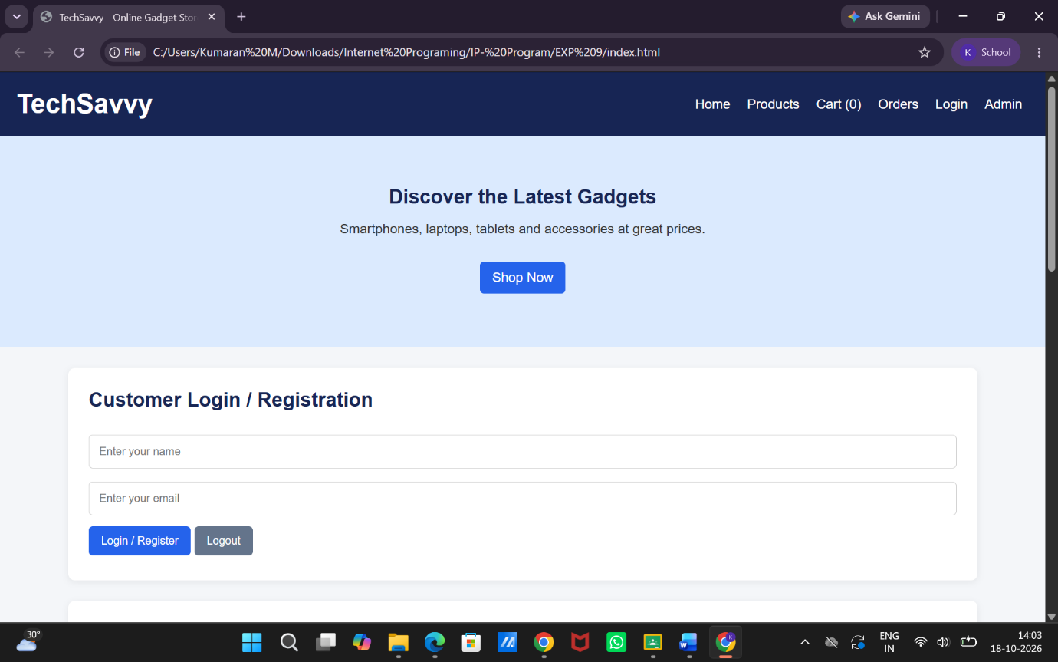

Result:
Thus, the Online Gadget Shopping System was developed successfully with product searching, category management, shopping cart, checkout, order tracking, and administrator management features.

