Ex.No:01 | Application using GUI Components, Font and Colours
20/07/2026 | Application using GUI Components, Font and Colours

Aim:
To develop an Android application using various GUI components such as TextView, EditText, Button, different fonts and colours.
Procedure:
- Create a new Android Studio project.
- Design the user interface using XML.
- Add GUI components such as TextView, EditText and Button.
- Set different font styles, sizes and colours.
- Write Java code to handle button events.
- Run the application on an emulator or Android device.
Program:
Xml Code:
<?xml version="1.0" encoding="utf-8"?>
<LinearLayout xmlns:android="http://schemas.android.com/apk/res/android"
android:layout_width="match_parent"
android:layout_height="match_parent"
android:orientation="vertical"
android:gravity="center"
android:padding="20dp">

<TextView
android:id="@+id/textView1"
android:layout_width="wrap_content"
android:layout_height="wrap_content"
android:text="MOBILE APPLICATION"
android:textSize="24sp"
android:textStyle="bold"
android:layout_marginBottom="30dp" />

<Button
android:id="@+id/button1"
android:layout_width="wrap_content"
android:layout_height="wrap_content"
android:text="Change Font Size" />

<Button
android:id="@+id/button2"
android:layout_width="wrap_content"
android:layout_height="wrap_content"
android:text="Change Colour"
android:layout_marginTop="15dp" />

</LinearLayout>
MainActivity.java
package com.example.gui;

import android.app.Activity;
import android.graphics.Color;
import android.os.Bundle;
import android.view.View;
import android.widget.Button;
import android.widget.TextView;

public class MainActivity extends Activity {

float font = 24;
int i = 1;

@Override
protected void onCreate(Bundle savedInstanceState) {
super.onCreate(savedInstanceState);
setContentView(R.layout.activity_main);

final TextView t1 = (TextView) findViewById(R.id.textView1);

Button b1 = (Button) findViewById(R.id.button1);

b1.setOnClickListener(new View.OnClickListener() {

@Override
public void onClick(View view) {

t1.setTextSize(font);

font = font + 4;

if (font > 40)
font = 20;
}
});

Button b2 = (Button) findViewById(R.id.button2);

b2.setOnClickListener(new View.OnClickListener() {

@Override
public void onClick(View view) {

switch (i) {

case 1:
t1.setTextColor(Color.parseColor("#0000FF"));
break;

case 2:
t1.setTextColor(Color.parseColor("#00FF00"));
break;

case 3:
t1.setTextColor(Color.parseColor("#FF0000"));
break;

case 4:
t1.setTextColor(Color.parseColor("#000000"));
break;
}

i++;

if (i > 4)
i = 1;
}
});
}
}
Output:
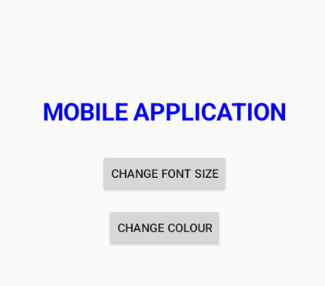
1.View 2.Colour Changing
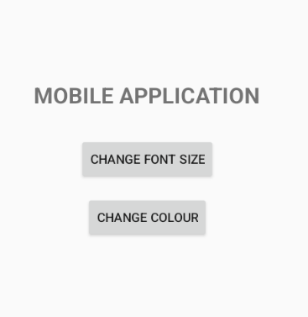
3.Font Size Change
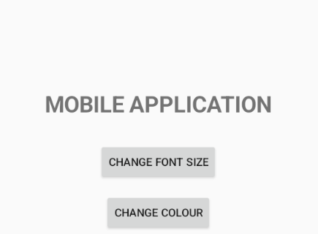

Result:
Thus, an Android application using GUI components, fonts and colours was successfully developed and executed.

Ex.No:02 | Application using Layout Managers and Event Listeners
20/07/2026 | Application using Layout Managers and Event Listeners
Aim:
To develop an Android application using different layout managers and event listeners.
Procedure:
- Create a new Android Studio project.
- Design the interface using LinearLayout, RelativeLayout or ConstraintLayout.
- Add required GUI components.
- Set the properties of the components.
- Implement event listeners for buttons and other components.
- Execute the application and verify the events.
Program:
Xml code:
activity.xml_1 code:
<?xml version="1.0" encoding="utf-8"?>
<androidx.constraintlayout.widget.ConstraintLayout xmlns:android="http://schemas.android.com/apk/res/android"
xmlns:app="http://schemas.android.com/apk/res-auto"
xmlns:tools="http://schemas.android.com/tools"
android:id="@+id/main"
android:layout_width="match_parent"
android:layout_height="match_parent"
tools:context=".MainActivity1">

<LinearLayout
android:layout_width="match_parent"
android:layout_height="wrap_content"
android:orientation="vertical"
android:gravity="center"
android:layout_margin="20dp">

<TextView
android:layout_width="wrap_content"
android:layout_height="wrap_content"
android:text="Student Information"
android:textAppearance="?android:attr/textAppearanceLarge"
android:textStyle="bold"
android:layout_gravity="center" />

<EditText
android:id="@+id/editTextName"
android:layout_width="match_parent"
android:layout_height="wrap_content"
android:hint="Enter Name" />

<EditText
android:id="@+id/editTextDno"
android:layout_width="match_parent"
android:layout_height="wrap_content"
android:hint="Enter D.NO" />

<EditText
android:id="@+id/editTextDept"
android:layout_width="match_parent"
android:layout_height="wrap_content"
android:hint="Enter Department" />

<EditText
android:id="@+id/editTextContact"
android:layout_width="match_parent"
android:layout_height="wrap_content"
android:hint="Enter Contact Number" />

<Button
android:id="@+id/buttonOpenActivity2"
android:layout_width="wrap_content"
android:layout_height="wrap_content"
android:text="OK"
android:layout_gravity="center"
android:layout_marginTop="20dp" />
</LinearLayout>
</androidx.constraintlayout.widget.ConstraintLayout>

Activity_xml-code-2:
<?xml version="1.0" encoding="utf-8"?>
<androidx.constraintlayout.widget.ConstraintLayout xmlns:android="http://schemas.android.com/apk/res/android"
xmlns:app="http://schemas.android.com/apk/res-auto"
xmlns:tools="http://schemas.android.com/tools"
android:id="@+id/main"
android:layout_width="match_parent"
android:layout_height="match_parent"
tools:context=".MainActivity2">

<LinearLayout
android:layout_width="match_parent"
android:layout_height="wrap_content"
android:orientation="vertical"
android:padding="20dp">

<TextView
android:id="@+id/textView1"
android:layout_width="wrap_content"
android:layout_height="wrap_content"
android:text="STUDENT INFORMATION"
android:textAppearance="?android:attr/textAppearanceLarge"
android:textStyle="bold"
android:paddingBottom="10dp" />

<TextView
android:id="@+id/textViewName"
android:layout_width="wrap_content"
android:layout_height="wrap_content"
android:text="Name:" />

<TextView
android:id="@+id/textViewDno"
android:layout_width="wrap_content"
android:layout_height="wrap_content"
android:text="D.NO:" />

<TextView
android:id="@+id/textViewDept"
android:layout_width="wrap_content"
android:layout_height="wrap_content"
android:text="Department:" />

<TextView
android:id="@+id/textViewContact"
android:layout_width="wrap_content"
android:layout_height="wrap_content"
android:text="ContactNO:" />
</LinearLayout>
</androidx.constraintlayout.widget.ConstraintLayout>

Mainactivity.java-1:
package com.example.sample;

import android.app.Activity;
import android.content.Intent;
import android.os.Bundle;
import android.view.View;
import android.widget.Button;
import android.widget.EditText;

public class MainActivity1 extends Activity {
@Override
protected void onCreate(Bundle savedInstanceState) {
super.onCreate(savedInstanceState);
setContentView(R.layout.activity_main);

final EditText editTextName = findViewById(R.id.editTextName);
final EditText editTextDno = findViewById(R.id.editTextDno);
final EditText editTextDept = findViewById(R.id.editTextDept);
final EditText editTextContact = findViewById(R.id.editTextContact);

Button buttonOpenActivity2 = findViewById(R.id.buttonOpenActivity2);

buttonOpenActivity2.setOnClickListener(new View.OnClickListener() {
@Override
public void onClick(View v) {
String name = editTextName.getText().toString();
String dno = editTextDno.getText().toString();
String department = editTextDept.getText().toString();
String contact = editTextContact.getText().toString();

Intent intent = new Intent(MainActivity1.this, MainActivity2.class);
intent.putExtra("NAME", name);
intent.putExtra("DNO", dno);
intent.putExtra("DEPARTMENT", department);
intent.putExtra("CONTACT", contact);
startActivity(intent);
}
});
}
}
Mainactivity.java-2:
package com.example.sample;

import android.app.Activity;
import android.os.Bundle;
import android.widget.TextView;

public class MainActivity2 extends Activity {
@Override
protected void onCreate(Bundle savedInstanceState) {
super.onCreate(savedInstanceState);
setContentView(R.layout.activity_main2);

TextView textViewName = findViewById(R.id.textViewName);
TextView textViewDno = findViewById(R.id.textViewDno);
TextView textViewDept = findViewById(R.id.textViewDept);
TextView textViewContact = findViewById(R.id.textViewContact);

String name = getIntent().getStringExtra("NAME");
String dno = getIntent().getStringExtra("DNO");
String department = getIntent().getStringExtra("DEPARTMENT");
String contact = getIntent().getStringExtra("CONTACT");

textViewName.setText("Name: " + name);
textViewDno.setText("D.NO: " + dno);
textViewDept.setText("Department: " + department);
textViewContact.setText("ContactNO: " + contact);
}
}
MAINFESTCODE:
<?xml version="1.0" encoding="utf-8"?>
<manifest xmlns:android="http://schemas.android.com/apk/res/android"
xmlns:tools="http://schemas.android.com/tools"
package="com.example.sample">

<application
android:allowBackup="true"
android:icon="@mipmap/ic_launcher"
android:label="@string/app_name"
android:roundIcon="@mipmap/ic_launcher_round"
android:supportsRtl="true"
android:theme="@style/Theme.Sample">

<activity
android:name=".MainActivity1"
android:exported="true"
android:windowSoftInputMode="adjustResize">
<intent-filter>
<action android:name="android.intent.action.MAIN" />
<category android:name="android.intent.category.LAUNCHER" />
</intent-filter>
</activity>

<activity android:name=".MainActivity2" />
</application>
</manifest>
Output:
1.Layout I: 2.Layout II:
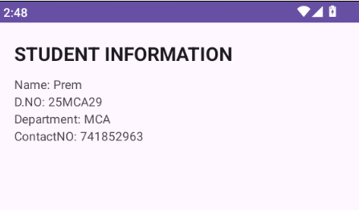
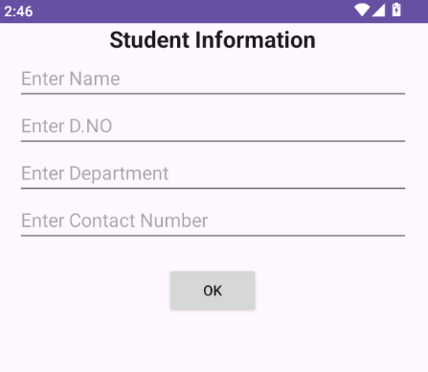
Result:
Thus, an Android application using layout managers and event listeners was successfully developed and executed.
Ex.No:03 | Native Calculator Application
27/07/2026 | Native Calculator Application

Aim:
To develop a native calculator application for performing basic arithmetic operations.
Procedure:
- Create a new Android Studio project.
- Design the calculator interface using XML.
- Add EditText/TextView for displaying numbers and results.
- Add buttons for addition, subtraction, multiplication and division.
- Write Java code to perform arithmetic operations.
- Run the application and verify the results.
Program:

Xml code:
<?xml version="1.0" encoding="utf-8"?>
<LinearLayout xmlns:android="http://schemas.android.com/apk/res/android"
android:layout_width="match_parent"
android:layout_height="match_parent"
android:orientation="vertical"
android:padding="16dp">
<EditText
android:id="@+id/editText11"
android:layout_width="match_parent"
android:layout_height="wrap_content"
android:hint="Enter first number"
android:inputType="number" />
<EditText
android:id="@+id/editText22"
android:layout_width="match_parent"
android:layout_height="wrap_content"
android:hint="Enter second number"
android:inputType="number" />
<Button
android:id="@+id/addButtonn"
android:layout_width="match_parent"
android:layout_height="wrap_content"
android:text="Add" />
<Button
android:id="@+id/button1"
android:layout_width="282dp"
android:layout_height="wrap_content"
android:text="sub" />
<EditText
android:id="@+id/editText33"
android:layout_width="match_parent"
android:layout_height="wrap_content"
android:ems="10"
android:focusable="false"
android:hint="Result" >
<requestFocus />
</EditText>
</LinearLayout>

mainactivity java code:
package com.example.calculator;
import android.app.Activity;
import android.os.Bundle;
import android.text.TextUtils;
import android.view.View;
import android.widget.Button;
import android.widget.EditText;
import android.widget.Toast;
public class MainActivity extends Activity {
private EditText editText1, editText2, editText3;
private Button addButton, subbutton;
@Override
protected void onCreate(Bundle savedInstanceState) {
super.onCreate(savedInstanceState);
setContentView(R.layout.activity_main);
// Initialize UI components
editText1 = (EditText) findViewById(R.id.editText11);
editText2 = (EditText) findViewById(R.id.editText22);
editText3 = (EditText) findViewById(R.id.editText33);
addButton = (Button) findViewById(R.id.addButtonn);
subbutton = (Button) findViewById(R.id.button1);
// Set the button's onClickListener
addButton.setOnClickListener(new View.OnClickListener() {
@Override
public void onClick(View v) {
calculateSum();
}
});
subbutton.setOnClickListener(new View.OnClickListener(){
@Override
public void onClick(View v){
calculateSub();
}
});
}
private void calculateSum() {
// Get the input values as strings
String input1 = editText1.getText().toString();
String input2 = editText2.getText().toString();
// Parse the inputs to integers
int number1 = Integer.parseInt(input1);
int number2 = Integer.parseInt(input2);
// Calculate the sum
int sum = number1 + number2;
// Display the result in editText3
editText3.setText(String.valueOf(sum));
}
private void calculateSub() {
// Get the input values as strings
String input1 = editText1.getText().toString();
String input2 = editText2.getText().toString();
// Parse the inputs to integers
int number1 = Integer.parseInt(input1);
int number2 = Integer.parseInt(input2);
// Calculate the sum
int sum = number1 - number2;
// Display the result in editText3
editText3.setText(String.valueOf(sum));
}
}
Output:
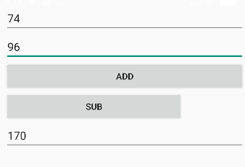

Result:
Thus, a native calculator application was successfully developed and executed to perform basic arithmetic operations.

Ex.No:04 | Application to Draw Basic Graphical Primitives
27/07/2026 | Application to Draw Basic Graphical Primitives
Aim:
To develop an Android application that draws basic graphical primitives such as lines, circles, rectangles and other shapes.
Procedure:
- Create a new Android Studio project.
- Create a custom View class.
- Override the onDraw() method.
- Create a Canvas and Paint object.
- Use drawing methods to draw lines, circles and rectangles.
- Run the application and verify the graphical output.
Program:
Xml Code:
<RelativeLayout xmlns:android="http://schemas.android.com/apk/res/android"
xmlns:app="http://schemas.android.com/apk/res-auto"
xmlns:tools="http://schemas.android.com/tools"
android:layout_width="match_parent"
android:layout_height="match_parent"
>
<ImageView
android:id="@+id/imageView1"
android:layout_width="wrap_content"
android:layout_height="wrap_content"
android:src="@drawable/ic_launcher_background" />
</RelativeLayout>

Mainactivity.java-code:
package com.example.myapplication;
import android.app.Activity;
import android.graphics.Bitmap;
import android.graphics.Canvas;
import android.graphics.Color;
import android.graphics.Paint;
import android.os.Bundle;
import android.view.Display;
import android.view.MotionEvent;
import android.view.View;
import android.view.View.OnTouchListener;
import android.widget.ImageView;
public class MainActivity extends Activity implements OnTouchListener {
private ImageView imageView;
private Bitmap bitmap;
private Canvas canvas;
private Paint paint;
private float downx = 0, downy = 0, upx = 0, upy = 0;
public void onCreate(Bundle savedInstanceState) {
super.onCreate(savedInstanceState);
setContentView(R.layout.activity_main);
imageView = (ImageView) this.findViewById(R.id.imageView1);
Display currentDisplay = getWindowManager().getDefaultDisplay();
@SuppressWarnings("deprecation")
float dw = currentDisplay.getWidth();
@SuppressWarnings("deprecation")
float dh = currentDisplay.getHeight();
bitmap = Bitmap.createBitmap((int) dw, (int) dh, Bitmap.Config.ARGB_8888);
canvas = new Canvas(bitmap);
paint = new Paint();
paint.setColor(Color.BLUE);
imageView.setImageBitmap(bitmap);
imageView.setOnTouchListener(this);
}
public boolean onTouch(View v, MotionEvent event) {
int action = event.getAction();
switch (action) {
case MotionEvent.ACTION_DOWN:
downx = event.getX();
downy = event.getY();
break;
case MotionEvent.ACTION_MOVE:
break;
case MotionEvent.ACTION_UP:
upx = event.getX();
upy = event.getY();
canvas.drawLine(downx, downy, upx, upy, paint);
imageView.invalidate();
break;
case MotionEvent.ACTION_CANCEL:
break;
default:
break;
}
return true;
}
}
Output:
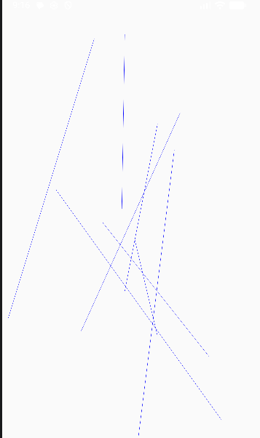
Result:
Thus, an Android application for drawing basic graphical primitives was successfully developed and executed.
Ex.No:05 | Application that Makes Use of Database
03/07/2026 | Application that Makes Use of Database

Aim:
To develop an Android application that stores and retrieves data using a database.
Procedure:
- Create a new Android Studio project.
- Design the user interface using XML.
- Create an SQLite database.
- Create the required database table.
- Implement Java code to insert and retrieve records.
- Display the stored records in the application.
- Run the application and verify the database operations.
Program:
Xml_code:
<?xml version="1.0" encoding="utf-8"?>
<LinearLayout
xmlns:android="http://schemas.android.com/apk/res/android"
android:layout_width="match_parent"
android:layout_height="match_parent"
android:orientation="vertical"
android:padding="20dp">
<TextView
android:layout_width="match_parent"
android:layout_height="wrap_content"
android:text="Student Database"
android:textSize="26sp"
android:textStyle="bold"
android:gravity="center"
android:padding="15dp" />
<EditText
android:id="@+id/etName"
android:layout_width="match_parent"
android:layout_height="wrap_content"
android:hint="Enter Student Name"
android:inputType="textPersonName" />
<EditText
android:id="@+id/etRegisterNo"
android:layout_width="match_parent"
android:layout_height="wrap_content"
android:hint="Enter Register Number"
android:inputType="text" />
<EditText
android:id="@+id/etDepartment"
android:layout_width="match_parent"
android:layout_height="wrap_content"
android:hint="Enter Department"
android:inputType="text" />
<Button
android:id="@+id/btnAdd"
android:layout_width="match_parent"
android:layout_height="wrap_content"
android:text="ADD STUDENT" />
<Button
android:id="@+id/btnView"
android:layout_width="match_parent"
android:layout_height="wrap_content"
android:text="VIEW STUDENTS" />
<Button
android:id="@+id/btnUpdate"
android:layout_width="match_parent"
android:layout_height="wrap_content"
android:text="UPDATE STUDENT" />
<Button
android:id="@+id/btnDelete"
android:layout_width="match_parent"
android:layout_height="wrap_content"
android:text="DELETE STUDENT" />
<TextView
android:id="@+id/tvResult"
android:layout_width="match_parent"
android:layout_height="wrap_content"
android:padding="10dp"
android:textSize="16sp" />
</LinearLayout>
MainActivity.java:
package com.example.myapplication;
import android.database.Cursor;
import android.os.Bundle;
import android.widget.Button;
import android.widget.EditText;
import android.widget.TextView;
import android.widget.Toast;
import androidx.appcompat.app.AppCompatActivity;
public class MainActivity extends AppCompatActivity {
EditText etName, etRegisterNo, etDepartment;
Button btnAdd, btnView, btnUpdate, btnDelete;
TextView tvResult;
DatabaseHelper databaseHelper;
@Override
protected void onCreate(Bundle savedInstanceState) {
super.onCreate(savedInstanceState);
setContentView(R.layout.activity_main);
etName = findViewById(R.id.etName);
etRegisterNo = findViewById(R.id.etRegisterNo);
etDepartment = findViewById(R.id.etDepartment);
btnAdd = findViewById(R.id.btnAdd);
btnView = findViewById(R.id.btnView);
btnUpdate = findViewById(R.id.btnUpdate);
btnDelete = findViewById(R.id.btnDelete);
tvResult = findViewById(R.id.tvResult);
databaseHelper = new DatabaseHelper(this);
// ADD
btnAdd.setOnClickListener(v -> {
String name = etName.getText().toString();
String regno = etRegisterNo.getText().toString();
String department = etDepartment.getText().toString();
if (name.isEmpty() || regno.isEmpty() || department.isEmpty()) {
Toast.makeText(
this,
"Please enter all details",
Toast.LENGTH_SHORT
).show();
return;
}
boolean result = databaseHelper.addStudent(
name,
regno,
department
);
if (result) {
Toast.makeText(
this,
"Student Added Successfully",
Toast.LENGTH_SHORT
).show();
clearFields();
} else {
Toast.makeText(
this,
"Register Number already exists",
Toast.LENGTH_SHORT
).show();
}
});
// VIEW
btnView.setOnClickListener(v -> {
Cursor cursor = databaseHelper.getStudents();
StringBuilder data = new StringBuilder();
if (cursor.getCount() == 0) {
tvResult.setText("No student records found");
} else {
while (cursor.moveToNext()) {
data.append("ID: ")
.append(cursor.getInt(0))
.append("\n");
data.append("Name: ")
.append(cursor.getString(1))
.append("\n");
data.append("Register No: ")
.append(cursor.getString(2))
.append("\n");
data.append("Department: ")
.append(cursor.getString(3))
.append("\n");
data.append("----------------------\n");
}
tvResult.setText(data.toString());
}
cursor.close();
});
// UPDATE
btnUpdate.setOnClickListener(v -> {
String name = etName.getText().toString();
String regno = etRegisterNo.getText().toString();
String department = etDepartment.getText().toString();
boolean result = databaseHelper.updateStudent(
name,
regno,
department
);
if (result) {
Toast.makeText(
this,
"Student Updated Successfully",
Toast.LENGTH_SHORT
).show();
clearFields();
} else {
Toast.makeText(
this,
"Student Not Found",
Toast.LENGTH_SHORT
).show();
}
});
// DELETE
btnDelete.setOnClickListener(v -> {
String regno = etRegisterNo.getText().toString();
boolean result = databaseHelper.deleteStudent(regno);
if (result) {
Toast.makeText(
this,
"Student Deleted Successfully",
Toast.LENGTH_SHORT
).show();
clearFields();
} else {
Toast.makeText(
this,
"Student Not Found",
Toast.LENGTH_SHORT
).show();
}
});
}
private void clearFields() {
etName.setText("");
etRegisterNo.setText("");
etDepartment.setText("");
}
}

DatabaseHelper.java:
package com.example.myapplication;
import android.content.ContentValues;
import android.content.Context;
import android.database.Cursor;
import android.database.sqlite.SQLiteDatabase;
import android.database.sqlite.SQLiteOpenHelper;
public class DatabaseHelper extends SQLiteOpenHelper {
private static final String DATABASE_NAME = "StudentDB";
private static final int DATABASE_VERSION = 1;
private static final String TABLE_NAME = "students";
private static final String COL_ID = "id";
private static final String COL_NAME = "name";
private static final String COL_REGNO = "regno";
private static final String COL_DEPT = "department";
public DatabaseHelper(Context context) {
super(context, DATABASE_NAME, null, DATABASE_VERSION);
}
@Override
public void onCreate(SQLiteDatabase db) {
String query = "CREATE TABLE " + TABLE_NAME + " (" +
COL_ID + " INTEGER PRIMARY KEY AUTOINCREMENT, " +
COL_NAME + " TEXT, " +
COL_REGNO + " TEXT UNIQUE, " +
COL_DEPT + " TEXT)";
db.execSQL(query);
}
@Override
public void onUpgrade(SQLiteDatabase db, int oldVersion, int newVersion) {
db.execSQL("DROP TABLE IF EXISTS " + TABLE_NAME);
onCreate(db);
}
// ADD STUDENT
public boolean addStudent(String name, String regno, String department) {
SQLiteDatabase db = this.getWritableDatabase();
ContentValues values = new ContentValues();
values.put(COL_NAME, name);
values.put(COL_REGNO, regno);
values.put(COL_DEPT, department);
long result = db.insert(TABLE_NAME, null, values);
return result != -1;
}
// VIEW STUDENTS
public Cursor getStudents() {
SQLiteDatabase db = this.getReadableDatabase();
return db.rawQuery(
"SELECT * FROM " + TABLE_NAME,
null
);
}
// UPDATE STUDENT
public boolean updateStudent(
String name,
String regno,
String department) {
SQLiteDatabase db = this.getWritableDatabase();
ContentValues values = new ContentValues();
values.put(COL_NAME, name);
values.put(COL_DEPT, department);
int result = db.update(
TABLE_NAME,
values,
COL_REGNO + "=?",
new String[]{regno}
);
return result > 0;
}
// DELETE STUDENT
public boolean deleteStudent(String regno) {
SQLiteDatabase db = this.getWritableDatabase();
int result = db.delete(
TABLE_NAME,
COL_REGNO + "=?",
new String[]{regno}
);
return result > 0;
}
}

Output:
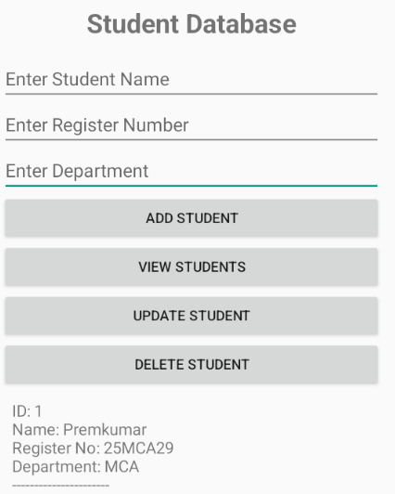
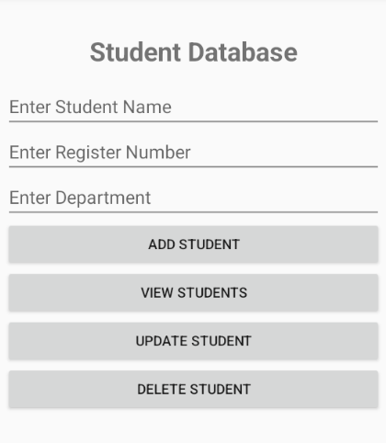

Result:
Thus, an Android database application was successfully developed and executed to store and retrieve data.

Ex.no.06 | Application that Implements Multithreading
03.08.2026 | Application that Implements Multithreading

Aim:
To develop an Android application that implements multithreading for performing tasks in the background.
Procedure:
- Create a new Android Studio project.
- Design the user interface using XML.
- Create a separate thread using the Java Thread class.
- Perform the required task inside the background thread.
- Use runOnUiThread() to update the user interface.
- Execute the application and observe the thread execution.
Program:

Xml code:
<?xml version="1.0" encoding="utf-8"?>
<LinearLayout xmlns:android="http://schemas.android.com/apk/res/android"
android:layout_width="match_parent"
android:layout_height="match_parent"
android:orientation="vertical"
android:padding="20dp"
android:background="#F5F5F5">
<TextView
android:layout_width="match_parent"
android:layout_height="wrap_content"
android:text="Multithreading Application"
android:textSize="24sp"
android:textStyle="bold"
android:gravity="center"
android:textColor="#222222"/>
<TextView
android:id="@+id/status"
android:layout_width="match_parent"
android:layout_height="wrap_content"
android:layout_marginTop="15dp"
android:text="Ready to Start"
android:textSize="17sp"
android:gravity="center"
android:textStyle="bold"/>
<!-- Thread 1 -->
<TextView
android:id="@+id/task1"
android:layout_width="match_parent"
android:layout_height="wrap_content"
android:layout_marginTop="25dp"
android:text="Thread 1 - Download Task"
android:textSize="17sp"
android:textStyle="bold"/>
<ProgressBar
android:id="@+id/progress1"
style="?android:attr/progressBarStyleHorizontal"
android:layout_width="match_parent"
android:layout_height="12dp"
android:max="100"/>
<TextView
android:id="@+id/text1"
android:layout_width="match_parent"
android:layout_height="wrap_content"
android:text="Waiting..."
android:textSize="14sp"/>
<!-- Thread 2 -->
<TextView
android:id="@+id/task2"
android:layout_width="match_parent"
android:layout_height="wrap_content"
android:layout_marginTop="20dp"
android:text="Thread 2 - File Processing"
android:textSize="17sp"
android:textStyle="bold"/>
<ProgressBar
android:id="@+id/progress2"
style="?android:attr/progressBarStyleHorizontal"
android:layout_width="match_parent"
android:layout_height="12dp"
android:max="100"/>
<TextView
android:id="@+id/text2"
android:layout_width="match_parent"
android:layout_height="wrap_content"
android:text="Waiting..."
android:textSize="14sp"/>
<!-- Overall -->
<TextView
android:id="@+id/overall"
android:layout_width="match_parent"
android:layout_height="wrap_content"
android:layout_marginTop="25dp"
android:text="Overall Progress: 0%"
android:textSize="18sp"
android:textStyle="bold"
android:gravity="center"/>
<TextView
android:id="@+id/log"
android:layout_width="match_parent"
android:layout_height="120dp"
android:layout_marginTop="15dp"
android:background="#222222"
android:padding="10dp"
android:text="Execution Log"
android:textColor="#FFFFFF"
android:textSize="13sp"/>
<Button
android:id="@+id/start"
android:layout_width="match_parent"
android:layout_height="wrap_content"
android:layout_marginTop="20dp"
android:text="START THREADS"/>
</LinearLayout>
mainactivity.java:

package com.example.myapplication;

import android.os.Bundle;
import android.os.Handler;
import android.widget.*;

import androidx.appcompat.app.AppCompatActivity;

public class MainActivity extends AppCompatActivity {

ProgressBar p1, p2;
TextView text1, text2, status, overall, log;
Button start;

Handler handler = new Handler();

int a = 0, b = 0;

@Override
protected void onCreate(Bundle savedInstanceState) {
super.onCreate(savedInstanceState);
setContentView(R.layout.activity_main);

p1 = findViewById(R.id.progress1);
p2 = findViewById(R.id.progress2);

text1 = findViewById(R.id.text1);
text2 = findViewById(R.id.text2);

status = findViewById(R.id.status);
overall = findViewById(R.id.overall);
log = findViewById(R.id.log);

start = findViewById(R.id.start);

start.setOnClickListener(v -> startThreads());
}

void startThreads() {

start.setEnabled(false);

status.setText("🧵 Two Threads Running...");
log.setText("Thread 1 started\nThread 2 started\n");

Thread thread1 = new Thread(() -> {

for (a = 0; a <= 100; a++) {

int value = a;

handler.post(() -> {
p1.setProgress(value);
text1.setText("Processing: " + value + "%");
updateOverall();
});

try {
Thread.sleep(50);
} catch (Exception e) {
e.printStackTrace();
}
}

handler.post(() ->
log.append("Thread 1 completed ✓\n"));
});

Thread thread2 = new Thread(() -> {

for (b = 0; b <= 100; b++) {

int value = b;

handler.post(() -> {
p2.setProgress(value);
text2.setText("Processing: " + value + "%");
updateOverall();
});

try {
Thread.sleep(80);
} catch (Exception e) {
e.printStackTrace();
}
}

handler.post(() ->
log.append("Thread 2 completed ✓\n"));
});

thread1.start();
thread2.start();

log.append("Both threads are executing simultaneously...\n");
}

void updateOverall() {

int progress = (a + b) / 2;

overall.setText(
"Overall Progress: " + progress + "%"
);

if (progress == 100) {
status.setText("✓ Both Threads Completed");
start.setEnabled(true);
}
}
}
Output:
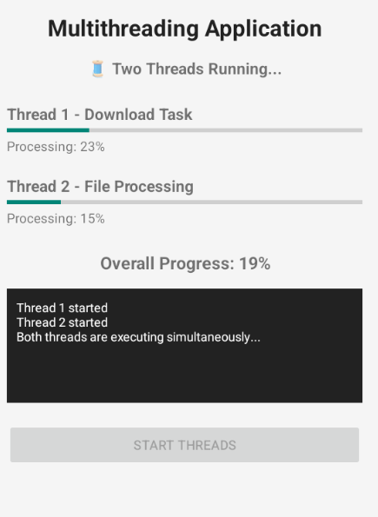
Result:
Thus, an Android application implementing multithreading was successfully developed and executed.

Ex.no.07 | GPS location information
07.08.2026 | GPS location information

Aim:
To develop a native Android application that uses GPS location information to display the user's Latitude and Longitude.

Procedure
- Open Android Studio and create a new project using Empty Views Activity.
- Select Java as the programming language.
- Create the application named GPS Location App.
- Design the user interface in activity_main.xml.
- Add two TextView controls to display Latitude and Longitude.
- Add a Button named Get Current Location.
- Add the required location permissions in AndroidManifest.xml:
  - ACCESS_FINE_LOCATION
  - ACCESS_COARSE_LOCATION
- In MainActivity.java, create a LocationManager object.
- Check whether GPS/Location service is enabled on the device.
- Request runtime permission from the user to access the device location.
- Implement a LocationListener to receive the current GPS location.
- Obtain the latitude and longitude values from the Location object.
- Display the obtained location information in the respective TextView controls.
- Run the application on an Android device or emulator.
- Enable GPS/Location and allow location permission.
- Click the GET CURRENT LOCATION button to display the current latitude and longitude.

Program:

XML CODE:
<?xml version="1.0" encoding="utf-8"?>
<LinearLayout
xmlns:android="http://schemas.android.com/apk/res/android"
android:layout_width="match_parent"
android:layout_height="match_parent"
android:orientation="vertical"
android:gravity="center"
android:padding="25dp">
<TextView
android:id="@+id/tvTitle"
android:layout_width="wrap_content"
android:layout_height="wrap_content"
android:text="GPS Location Application"
android:textSize="24sp"
android:textStyle="bold"
android:layout_marginBottom="30dp" />
<TextView
android:id="@+id/tvLatitude"
android:layout_width="wrap_content"
android:layout_height="wrap_content"
android:text="Latitude: Not Available"
android:textSize="18sp"
android:layout_margin="10dp" />
<TextView
android:id="@+id/tvLongitude"
android:layout_width="wrap_content"
android:layout_height="wrap_content"
android:text="Longitude: Not Available"
android:textSize="18sp"
android:layout_margin="10dp" />
<Button
android:id="@+id/btnLocation"
android:layout_width="match_parent"
android:layout_height="wrap_content"
android:text="GET CURRENT LOCATION"
android:layout_marginTop="30dp" />
</LinearLayout>

Mainactivity.java Code:
package com.example.myapplication;
import android.Manifest;
import android.content.Context;
import android.content.pm.PackageManager;
import android.location.Location;
import android.location.LocationListener;
import android.location.LocationManager;
import android.os.Bundle;
import android.provider.Settings;
import android.content.Intent;
import android.widget.Button;
import android.widget.TextView;
import android.widget.Toast;
import androidx.annotation.NonNull;
import androidx.appcompat.app.AppCompatActivity;
import androidx.core.app.ActivityCompat;
public class MainActivity extends AppCompatActivity {
TextView tvLatitude, tvLongitude;
Button btnLocation;
LocationManager locationManager;
private static final int LOCATION_PERMISSION_CODE = 100;
@Override
protected void onCreate(Bundle savedInstanceState) {
super.onCreate(savedInstanceState);
setContentView(R.layout.activity_main);
tvLatitude = findViewById(R.id.tvLatitude);
tvLongitude = findViewById(R.id.tvLongitude);
btnLocation = findViewById(R.id.btnLocation);
locationManager =
(LocationManager) getSystemService(Context.LOCATION_SERVICE);
btnLocation.setOnClickListener(v -> checkLocationPermission());
}
private void checkLocationPermission() {
if (ActivityCompat.checkSelfPermission(
this,
Manifest.permission.ACCESS_FINE_LOCATION)
!= PackageManager.PERMISSION_GRANTED
||
ActivityCompat.checkSelfPermission(
this,
Manifest.permission.ACCESS_COARSE_LOCATION)
!= PackageManager.PERMISSION_GRANTED) {
ActivityCompat.requestPermissions(
this,
new String[]{
Manifest.permission.ACCESS_FINE_LOCATION,
Manifest.permission.ACCESS_COARSE_LOCATION
},
LOCATION_PERMISSION_CODE
);
} else {
getCurrentLocation();
}
}
private void getCurrentLocation() {
boolean gpsEnabled =
locationManager.isProviderEnabled(
LocationManager.GPS_PROVIDER);
boolean networkEnabled =
locationManager.isProviderEnabled(
LocationManager.NETWORK_PROVIDER);
if (!gpsEnabled && !networkEnabled) {
Toast.makeText(
this,
"Please Turn ON Location",
Toast.LENGTH_LONG
).show();
Intent intent =
new Intent(Settings.ACTION_LOCATION_SOURCE_SETTINGS);
startActivity(intent);
return;
}
tvLatitude.setText("Latitude: Getting location...");
tvLongitude.setText("Longitude: Please wait...");
if (gpsEnabled) {
if (ActivityCompat.checkSelfPermission(this, Manifest.permission.ACCESS_FINE_LOCATION) != PackageManager.PERMISSION_GRANTED && ActivityCompat.checkSelfPermission(this, Manifest.permission.ACCESS_COARSE_LOCATION) != PackageManager.PERMISSION_GRANTED) {
// TODO: Consider calling
// ActivityCompat#requestPermissions
// here to request the missing permissions, and then overriding
// public void onRequestPermissionsResult(int requestCode, String[] permissions,
// int[] grantResults)
// to handle the case where the user grants the permission. See the documentation
// for ActivityCompat#requestPermissions for more details.
return;
}
locationManager.requestLocationUpdates(
LocationManager.GPS_PROVIDER,
1000,
1,
locationListener
);
}
if (networkEnabled) {
locationManager.requestLocationUpdates(
LocationManager.NETWORK_PROVIDER,
1000,
1,
locationListener
);
}
}
LocationListener locationListener = new LocationListener() {
@Override
public void onLocationChanged(@NonNull Location location) {
double latitude = location.getLatitude();
double longitude = location.getLongitude();
tvLatitude.setText("Latitude: " + latitude);
tvLongitude.setText("Longitude: " + longitude);
Toast.makeText(
MainActivity.this,
"Location Found Successfully",
Toast.LENGTH_SHORT
).show();
locationManager.removeUpdates(this);
}
};
@Override
public void onRequestPermissionsResult(
int requestCode,
@NonNull String[] permissions,
@NonNull int[] grantResults) {
super.onRequestPermissionsResult(
requestCode,
permissions,
grantResults
);
if (requestCode == LOCATION_PERMISSION_CODE) {
if (grantResults.length > 0
&& grantResults[0]
== PackageManager.PERMISSION_GRANTED) {
getCurrentLocation();
} else {
Toast.makeText(
this,
"Location Permission Denied",
Toast.LENGTH_LONG
).show();
}
}
}
@Override
protected void onDestroy() {
super.onDestroy();
if (locationManager != null) {
locationManager.removeUpdates(locationListener);
}
}
}

Mainfest.xml code:
<?xml version="1.0" encoding="utf-8"?>
<manifest xmlns:android="http://schemas.android.com/apk/res/android"
xmlns:tools="http://schemas.android.com/tools">
<uses-permission android:name="android.permission.ACCESS_FINE_LOCATION" />
<uses-permission android:name="android.permission.ACCESS_COARSE_LOCATION" />
<application
android:allowBackup="true"
android:dataExtractionRules="@xml/data_extraction_rules"
android:fullBackupContent="@xml/backup_rules"
android:icon="@mipmap/ic_launcher"
android:label="@string/app_name"
android:roundIcon="@mipmap/ic_launcher_round"
android:supportsRtl="true"
android:theme="@style/Theme.MyApplication">
<activity
android:name=".MainActivity"
android:exported="true"
android:windowSoftInputMode="adjustResize">
<intent-filter>
<action android:name="android.intent.action.MAIN" />
<category android:name="android.intent.category.LAUNCHER" />
</intent-filter>
</activity>
</application>
</manifest>

Output:
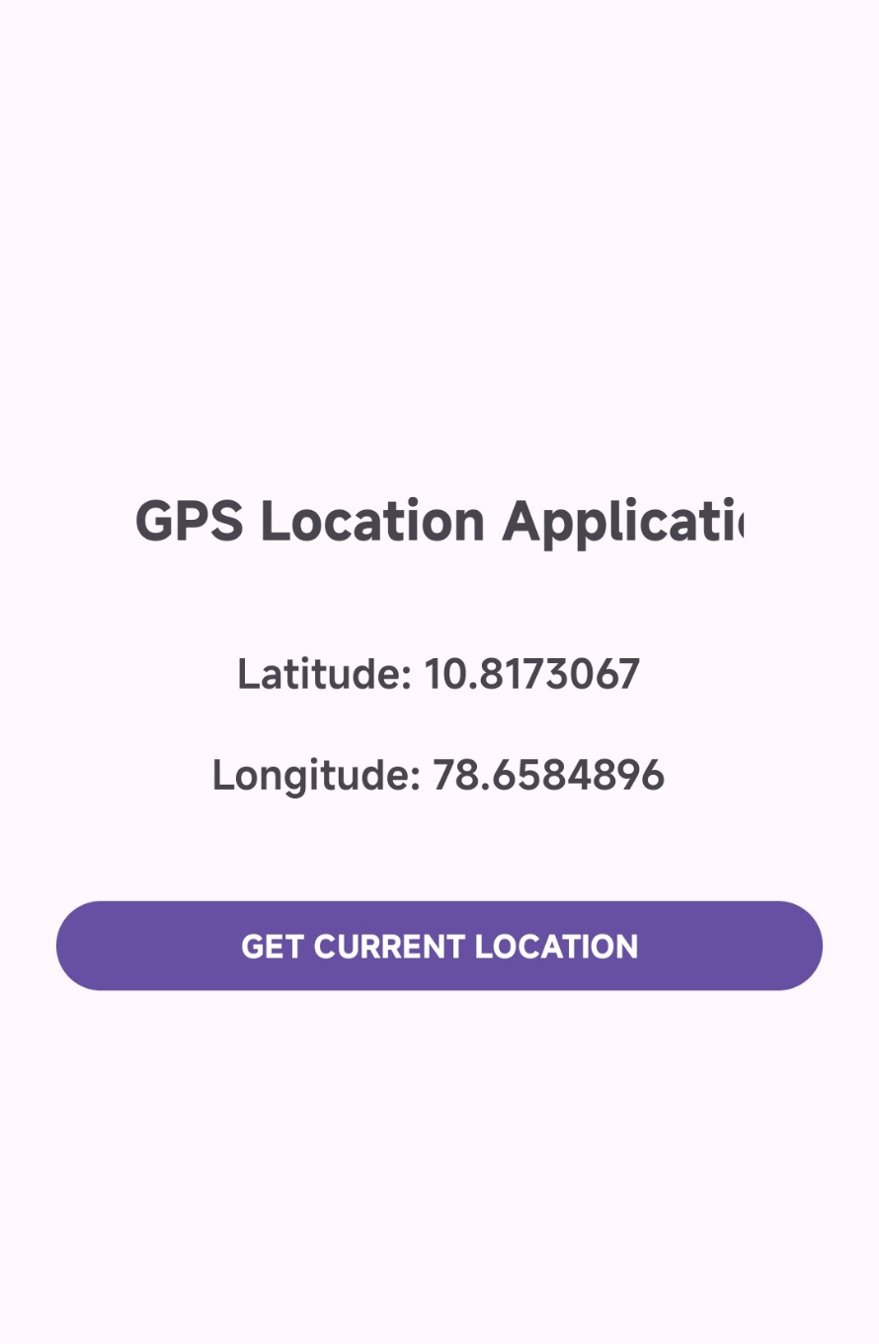

Result:
Thus, a native Android application was successfully developed to obtain and display the user's current GPS location information, including latitude and longitude.

Ex.no.08 | Implement an application that writes data to the SD Card
07.08.2026 | Implement an application that writes data to the SD Card

Aim:
To develop an Android application that writes user-entered data to external storage (SD Card).

Procedure:
- Open Android Studio and create a new project.
- Select Empty Views Activity.
- Choose Java as the programming language.
- Create the application for writing data to external storage.
- Design the user interface in activity_main.xml.
- Add an EditText to allow the user to enter data.
- Add a Button to save the entered data.
- Add a TextView to display the status or file path.
- In MainActivity.java, initialize the EditText, Button, and TextView.
- Use getExternalFilesDir() to access the application's external storage directory.
- Create a text file named MyData.txt using the File class.
- Use FileOutputStream to write the user-entered data into the file.
- Close the output stream after writing the data.
- Display a success message after the data is stored successfully.
- Run the application on an Android device or emulator.
- Enter some text and click the SAVE TO SD CARD button.
- Verify that the data is successfully written to MyData.txt in external storage.
Program:
XML CODE:
<?xml version="1.0" encoding="utf-8"?>
<LinearLayout xmlns:android="http://schemas.android.com/apk/res/android"
android:layout_width="match_parent"
android:layout_height="match_parent"
android:orientation="vertical"
android:gravity="center"
android:padding="25dp">
<TextView
android:layout_width="wrap_content"
android:layout_height="wrap_content"
android:text="Write Data to SD Card"
android:textSize="24sp"
android:textStyle="bold"
android:layout_marginBottom="30dp" />
<EditText
android:id="@+id/editTextData"
android:layout_width="match_parent"
android:layout_height="wrap_content"
android:hint="Enter data"
android:inputType="text" />
<Button
android:id="@+id/btnSave"
android:layout_width="match_parent"
android:layout_height="wrap_content"
android:text="SAVE TO SD CARD"
android:layout_marginTop="20dp" />
<TextView
android:id="@+id/tvStatus"
android:layout_width="wrap_content"
android:layout_height="wrap_content"
android:text=""
android:textSize="18sp"
android:layout_marginTop="20dp" />
</LinearLayout>

MainActivity.java Code:
package com.example.myapplication;
import android.os.Bundle;
import android.os.Environment;
import android.widget.Button;
import android.widget.EditText;
import android.widget.TextView;
import android.widget.Toast;
import androidx.appcompat.app.AppCompatActivity;
import java.io.File;
import java.io.FileOutputStream;
public class MainActivity extends AppCompatActivity {
EditText editTextData;
Button btnSave;
TextView tvStatus;
@Override
protected void onCreate(Bundle savedInstanceState) {
super.onCreate(savedInstanceState);
setContentView(R.layout.activity_main);
editTextData = findViewById(R.id.editTextData);
btnSave = findViewById(R.id.btnSave);
tvStatus = findViewById(R.id.tvStatus);
btnSave.setOnClickListener(v -> {
String data = editTextData.getText().toString();
if (data.isEmpty()) {
Toast.makeText(
MainActivity.this,
"Please enter some data",
Toast.LENGTH_SHORT
).show();
return;
}
writeData(data);
});
}
private void writeData(String data) {
try {
File folder = getExternalFilesDir(null);
File file = new File(
folder,
"MyData.txt"
);
FileOutputStream outputStream =
new FileOutputStream(file);
outputStream.write(data.getBytes());
outputStream.close();
tvStatus.setText(
"Data saved successfully!\n\nFile Path:\n"
+ file.getAbsolutePath()
);
Toast.makeText(
this,
"Data Written Successfully",
Toast.LENGTH_LONG
).show();
editTextData.setText("");
} catch (Exception e) {
tvStatus.setText(
"Error: " + e.getMessage()
);
Toast.makeText(
this,
"Failed to write data",
Toast.LENGTH_LONG
).show();
}
}
}
Output:
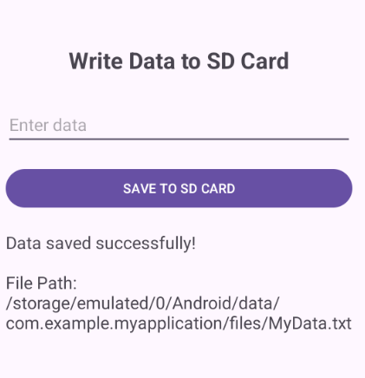

Result:
Thus, an Android application was successfully developed to write user-entered data into a text file stored in external storage (SD Card).

Ex.no.09 | SMS Alert Application
07.08.2026 | SMS Alert Application

Aim
To develop an Android application that receives incoming SMS messages and displays an alert notification containing the sender's phone number and message.
Procedure
- Create a new Android Studio project named SMS Alert App.
- Design the user interface using a LinearLayout with TextView components.
- Add RECEIVE_SMS and READ_SMS permissions in the AndroidManifest.xml.
- Request SMS permissions from the user at runtime.
- Create a BroadcastReceiver named SmsReceiver to receive incoming SMS.
- Retrieve the sender number and SMS message using SmsMessage.
- Create a notification channel for Android 8.0 and above.
- Display the received SMS details through a notification.
- Run the application on an Android Emulator.
- Send a test SMS and verify the sender and message in the application/log output.
Program:
XML Code:
<?xml version="1.0" encoding="utf-8"?>

<LinearLayout
xmlns:android="http://schemas.android.com/apk/res/android"
android:layout_width="match_parent"
android:layout_height="match_parent"
android:orientation="vertical"
android:gravity="center"
android:padding="24dp">

<TextView
android:id="@+id/titleText"
android:layout_width="wrap_content"
android:layout_height="wrap_content"
android:text="SMS Alert App"
android:textSize="28sp"
android:textStyle="bold"
android:layout_marginBottom="20dp"/>

<TextView
android:id="@+id/statusText"
android:layout_width="wrap_content"
android:layout_height="wrap_content"
android:text="Checking SMS permission..."
android:textSize="18sp"
android:gravity="center"/>

</LinearLayout>
Java Code:
MainActivity.java:

package com.example.myapplication;
import android.Manifest;
import android.content.pm.PackageManager;
import android.os.Bundle;
import android.widget.TextView;
import androidx.appcompat.app.AppCompatActivity;
import androidx.core.app.ActivityCompat;
import androidx.core.content.ContextCompat;
public class MainActivity extends AppCompatActivity {
private static final int SMS_PERMISSION_CODE = 100;
@Override
protected void onCreate(Bundle savedInstanceState) {
super.onCreate(savedInstanceState);
setContentView(R.layout.activity_main);
TextView statusText = findViewById(R.id.statusText);
if (ContextCompat.checkSelfPermission(
this,
Manifest.permission.RECEIVE_SMS
) != PackageManager.PERMISSION_GRANTED) {
ActivityCompat.requestPermissions(
this,
new String[]{
Manifest.permission.RECEIVE_SMS,
Manifest.permission.READ_SMS
},
SMS_PERMISSION_CODE
);
} else {
statusText.setText("SMS permission granted.\nWaiting for messages...");
}
}
}
SMSReceiver:
package com.example.myapplication;
import android.app.NotificationChannel;
import android.app.NotificationManager;
import android.app.PendingIntent;
import android.content.BroadcastReceiver;
import android.content.Context;
import android.content.Intent;
import android.os.Build;
import android.provider.Telephony;
import androidx.core.app.NotificationCompat;
public class SmsReceiver extends BroadcastReceiver {
private static final String CHANNEL_ID = "SMS_ALERT_CHANNEL";
private static final int NOTIFICATION_ID = 101;
@Override
public void onReceive(Context context, Intent intent) {
if (!Telephony.Sms.Intents.SMS_RECEIVED_ACTION.equals(intent.getAction())) {
return;
}
android.telephony.SmsMessage[] messages =
Telephony.Sms.Intents.getMessagesFromIntent(intent);
if (messages == null || messages.length == 0) {
return;
}
String sender = messages[0].getDisplayOriginatingAddress();
StringBuilder messageBody = new StringBuilder();
for (android.telephony.SmsMessage message : messages) {
messageBody.append(message.getMessageBody());
}
showNotification(context, sender, messageBody.toString());
}
private void showNotification(
Context context,
String sender,
String message
) {
NotificationManager notificationManager =
(NotificationManager) context.getSystemService(
Context.NOTIFICATION_SERVICE
);
// Create notification channel for Android 8+
if (Build.VERSION.SDK_INT >= Build.VERSION_CODES.O) {
NotificationChannel channel = new NotificationChannel(
CHANNEL_ID,
"SMS Alerts",
NotificationManager.IMPORTANCE_HIGH
);
channel.setDescription("Alerts for incoming SMS messages");
notificationManager.createNotificationChannel(channel);
}
Intent openIntent = new Intent(context, MainActivity.class);
PendingIntent pendingIntent = PendingIntent.getActivity(
context,
0,
openIntent,
PendingIntent.FLAG_UPDATE_CURRENT |
PendingIntent.FLAG_IMMUTABLE
);
NotificationCompat.Builder builder =
new NotificationCompat.Builder(context, CHANNEL_ID)
.setSmallIcon(android.R.drawable.ic_dialog_info)
.setContentTitle("New SMS from " + sender)
.setContentText(message)
.setStyle(
new NotificationCompat.BigTextStyle()
.bigText(message)
)
.setPriority(NotificationCompat.PRIORITY_HIGH)
.setAutoCancel(true)
.setContentIntent(pendingIntent);
notificationManager.notify(
NOTIFICATION_ID,
builder.build()
);
}
}
Run time Command Prompt:
SMS_ALERT: NEW SMS RECEIVED
SMS_ALERT: Sender: 9876543210
SMS_ALERT: Message: Hello Macha

Output:
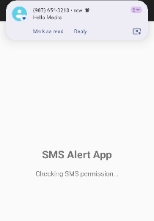
Result
Thus, the SMS Alert App was successfully developed and executed. The application successfully receives incoming SMS messages and displays the sender number and message as an alert notification.

Ex.no.10 | Sets an alarm clock
07.08.2026 | Sets an alarm clock

Aim:
To develop a mobile application that creates and sets an alarm clock using Android Studio.

PROCEDURE
- Open Android Studio and create a new project.
- Select Empty Views Activity.
- Choose Java as the programming language.
- Create the user interface using activity_main.xml.
- Add a TextView to display the selected alarm time.
- Add a SELECT ALARM TIME button.
- Add a SET ALARM button.
- In MainActivity.java, initialize the TextView and Buttons.
- Use TimePickerDialog to allow the user to select the alarm time.
- Create an AlarmManager object to manage and schedule the alarm.
- Create a separate Java class named AlarmReceiver by extending BroadcastReceiver.
- Register the AlarmReceiver in the AndroidManifest.xml file.
- Create a PendingIntent to trigger the AlarmReceiver at the selected time.
- Set the alarm using AlarmManager.setExactAndAllowWhileIdle().
- Add notification and exact alarm permissions in AndroidManifest.xml.
- Run the application on an Android device or emulator.
- Select a future alarm time using the SELECT ALARM TIME button.
- Click the SET ALARM button.
- Allow the required Notification and Alarms & reminders permissions.
- When the selected time is reached, the AlarmReceiver is triggered and displays the alarm notification.

XmL Code:
activity code:
<?xml version="1.0" encoding="utf-8"?>
<LinearLayout
xmlns:android="http://schemas.android.com/apk/res/android"
android:layout_width="match_parent"
android:layout_height="match_parent"
android:orientation="vertical"
android:gravity="center"
android:padding="25dp">
<TextView
android:layout_width="wrap_content"
android:layout_height="wrap_content"
android:text="Alarm Clock Application"
android:textSize="26sp"
android:textStyle="bold"
android:layout_marginBottom="30dp" />
<TextView
android:id="@+id/tvTime"
android:layout_width="wrap_content"
android:layout_height="wrap_content"
android:text="Select Alarm Time"
android:textSize="20sp"
android:layout_marginBottom="20dp" />
<Button
android:id="@+id/btnSelectTime"
android:layout_width="match_parent"
android:layout_height="wrap_content"
android:text="SELECT TIME" />
<Button
android:id="@+id/btnSetAlarm"
android:layout_width="match_parent"
android:layout_height="wrap_content"
android:text="SET ALARM"
android:layout_marginTop="15dp" />
</LinearLayout>

Mainfestxml code:
<?xml version="1.0" encoding="utf-8"?>
<manifest xmlns:android="http://schemas.android.com/apk/res/android">
<!-- Notification Permission -->
<uses-permission
android:name="android.permission.POST_NOTIFICATIONS" />
<!-- Exact Alarm Permission -->
<uses-permission
android:name="android.permission.SCHEDULE_EXACT_ALARM" />
<application
android:allowBackup="true"
android:label="Alarm Clock"
android:supportsRtl="true"
android:theme="@style/Theme.AppCompat.Light.DarkActionBar">
<activity
android:name=".MainActivity"
android:exported="true">
<intent-filter>
<action android:name="android.intent.action.MAIN" />
<category android:name="android.intent.category.LAUNCHER" />
</intent-filter>
</activity>
<receiver
android:name=".AlarmReceiver"
android:exported="false" />
</application>
</manifest>

Java Code:
Mainactivity.java:
package com.example.myapplication;
import android.Manifest;
import android.app.AlarmManager;
import android.app.PendingIntent;
import android.app.TimePickerDialog;
import android.content.Intent;
import android.content.pm.PackageManager;
import android.os.Build;
import android.os.Bundle;
import android.provider.Settings;
import android.widget.Button;
import android.widget.TextView;
import android.widget.Toast;
import androidx.appcompat.app.AppCompatActivity;
import androidx.core.app.ActivityCompat;
import java.util.Calendar;
public class MainActivity extends AppCompatActivity {
private TextView tvTime;
private Button btnSelectTime;
private Button btnSetAlarm;
private int hour;
private int minute;
private boolean timeSelected = false;
private static final int NOTIFICATION_PERMISSION_CODE = 101;
@Override
protected void onCreate(Bundle savedInstanceState) {
super.onCreate(savedInstanceState);
setContentView(R.layout.activity_main);
tvTime = findViewById(R.id.tvTime);
btnSelectTime = findViewById(R.id.btnSelectTime);
btnSetAlarm = findViewById(R.id.btnSetAlarm);
requestNotificationPermission();
btnSelectTime.setOnClickListener(v -> selectTime());
btnSetAlarm.setOnClickListener(v -> {
if (!timeSelected) {
Toast.makeText(
MainActivity.this,
"Please select alarm time first",
Toast.LENGTH_SHORT
).show();
} else {
setAlarm();
}
});
}
private void requestNotificationPermission() {
if (Build.VERSION.SDK_INT >= Build.VERSION_CODES.TIRAMISU) {
if (ActivityCompat.checkSelfPermission(
this,
Manifest.permission.POST_NOTIFICATIONS
) != PackageManager.PERMISSION_GRANTED) {
ActivityCompat.requestPermissions(
this,
new String[]{
Manifest.permission.POST_NOTIFICATIONS
},
NOTIFICATION_PERMISSION_CODE
);
}
}
}
private void selectTime() {
Calendar currentTime = Calendar.getInstance();
int currentHour =
currentTime.get(Calendar.HOUR_OF_DAY);
int currentMinute =
currentTime.get(Calendar.MINUTE);
TimePickerDialog timePickerDialog =
new TimePickerDialog(
MainActivity.this,
(view, selectedHour, selectedMinute) -> {
hour = selectedHour;
minute = selectedMinute;
timeSelected = true;
tvTime.setText(
String.format(
"Alarm Time: %02d:%02d",
hour,
minute
)
);
},
currentHour,
currentMinute,
true
);
timePickerDialog.show();
}
private void setAlarm() {
AlarmManager alarmManager =
(AlarmManager) getSystemService(ALARM_SERVICE);
Calendar calendar = Calendar.getInstance();
calendar.set(
Calendar.HOUR_OF_DAY,
hour
);
calendar.set(
Calendar.MINUTE,
minute
);
calendar.set(
Calendar.SECOND,
0
);
calendar.set(
Calendar.MILLISECOND,
0
);
// If selected time has passed,
// set alarm for next day
if (calendar.getTimeInMillis()
<= System.currentTimeMillis()) {
calendar.add(
Calendar.DAY_OF_YEAR,
1
);
}
Intent intent =
new Intent(
MainActivity.this,
AlarmReceiver.class
);
PendingIntent pendingIntent =
PendingIntent.getBroadcast(
MainActivity.this,
100,
intent,
PendingIntent.FLAG_UPDATE_CURRENT
|
PendingIntent.FLAG_IMMUTABLE
);
// Android 12 and above
if (Build.VERSION.SDK_INT
>= Build.VERSION_CODES.S) {
if (!alarmManager.canScheduleExactAlarms()) {
try {
Intent settingsIntent =
new Intent(
Settings
.ACTION_REQUEST_SCHEDULE_EXACT_ALARM
);
startActivity(settingsIntent);
Toast.makeText(
this,
"Please allow Alarms & reminders permission",
Toast.LENGTH_LONG
).show();
} catch (Exception e) {
Toast.makeText(
this,
"Please enable Alarms & reminders in Settings",
Toast.LENGTH_LONG
).show();
}
return;
}
}
alarmManager.setExactAndAllowWhileIdle(
AlarmManager.RTC_WAKEUP,
calendar.getTimeInMillis(),
pendingIntent
);
Toast.makeText(
MainActivity.this,
"Alarm Set for "
+ String.format(
"%02d:%02d",
hour,
minute
),
Toast.LENGTH_LONG
).show();
}
}

AlarmReceiver Code:
package com.example.myapplication;
import android.app.NotificationChannel;
import android.app.NotificationManager;
import android.content.BroadcastReceiver;
import android.content.Context;
import android.content.Intent;
import android.os.Build;
import androidx.core.app.NotificationCompat;
import androidx.core.app.NotificationManagerCompat;
public class AlarmReceiver extends BroadcastReceiver {
private static final String CHANNEL_ID = "alarm_channel";
@Override
public void onReceive(Context context, Intent intent) {
createNotificationChannel(context);
NotificationCompat.Builder builder =
new NotificationCompat.Builder(
context,
CHANNEL_ID
)
.setSmallIcon(
android.R.drawable.ic_dialog_alert
)
.setContentTitle("ALARM!")
.setContentText(
"Wake Up! Your alarm is ringing."
)
.setPriority(
NotificationCompat.PRIORITY_HIGH
)
.setAutoCancel(true);
NotificationManagerCompat notificationManager =
NotificationManagerCompat.from(context);
notificationManager.notify(
100,
builder.build()
);
}
private void createNotificationChannel(Context context) {
if (Build.VERSION.SDK_INT
>= Build.VERSION_CODES.O) {
NotificationChannel channel =
new NotificationChannel(
CHANNEL_ID,
"Alarm Notifications",
NotificationManager.IMPORTANCE_HIGH
);
channel.setDescription(
"Notification for Alarm Clock"
);
NotificationManager manager =
context.getSystemService(
NotificationManager.class
);
if (manager != null) {
manager.createNotificationChannel(
channel
);
}
}
}
}

Output:
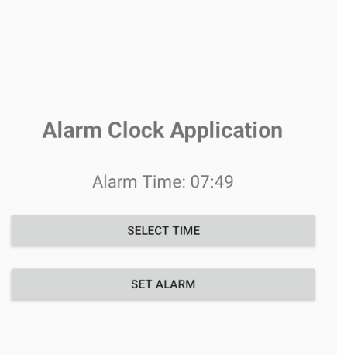

Result:
Thus, the Android mobile application was successfully developed using Android Studio to create and set an alarm clock. The application allows the user to select the desired time and sets the alarm successfully.

