Face Mask Compliance Detection Using LBP + HOG + SVM
Register No: 2116230701158
Department of CSE
Rajalakshmi Engineering College

1. Introduction
Face mask compliance monitoring is essential for public safety and health governance. This project implements a lightweight classical computer vision system using Local Binary Patterns (LBP), Histogram of Oriented Gradients (HOG), and a Support Vector Machine (SVM) for high-precision, real-time detection.

2. Dataset Description
The dataset is well-balanced with thousands of high-quality samples.
Class | Images | Description
with_mask | 3725 | Mask worn correctly
without_mask | 3828 | No mask detected
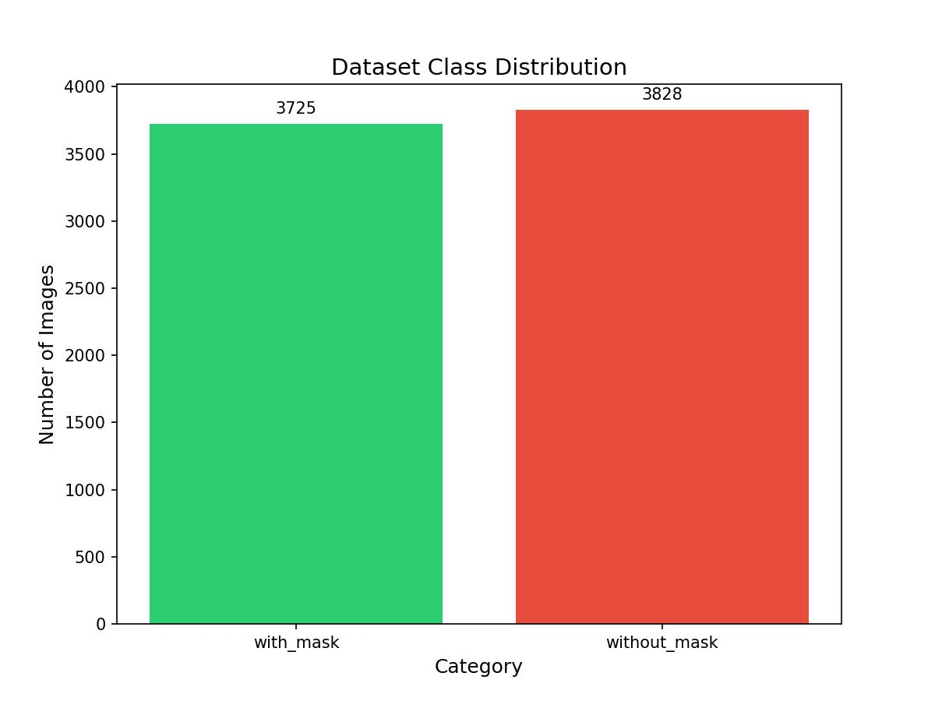

3. Preprocessing
Steps applied: Resize (64x64), Grayscale, and CLAHE enhancement.


4. Feature Extraction
Texture (LBP) and Structural (HOG) features are combined for robust detection.

4.1 LBP Visualization


4.2 HOG Visualization


5. Results and Evaluation
The model achieved a final accuracy of 90.21%.
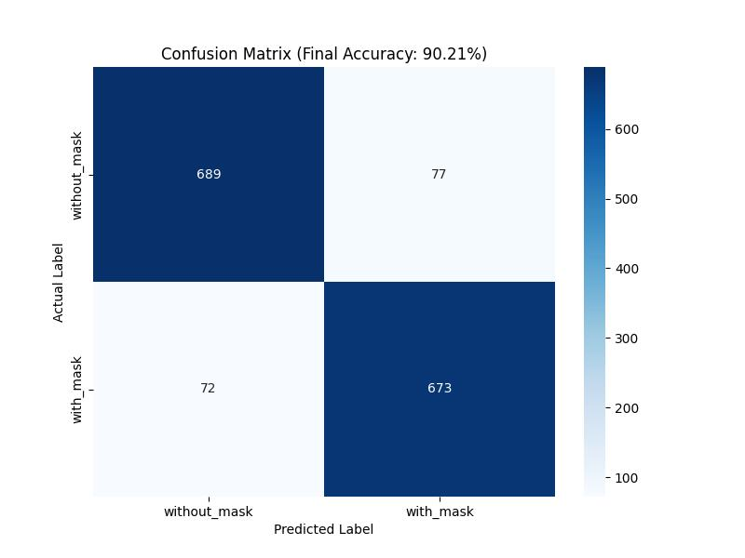

6. Conclusion
The 90.21% accuracy shows that classical feature extraction (LBP+HOG) remains a powerful tool for visual classification tasks with low CPU overhead.

7. Real-time Detection Demos
