BGRFC Destination

1. Issue Overview
We have encountered issues during Financial Accounting (FI) postings where multiple background tasks, triggered via the Business Transaction Event (BTE) framework, were causing document posting failures due to record locking conflicts. These locking issues stem from concurrent processes attempting to update the same data records.
2. Changes Implemented
To mitigate these issues, we have shifted to using background Remote Function Calls (bgRFC) for RFC calls initiated by the BTE. Currently, these bgRFC calls use the system’s shared 'DEFAULT' inbound RFC destination, which means BTE-triggered processes are still processed alongside other background tasks.
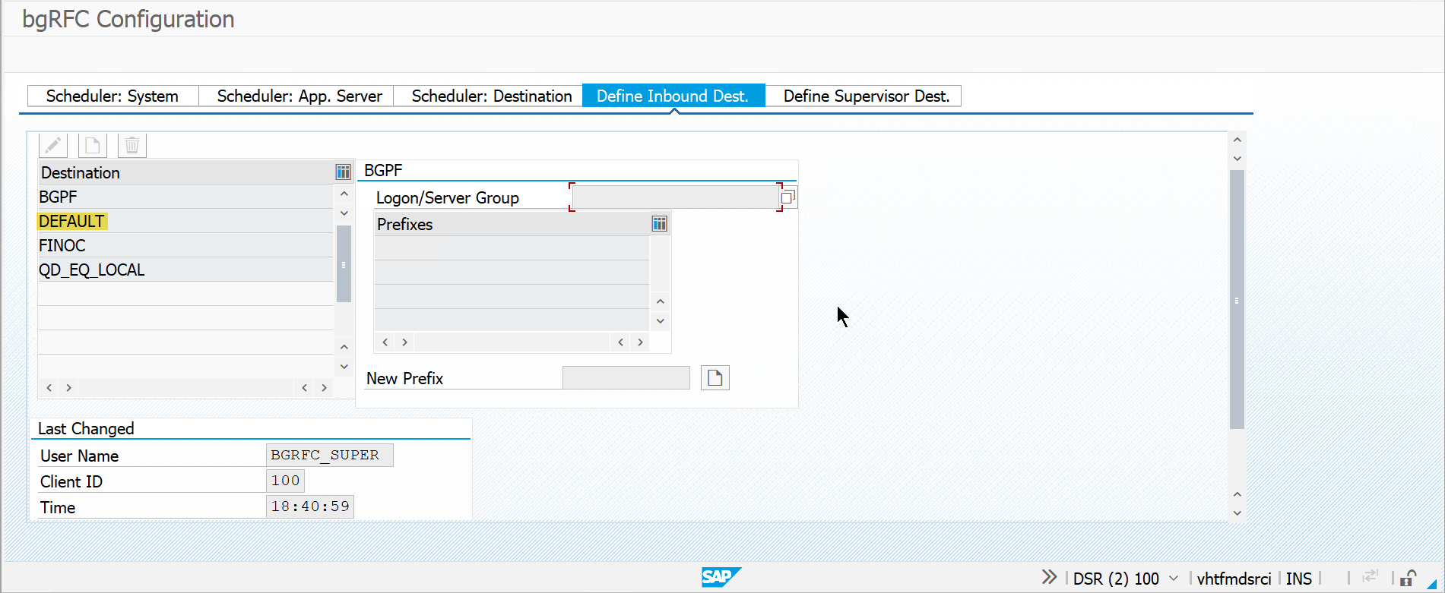
3. Inbound RFC Destination Setup Needed
We propose the configuration of a dedicated bgRFC inbound RFC destination in all system environments (Development, Quality, and Production). This new destination will be exclusively used for bgRFC calls originating from the BTE framework and will be a copy of the current configured ‘DEFAULT’ destination.
Rationale:
- Process Isolation: Separates BTE-triggered bgRFC calls from other background processing, reducing locking conflicts and failures.
- Resource Management: Allows for better monitoring and allocation of resources to BTE-related tasks.
- Operational Clarity: Simplifies troubleshooting and root cause analysis by segregating processing streams.

