**Web Development**

**Project**

**Done By:**

**24BCE5186-Synthea Gautam**

**24BCE5187-Ishani Ghosh**

**Faculty:** **Dr. K. Vallidevi ma’am**

**Course Name: BCSE203E**

**Title: CyberSafe**

**Index**

Title 1

Introduction 3-4

Functional Overview 4

Technical Analysis 5

Structure 6

Output 7-15

Conclusion 16

**Introduction**

**CyberSafe: A Freshman's Analysis of a Cybersecurity Awareness Web Project**

**Introduction**

**In an era where digital threats are evolving at an unprecedented pace, cybersecurity awareness has become more critical than ever. Individuals and organizations alike face constant risks from cyberattacks, including phishing scams, data breaches, malware, and identity theft. Despite increasing awareness, many users still fall victim to online threats due to a lack of proper knowledge and preparedness. Recognizing this urgent need, the CyberSafe web project was developed to educate users on cybersecurity best practices and provide them with the necessary tools to protect their digital presence effectively.**

**As a freshman at VIT Chennai, my exploration of CyberSafe introduced me to the intersection of web development and cybersecurity. This project serves as an interactive learning platform that aims to bridge the gap between technical knowledge and everyday online safety. Through an engaging and user-friendly interface, CyberSafe simplifies complex security concepts, making them accessible to users with varying levels of expertise. The website covers fundamental cybersecurity topics, such as phishing awareness, password security, malware prevention, and safe browsing practices. By incorporating interactive elements like quizzes and simulations, CyberSafe ensures a hands-on learning experience that reinforces key security principles.**

**Cybersecurity is no longer just a concern for IT professionals—it is a necessity for everyone who engages in online activities. Whether it’s social media interactions, financial transactions, or cloud-based data storage, understanding cybersecurity is crucial for safeguarding personal and professional information. CyberSafe takes an educational approach by presenting real-world scenarios and practical solutions, empowering users to make informed decisions and develop strong security habits.**

**My analysis of CyberSafe allowed me to understand the importance of structuring web applications effectively while maintaining an intuitive and visually appealing design. As a beginner in web development, I appreciated the seamless integration of HTML, CSS, and JavaScript, which not only enhanced the project’s functionality but also made it engaging for users. The project highlights the importance of cybersecurity education and serves as a valuable starting point for individuals seeking to enhance their digital security awareness.**

**This report aims to provide an in-depth analysis of CyberSafe’s structure, functionality, strengths, and areas for improvement. By examining its technical aspects and educational impact, I hope to highlight the importance of cybersecurity and the role that web-based learning tools play in promoting safer digital practices.**

**Functional Overview**

**The CyberSafe project integrates various cybersecurity topics, such as:**

1. **Phishing Awareness: Educating users on fraudulent emails and links.**
2. **Password Security: Guidelines for creating strong and secure passwords.**
3. **Malware Prevention: Identifying different types of malware and their impact.**
4. **Safe Browsing Practices: Encouraging users to adopt secure internet habits.**

**Interactive elements, such as quizzes or simulated phishing attempts, enhance engagement and practical learning.**

**Technical Analysis**

* **Frontend Implementation:**
  + **The project effectively utilizes HTML5 for semantic structure.**
  + **CSS is used to ensure a user-friendly and visually appealing experience.**
  + **JavaScript enhances interactivity, potentially through event listeners and form validation.**
* **Strengths:**
  + **Well-organized file structure.**
  + **User-centric design with intuitive navigation.**
  + **Engaging educational content with interactive elements.**
* **Areas for Improvement:**
  + **Performance Optimization: Minification of CSS/JS files can improve loading times.**
  + **Accessibility Enhancements: Implementing ARIA attributes for better screen reader support.**
  + **Security Considerations: Adding HTTPS enforcement and sanitizing inputs to prevent security vulnerabilities.**

**Structure:**

**HTML:**

**There were 5 html files involved:**

**index.html- Home page**

**pc.html-(Password-Checker)Make users to have a good practice of having strong passwords**

**lw.html-(Legitimate website Guide )Teach users to identify which websites are fake or real.**

**cc.html-(CyberChoices)Teach users about other cybercrimes like phishing,malware prevention,safe browsing practice.**

**th.html-(Thank You)Thank You Page.**

**CSS:**

**One CSS file involved-style.css**

**Media:**

**Multiple images in JPG,PNG,JPEG format for the quiz and icon.One audio file for the quiz in cc.html when the users finish the quiz.**

**OUTPUT:**

**Home Page:**

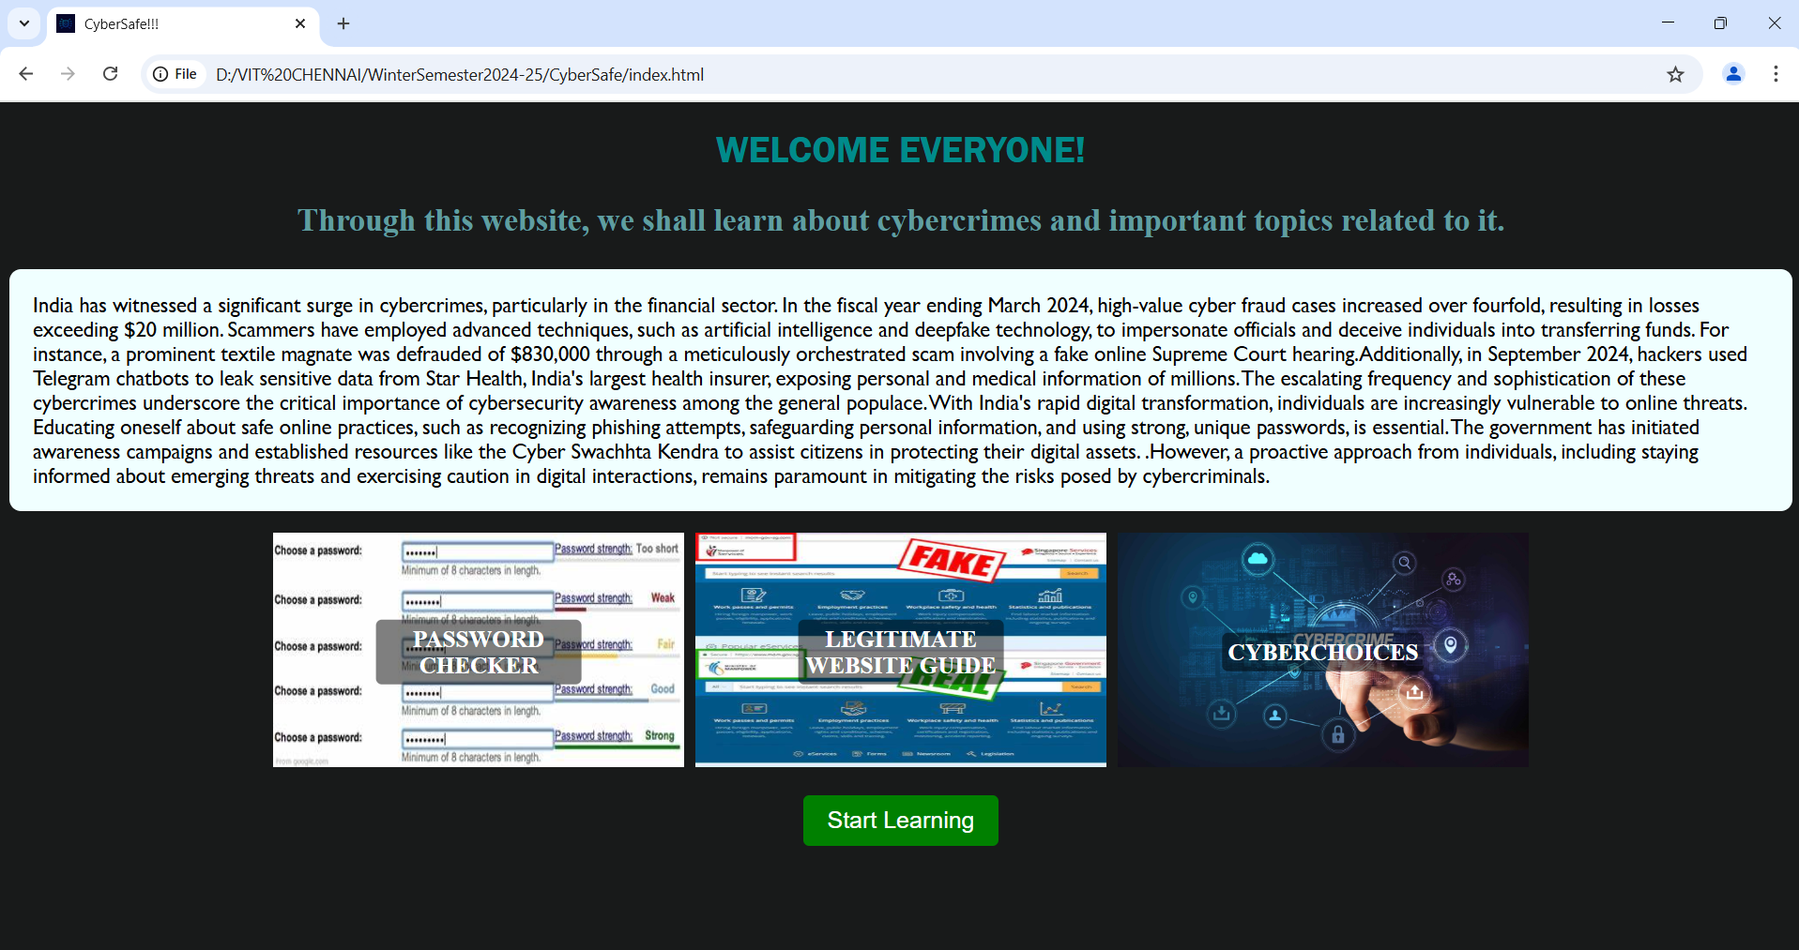

**Blurring effect when we hover on this images:**

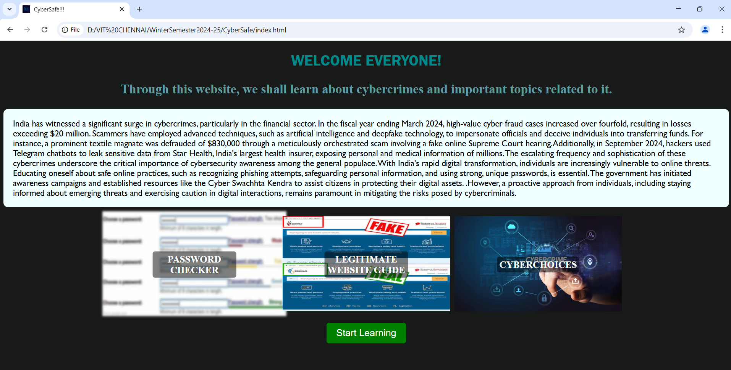

**When we press on the start learning button it directs to the first lesson password checker-pc.html**

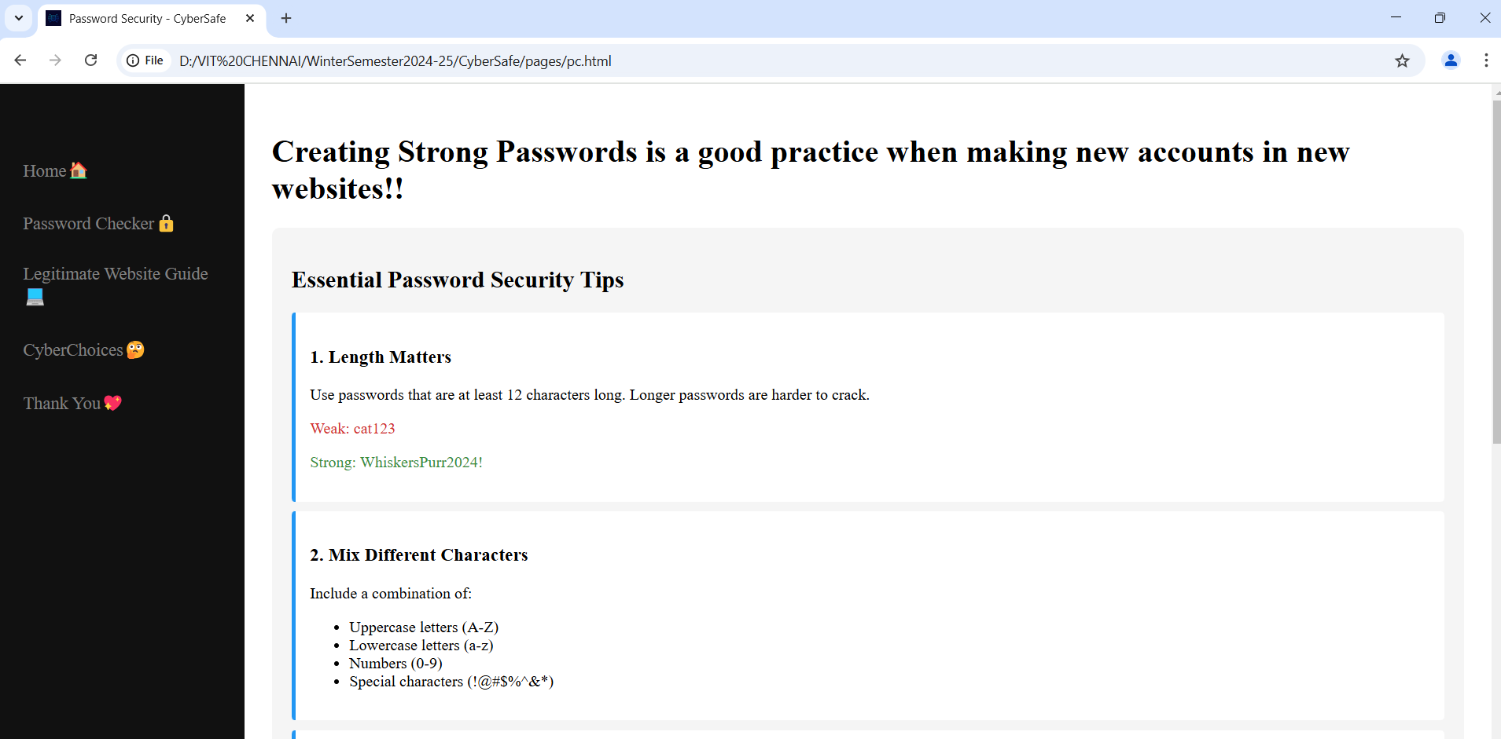

**The pc.html has multiple tips on how to make a strong passwords.We also have the feature of users checking wheather their password is strong or not.**

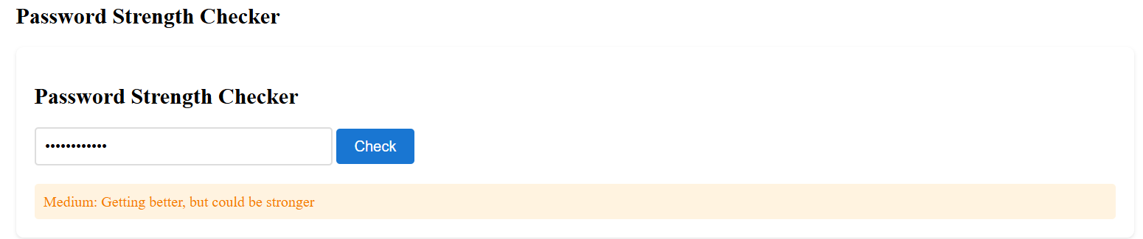

**We can also see the password:**

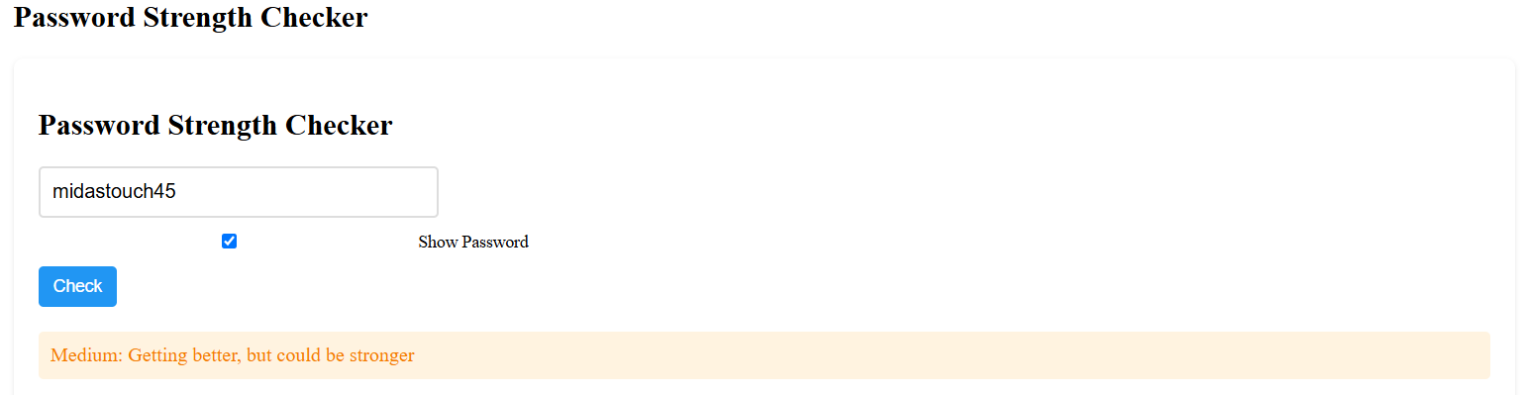

**Next we have navigation where we can navigate to our next lesson Legitimate website Guide where we give multiple tips to users on how to identify wheather a website is fake or real.**

**Navigation Bar:**

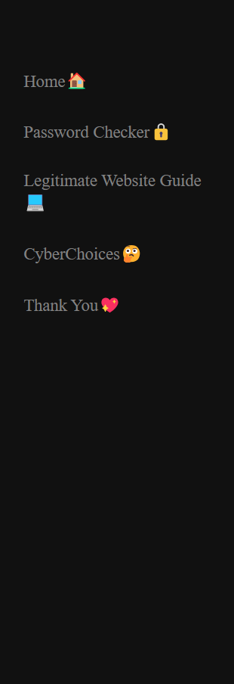

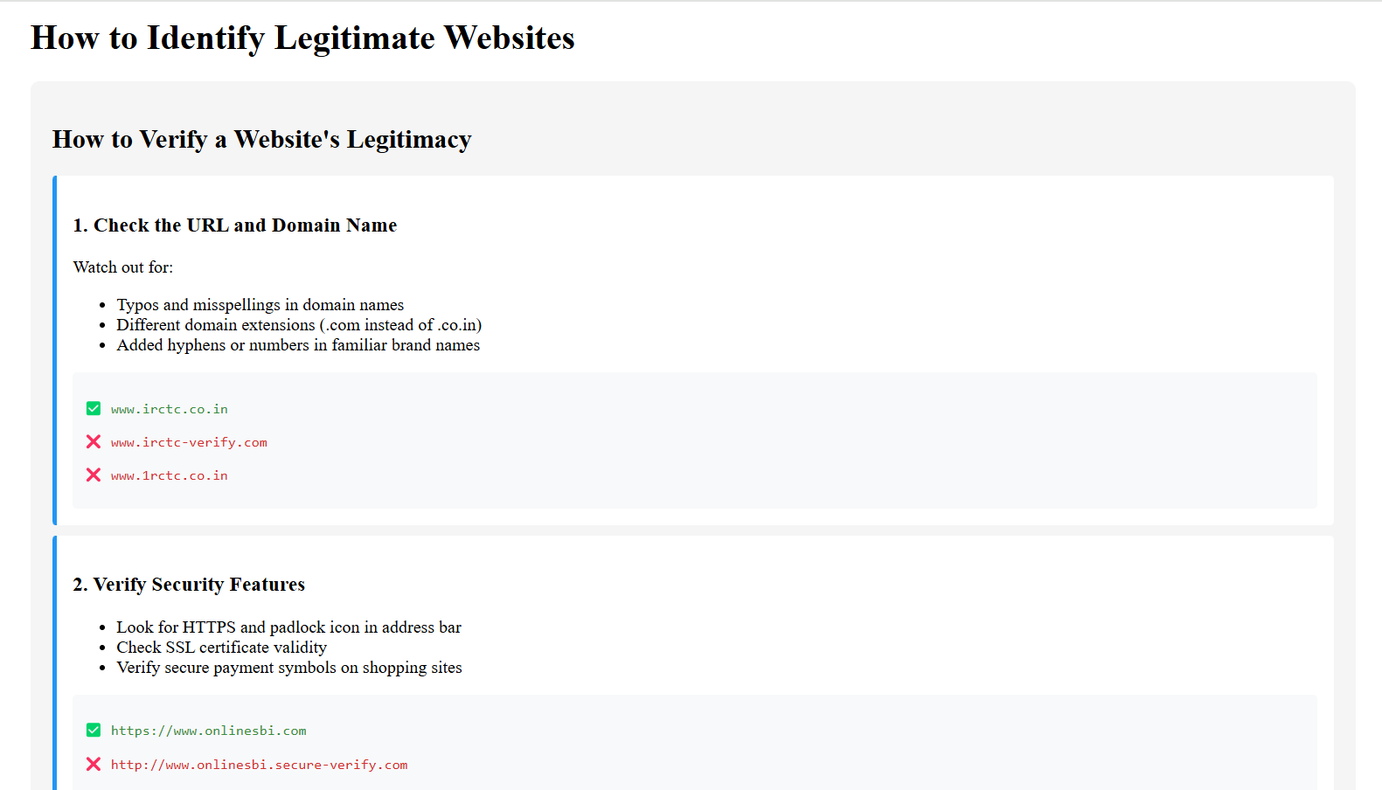

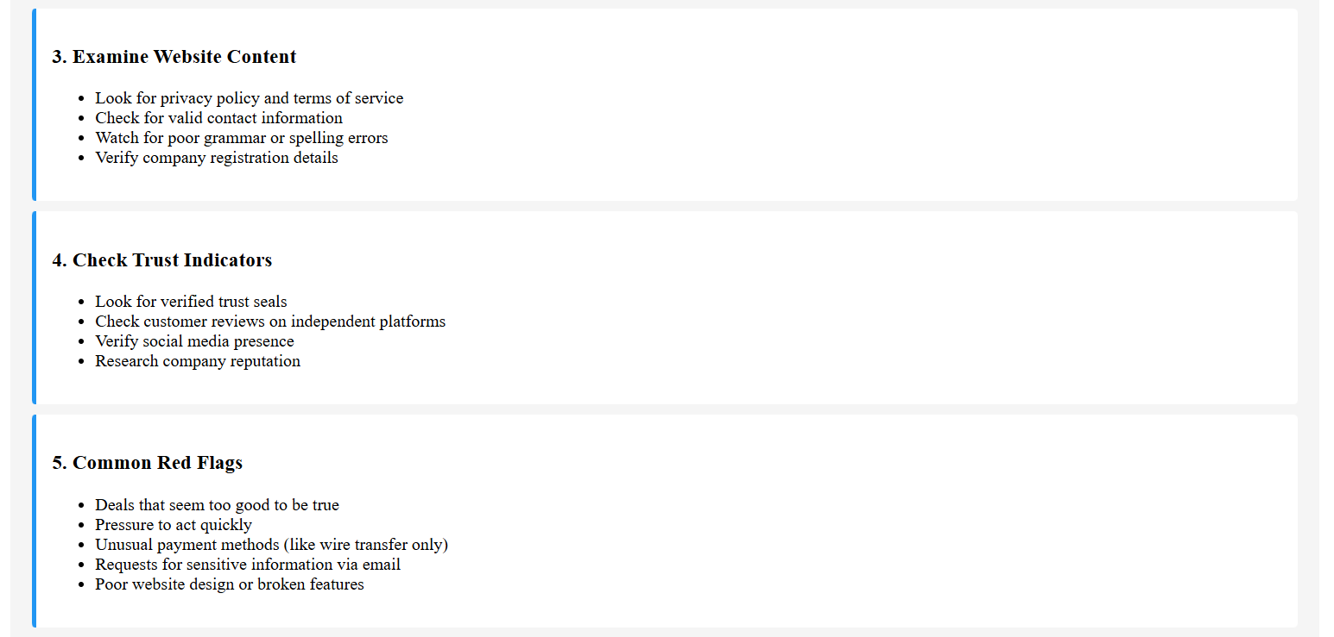

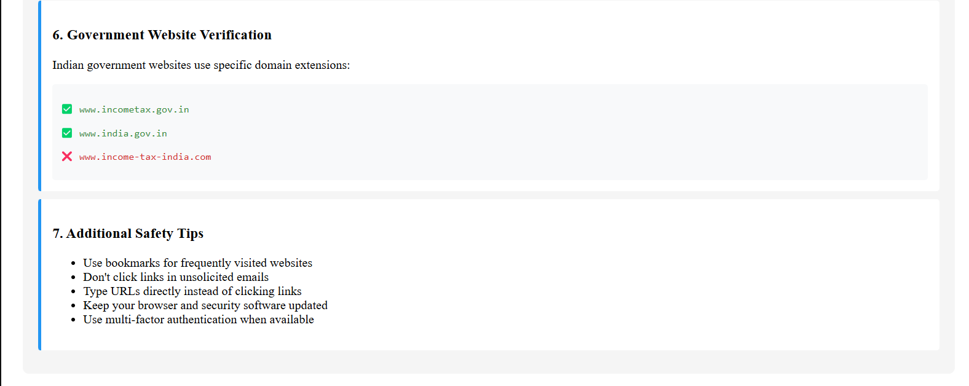

**Image-Based Quiz:**

**We also image based quiz where we make the users practice website verifaction(total-7questions.)**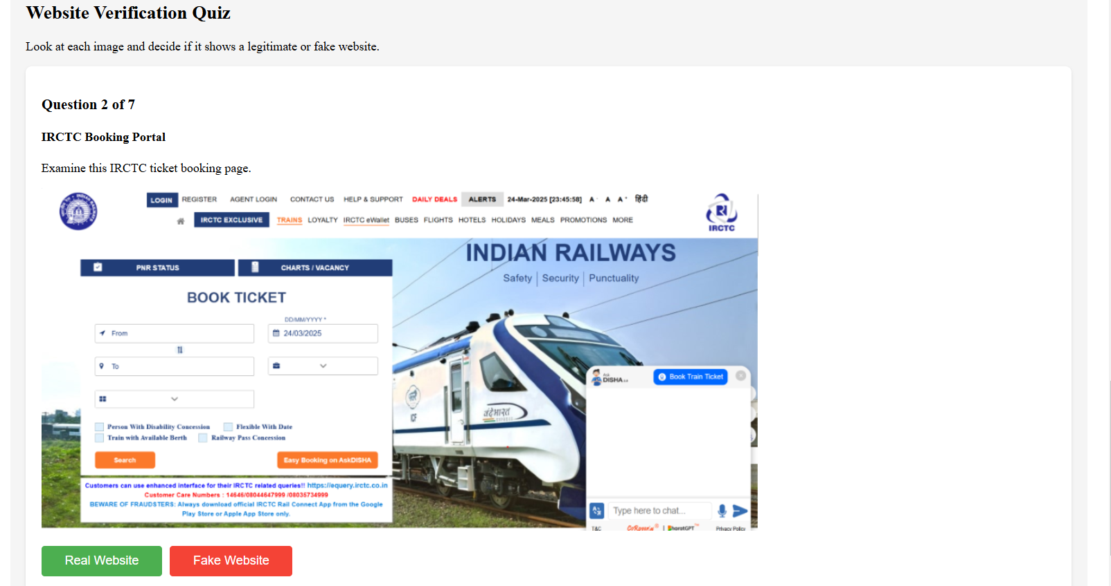

**It also tells you the score:**

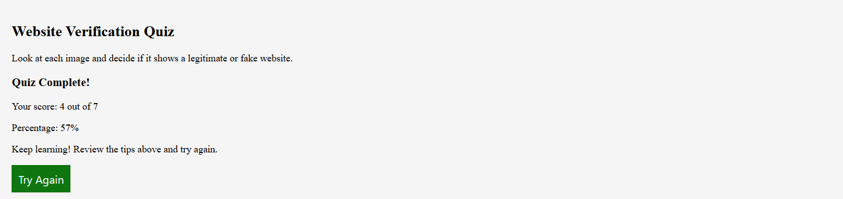

**We can also reattempt the quiz by clicking on try-again button.**

**Next we navigate to cc.html(CyberChoices) where we tell the users different stories of different cybercrimes and also take a quiz on these cybercrimes.You can say this quiz is inspired by game CHOICES where the users are given situations and options of what action they will take in that situation.**

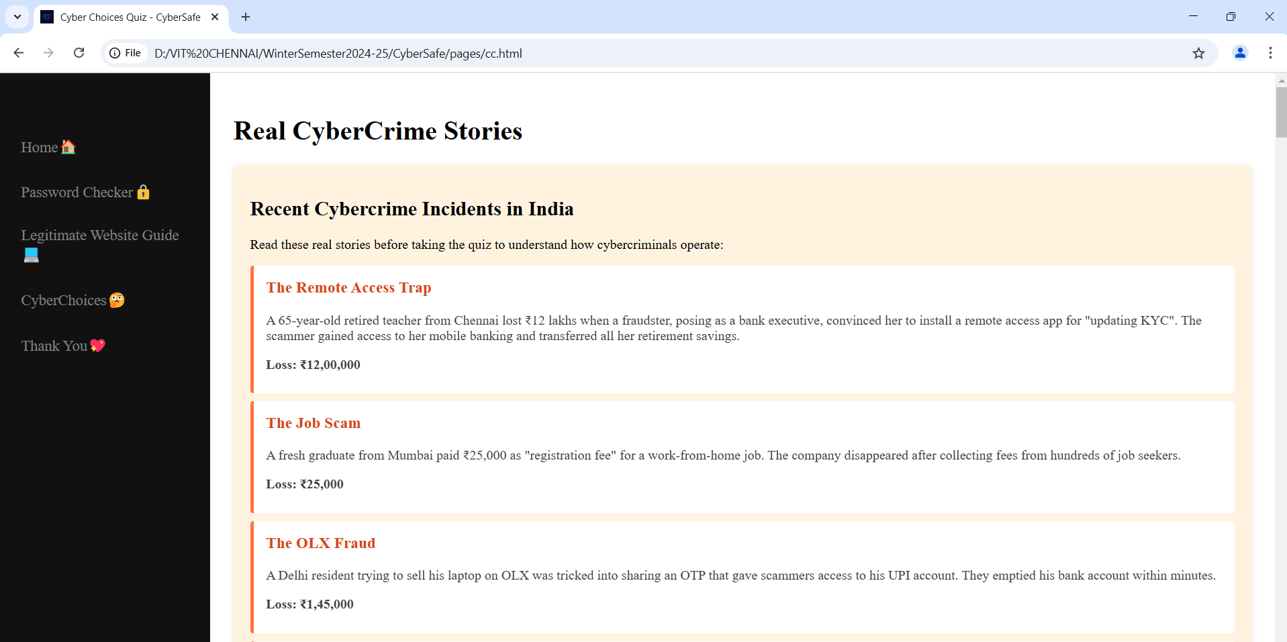

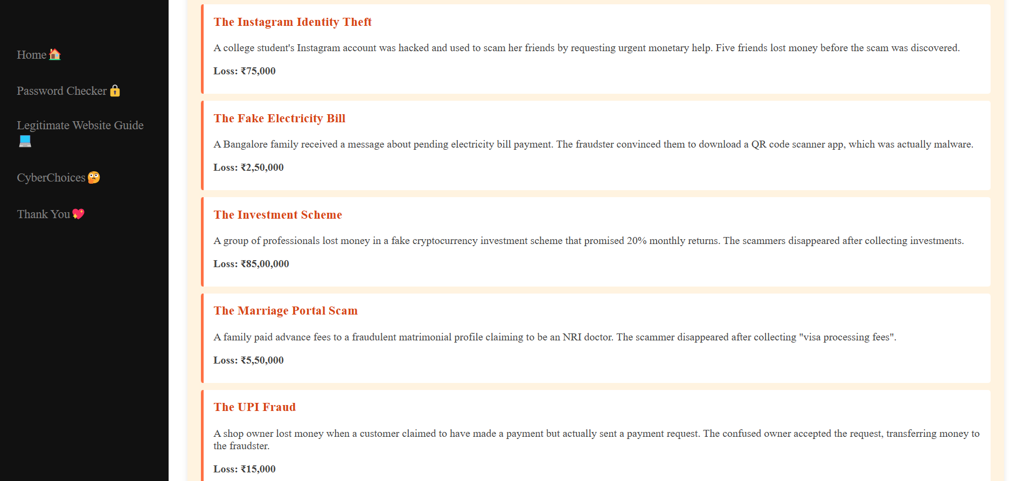

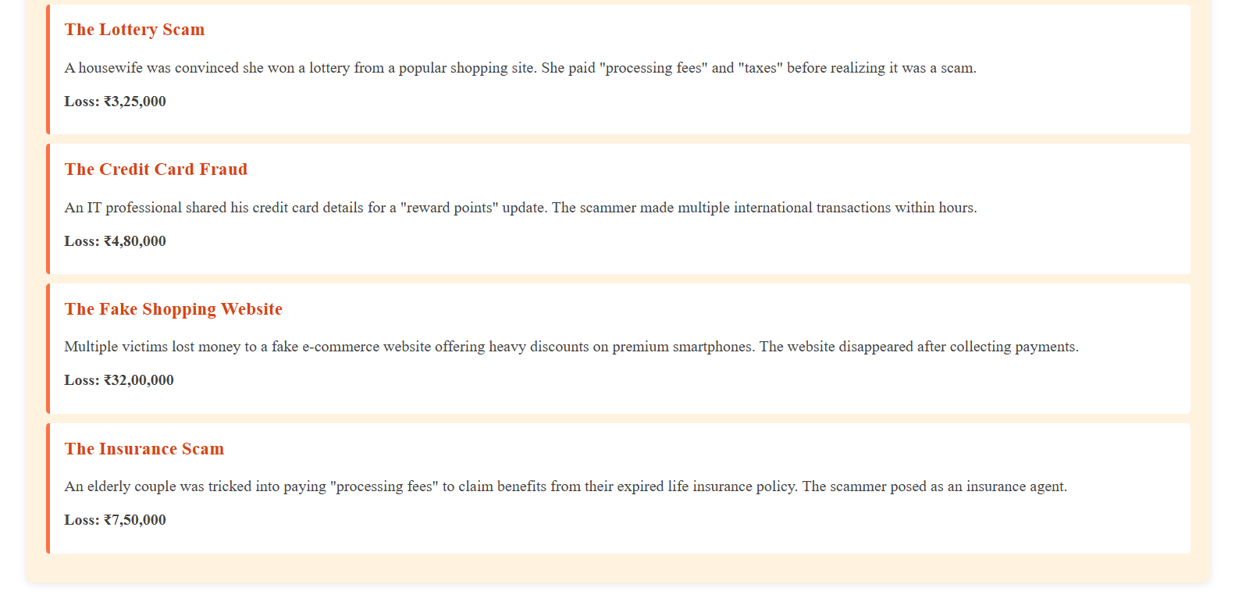

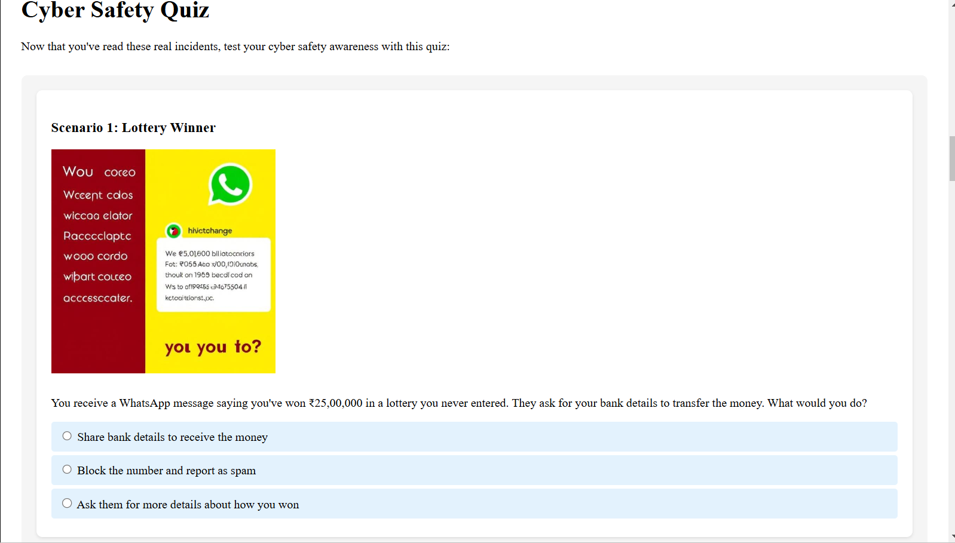

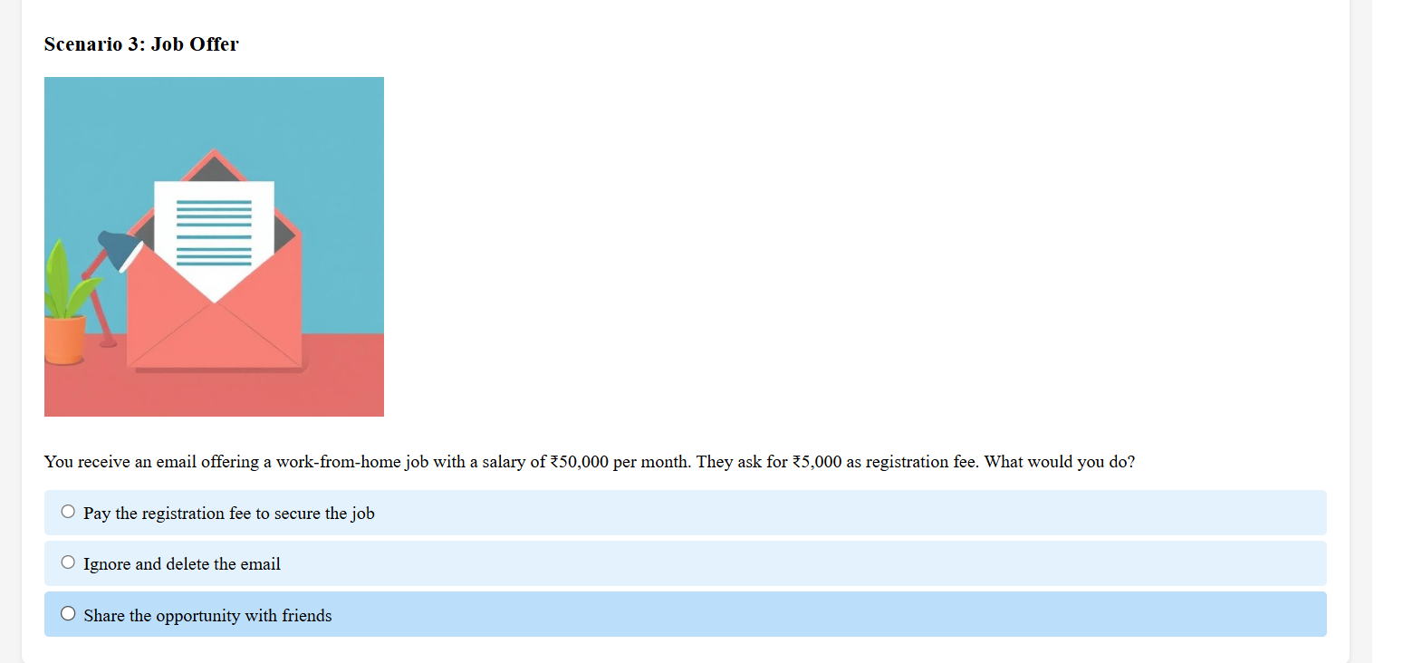

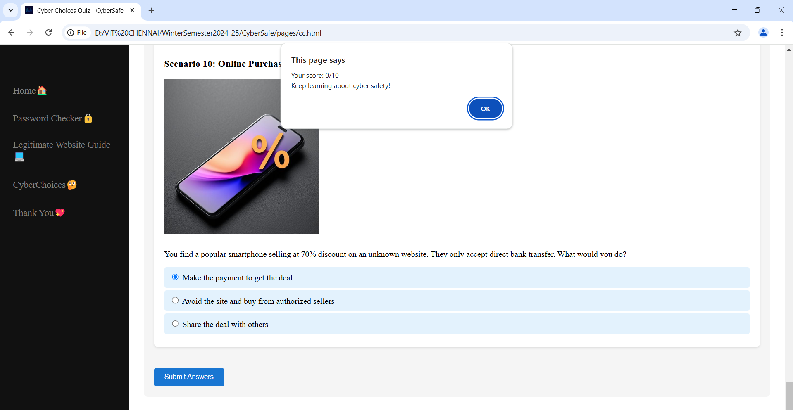

**When the score is shown a buzzer sound to prompt the user that finished the quiz successfully.**

**Thank You page**

**Then we move on to Thank You page-th.html.In thank you page we tell the users about the different government agencies who handles cybercrimes.**

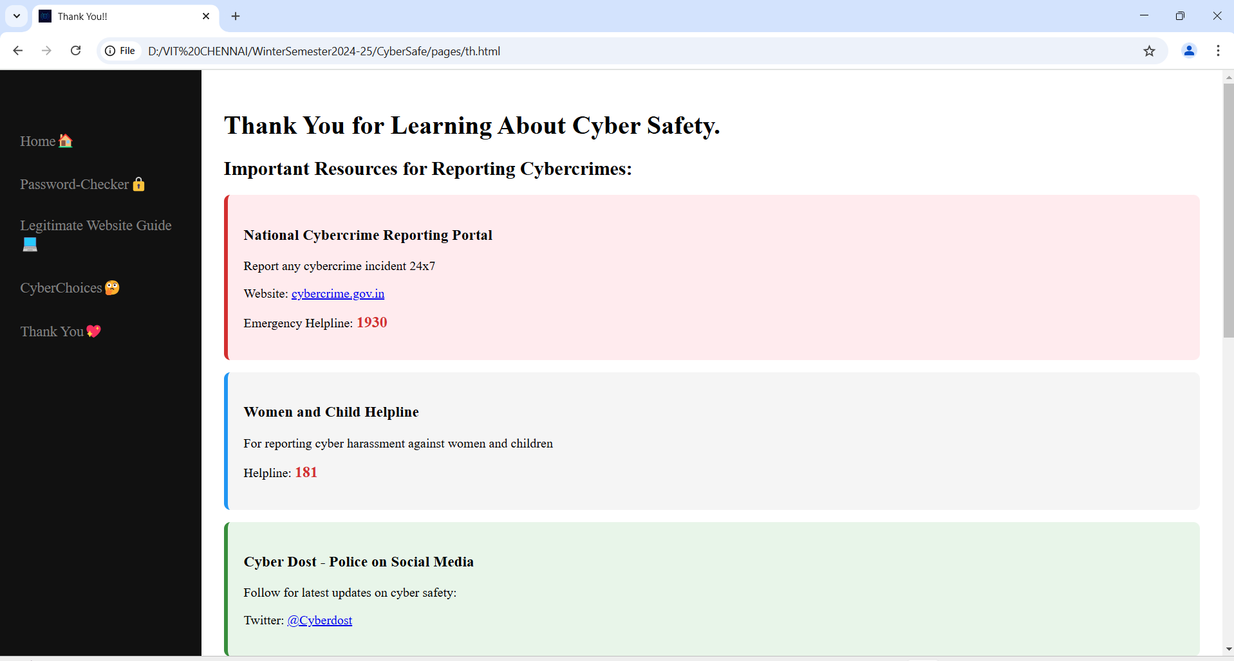

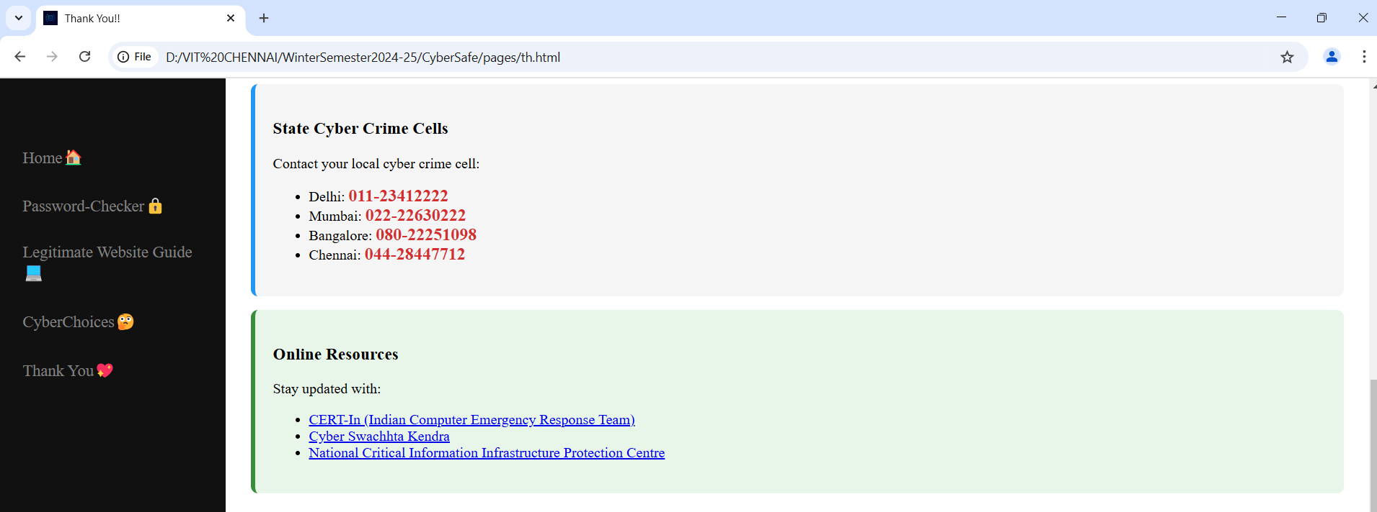

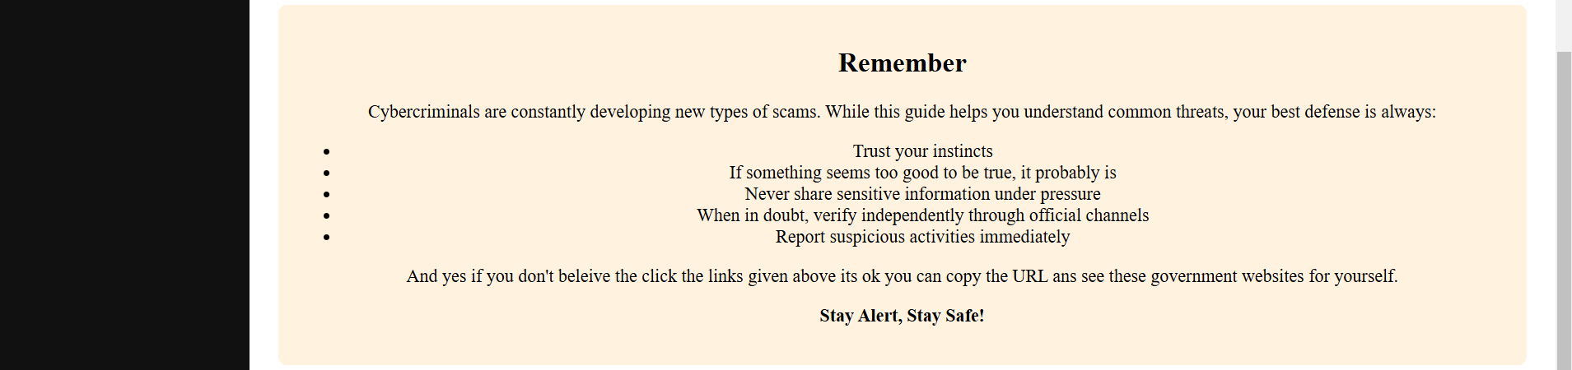

**Conclusion**

**As a freshman, analyzing the CyberSafe project provided us with valuable insights into both web development and cybersecurity principles. The project effectively communicates essential security concepts and demonstrates the importance of interactive learning in digital safety education. With minor improvements in optimization and security practices, CyberSafe has the potential to be an even more impactful educational tool.**

**Future Scope: Implementing AI-driven phishing detection simulations and real-time security updates could further enhance the project’s effectiveness.**