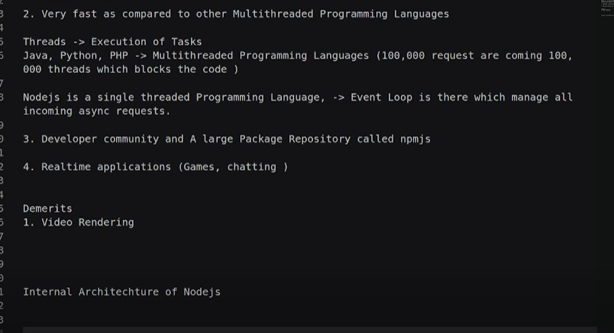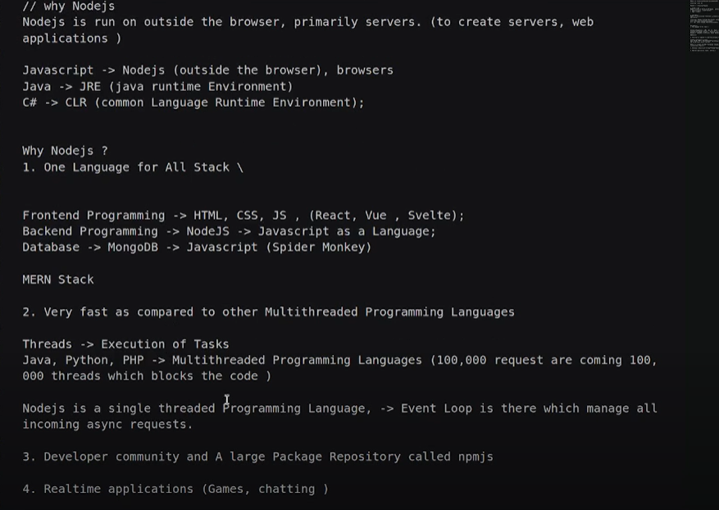

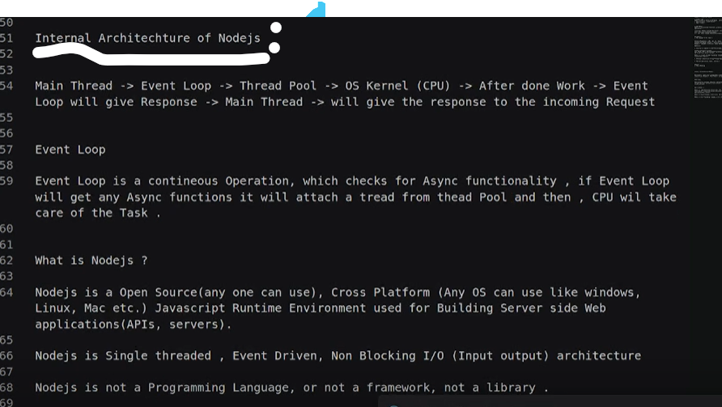
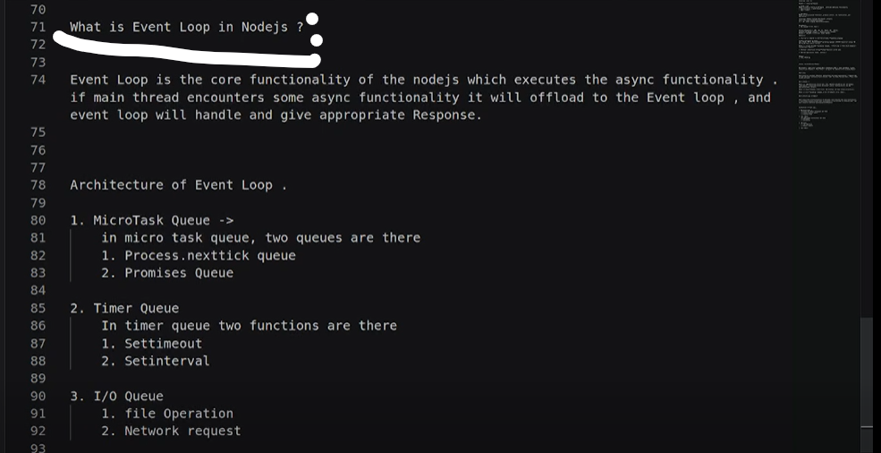
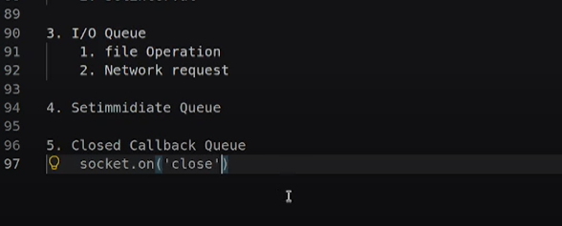
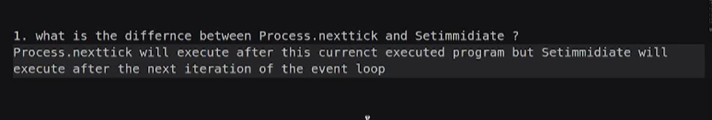
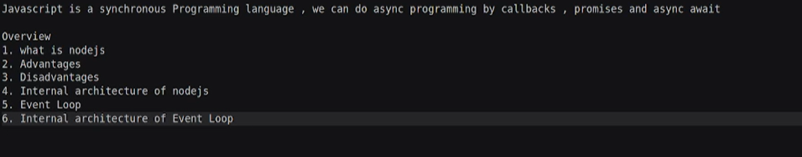

Interview question -1
console.log('1');
setTimeout(() => console.log(2), 0);
console.log('3');
process.nextTick(() => console.log(4));
setImmediate(() => console.log(5));
console.log(6);
Promise.resolve().then(() => console.log(7));
//Why?
/*
Synchronous code runs first:
1
3
6
process.nextTick() queue runs:
4
Promise microtasks run:
7
Timers (setTimeout) run:
2
setImmediate() runs:
5 */
Interview Question -2
const fs = require('fs');
fs.readFile(__filename,()=>{
console.log('inside IO Queue');
setTimeout(()=> console.log('time out'),0);
setImmediate(()=>console.log('check queue'));

});
console.log('1');

o/p :
1
inside IO Queue
check queue
time out

2. Your code is almost correct, but there are two issues:
- It should be __filename (two underscores), not _filename.
- It's helpful to understand why the close event and readFile callback are asynchronous.
Here's the corrected code:
const fs = require('fs');
const readStream = fs.createReadStream(__filename);
readStream.close();
// Fires when the stream has been closed
readStream.on('close', () => {
console.log('closed stream');
});
// Asynchronous I/O operation
fs.readFile(__filename, () => {
console.log('file read');
});
console.log('End of synchronous code');
Step-by-step execution
1. Synchronous Phase
JavaScript executes these statements immediately:
const fs = require('fs');
const readStream = fs.createReadStream(__filename);
readStream.close();
readStream.on('close', ...);
fs.readFile(__filename, ...);
console.log('End of synchronous code');
At this point:
- The stream is created.
- The stream is told to close.
- The close event listener is registered.
- readFile() starts reading the file in the background.
- "End of synchronous code" is printed.
Output so far:
End of synchronous code

2. Event Loop
After all synchronous code finishes:
- The operating system completes the stream close operation.
- The operating system completes the file read.
Node.js places their callbacks into the appropriate event loop phases.
Possible output:
End of synchronous code
closed stream
file read
or
End of synchronous code
file read
closed stream
The exact order of closed stream and file read is not guaranteed because they are asynchronous operations.

Visual Flow
Main Thread
-----------------------
require('fs')
createReadStream()
close()
register close event
readFile()
console.log("End")
-----------------------
↓
Event Loop
-----------------------
close event callback
readFile callback
-----------------------

Why is fs.readFile() asynchronous?
When Node.js reaches:
fs.readFile(__filename, () => {
console.log("file read");
});
it does not wait for the file to finish reading.
Instead:
- Node.js asks the operating system to read the file.
- JavaScript immediately continues executing the next line.
- When the OS finishes reading the file, Node.js places the callback into the event loop.
- The callback runs only after the current synchronous code (and any pending microtasks) has completed.

Important Note
The close event is not a microtask. It is an event callback that runs in the event loop after the stream is actually closed. Similarly, the fs.readFile() callback is an I/O callback that runs in the event loop once the file operation completes. Both occur after synchronous code, but their relative order depends on when the underlying operations finish.

What is Synchronous JavaScript?
Synchronous means code is executed one line at a time, in order. JavaScript waits for the current line to finish before moving to the next line.
Think of it like standing in a queue at a store—you can't be served until the person in front of you is done.
Example 1
console.log("Start");
console.log("Middle");
console.log("End");
Output:
Start
Middle
End
Execution flow:
Line 1 → Line 2 → Line 3

Example 2
function greet() {
console.log("Hello");
}
console.log("Before");
greet();
console.log("After");
Output:
Before
Hello
After
JavaScript executes:
- console.log("Before")
- Calls greet()
- Prints "Hello"
- Returns from greet()
- Prints "After"

Synchronous vs Asynchronous
Synchronous
console.log("1");
console.log("2");
console.log("3");
Output:
1
2
3
Everything happens immediately, one after another.

Asynchronous
console.log("1");
setTimeout(() => {
console.log("2");
}, 1000);
console.log("3");
Output:
1
3
2
Why?
- console.log("1") → Executes immediately.
- setTimeout(...) → Schedules the callback to run after about 1 second.
- console.log("3") → Executes immediately.
- After 1 second, the callback runs and prints 2.

In Your Previous Code
console.log("1"); // Synchronous
setTimeout(() => console.log(2), 0); // Asynchronous
console.log("3"); // Synchronous
process.nextTick(() => console.log(4)); // Asynchronous (Node.js microtask)
console.log("6"); // Synchronous
Promise.resolve().then(() => console.log(7)); // Asynchronous (microtask)
Synchronous statements are:
console.log("1");
console.log("3");
console.log("6");
They execute immediately in the order they're written.
Asynchronous statements are:
setTimeout(() => console.log(2), 0);
process.nextTick(() => console.log(4));
Promise.resolve().then(() => console.log(7));
These are scheduled to run later, after the synchronous code finishes.
Key Points
- ✅ Synchronous code runs line by line.
- ✅ JavaScript executes one task at a time on its main thread.
- ✅ Asynchronous operations (like setTimeout, Promises, and I/O) are scheduled and execute after the current synchronous code completes.
A simple rule to remember is:
If JavaScript has to wait for something, it usually uses an asynchronous API. If it doesn't need to wait, the code runs synchronously.
what are there in Synchronous in javascript ?
In JavaScript, synchronous code is any code that executes immediately, one statement at a time, without being delayed or scheduled.
Here are the common things that are synchronous:
1. Variable declarations
let a = 10;
const b = 20;
var c = 30;

2. Arithmetic operations
let sum = 10 + 20;
let product = 5 * 4;
console.log(sum);

3. Conditional statements
let age = 18;
if (age >= 18) {
console.log("Adult");
} else {
console.log("Minor");
}

4. Loops
for (let i = 1; i <= 3; i++) {
console.log(i);
}
Output:
1
2
3
The loop completes before the next line executes.

5. Function calls
function greet() {
console.log("Hello");
}
greet();
console.log("Done");
Output:
Hello
Done

6. Object and Array operations
const person = {
name: "John",
age: 25
};
console.log(person.name);
const numbers = [10, 20, 30];
console.log(numbers[1]);

7. String methods
let name = "javascript";
console.log(name.toUpperCase());
console.log(name.length);

8. Array methods (that don't use asynchronous callbacks)
const numbers = [1, 2, 3];
numbers.forEach(num => {
console.log(num);
});
forEach() executes synchronously.

9. console.log()
console.log("A");
console.log("B");
console.log("C");
Output:
A
B
C

Complete Example
console.log("Start");
let a = 10;
let b = 20;
function add(x, y) {
return x + y;
}
let result = add(a, b);
if (result > 20) {
console.log(result);
}
for (let i = 1; i <= 3; i++) {
console.log(i);
}
console.log("End");
Output
Start
30
1
2
3
End
Everything above is synchronous because JavaScript executes each statement completely before moving to the next one.

What is not synchronous?
These are asynchronous:
setTimeout(() => console.log("Timeout"), 1000);
setInterval(() => console.log("Interval"), 1000);
fetch("https://api.example.com/users");
Promise.resolve().then(() => console.log("Promise"));
queueMicrotask(() => console.log("Microtask")); // Browser
process.nextTick(() => console.log("Next Tick")); // Node.js
setImmediate(() => console.log("Immediate")); // Node.js
These APIs schedule work to happen later instead of executing immediately.
Rule to remember
- Synchronous: Runs immediately and blocks the next line until it finishes.
- Asynchronous: Schedules work to happen later, allowing JavaScript to continue executing the remaining synchronous code first.

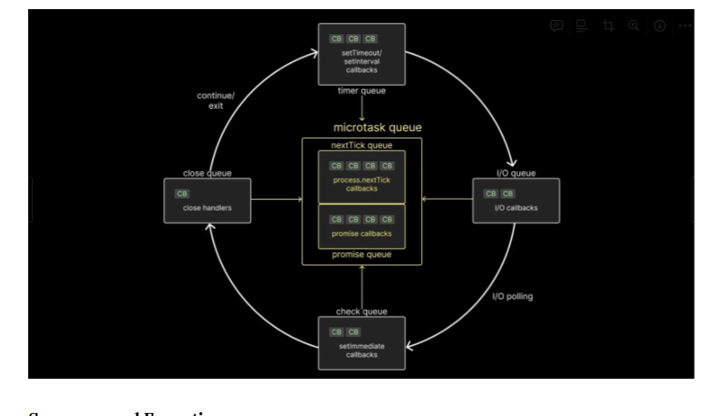

Deep dive into Node.js event-loop mechanism
Whenever the call stack receives asynchronous operations such as setTimeout, setImmediate, API calls, or file system operations, Node.js offloads these tasks to libuv.
libuv is a C library that manages how asynchronous tasks should be executed. It interacts with the operating system’s kernel when needed to perform tasks like I/O operations efficiently.
The event loop is what allows Node.js (via libuv) to coordinate and manage these asynchronous operations. The event loop has several phases where different types of tasks are processed. In total, there are six phases, though four are the main ones typically mentioned:
Timers phase:
Executes callbacks scheduled by setTimeout() and setInterval(). I/O callbacks phase: Handles I/O-related callbacks, like reading or writing to files or networks. Check phase: Executes callbacks scheduled by setImmediate(). Close callbacks phase: Executes callbacks for tasks that have been closed, like socket.destroy(), or when a server is stopped with server.close().
Apart from these, there are two microtask queues that handle tasks like:
process.nextTick()Promise callbacksThe microtask queue has priority over the event loop phases and is processed after the current operation in the call stack is complete and before moving on to the next phase of the event loop.
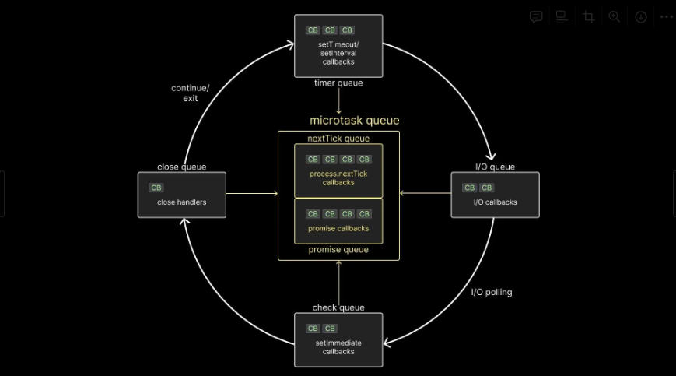
Sequence and Execution
The event loop runs continuously, checking if any tasks are pending in any of the phases. If no tasks are ready, it sits in the poll phase (which is part of the I/O phase) waiting for I/O operations to complete or timeouts to expire.
If any phase contains multiple callbacks, the event loop will first process them one at a time until the queue is empty or a system-defined limit is reached, before moving to the next phase.
Exection of setTimeout(cb,0) and setImmediate(cb) is non-deterministic. It depends on the performance of the process.
But since eventloop sits in poll phase, then setImmediate will always execute first.

