Day-2

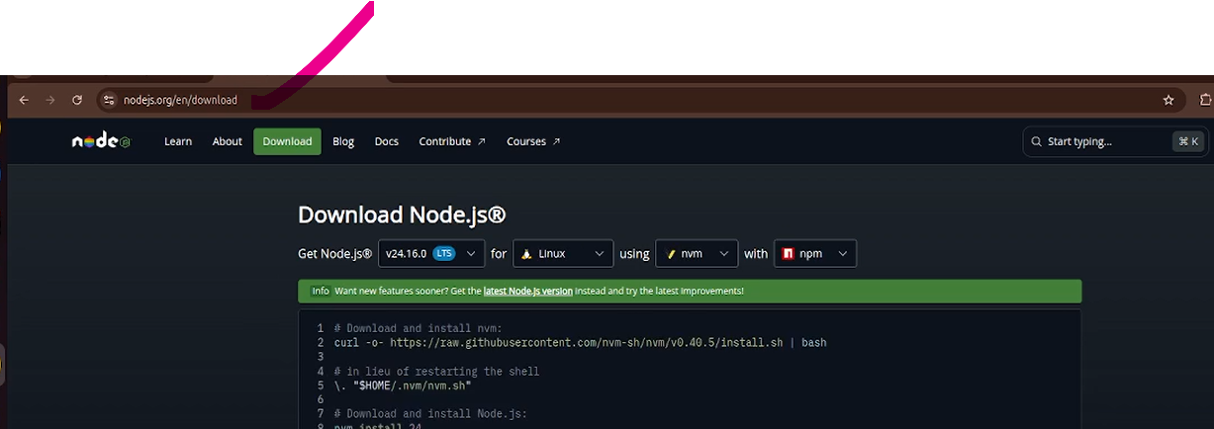
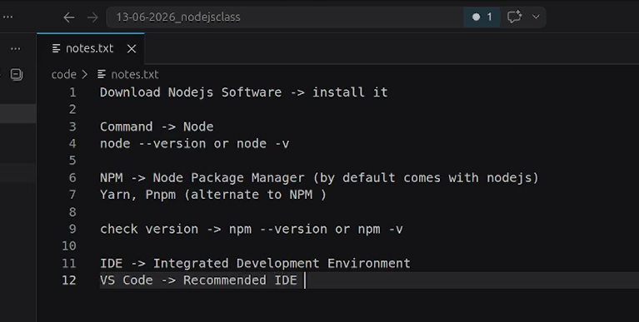
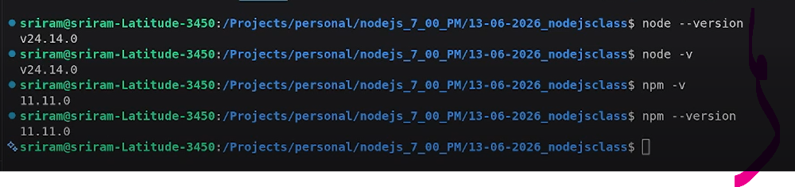
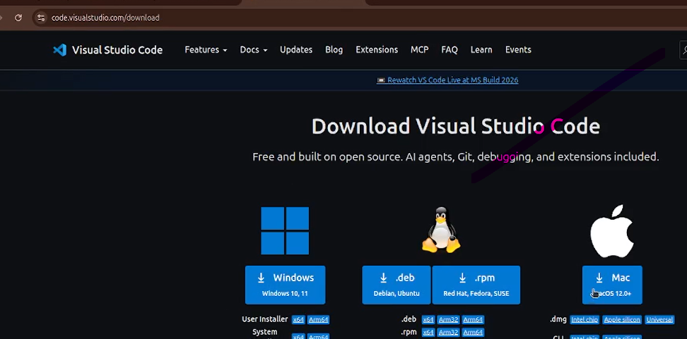
The REPL is Running Now like this

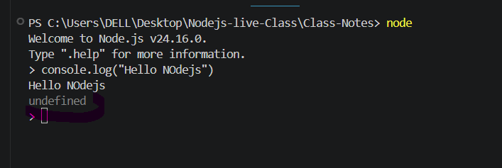
Does undefined here mean that console.log() doesn't return a value? Is undefined the return value of the console.log() function?
Nothing means undefind

> 'kumar'.toUpperCase();
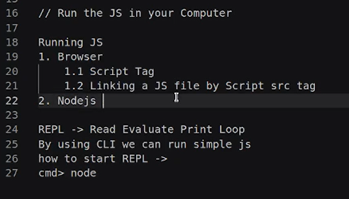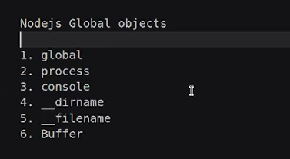
Window is a global object in browser ?
- In browsers, window is the global object. ✅
- In Node.js, there is no window object. The global object is global (or globalThis in modern JavaScript). ❌
Answer: ✅ True — window is the global object in browser environments.
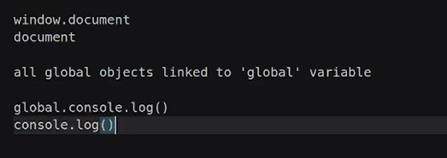

Process : Is also global object
Process have use in production application ,how if storing some database,creditinals
Data base urls and some API keys API Port,Database credentials,we all are load to the (process.env)
Console : means debugging purpose ,Printing the Logs(in the terminal)
__dirname : creating files ,storing files by using filesystems
‘public ’,__dirname + ‘public’ - > we can store the files
__filename : working on current file name
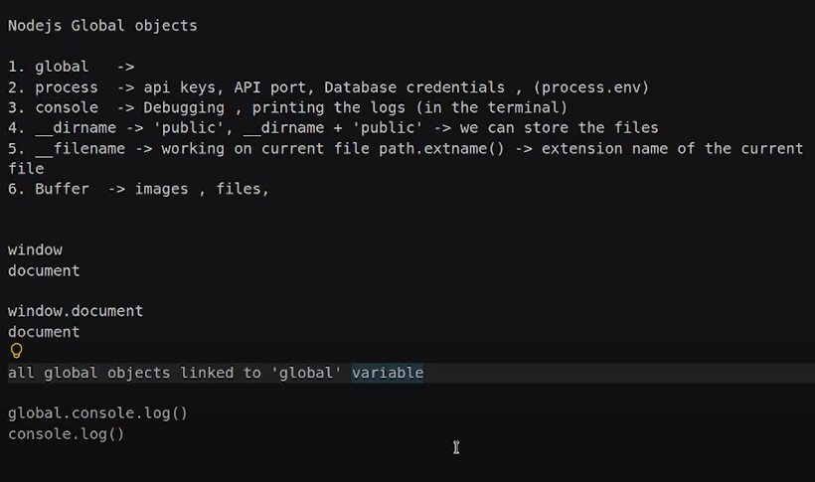

23:00 sec

