Contents

Github Link 2

Q1. Create a Python script to check the strength of the password. 3

Q2**.**Monitor the health and performance of servers: 4

Q3**.**Automating configuration management tasks: 5

# Github Link

# Q1. Python script to check the strength of the password:

Test 1: Entering wrong password. (Kumar)

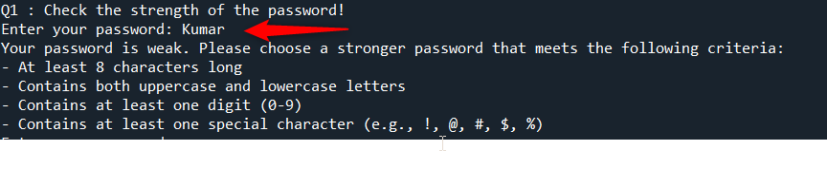

Test 2: Entering Correct password. Star@*Kumar10



# **Q2.**Monitor the health and performance of servers:

For testing predefined threshold is only 5%

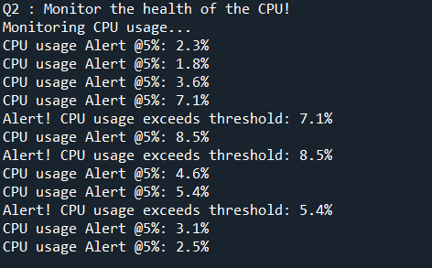

# **Q3.**Automating configuration management tasks:

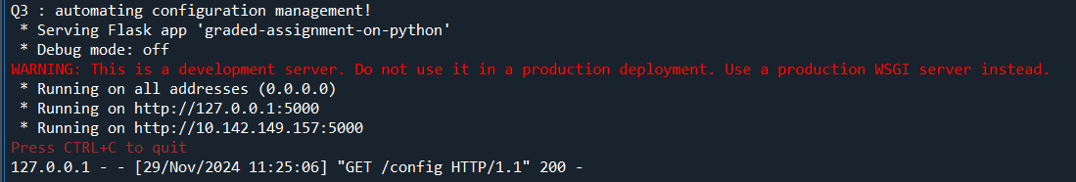

Config.ini

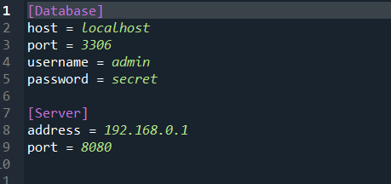

Output file data as JSON data in the database:

GET request to fetch:

