Android Application Framework

Submitted by

Kumaravel S
Roll No. : 1201FOSS0023
Reg No.: 75812100027

A PROJECT REPORT
Submitted to the
FACULTY OF SCIENCE AND HUMANITIES
in partial fulfillment for the requirement of award of the degree
of

MASTER OF SCIENCE
IN
FREE / OPEN SOURCE SOFTWARE (CS-FOSS)



CENTRE FOR DISTANCE EDUCATION
ANNA UNIVERSITY
CHENNAI 600 025

FEBRUARY 2014

CENTRE FOR DISTANCE EDUCATION
ANNA UNIVERSITY
CHENNAI 600 025

BONA FIDE CERTIFICATE

Certified that this Project report titled “Android Application Framework” is the bona fide work of Mr. Kumaravel. Who carried out the research under my supervision. Certified further, that to the best of my knowledge the work reported herein does not form part of any other Project report or dissertation on the basis of which a degree or award was conferred on an earlier occasion on this or any other candidate.

S.Kumaravel Dr. Sanjeev Kumar Saini
Technical Lead, AU-KBC Research Center,
Plot No. 18, 1-A, Comfort Pearl Apartment, MIT Campus,
1st Cross Street, Raghavendra Nagar, Anna University,
Rajakilpakkam, Chennai 600073. Crompet.

Project in-charge

ABSTRACT

This project is designed to create android application without knowledge of programming experience. It gives easy way to generate android application quickly.

The desired requiremets will be captured through PHP web page and it generates dynamic_fields.xml.

Android Application Framework Template project will read the dynamic_fields.xml and generate the screen with sqlite database binding dynamically.

The following controls are covered in the current version of framework:
- Normal Edit Text Box
- Number Text Box
- Radio Button
- Date Picker
- Drop Down
- Checkbox
- Phone Text Box
- Multiline Text Box [Similar to rich text box]
- Password Text Box
- Email Text Box
- Web URL Text Box

TABLE OF CONTENTS

1 INTRODUCTION

Now a days, Mobile Technology is essential to fulfill the customers day today requirements. So lot

of research has been initiated in the field of Mobile Technology. Every one aim to do projects in

simple and effective application. This thought force me to do a application framework in Anroid.

Advantage of this framework is that User not necessaryly know about programming knowlege of

java.

1.1 Sub Tasks and developments

This project contain three phases
- PHP Web Page
- Android Application Template to generate dynamic UI
- Generate and Deploy the apk file

1.1.1 PHP Web page is used to get the users for the folloing parameters :
- Application Name
- Screen Name
- Field Name
- Field Type
- Field Values
After providing all the parameters, Generate button has been provided in the PHP Web page. It will generate the dynamic_fields.xml file.

1.1.2 Anroid Application framework will parse the dynamic_fields.xml file and generate the UI scree based upon the field name, field type and field values. The following sub tasks have covered in this phase:
- Parsing the XML.
- Generate the Screen for data entry for user specified fields.
- Create database, tables for the user specified fields & store the data into database.
- Providing the screen to list the user entered data as list view style.
- Rest option to delete the database, tables.

1.1.3 Prepare apk file and deployment:

Android studio, Eclipse IDE provides facility to generate the apk file. After creatig the apk file, it will be easy to deploy in the any of Android devices.

2 DESIGN AND IMPLEMENTATION

This chapter describes the design and implementation of the android application framework .Use cases and activities will be used to analyze the requirements and specifications, which will be fol- lowed with the actual implementation of the specified functionalities of the application framework.

2.1 Requirement specifications

Use Case Diagram

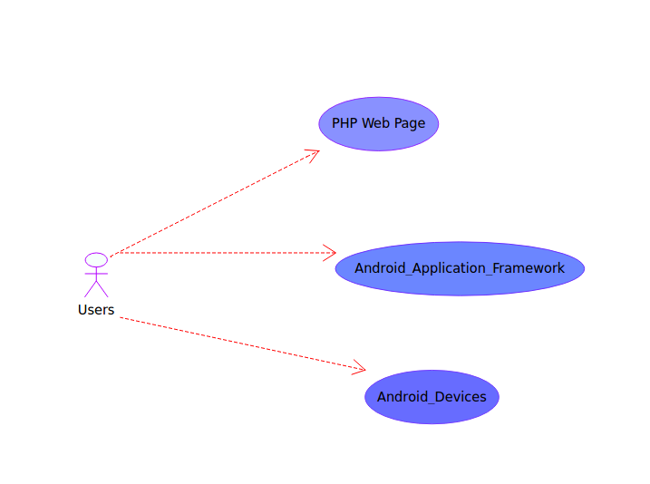

2.2 Architecture

Overall architecture of Android Application Framework as follows:

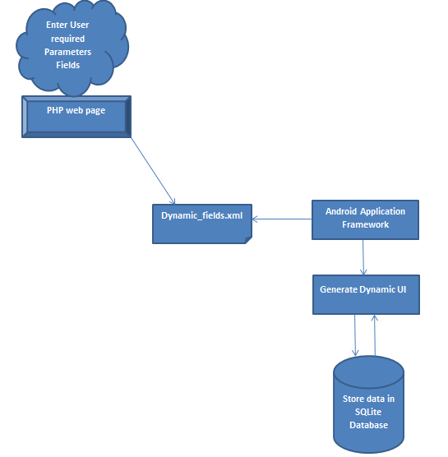

2.3 Implementing the Android application framework

This section describes the implementation of the android application framework.

2.3.1 Current scope

The following controls are covered in the current version of framework:
- Normal Edit Text Box
- Number Text Box
- Radio Button
- Date Picker
- Drop Down
- Checkbox
- Phone Text Box
- Multiline Text Box [Similar to rich text box]
- Password Text Box
- Email Text Box
- Web URL Text Box

2.3.3 Future Visions

Currently around 11 type of controls has been covered. In future, all the possible controls will be included in the android application framework.

List of records are showing in the page when press on view button. If Edit button will also help to edit the particular record. So Edit option is very important. It will be handled in furture versions.

Export the data into csv, pdf will be provided in future option. So that it will help us to generate
report.

2 Components

2.1 PHP Web Page
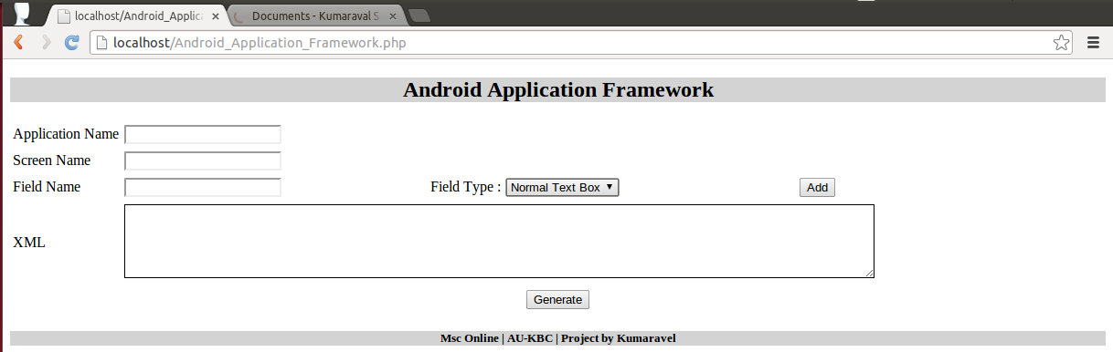
Figure 1.

Application name will represent the title of the screen in Android. Screen Name parameter represents functionality. Field Name used to declare the unique field. Field type represents the control type like text box or drop down. When ever click on add button for the each field details, XML text box will generate the XML string. The sample detail scree shot is available for reference:

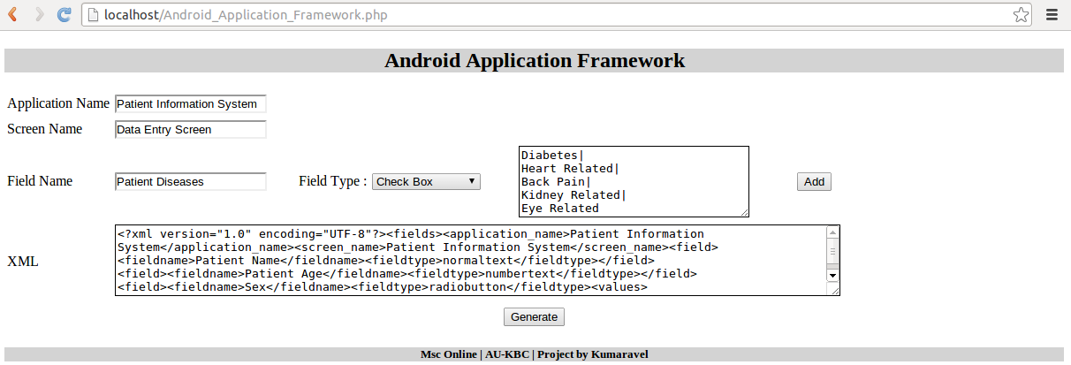
Figure 2. When press on Generate button, page will create the dynamic_fields.xml file.

2.2 Android Application Framework

The Android Application Framework is based upon the default empty project template. The mai activity.java file contain five sub compontents:

2.2.1 Parse XML

Parse XML part of code read the xml and transform into generate control and add into dynamic liner content.
2.2.2 Generate UI Screen

The dynamic screen will be generated after parse the xml.

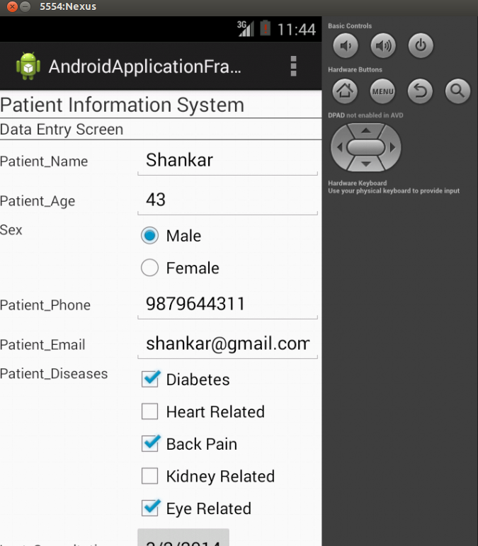
Figure 3. Dynamic screen part1

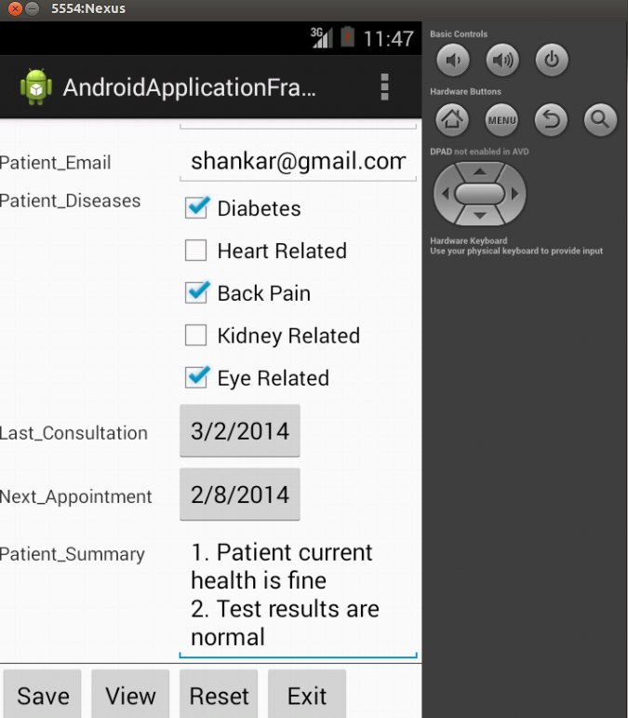
Figure 4. Dynamic Screen part2

2.2.3 Sqlite Database Creation

Android contains a set of C and C++ libraries that are responsible for performance optimization and efficiency. This includes
- System C library that is an implementation of the standard C system library (libc), tuned for embedded Linux-based devices (Android Developers, date of retrieval 6.2.2012.)

- SQLite that is a lightweight relational database engine
Dyamically generate the database, tables based upon the xml file.

2.2.4 Listing the stroed data

List the stored the data.

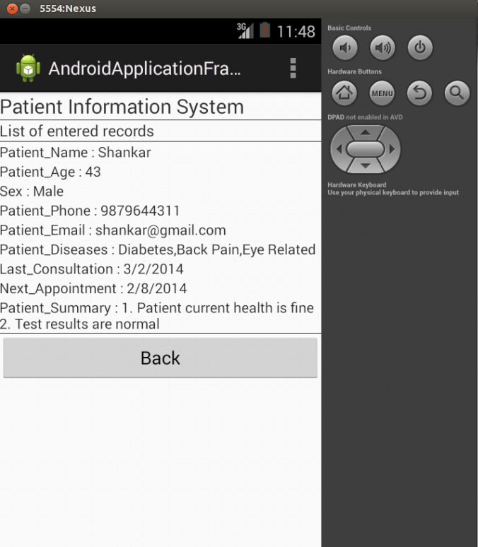
Figure 5. Dynamic List Screen

2.2.5 Reset the stroed data

Delete the dynamic database, tables for the application.

2.3 Generate & deploy apk file

Android applications are written in the Java language, compiled into byte codes which will be converted to a .dex file (Dalvik executable file) using the dx converter. This will further be compiled in to android package file (apk file), that can be installed on the android devices.

4 CONCLUSIONS

The thesis project has covered android application framework in the android Platform, basic components of android applications framework is described briefly. The result of the project has achieved part of the objectives that were set at the beginning. However, the scope has been limited to make base line of framework to create android application easily and quickly. Recurasive development will be planned to enhance the framework for achieving further level.

REFERENCES

1. http://developer.android.com/index.html

APPENDIX

Android_Application_Framework.php

<!DOCTYPE html>
<head>
<script type="text/javascript">

/*
* Function used to create XML for all the controls and populate in txtXML.
*/
function addText()
{
//Variables decalaration
var applicationTitle, screenTitle, selectedControls,controlName,controlType,controlValue, xmlText;

//Assign values
applicationTitle = document.getElementById("txtApplicationName").value;
screenTitle = document.getElementById("txtScreenName").value;
selectedControls = document.getElementById("txtXml").value;
controlName = document.getElementById("controlName").value;
controlType = document.getElementById("controlType").value;
controlValue = document.getElementById("controlValue").value;

//Framing xml
xmlText = '<?xml version="1.0" encoding="UTF-8"?><fields>';

//Application Name
xmlText = xmlText + "<application_name>"+applicationTitle+"</application_name>";

//Screen Name
xmlText = xmlText + "<screen_name>"+applicationTitle+"</screen_name>";

if ( selectedControls.length > 0 )
{
xmlText = selectedControls.replace("</fields>","") + "\n" + getXml(controlName,controlType,controlValue);
}
else
{
xmlText = xmlText + getXml(controlName,controlType,controlValue);
}
xmlText = xmlText + "</fields>";
document.getElementById("txtXml").innerHTML = xmlText;

//Clear the content of the control
document.getElementById("controlName").value = "";
document.getElementById("controlType").selectedIndex = 0;
document.getElementById("controlValue").value = "";
}

/*
* Function used to show or hide the controlValue based upon the control type
* Usually control values parameter is required only for Drop down, Radio Button and Checkbox
*/
function visibleControl(sel)
{
var controlType = sel.options[sel.selectedIndex].value;
if ( controlType == "spinner" || controlType == "radiobutton" || controlType == "checkbox" )
{
document.getElementById("controlValue").style.display = "block";
}
else
{
document.getElementById("controlValue").style.display = "none";
}
}

/*
* Function used to ammend the | symbol when press enter key
*/
function fKeyDown(e)
{
var kc = window.event ? window.event.keyCode : e.which;
if (kc == 13)
{
document.getElementById('controlValue').value = document.getElementById('controlValue').value + "|";
}
}

/*
* Function used to get the XML based upon each control add
*/
function getXml(controlName, controlType, controlValue)
{
var xmlText = "<field><fieldname>" + controlName + "</fieldname>";
xmlText = xmlText + "<fieldtype>" + controlType +"</fieldtype>";
if (controlValue.length > 0 )
{
var controlValues = controlValue.split("|");
if (controlValues.length > 0 )
{
xmlText = xmlText + "<values>";
for (var index=0,len=controlValues.length; index<len; index++)
{

xmlText = xmlText + "<fieldvalue"+index+">"+ controlValues[index] +"</fieldvalue"+index+">";
}
xmlText = xmlText + "</values>";
}
}
xmlText=xmlText + "</field>";
return xmlText;
}

</script>
</head>
<body>
<div style="background-color:lightgrey"><h2 align="center">Android Application Framework</h2></div>
<form method="post" action="<?php echo $_SERVER['PHP_SELF']; ?>">
<table>
<tr>
<td>Application Name</td>
<td><input type="text" name="txtApplicationName" id="txtApplicationName"/></td>
</tr>
<tr>

<td>Screen Name</td><td><input type="text" name="txtScreenName" id="txtScreenName"/></td>
</tr>
<tr border><td>Field Name</td><td><input type="text" name="controlName" id="controlName"></td>
<td>
Field Type :
<select name="controlType" id="controlType" onchange="visibleControl(this);">
<option value="normaltext">Normal Text Box</option>
<option value="numbertext">Number</option>
<option value="radiobutton">Radio Button</option>
<option value="datepicker">Date Picker</option>
<option value="spinner">Drop Down</option>
<option value="checkbox">Check Box</option>
<option value="phonetext">Phone</option>
<option value="multilinetext">Multiline Text</option>
<option value="passwordtext">Password Text</option>
<option value="emailtext">Email</option>
<option value="uritext">Web URL</option>
</select>
</td>
<td>
<textarea name="controlValue" id="controlValue" rows="5" cols="30" style="display:none" onKeyDown=javascript:fKeyDown(event);></textarea>
</td>
<td><input type="button" onclick="addText();" name="btnAdd" value="Add" width="100"/></td>
</tr>
<tr>
<td>XML </td><td colspan="6" align="left"><textarea name="txtXml" id="txtXml" rows="5" cols="100"></textarea>
</td>
</tr>
<tr></tr>

</table>
<div align="center"><input type="submit" name="submit" value="Generate" align="center"></div>
<p style="background-color:lightgrey" align="center">
<?php
if(isset($_POST['submit']))
{
$txtXml = $_POST['txtXml'];
file_put_contents("dynamic_fields.xml", $txtXml);
echo "dynamic_fields.xml has been generated successfully";
}
?>
</p>
</form>
<div style="background-color:lightgrey"><h5 align="center">Msc Online | AU-KBC | Project by Kumaravel</h2></div>
</body>
</html>

dynamic_fields.xml

<?xml version="1.0" encoding="UTF-8"?>
<fields>
<application_name>Patient Information System</application_name>
<screen_name>Data Entry Screen</screen_name>
<field>
<fieldname>Patient Name</fieldname>
<fieldtype>normaltext</fieldtype>
</field>
<field>
<fieldname>Patient Age</fieldname>

<fieldtype>numbertext</fieldtype>
</field>
<field>
<fieldname>Sex</fieldname>
<fieldtype>radiobutton</fieldtype>
<values>
<fieldvalue0>Male</fieldvalue0>
<fieldvalue1>Female</fieldvalue1>
</values>
</field>
<field>
<fieldname>Patient Phone</fieldname>
<fieldtype>phonetext</fieldtype>
</field>
<field>
<fieldname>Patient Email</fieldname>
<fieldtype>emailtext</fieldtype>
</field>
<field>
<fieldname>Patient Diseases</fieldname>
<fieldtype>checkbox</fieldtype>
<values>
<fieldvalue0>Diabetes</fieldvalue0>
<fieldvalue1>Heart Related</fieldvalue1>
<fieldvalue2>Back Pain</fieldvalue2>
<fieldvalue3>Kidney Related</fieldvalue3>
<fieldvalue4>Eye Related</fieldvalue4>
</values>
</field>
<field>
<fieldname>Last Consultation</fieldname>
<fieldtype>datepicker</fieldtype>
</field>
<field>
<fieldname>Next Appointment</fieldname>
<fieldtype>datepicker</fieldtype>
</field>
<field>
<fieldname>Patient Summary</fieldname>
<fieldtype>multilinetext</fieldtype>
</field>
</fields>

MainActivity.java
package foss.projects.androidapplicationframework;

import android.app.ActionBar;
import android.app.Dialog;
import android.content.ContentValues;
import android.content.Context;
import android.content.res.AssetManager;
import android.database.Cursor;
import android.graphics.Color;
import android.os.Bundle;
import android.app.Activity;
import android.text.InputType;
import android.view.Gravity;
import android.view.Menu;
import android.view.View;
import android.view.ViewGroup;
import android.view.inputmethod.EditorInfo;
import android.widget.Button;
import android.widget.CheckBox;
import android.widget.DatePicker;
import android.widget.ListView;
import android.widget.RadioGroup;
import android.widget.ScrollView;
import android.widget.LinearLayout;
import android.widget.TextView;
import android.widget.EditText;
import android.widget.Spinner;
import android.widget.RadioButton;
import android.app.DatePickerDialog;
import android.widget.ArrayAdapter;

import android.database.sqlite.SQLiteDatabase;
import android.database.sqlite.SQLiteDatabase.CursorFactory;
import android.database.sqlite.SQLiteOpenHelper;

import org.xmlpull.v1.XmlPullParser;
import org.xmlpull.v1.XmlPullParserFactory;
import org.xmlpull.v1.XmlPullParserException;

import java.io.IOException;
import java.io.InputStream;
import java.util.ArrayList;
import java.util.Calendar;

@SuppressWarnings("ALL")
public class MainActivity extends Activity
{
String strApplicationName = null;
String strScreenName = null;
String currentControl = null;
ArrayList<Fields> fieldsList = null;
Button btnSave = null;
Button btnView = null;
Button btnExit = null;
Button btnReset = null;
Button btnDatePicker = null;

SQLiteDatabase db;
String tableName;
ScrollView sv = null;
LinearLayout parentLinearLayout = null;
LinearLayout checkBoxLayout = null;
LinearLayout fieldLL = null;

ListView lstFields = null;
int year,month,day,mYear, mMonth, mDay;

@Override
protected void onCreate(Bundle savedInstanceState)
{
super.onCreate(savedInstanceState);

try
{
populateMainView();
}
catch(Exception ex)
{
ex.printStackTrace();
}
}

void populateMainView()
{
sv = new ScrollView(this);
sv.setLeft(10);
parentLinearLayout = new LinearLayout(this);
parentLinearLayout.setGravity(parentLinearLayout.TEXT_ALIGNMENT_GRAVITY);
parentLinearLayout.setOrientation(LinearLayout.VERTICAL);
sv.addView(parentLinearLayout);

parentLinearLayout.setDividerPadding(5);

TextView textViewControl = null;
EditText editTextControl = null;
RadioGroup radioGroup = null;
RadioButton radioButtonControl = null;
Spinner spinnerControl = null;
CheckBox checkBox = null;

//Read the Fields xml file
readXML();

LinearLayout.LayoutParams params = new LinearLayout.LayoutParams(
ViewGroup.LayoutParams.FILL_PARENT, ViewGroup.LayoutParams.WRAP_CONTENT);
params.gravity = Gravity.CENTER;

//Set Application Title
textViewControl = new TextView(this);
textViewControl.setText(strApplicationName);
textViewControl.setLeft(10);
textViewControl.setGravity(View.TEXT_ALIGNMENT_CENTER);
textViewControl.setTextSize(20);
textViewControl.setLayoutParams(params);
parentLinearLayout.addView(textViewControl);

View line = new View(this);
line.setLayoutParams(new ViewGroup.LayoutParams(ViewGroup.LayoutParams.FILL_PARENT, 1));
line.setBackgroundColor(Color.rgb(51, 51, 51));
parentLinearLayout.addView(line);

//Set Table Name
tableName = strApplicationName.replace(' ','_');

//Set Screen heading
textViewControl = new TextView(this);
textViewControl.setText(strScreenName);
textViewControl.setLeft(10);
textViewControl.setTextSize(15);
textViewControl.setLayoutParams(params);
parentLinearLayout.addView(textViewControl);

line = new View(this);
line.setLayoutParams(new ViewGroup.LayoutParams(ViewGroup.LayoutParams.FILL_PARENT, 1));
line.setBackgroundColor(Color.rgb(51, 51, 51));
parentLinearLayout.addView(line);

//Create all the controls for fields dynamically
if ( fieldsList != null && fieldsList.size() > 0 )
{
for(Fields currentField : fieldsList)
{
fieldLL = new LinearLayout(this);
fieldLL.setOrientation(LinearLayout.HORIZONTAL);
fieldLL.setLeft(10);
if (currentField.fieldType.equalsIgnoreCase("normaltext"))
{
textViewControl = new TextView(this);
textViewControl.setText(currentField.fieldName);
textViewControl.setWidth(200);
fieldLL.addView(textViewControl);

editTextControl = new EditText(this);
editTextControl.setWidth(300);
editTextControl.setTag(currentField.fieldName);
fieldLL.addView(editTextControl);

}
else if (currentField.fieldType.equalsIgnoreCase("emailtext"))
{
textViewControl = new TextView(this);
textViewControl.setText(currentField.fieldName);
textViewControl.setWidth(200);
fieldLL.addView(textViewControl);

editTextControl = new EditText(this);
editTextControl.setWidth(300);
editTextControl.setTag(currentField.fieldName.replace(' ', '_'));
editTextControl.setInputType(InputType.TYPE_TEXT_VARIATION_EMAIL_ADDRESS);
fieldLL.addView(editTextControl);

}
else if (currentField.fieldType.equalsIgnoreCase("phonetext"))
{
textViewControl = new TextView(this);
textViewControl.setText(currentField.fieldName);
textViewControl.setWidth(200);
fieldLL.addView(textViewControl);

editTextControl = new EditText(this);
editTextControl.setWidth(300);
editTextControl.setTag(currentField.fieldName);
editTextControl.setInputType(InputType.TYPE_CLASS_PHONE);
fieldLL.addView(editTextControl);
}
else if (currentField.fieldType.equalsIgnoreCase("numbertext"))
{
textViewControl = new TextView(this);
textViewControl.setText(currentField.fieldName);
textViewControl.setWidth(200);
fieldLL.addView(textViewControl);

editTextControl = new EditText(this);
editTextControl.setWidth(300);
editTextControl.setTag(currentField.fieldName);
editTextControl.setInputType(InputType.TYPE_CLASS_NUMBER);
fieldLL.addView(editTextControl);
}
else if (currentField.fieldType.equalsIgnoreCase("uritext"))
{
textViewControl = new TextView(this);
textViewControl.setText(currentField.fieldName);
textViewControl.setWidth(200);
fieldLL.addView(textViewControl);

editTextControl = new EditText(this);
editTextControl.setWidth(300);
editTextControl.setTag(currentField.fieldName);
editTextControl.setInputType(InputType.TYPE_TEXT_VARIATION_URI);
fieldLL.addView(editTextControl);
}
else if (currentField.fieldType.equalsIgnoreCase("multilinetext"))
{
textViewControl = new TextView(this);
textViewControl.setText(currentField.fieldName);
textViewControl.setWidth(200);
fieldLL.addView(textViewControl);

editTextControl = new EditText(this);
editTextControl.setWidth(300);
editTextControl.setTag(currentField.fieldName);
editTextControl.setSingleLine(false);

editTextControl.setImeOptions(EditorInfo.IME_FLAG_NO_EXTRACT_UI);
editTextControl.setFocusableInTouchMode(true);
editTextControl.setInputType(EditorInfo.TYPE_CLASS_TEXT | EditorInfo.TYPE_TEXT_FLAG_MULTI_LINE | EditorInfo.TYPE_TEXT_FLAG_IME_MULTI_LINE);
editTextControl.setMaxLines(Integer.MAX_VALUE);
editTextControl.setHorizontallyScrolling(false);
editTextControl.setTransformationMethod(null);
fieldLL.addView(editTextControl);
}
else if (currentField.fieldType.equalsIgnoreCase("passwordtext"))
{
textViewControl = new TextView(this);
textViewControl.setText(currentField.fieldName);
textViewControl.setWidth(200);
fieldLL.addView(textViewControl);

editTextControl = new EditText(this);
editTextControl.setWidth(300);
editTextControl.setTag(currentField.fieldName);
editTextControl.setInputType(InputType.TYPE_MASK_VARIATION);
fieldLL.addView(editTextControl);
}
else if (currentField.fieldType.equalsIgnoreCase("datepicker"))
{
textViewControl = new TextView(this);
textViewControl.setText(currentField.fieldName);
textViewControl.setWidth(200);
fieldLL.addView(textViewControl);

btnDatePicker = new Button(this);

btnDatePicker.setTag(currentField.fieldName.replace(' ', '_'));
fieldLL.addView(btnDatePicker);

final Calendar c = Calendar.getInstance();
mYear = c.get(Calendar.YEAR);
mMonth = c.get(Calendar.MONTH) + 1;
mDay = c.get(Calendar.DAY_OF_MONTH);

btnDatePicker.setText(mDay+"/"+mMonth+"/"+mYear);

// Set ClickListener on btnDatePicker
btnDatePicker.setOnClickListener(new View.OnClickListener() {

public void onClick(View v)
{
currentControl = v.getTag().toString();
// Show the DatePickerDialog
showDialog(0);
}
});
}
else if (currentField.fieldType.equalsIgnoreCase("radiobutton"))
{
textViewControl = new TextView(this);
textViewControl.setText(currentField.fieldName);
textViewControl.setLeft(10);
textViewControl.setWidth(200);
fieldLL.addView(textViewControl);

radioGroup = new RadioGroup(this);
for(String fieldValue : currentField.fieldValues)
{
radioButtonControl = new RadioButton(this);
radioButtonControl.setText(fieldValue);
radioButtonControl.setTag(fieldValue.replace(' ','_'));
radioGroup.addView(radioButtonControl);
}
fieldLL.addView(radioGroup);
}
else if (currentField.fieldType.equalsIgnoreCase("spinner"))
{
textViewControl = new TextView(this);
textViewControl.setText(currentField.fieldName);
textViewControl.setLeft(10);
textViewControl.setWidth(200);
fieldLL.addView(textViewControl);

spinnerControl = new Spinner(this);
spinnerControl.setTag(currentField.fieldName);
ArrayAdapter<String> aa = new ArrayAdapter<String>( this, android.R.layout.simple_spinner_item,
currentField.fieldValues);
spinnerControl.setAdapter(aa);
fieldLL.addView(spinnerControl);
}
else if (currentField.fieldType.equalsIgnoreCase("checkbox"))
{

textViewControl = new TextView(this);
textViewControl.setText(currentField.fieldName);
textViewControl.setLeft(10);
textViewControl.setWidth(200);
fieldLL.addView(textViewControl);

checkBoxLayout = new LinearLayout(this);
checkBoxLayout.setOrientation(LinearLayout.VERTICAL);
checkBoxLayout.setTag("checkbox");

for(String fieldValue : currentField.fieldValues)
{
checkBox = new CheckBox(this);
checkBox.setTag(fieldValue);
checkBox.setText(fieldValue);
checkBoxLayout.addView(checkBox);
}

fieldLL.addView(checkBoxLayout);
}

parentLinearLayout.addView(fieldLL);
}
}

btnSave = new Button(this);
btnSave.setText("Save");
btnSave.setWidth(100);
btnSave.setHeight(30);
btnSave.setPadding(10, 10, 10, 10);

btnView = new Button(this);
btnView.setText("View");
btnView.setWidth(100);
btnView.setHeight(30);
btnView.setPadding(10, 10, 10, 10);

btnReset = new Button(this);
btnReset.setText("Reset");
btnReset.setWidth(100);
btnReset.setHeight(30);
btnReset.setPadding(10, 10, 10, 10);

btnExit = new Button(this);
btnExit.setText("Exit");
btnExit.setWidth(100);
btnExit.setHeight(50);
btnExit.setPadding(10, 10, 10, 10);

fieldLL = new LinearLayout(this);
fieldLL.setOrientation(LinearLayout.HORIZONTAL);

line = new View(this);
line.setLayoutParams(new ViewGroup.LayoutParams(ViewGroup.LayoutParams.FILL_PARENT, 1));
line.setBackgroundColor(Color.rgb(51, 51, 51));
parentLinearLayout.addView(line);

fieldLL.addView(btnSave);
fieldLL.addView(btnView);
fieldLL.addView(btnReset);
fieldLL.addView(btnExit);

fieldLL.setGravity(View.TEXT_ALIGNMENT_CENTER);

parentLinearLayout.addView(fieldLL);

line = new View(this);
line.setLayoutParams(new ViewGroup.LayoutParams(ViewGroup.LayoutParams.FILL_PARENT, 1));
line.setBackgroundColor(Color.rgb(51, 51, 51));
parentLinearLayout.addView(line);

this.setContentView(sv);

//Getting database instance
db = new MySQLiteOpenHelper(this,
"dynamic_db_"+tableName,null,1,fieldsList).getWritableDatabase();

btnSave.setOnClickListener(new View.OnClickListener()
{

@Override
public void onClick(View v)
{

//Creating a row to be inserted in database with the help of ContentValues.
ContentValues cv = new ContentValues();

//Fetching all data for user has entered before clicking save button
for (int i = 0; i < parentLinearLayout.getChildCount(); i++)
{
View view = parentLinearLayout.getChildAt(i);
if (view.getClass().equals(LinearLayout.class))
{
LinearLayout childLL = (LinearLayout)view;
getConentValues(childLL,cv);
}
else
{
getConentValues(view,cv);
}
}

try
{
//Check whether table exist or not
if (!isTableExists(db,tableName))
{
createTable(db,tableName);
}

//Inserting newly created row in table in database
//db.insert(strApplicationName.replace(' ','_'),null, cv);

StringBuilder sbInsertSql = new StringBuilder();
sbInsertSql.append("Insert into "+tableName );

StringBuilder sbKeys = new StringBuilder();
sbKeys.append(" (");
for(String keyItem : cv.keySet())
{
sbKeys.append(" "+ keyItem + ",");
}

sbInsertSql.append( sbKeys.substring(0, sbKeys.length() -1) + " ) values ( ");
for(String keyItem : cv.keySet())
{
sbInsertSql.append("'" + cv.get(keyItem) + "',");
}

String finalQuery = sbInsertSql.substring(0,sbInsertSql.length()-1) + " );";

db.execSQL(finalQuery);

}
catch (Exception ex)
{
ex.printStackTrace();
}

populateDataList();

}
});

btnView.setOnClickListener(new View.OnClickListener()
{
@Override
public void onClick(View v)
{
populateDataList();
}
});

btnReset.setOnClickListener(new View.OnClickListener()
{
@Override
public void onClick(View v)
{
deleteDatabse(db,tableName);
}
});

btnExit.setOnClickListener(new View.OnClickListener()
{
@Override
public void onClick(View v)
{
MainActivity.this.finish();
}
});

}

private void getConentValues(LinearLayout linearLayout, ContentValues contentValues)
{
for(int controlIndex=0; controlIndex < linearLayout.getChildCount(); controlIndex++)
{
View view = linearLayout.getChildAt(controlIndex);

getConentValues(view,contentValues);
}

}

private void getConentValues(View view, ContentValues contentValues)
{
Class viewClass = view.getClass();
if (viewClass == EditText.class)
{
for (Fields currentField : fieldsList)
{
if (currentField.fieldType.equals("normaltext") || currentField.fieldType.equals("emailtext")
|| currentField.fieldType.equals("phonetext") || currentField.fieldType.equals("numbertext")
|| currentField.fieldType.equals("uritext") || currentField.fieldType.equals("multilinetext")
|| currentField.fieldType.equals("passwordtext")
)
{
if (view.getTag() != null && view.getTag().equals(currentField.fieldName))
{
contentValues.put("COL_"+currentField.fieldName, ((EditText)view).getText().toString());
break;
}
}
}
}
else if (viewClass == Button.class)
{
for (Fields currentField : fieldsList)
{
if (currentField.fieldType.equals("datepicker"))
{
if (view.getTag() != null && view.getTag().equals(currentField.fieldName))
{
contentValues.put("COL_"+currentField.fieldName, ((Button)view).getText().toString());
break;
}
}
}
}
else if (viewClass == RadioGroup.class)
{
int radioGroupChildCount = ((RadioGroup)view).getChildCount();
for( int radioButtonIndex =0; radioButtonIndex < radioGroupChildCount; radioButtonIndex++)
{
RadioButton childRadioButton = (RadioButton) ((RadioGroup)view).getChildAt(radioButtonIndex);
for (Fields currentField : fieldsList)
{
if (currentField.fieldType.equals("radiobutton") && !contentValues.containsKey("COL_"+currentField.fieldName))
{
for(String radioButtonName : currentField.fieldValues)
{
if ( childRadioButton.getTag() != null )
{
if ( childRadioButton.getTag().equals(radioButtonName) && childRadioButton.isChecked())
{
contentValues.put("COL_"+currentField.fieldName, radioButtonName);
break;
}
}

}
}

}
}
}
else if (viewClass == Spinner.class)
{
for (Fields currentField : fieldsList)
{
if (currentField.fieldType.equals("spinner"))
{
if ( view.getTag() != null && view.getTag().equals(currentField.fieldName) )
{
int positionIndex = ((Spinner)view).getSelectedItemPosition();
contentValues.put("COL_"+currentField.fieldName,
currentField.fieldValues.get(positionIndex));
break;
}

}

}
}
else if (viewClass == LinearLayout.class && view.getTag() != null && view.getTag().equals("checkbox"))
{
for (Fields currentField : fieldsList)
{
if ( !contentValues.containsKey("COL_"+currentField.fieldName))
{
int checkBoxChildCount = checkBoxLayout.getChildCount();
StringBuilder sbCheckBoxValues = new StringBuilder();
for(int checkBoxIndex = 0; checkBoxIndex< checkBoxChildCount; checkBoxIndex++)
{
CheckBox currentCheckBox = (CheckBox)checkBoxLayout.getChildAt(checkBoxIndex);
if ( currentCheckBox.isChecked() )
{
sbCheckBoxValues.append(currentCheckBox.getTag());
sbCheckBoxValues.append(",");
}
}
contentValues.put("COL_"+currentField.fieldName,sbCheckBoxValues.substring(0,sbCheckBoxValues.length()-1));
break;

}

}
}
}

private View getButtonView(LinearLayout linearLayout)
{
View buttonView = null;

for(int controlIndex=0; controlIndex < linearLayout.getChildCount(); controlIndex++)
{
View view = linearLayout.getChildAt(controlIndex);

buttonView = getButtonView(view);
}

return buttonView;
}

private View getButtonView(View view)
{
View buttonControl = null;

if (view.getClass().equals(Button.class) && view.getTag() != null && view.getTag() == currentControl)
{
buttonControl = view;
return buttonControl;
}
else if (view.getClass().equals(LinearLayout.class))
{
LinearLayout linearLayout = (LinearLayout)view;
buttonControl = getButtonView(linearLayout);
}

return buttonControl;
}

private void populateDataList()
{
try
{
sv = new ScrollView(this);
parentLinearLayout = new LinearLayout(this);
parentLinearLayout.setOrientation(LinearLayout.VERTICAL);
parentLinearLayout.setGravity(parentLinearLayout.TEXT_ALIGNMENT_GRAVITY);
sv.addView(parentLinearLayout);

LinearLayout.LayoutParams params = new LinearLayout.LayoutParams(
ViewGroup.LayoutParams.FILL_PARENT, ViewGroup.LayoutParams.WRAP_CONTENT);
params.gravity = Gravity.CENTER;

//Set Application Title
TextView textViewControl = new TextView(this);
textViewControl.setText(strApplicationName);
textViewControl.setLeft(10);
textViewControl.setGravity(View.TEXT_ALIGNMENT_CENTER);
textViewControl.setTextSize(20);
textViewControl.setLayoutParams(params);
parentLinearLayout.addView(textViewControl);

View line = new View(this);
line.setLayoutParams(new ViewGroup.LayoutParams(ViewGroup.LayoutParams.FILL_PARENT, 1));
line.setBackgroundColor(Color.rgb(51, 51, 51));
parentLinearLayout.addView(line);

//Set Screen heading
textViewControl = new TextView(this);
textViewControl.setText("List of entered records");
textViewControl.setLeft(10);
textViewControl.setTextSize(15);
textViewControl.setLayoutParams(params);
parentLinearLayout.addView(textViewControl);

line = new View(this);
line.setLayoutParams(new ViewGroup.LayoutParams(ViewGroup.LayoutParams.FILL_PARENT, 1));
line.setBackgroundColor(Color.rgb(51, 51, 51));
parentLinearLayout.addView(line);

//Getting an instance of database
db = new MySQLiteOpenHelper(this,
"dynamic_db_"+strApplicationName.replace(' ','_'),null,1,fieldsList).getWritableDatabase();

//Check whether table exist or not
if (isTableExists(db,tableName))
{
StringBuilder sbFieldNames = new StringBuilder();
for(Fields currentField : fieldsList)
{
sbFieldNames.append("COL_"+currentField.fieldName+",");
}
String fieldNames = sbFieldNames.substring(0,sbFieldNames.length()-1);

//Fetching data by executing query on our table.
Cursor cursor = db.query(tableName, new String[]{fieldNames}, null, null, null, null, null);

//Checking wether cursor pointing to first record or not ?
if(!cursor.isAfterLast())
{
cursor.moveToFirst();

int fieldsCount = fieldsList.size();

//Navigating through all records and storing each row in a new candidate object and then adding it to ArrayList
do
{
for(int fieldIndex = 0; fieldIndex < fieldsCount; fieldIndex++)
{
textViewControl = new TextView(this);
textViewControl.setText(fieldsList.get(fieldIndex).fieldName + " : "+ cursor.getString(fieldIndex));
parentLinearLayout.addView(textViewControl);
}
line = new View(this);
line.setLayoutParams(new ViewGroup.LayoutParams(ViewGroup.LayoutParams.FILL_PARENT, 1));
line.setBackgroundColor(Color.rgb(51, 51, 51));
parentLinearLayout.addView(line);

cursor.moveToNext();
}
while(!cursor.isAfterLast());

}
else
{
textViewControl = new TextView(this);
textViewControl.setText("No records exist in database");
parentLinearLayout.addView(textViewControl);
}
cursor.close();
}
else
{
textViewControl = new TextView(this);
textViewControl.setText("Table is not created yet");
parentLinearLayout.addView(textViewControl);
}
Button btnBack = new Button(this);
btnBack.setText("Back");
parentLinearLayout.addView(btnBack);

btnBack.setOnClickListener(new View.OnClickListener() {

@Override
public void onClick(View v) {
populateMainView();

}
});

this.setContentView(sv);
}
catch (Exception ex)
{
ex.printStackTrace();
}
}

@Override
public boolean onCreateOptionsMenu(Menu menu) {
// Inflate the menu; this adds items to the action bar if it is present.
getMenuInflater().inflate(R.menu.main, menu);
return true;
}

private void readXML()
{
XmlPullParserFactory pullParserFactory;
try
{
pullParserFactory = XmlPullParserFactory.newInstance();
XmlPullParser parser = pullParserFactory.newPullParser();

AssetManager assetManager = getAssets();
InputStream inputStream = assetManager.open("dynamic_fields.xml");
//InputStream in_s = getApplicationContext().getAssets().open("dynamic_fields.xml");
parser.setFeature(XmlPullParser.FEATURE_PROCESS_NAMESPACES, false);
parser.setInput(inputStream, null);

parseXML(parser);

}
catch (XmlPullParserException e)
{
e.printStackTrace();
}
catch (IOException e)
{
e.printStackTrace();
}
}

private void parseXML(XmlPullParser parser) throws XmlPullParserException,IOException
{

int eventType = parser.getEventType();
Fields currentField = null;

while (eventType != XmlPullParser.END_DOCUMENT){
String name = null;
switch (eventType){
case XmlPullParser.START_DOCUMENT:
fieldsList = new ArrayList();
break;
case XmlPullParser.START_TAG:
name = parser.getName();
if (name.equalsIgnoreCase("application_name"))
{
this.strApplicationName = parser.nextText();
}
else if (name.equalsIgnoreCase("screen_name"))
{
this.strScreenName = parser.nextText();
}
else if (name.equalsIgnoreCase("field"))
{
currentField = new Fields();
}
else if (currentField != null)
{
if (name.equalsIgnoreCase("fieldname"))
{
currentField.fieldName = parser.nextText();
currentField.fieldName = currentField.fieldName.replace(' ', '_');
}
else if (name.equalsIgnoreCase("fieldtype"))
{
currentField.fieldType = parser.nextText();
}
else if (name.equalsIgnoreCase("values"))
{
currentField.fieldValues = new ArrayList<String>();
}
else if (name.startsWith("fieldvalue"))
{
currentField.fieldValues.add(parser.nextText());
}

}
break;
case XmlPullParser.END_TAG:
name = parser.getName();
if (name.equalsIgnoreCase("field") && currentField != null)
{
fieldsList.add(currentField);
}

}

eventType = parser.next();
}

}

private void createTable(SQLiteDatabase db, String tableName)
{
StringBuilder sbSql = new StringBuilder();
sbSql.append("CREATE TABLE "+tableName+" ( COL_ID INTEGER PRIMARY KEY AUTOINCREMENT,");

for(Fields currentField : fieldsList)
{
sbSql.append("COL_"+currentField.fieldName + " TEXT,");
}

db.execSQL(sbSql.substring(0,sbSql.length() - 1) +")");
}

private boolean isTableExists(SQLiteDatabase db, String tableName)
{
Cursor cursor = db.rawQuery("Select count(*) from sqlite_master where type = ? AND name = ?",
new String[] {"table", tableName});
if (!cursor.moveToFirst())
{
return false;
}
int count = cursor.getInt(0);
cursor.close();
return count > 0;
}

public void deleteDatabse(SQLiteDatabase db, String tableName)
{
db.delete(tableName, "1", new String[] {});
}

// Register DatePickerDialog listener
private DatePickerDialog.OnDateSetListener mDateSetListener =
new DatePickerDialog.OnDateSetListener() {
// the callback received when the user "sets" the Date in the DatePickerDialog
public void onDateSet(DatePicker view, int yearSelected,
int monthOfYear, int dayOfMonth) {
year = yearSelected;
month = monthOfYear + 1;
day = dayOfMonth;

for (int i = 0; i < parentLinearLayout.getChildCount(); i++)
{
View childView = parentLinearLayout.getChildAt(i);
if (view.getClass().equals(LinearLayout.class))
{
LinearLayout childLL = (LinearLayout)childView;
childView = getButtonView(childLL);
}
else
{
childView = getButtonView(childView);
}

if (childView != null)
{
((Button)childView).setText(day+"/"+month+"/"+year);
break;
}
}

}
};

// Method automatically gets Called when you call showDialog() method
protected Dialog onCreateDialog(int parameter) {
// create a new DatePickerDialog with values you want to show
return new DatePickerDialog(this,
mDateSetListener,
mYear, mMonth, mDay);

}

}

class Fields
{

public String fieldName;
public String fieldType;
public ArrayList<String> fieldValues;

}

class MySQLiteOpenHelper extends SQLiteOpenHelper
{
ArrayList<Fields> fieldsList = null;
String strApplicationName = null;

public MySQLiteOpenHelper(Context context, String applicationName,
CursorFactory factory, int version,
ArrayList<Fields> parametersList)
{

super(context, applicationName, null, version);
fieldsList = parametersList;
strApplicationName = applicationName;

}

@Override
public void onCreate(SQLiteDatabase db)
{
StringBuilder sbSql = new StringBuilder();
sbSql.append("CREATE TABLE ");
sbSql.append(strApplicationName.replace(' ','_'));
sbSql.append("( COL_ID INTEGER PRIMARY KEY AUTOINCREMENT,");

for(Fields currentField : fieldsList)
{
sbSql.append("COL_");
sbSql.append(currentField.fieldName );
sbSql.append(" TEXT,");
}
db.execSQL(sbSql.substring(0,sbSql.length() - 1) +")");

}

@Override
public void onUpgrade(SQLiteDatabase db, int oldVersion, int newVersion) {
// TODO Auto-generated method stub

}

}

CERTIFICATE OF VIVA-VOCE-EXAMINATION

This is to certify that Thiru. S.Kumaravel (Roll No. 1201FOSS0023; Register No. 75812100027) has been subjected to Viva-voce-Examination on ........................(Date) at ..............(Time) at the Study centre AU-KBC Research Center, M.I.T, Crompet, Chennai.

Internal Examiner External Examiner
Name : Name :
(in capital letters) (in capital letters)
Designation : Designation :
Address : Address :
Coordinator centre
Name :
(in capital letters)
Designation :
Address :
Date :

