**Eye Disease Detection Using Deep Learning**

**Table of Contents**

1. **Introduction**
2. **Objectives**
3. **Project Flow**
4. **Project Structure**
5. **Technical Architecture**
6. **Data Collection**
7. **Data Preprocessing**
8. **Model Building**
9. **Milestones**
   * 9.1 Data Collection
   * 9.2 Data Preprocessing
   * 9.3 Model Training
   * 9.4 Model Saving
   * 9.5 Application Development
   * 9.6 Testing and Deployment
10. **Application Building**
11. **Conclusion**

**1. Introduction**

Eye diseases are a significant global health concern, with conditions such as **cataracts**, **diabetic retinopathy (DR)**, and **glaucoma** leading to vision impairment or blindness if not diagnosed and treated early. Traditional diagnostic methods rely on manual examination by ophthalmologists, which can be time-consuming, expensive, and prone to human error.

**Deep Learning (DL)**, a subset of Artificial Intelligence (AI), has emerged as a transformative tool for automating the detection of eye diseases using medical images. By leveraging **Convolutional Neural Networks (CNNs)** and **Transfer Learning**, we can build highly accurate models to classify eye diseases into four categories: **Normal**, **Cataract**, **Diabetic Retinopathy**, and **Glaucoma**.

This project focuses on developing a deep learning-based system for eye disease detection and integrating it into a user-friendly web application using the **Flask** framework. The system aims to provide a cost-effective, scalable, and efficient solution for early diagnosis of eye diseases.

**2. Objectives**

By the end of this project, you will:

* Understand the process of preprocessing medical images for deep learning.
* Apply **Transfer Learning** techniques using pre-trained models like **VGG19**, **ResNet50**, **InceptionV3**, and **Xception**.
* Build and train a deep learning model to classify eye diseases into four categories.
* Evaluate the model's performance using metrics such as accuracy, loss, and confusion matrices.
* Develop a web application using **Flask** to deploy the model for real-time predictions.
* Gain insights into the challenges and future scope of deep learning in medical image analysis.

**3. Project Flow**

The project follows a structured workflow to ensure systematic development and deployment:

1. **Data Collection**: Gather and organize eye disease images into categories.
2. **Data Preprocessing**: Augment and normalize images to prepare them for model training.
3. **Model Building**: Use transfer learning to train a deep learning model on the preprocessed dataset.
4. **Model Evaluation**: Test the model on unseen data to measure its accuracy and generalization ability.
5. **Application Building**: Integrate the trained model into a Flask web application for real-time predictions.
6. **Deployment**: Run the application and allow users to upload images for disease classification.

**4. Project Structure**

The project is organized into the following folders and files:

* **Dataset**: Contains training and testing images categorized into four classes: Normal, Cataract, Diabetic Retinopathy, and Glaucoma.
* **Training**: Includes the model training notebook and the saved model file.
* **templates**: Contains the HTML file for the web interface.
* **static**: Includes CSS files for styling the web interface.
* **app.py**: The Flask application script for handling user requests and predictions.

**5. Technical Architecture**

The technical architecture of the project consists of the following components:

1. **Frontend**: HTML and CSS for the user interface, allowing users to upload images and view predictions.
2. **Backend**: Flask framework for handling user requests, processing images, and serving predictions.
3. **Deep Learning Model**: Pre-trained CNN models (e.g., VGG19, ResNet50) for feature extraction and classification.
4. **Database**: Local storage for training and testing datasets.

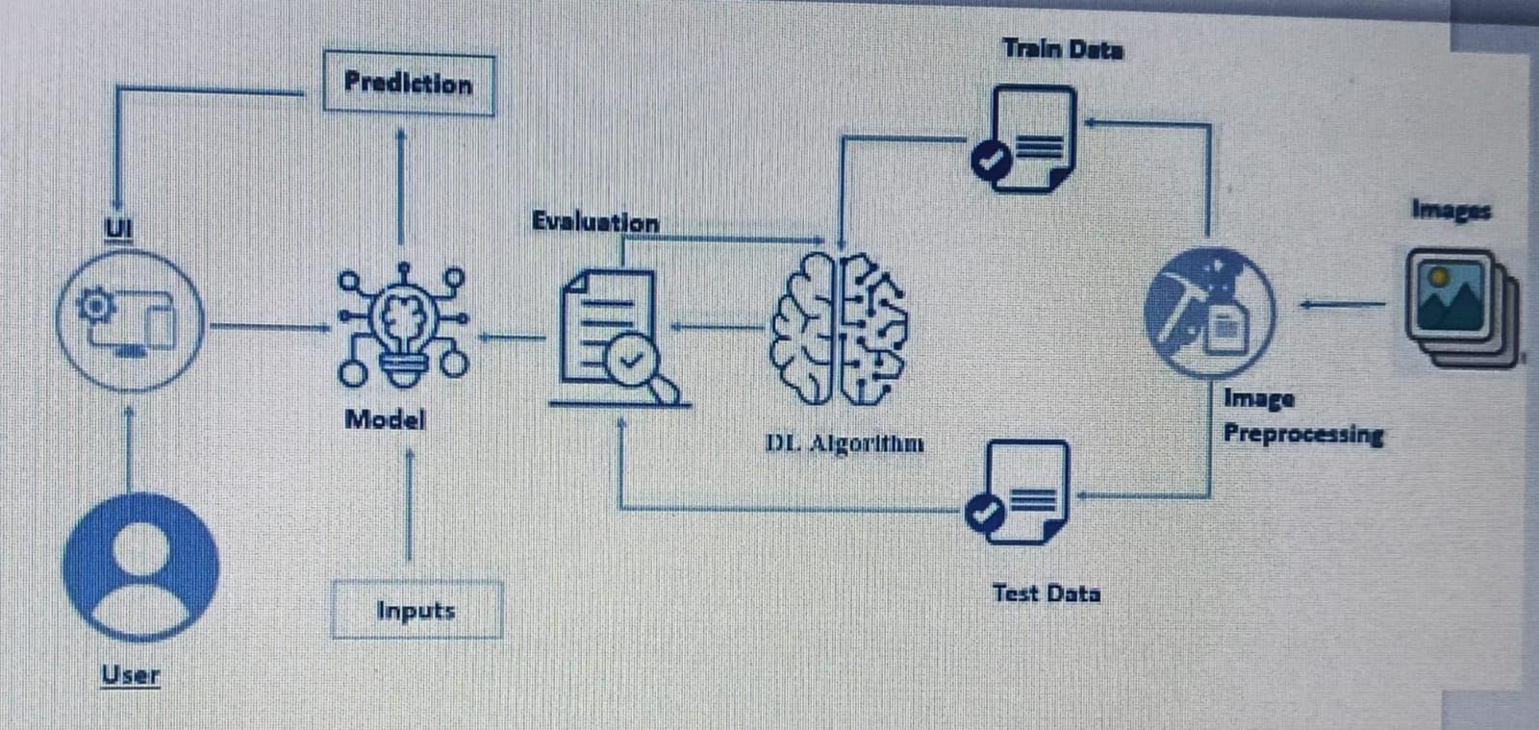

**6. Data Collection**

* **Dataset Source**: The dataset is collected from publicly available sources like **Kaggle** and organized into four categories: **Normal**, **Cataract**, **Diabetic Retinopathy**, and **Glaucoma**.
* **Dataset Link**: [Eye Diseases Classification Dataset](https://www.kaggle.com/datasets/gunavenkatdoddi/eye-diseases-classification)
* **Dataset Structure**:
  + **Training Data**: 3,372 images.
  + **Testing Data**: 845 images.

**7. Data Preprocessing**

* **Image Augmentation**: Techniques like rotation, scaling, flipping, and brightness adjustment are applied to increase dataset diversity and improve model generalization.
* **Normalization**: Pixel values are scaled to the range [0, 1] by dividing by 255 to ensure consistent input for the model.
* **Resizing**: Images are resized to 224x224 pixels to match the input size of pre-trained models like VGG19.

**8. Model Building**

**8.1 Transfer Learning**

* **Pre-trained Models**: VGG19, ResNet50, InceptionV3, and Xception are used as feature extractors. These models are pre-trained on the ImageNet dataset and fine-tuned for the eye disease classification task.
* **Model Architecture**:
  + The base model (e.g., VGG19) is used with frozen layers to extract features from the input images.
  + Additional dense layers are added for classification, followed by a softmax activation layer to output probabilities for the four classes.

**8.2 Training**

* The model is trained for 50 epochs using the training dataset.
* Model checkpoints are saved to retain the best-performing model based on validation accuracy.

**8.3 Evaluation**

* The model is evaluated on the testing dataset to measure its performance.
* Metrics such as accuracy, loss, and confusion matrices are used to assess the model's effectiveness.

**9. Milestones**

**9.1 Data Collection**

* **Objective**: Gather a comprehensive dataset of eye disease images.
* **Tasks**:
  + Download the dataset from Kaggle or other reliable sources.
  + Organize the dataset into folders for each class: Normal, Cataract, Diabetic Retinopathy, and Glaucoma.
  + Split the dataset into training and testing sets (e.g., 80% training, 20% testing).
* **Outcome**: A well-organized dataset ready for preprocessing.

**9.2 Data Preprocessing**

* **Objective**: Prepare the dataset for model training.
* **Tasks**:
  + Resize images to 224x224 pixels to match the input size of pre-trained models.
  + Normalize pixel values to the range [0, 1].
  + Apply data augmentation techniques (e.g., rotation, flipping, brightness adjustment) to increase dataset diversity.
* **Outcome**: A preprocessed dataset ready for model training.

**9.3 Model Training**

* **Objective**: Train a deep learning model using transfer learning.
* **Tasks**:
  + Load a pre-trained model (e.g., VGG19) and freeze its layers.
  + Add custom dense layers for classification.
  + Compile the model with an appropriate optimizer (e.g., Adam) and loss function (e.g., categorical cross-entropy).
  + Train the model on the training dataset for a specified number of epochs.
  + Monitor training and validation accuracy/loss to avoid overfitting.
* **Outcome**: A trained model with high accuracy on the validation set.

**9.4 Model Saving**

* **Objective**: Save the best-performing model for deployment.
* **Tasks**:
  + Save the model weights and architecture in a file (e.g., .h5 format).
  + Ensure the saved model can be loaded and used for predictions.
* **Outcome**: A saved model file ready for integration into the Flask application.

**9.5 Application Development**

* **Objective**: Build a web application for real-time predictions.
* **Tasks**:
  + Create an HTML interface for users to upload images and view predictions.
  + Develop a Flask backend to handle image uploads, process them using the trained model, and display the results.
  + Style the web interface using CSS for a user-friendly experience.
* **Outcome**: A fully functional web application for eye disease detection.

**9.6 Testing and Deployment**

* **Objective**: Test the application and deploy it for user interaction.
* **Tasks**:
  + Test the application with sample images to ensure accurate predictions.
  + Debug any issues in the Flask application or model integration.
  + Deploy the application on a local server or cloud platform for wider accessibility.
* **Outcome**: A deployed web application ready for use.

**10. Application Building**

**10.1 Flask Web Application**

* **Frontend**: A simple and intuitive user interface built using HTML and CSS, allowing users to upload images and view predictions.
* **Backend**: Flask framework for handling image uploads, processing them using the trained model, and displaying the results.

**10.2 HTML Interface**

* The web interface includes a file upload feature and a display area to show the uploaded image and the predicted disease class.

**Conclusion**

This project demonstrates the effectiveness of deep learning in detecting eye diseases using medical images. By leveraging transfer learning and Flask, we have built a scalable and user-friendly system for automated eye disease classification. The system can assist healthcare professionals in diagnosing eye diseases more efficiently and accurately.

Future work can focus on:

* Improving model accuracy by using larger and more diverse datasets.
* Expanding the system to detect additional eye diseases.
* Deploying the application on cloud platforms for wider accessibility.
* Incorporating explainable AI techniques to provide insights into the model's predictions.

This project highlights the potential of deep learning in revolutionizing healthcare and improving patient outcomes.