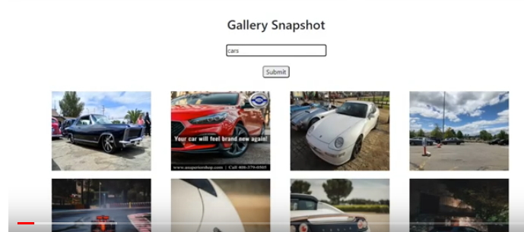

- Create a form with text field and submit button and define the onChange and onSubmit event handlers
import "./styles.css";
import { useState } from "react";

function App() {
const [search, setSearch] = useState("");

function handleSearch(e) {
setSearch(e.target.value);
}

function handleSubmit(e) {
e.preventDefault();
console.log(search);
}

return (
<div className="App">
<center>
<h2>Gallery Snapshot</h2>
<form onSubmit={handleSubmit}>
<input type="text" value={search} onChange={handleSearch} />
<br /> <br />
<input type="submit" value="submit" />
</form>
</center>
</div>
);
}

export default App;
- Install the bootstrap and link it in index.html
- Install the axios library to fetch the data from the API and import it in the App.js component
- Go to flickr https://www.flickr.com/services/apps/create/noncommercial/? And get API key

Email:alladapavanonline1@gmail.com
Password: Pavanflickr@#23
Image-Gallery App
Key:
8bb32993cf93df6168df711706c05cac
Secret:
aca9514b5f0c5c46

import axios from "axios";

const apiKey = "8bb32993cf93df6168df711706c05cac";
function App() {
const [search, setSearch] = useState("");

function handleSearch(e) {
setSearch(e.target.value);
}

function handleSubmit(e) {
e.preventDefault();
axios .get( `https://api.flickr.com/services/rest/?method=flickr.photos.search&api_key=${apiKey}&tags=${search}&per_page=24&format=json&nojsoncallback=1`
)
.then((response) => {
console.log(response.data.photos.photo); ////to check whether we can able to get data from API . later we will change
});
console.log(search); //to check whether we can able to get value entered in text field
}

return (
<div className="App">
<center>
<h2>Gallery Snapshot</h2>
<form onSubmit={handleSubmit}>
<input type="text" value={search} onChange={handleSearch} />
<br /> <br />
<input type="submit" value="submit" />
</form>
</center>
</div>
);
}

export default App;

Now after checking that all is working correctly using console.log, we need to store the data. So we will take one variable and set the data to that variable using useState() hook.

const [data, setData] = useState([]);

function handleSubmit(e) {
e.preventDefault();
axios
.get(
`https://api.flickr.com/services/rest/?method=flickr.photos.search&api_key=${apiKey}&tags=${search}&per_page=24&format=json&nojsoncallback=1`
)
.then((response) => {
setData(response.data.photos.photo);
});
console.log(search);
}

Now we have to see our data of images below the form. So we create the Gallery Component and it is used to display the data as follows.
{data.length >= 1 ? <Gallery data={data} /> : <h4>No Image Loaded</h4>}

Gallery.js
import React from "react";

const Gallery = ({ data }) => {
return (
<div className="row">
{data.map((image) => (
<div key={image.id}>
<div className="col-md-3">
<img
src={`https://farm${image.farm}.staticflickr.com/${image.server}/${image.id}_${image.secret}_m.jpg`}
height="200"
width="250"
alt={image.title}
/>
</div>
</div>
))}
</div>
);
};

export default Gallery;

Now add the following styles in the css file
img {
margin: 20px;
}

input {
border-radius: 5px;
}

@media screen and (max-width: 767px) {
.col-md-6 {
width: 50%;
float: left;
}
}

Now we can see the results.

Suppose I want to get images from local system having src and id attribute
import React from "react";
import "./Gallery.css";

const Gallery = ({ data }) => {
return (
<div className="row">
{data.map((image) => (
<div key={image.id} className="col-lg-3 col-md-6">
<img src={image.src} height="200" width="250" alt={image.id} />
</div>
))}
</div>
);
};

export default Gallery;

