**NXP Radar RFE Firmware**

**Product Brief**

|  |
| --- |
| All information hereunder is per NXP’s best knowledge. This document does not provide for any representation or warranty express or implied by NXP. NXP makes no representation or warranty that customer’s applications or design will be suitable for customers’ specified use without further testing or modification.  Customers are responsible for the design and operation of their applications and products using NXP products, and NXP accepts no liability for any assistance with applications or customer product design. Customers should provide appropriate design and operating safeguards to minimize the risks associated with their applications and products.  For reliable information on the NXP product please consult the respective NXP data sheet. Unless otherwise recorded in a written agreement, all sales transactions by NXP are subject to our general terms and conditions of commercial sale. These are published at <http://www.nxp.com/about/about-nxp/our-terms-and-conditions-of-commercial-sale:TERMSCONDITIONSSALE> |

# Software Product Overview

The NXP Radar RFE Firmware is meant to run on a microprocessor that is embedded in the Radar RFE. It is meant to configure, run, and control execution of customer specific radar system cycles for radar RFE HW.

An example of radar system cycle is present on Figure 1.

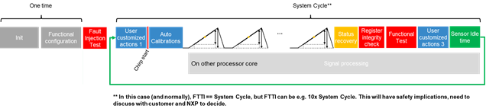

**Radar Config**

**Radar Re-Config**

**Calibration Phase**

**Radar Frame Acquisition Phase**

**Repetitions = Autonomous Radar Cycle**

**Idle Phase**

**Self-Test Phase**

Figure 1. *Typical FMCW Radar System Cycle (in blue user visible states)*

For that purpose the NXP Radar RFE Firmware exposes RFE API, through which a customer can interact with RFE SW running on a dedicated embedded RFE microprocessor.

The RFE API is presented on Figure 2



Figure 2. NXP’s Security Components in Play

The NXP Radar RFE Firmware supports both integrated radar solution ICs as well as stand alone mmWave FE ICs.

The RFE Firmware architecture for integrated and standalone FE solution is presented on Figure 3 and Figure 4 respectively.



Figure 3. NXP Radar RFE Firmware: Integrated Radar mmWave FE



Figure 4. NXP Radar RFE Firmware: Standalone Radar mmWave FE

The NXP Radar RFE Firmware supports different types of customers from experts to less experienced customers, as presented on Figure 5.



Figure 5. NXP Radar RFE Firmware used for different radar FEs.

The NXP Radar RFE Firmware allows for seamless integration with customer radar application. The Figure 6 presents integration with customer application for different types of NXP Front Ends.

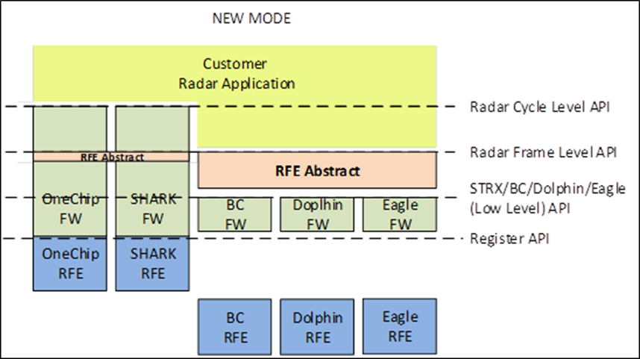

Figure 6. NXP Radar RFE Firmware used for different radar FEs.

The NXP Radar RFE Firmware is accessed from (internal/external) Host processor implementing remote procedure call using messaging command Client-Server architecture, as presented on Figure 7.

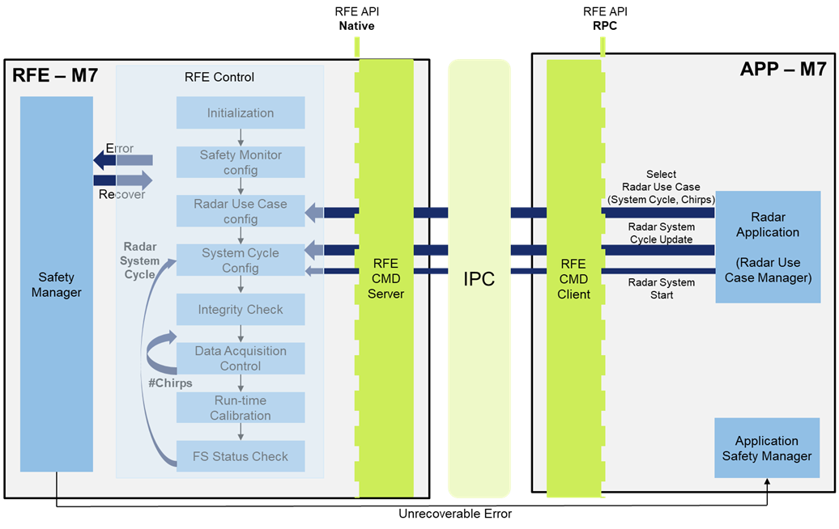

Figure 7. NXP Radar RFE Firmware access: Remote Procedure Call

# Software Content

The Radar RFE Firmware is delivered in binary format, encrypted with NXP Firmware Delivery Key (FDK) and signed with NXP Signing Key (NSKPriv).

The Radar RFE Firmware contains RFE API that is accessable from (internal or external) Host via RFE Driver. Customer radar application makes use of RFE API to configure, control, and run RFE Services provided by RFE Firmware.

The main elements of NXP Radar RFE Firmware are

* (Autonomous) Main FSM
  + Realizing repetitive (configurable) radar system cycle (Configure, Calibrate, Acquire, BIST)
* RFE Config
  + RFE configuration for a custom radar cycle, configuration of Calibration, Acqusition and BIST phase, configuration of (autonomous) RFE Safety
* RFE Calibration
  + Running the configured calibrations
* Data Acqusition
  + Running the configured radar frame
  + Static Tx/Rx control for data acquisition
  + Dynamic chirp to chirp Rx/Tx control for MIMO control
* RFE Self-Test (BIST)
  + Running the configured RFE Self-Tests
* (Autonomous) RFE Safety Manager
  + (configurable) RFE safety error handling, including (programmable) error recovery

Mentioned services are presented on Figure 8.

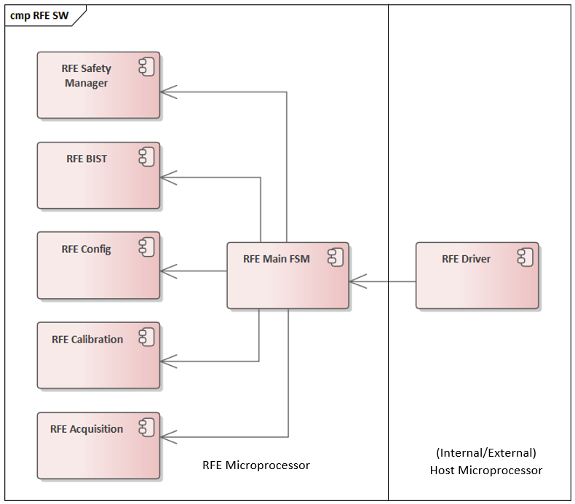

Figure 8. NXP Radar RFE Firmware Services

# Supported Targets

The Radar RFE Firmware is intended to be uses for the following devices of NXP Semiconductors

* SmartTRX OneChip integrated radar IC
* SmartTRX STRX Remote integrated radar IC
* SmartTRX Shark stand alone radar front end mmWave IC

# Quality, Standards Compliance and Testing Approach

The Radar RFE Firmware product is developed according to NXP Software Development Processes that is Automotive-SPICE, IATF16949 and ISO9001 compliant.

The Radar RFE Firmware product is developed according to ASIL-D development process and the SW adheres to ASIL-B safety level.

# Document Information

|  |  |  |  |
| --- | --- | --- | --- |
| Version | Author | Date | Changes Description |
| V0.1 | Artur Burchard | 15-07-2020 | Draft |
| V0.15 | Artur Burchard | 16-07-2020 | STRX PDA version |
|  |  |  |  |
|  |  |  |  |
|  |  |  |  |

Table 1 Revision History