|  |  |
| --- | --- |
| Document information | |
| Info | Content |
| Keywords | Radar, SAF85xx, RFE FW, DfT |
| Abstract | Release notes describing package contents, instructions, open issues, fixes, and limitations. |

| Revision history | | |
| --- | --- | --- |
| Rev | Date | Description |
| 0.1 | 23-April-2021 | Release Notes for SAF85xx RFE DfT FW Release 0.1.0 |

| Glossary | | |
| --- | --- | --- |
| Abbreviations | Description |
| RFE | mmW mixed signal Radar Front-End of SAF85xx |
| A53 | ARM Cortex-A53, the Radar processing core of SAF85xx |
| RFE-M7 | ARM Cortex-M7, the core embedded in RFE of SAF85xx |
| DfT | Discrete Functional Testing |

# Introduction

This document contains the release notes for the SAF85xx RFE DfT Firmware (FW).

The SAF85xx is a NXP CMOS One Chip Radar IC integrating mixed signal radar transceiver and radar processing SoC.

This document describes the contents, open issues, changes, fixes, and limitations of DfT releases.

The SAF85xx RFE DfT FW Reference Manual is included in the release.

Instructions on how to use the SAF85xx RFE DfT FW can be found in the specific documentation (TBD).

# Release Contents

1. Release contents

| Item | Version |
| --- | --- |
| Documentation |  |
| * SAF85xx_RFE_DfT_FW_ReleaseNotes.pdf | 0.1 |
| * ATE-Basic-Functions-Description-Doc_ v0p5.xlsx | 0.5 |
| * readMe.md | 0.1 |
| RFE Firmware (RFE-M7) |  |
| * dft.elf debug version | **0.1.0** |
| * dft.elf release version | **0.1.0** |
| * dft.srec release version | **0.1.0** |
| Dft Matlab | 0.1.0 |
| * Matlab API | 0.1.0 |
| * RFE SW Command Client | 0.1.0 |
| * mri | 0.1.0 |
| M3SA Simulator |  |
| * M3SAStrxBronze.ex | Bronze |
| * M3SAMatlab | 0.1.0 |
| * M3SASimSupport | 0.1.0 |
|  |  |

Please refer to the corresponding user manuals to use and upgrade to the software and firmware provided by this release.

# Changes

## SAF85xx RFE Dft FW release 0.1.0

* Implementation of full basic arithmetic array functionality and related functionality for DfT application
* Implementation of Matlab interface to MESA for DfT application
* Implementation of unit-testing via Matlab and MESA for DfT application

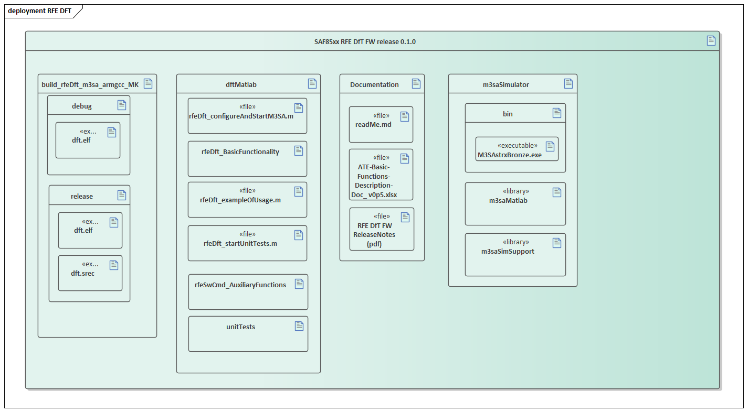

**Figure 1 Release Content**

### Release Structure

Refer to **Figure 1 Release Content**

# Limitations

1. Limitations

| Item | Description |
| --- | --- |
| rfeSwCmdClient_call.m | Current timeout is set to 60s, for future release it will be increased to 120s to avoid connections timeout when displaying results in MESA |
|  |  |

# Known issues

1. Known issues

| Item | Description |
| --- | --- |
| MESABronze.exe | The simulator has a known issue when using it to debug code. So the debug mode when attaching to mesa process with Eclipse will fail. |
|  |  |

# Compatibility

Table 4 gives an overview of the compatibility of the various software and firmware components. Combinations that are not listed are not supported and may not work.

1. Software and firmware compatibility

| RFE FW | RFE API | RFE Driver | RFE Configurator | Other |
| --- | --- | --- | --- | --- |
|  |  |  |  |  |
|  |  |  |  |  |
|  |  |  |  |  |
| n/a | 0.1.0 | n/a |  |  |

Legal information

Definitions

**Draft —**The document is a draft version only. The content is still under internal review and subject to formal approval, which may result in modifications or additions. NXP Semiconductors does not give any representations or warranties as to the accuracy or completeness of information included herein and shall have no liability for the consequences of use of such information.

Disclaimers

**Limited warranty and liability —** Information in this document is believed to be accurate and reliable. However, NXP Semiconductors does not give any representations or warranties, expressed or implied, as to the accuracy or completeness of such information and shall have no liability for the consequences of use of such information. NXP Semiconductors takes no responsibility for the content in this document if provided by an information source outside of NXP Semiconductors.

In no event shall NXP Semiconductors be liable for any indirect, incidental, punitive, special or consequential damages (including - without limitation - lost profits, lost savings, business interruption, costs related to the removal or replacement of any products or rework charges) whether or not such damages are based on tort (including negligence), warranty, breach of contract or any other legal theory.

Notwithstanding any damages that customer might incur for any reason whatsoever, NXP Semiconductors’ aggregate and cumulative liability towards customer for the products described herein shall be limited in accordance with the *Terms and conditions of commercial sale* of NXP Semiconductors.

**Right to make changes —**NXP Semiconductors reserves the right to make changes to information published in this document, including without limitation specifications and product descriptions, at any time and without notice. This document supersedes and replaces all information supplied prior to the publication hereof.

**Suitability for use —** NXP Semiconductors products are not designed, authorized or warranted to be suitable for use in life support, life-critical or safety-critical systems or equipment, nor in applications where failure or malfunction of an NXP Semiconductors product can reasonably be expected to result in personal injury, death or severe property or environmental damage. NXP Semiconductors and its suppliers accept no liability for inclusion and/or use of NXP Semiconductors products in such equipment or applications and therefore such inclusion and/or use is at the customer’s own risk.

**Applications —**Applications that are described herein for any of these products are for illustrative purposes only. NXP Semiconductors makes no representation or warranty that such applications will be suitable for the specified use without further testing or modification.

Customers are responsible for the design and operation of their applications and products using NXP Semiconductors products, and NXP Semiconductors accepts no liability for any assistance with applications or customer product design. It is customer’s sole responsibility to determine whether the NXP Semiconductors product is suitable and fit for the customer’s applications and products planned, as well as for the planned application and use of customer’s third party customer(s). Customers should provide appropriate design and operating safeguards to minimize the risks associated with their applications and products.

NXP Semiconductors does not accept any liability related to any default, damage, costs or problem which is based on any weakness or default in the customer’s applications or products, or the application or use by customer’s third party customer(s). Customer is responsible for doing all necessary testing for the customer’s applications and products using NXP Semiconductors products in order to avoid a default of the applications and the products or of the application or use by customer’s third party customer(s). NXP does not accept any liability in this respect.

**Export control —**This document as well as the item(s) described herein may be subject to export control regulations. Export might require a prior authorization from competent authorities.

**Translations —** A non-English (translated) version of a document is for reference only. The English version shall prevail in case of any discrepancy between the translated and English versions.

**Evaluation products —**This product is provided on an “as is” and “with all faults” basis for evaluation purposes only. NXP Semiconductors, its affiliates and their suppliers expressly disclaim all warranties, whether express, implied or statutory, including but not limited to the implied warranties of non-infringement, merchantability and fitness for a particular purpose. The entire risk as to the quality, or arising out of the use or performance, of this product remains with customer.

In no event shall NXP Semiconductors, its affiliates or their suppliers be liable to customer for any special, indirect, consequential, punitive or incidental damages (including without limitation damages for loss of business, business interruption, loss of use, loss of data or information, and the like) arising out the use of or inability to use the product, whether or not based on tort (including negligence), strict liability, breach of contract, breach of warranty or any other theory, even if advised of the possibility of such damages.

Notwithstanding any damages that customer might incur for any reason whatsoever (including without limitation, all damages referenced above and all direct or general damages), the entire liability of NXP Semiconductors, its affiliates and their suppliers and customer’s exclusive remedy for all of the foregoing shall be limited to actual damages incurred by customer based on reasonable reliance up to the greater of the amount actually paid by customer for the product or five dollars (US$5.00). The foregoing limitations, exclusions and disclaimers shall apply to the maximum extent permitted by applicable law, even if any remedy fails of its essential purpose.

# Contents

1. Introduction 5

2. Release Contents 6

3. Changes 6

3.1 SAF85xx RFE Dft FW release 0.1.0 6

3.1.1 Release Structure 7

4. Limitations 7

5. Known issues 8

6. Compatibility 8

7. Legal information 10

7.1 Definitions 10

7.2 Disclaimers 10

8. Contents 11