Table of contents

1.0 Objectives / Purpose 4

2.0 Scope 4

3.0 Project Description 4

3.1 Purpose/Scope of the Project 4

3.2 NXP- Supplier Contact Info 4

4.0 Collaboration 4

4.1 Steering Team 4

4.2 Project Team 5

4.3 Meetings 5

4.4 Reports 5

4.5 Environment and Tools 6

4.6 Methods 6

5.0 Non-Technical Requirements 6

5.1 Schedule 7

5.2 Documentation 7

5.3 Quality Assurance 7

5.4 Risk Management 10

5.5 Configuration Management 10

5.6 Problem Reports 10

5.7 Change requests 10

5.8 Problem Reporting after production 11

5.9 Problem Change Notification 11

5.10 Escalation 11

6.0 Technical requirements 11

6.1 Product perspective 11

6.2 Critical / Key Characteristics 12

6.3 Product Requirements 12

6.4 Functional Requirements 12

6.5 Quality Requirements 13

6.6 Functional safety technical requirements 13

6.7 Implementation constraints 13

6.8 Requirements Management and Traceability 14

7.0 Deliverables 14

7.1 Deliverables (from the supplier) 14

7.2 Functional Safety Deliverables from the Supplier 15

7.3 Deliverables (to the supplier) 15

7.4 Functional Safety Deliverables (to the supplier) 15

7.5 Acceptance Criteria 15

7.6 Warranty 16

8.0 Acceptance Reviews and Approvals 16

9.0 Annexes 16

10.0 Document Information 17

10.1 Records 17

10.2 References 17

10.3 Terms/Acronyms and Definitions 17

10.4 Revision History 17

# Objectives / Purpose

This document is intended to capture all relevant information and agreements on the collaboration for the RFE SW development for the OneChip (OC) and Remote platform.

RFE SW development for the OneChip will be completely reused in Remote platform. On top of that, applicable change requests and bring up activities will be planned.

# Scope

This document is applicable to the following organisation(s): BL RFP. This SoW is purely for co-ordination and describes in general terms the guidelines, the outline of agreed work, the deliverables, the receivables, ways of working context of the for the RFE SW OC team to cater Remote platform.

RFE SW project objectives are on-time delivery of the official release with the achievement of the required content, safety goals quality goals and project execution within the estimated costs. The Software Quality Assurance Plan contains the project quality goals and their targets.

# Project Description

## Purpose/Scope of the Project

This section contains description of the project scope, out of scope, project objectives and cooperation model with supplier.

## NXP- Supplier Contact Info

Internal supplier.

# Collaboration

This chapter describes the framework of cooperation. The next tables will be filled out with

examples.

Note: For functional safety projects, describe the collaboration model and safety managers

(from both sides) assignment, cooperation and exchanged deliverables as per ISO26262 –Part 8 requirements.

## Steering Team



Covered in Section 4.1 <https://bitbucket.sw.nxp.com/projects/STRX/repos/rfe/browse/docs/Project_Management/STRX_Remote_SW_RFE_SW_Project_Management_Plan_(Safety_Plan).docx>

## Project Team

Covered in Section 4.1 <https://bitbucket.sw.nxp.com/projects/STRX/repos/rfe/browse/docs/Project_Management/STRX_Remote_SW_RFE_SW_Project_Management_Plan_(Safety_Plan).docx>



## Meetings

Covered in Section 4.3

<https://bitbucket.sw.nxp.com/projects/STRX/repos/rfe/browse/docs/Project_Management/STRX_Remote_SW_RFE_SW_Project_Management_Plan_(Safety_Plan).docx>



## Reports

Updated on a weekly basis to the program via SoS and maintained in collabnet. Eg: [TeamForge : Documents (nxp.com)](https://www.collabnet.nxp.com/ctf/documents/home/projects.smarttrx/docman.root.es0.050_reports_and_minutes.non_fdo_documents.sw_weekly)



Note: Progress reports should be at least once per month and or on release base , and contain status of project, quality metrics and review status.

## Environment and Tools

This section contains:

* Description of used environment and tools in collaboration framework
* Design environment (e.g.: provide checkout link)
* Software development environment
* Test environment
* Version management system (e.g.: provide checkout link)
* File releases / exchange system
* Change request tool
* Problem report tool
* Action Tracking
* Reviews Documentation / Tracking
* IT infrastructure setup, usage and support details including onboarding procedures and account/license access details
* The list of the software tools used during RFE SW project lifecycle and their versions are listed within the link: [RFE_SW_Tool_Eval_Qualificaion.xlsx](https://bitbucket.sw.nxp.com/projects/STRX/repos/rfe/browse/docs/Functional_Safety/Tool_Evaluation_Qualification/RFE_SW_Tool_Eval_Qualificaion.xlsx)

## Methods

This section contains a list all specific methods that must be used by the project if applicable

Remove the bulleted oints and add that project follows BL-AP sw development processes and necessary releases are planned as required by BCAM. Process requirements are in QAP .

Refer to details in <https://bitbucket.sw.nxp.com/projects/STRX/repos/rfe/browse/docs/Quality_Assurance/RFE_FW_RFE_GUI_Quality_Assurance_Plan.docx>

# Non-Technical Requirements

## Schedule

This section describes the overall schedule and constraints. Milestones numbers can be used

for tracking purpose.

A similar schedule will be maintained for Remote in collabnet as similar to STRX OneChip

Eg: [STRX_SW_Release Plan.xlsx](https://nxp1.sharepoint.com/:x:/r/teams/206_16/Shared%20Documents/STRX/ProjectPlanning/STRX_SW_Release%20Plan.xlsx?d=w3e56ecd62ff7491b9dd8eda8f33f2987&csf=1&web=1&e=gvH6Wo).

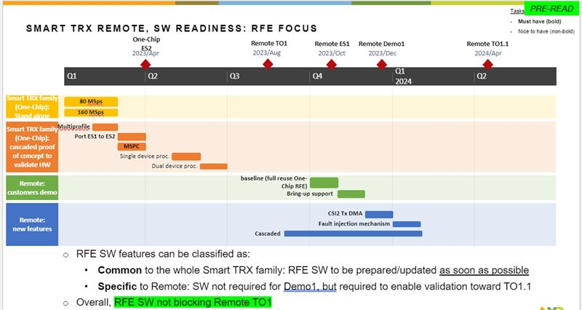



## Documentation

The supplier shall supply full technical documentation for the project. Provide the relevant

guidelines to be followed for making these documents.



Covered in Section 5.2 <https://bitbucket.sw.nxp.com/projects/STRX/repos/rfe/browse/docs/Project_Management/STRX_Remote_SW_RFE_SW_Project_Management_Plan_(Safety_Plan).docx>

## Quality Assurance

The supplier shall establish and practice quality procedures as per the following IATF16949 and ISO9000 standards.   
(IATF16949 quality mandatory for automotive supplier)

* Following items can be considered:
* Checklists (e.g.: QA process compliance report)
* Pre definitions of Audits
* KPIs for quality assurance (slip of milestones, slip of phase gates)

The supplier shall show evidences of their Quality Management System compliant with mutually agreed industrial standards ISO9001, IATF16949, CMMi , A-SPICE, ISO26262 and evidence of product assessments/audits result, including continuous improvement process. The supplier shall forward assessment reports not older than 3 years from effective date of the Statement of Work.

The supplier shall ensure the agreed Certified Quality Management used (System Automotive SPICE® , CMMI, ISO/IEC 15504, other) are followed for all activities under this Statement of Work.

The Expected processes to be tailored in a specific Project, and clear identification of which of the below listed processes needs to be tailored and executed by the Supplier:

* ACQ.4 Supplier Monitoring
* SPL.2 Product Release
* SYS.1 Requirements Elicitation
* SYS.2 System Requirements Analysis
* SYS.3 System Architectural Design
* SYS.4 System Integration and Integration Test
* SYS.5 System Qualification Test
* SWE.1 Software Requirements Analysis
* SWE.2 Software Architectural Design
* SWE.3 Software Detailed Design and Unit construction
* SWE.4 Software Unit Verification
* SWE.5 Software Integration and Integration Test
* SWE.6 Software Qualification Test
* SUP.1 Quality assurance
* SUP.4 Joint review
* SUP.8 Configuration management
* SUP.9 Problem resolution management
* SUP.10 Change request management
* MAN.3 Project management
* MAN.5 Risk Management

For reference, see below the complete V-model to be followed for any Statement of Work. The scope of SoW compliance to this shall be tailored with respect to the nrs of levels involved in the SoW scope (.g. for a small SW component development the HW elements and maybe even system elements may not be applicable):

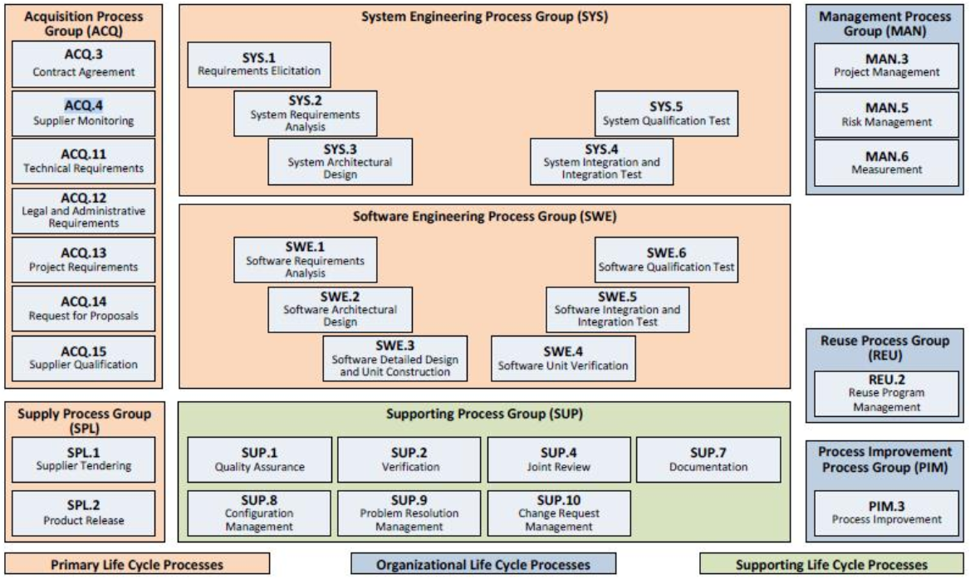

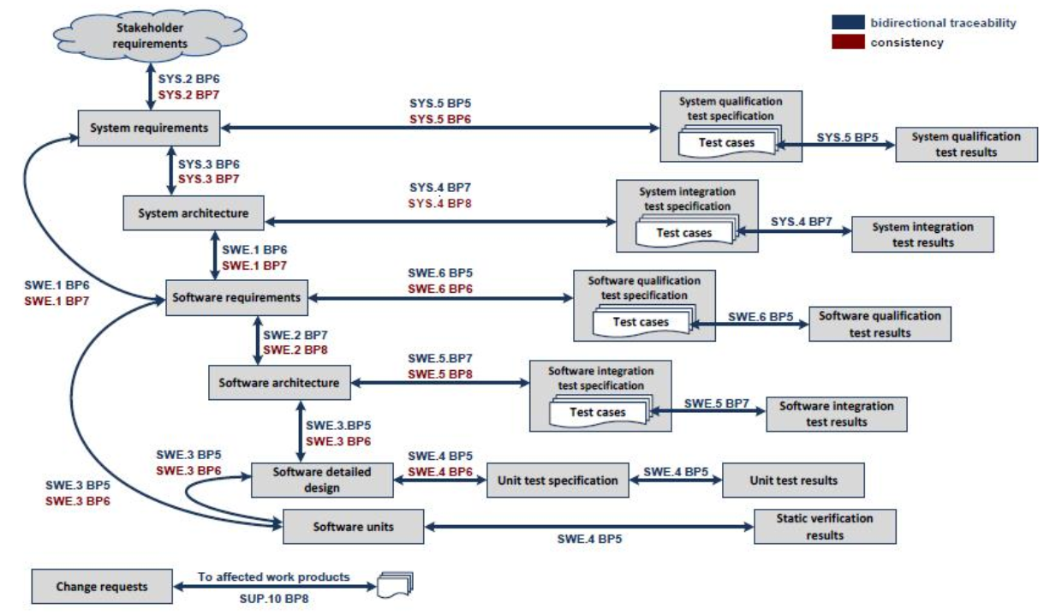

Note: NXP and its customers are entitled to perform quality assurance audits at supplier location for checking that supplied product development conforms with mutually agreed automotive industry requirements.

Non compliances identified during Audits need to be corrected by the supplier at the suppliers expense within 60 days and documented in 8D format.

This SoW shall be evaluated for updates for every major project milestone mutually agreed between parties. NXP BCaM milestones (PI til R or even E (Entitlement) gate can be used as example/reference

Refer to details in <https://bitbucket.sw.nxp.com/projects/STRX/repos/rfe/browse/docs/Quality_Assurance/RFE_FW_RFE_GUI_Quality_Assurance_Plan.docx>

## Risk Management

Technical risk will be managed by FMEA, non-technical risk will be tracked via collabnet risk register.

## Configuration Management

RFE OC team will follow same configuration management for the OC and Remote both.

## Problem Reports

Problem Reports (PR) are to be submitted when any technical or managerial problem arise,

including issues that appear after release.

The standard format of the problem report, to be agreed upon, will include problem description, the risks involved, the impact on schedule/ effort and the proposed solution. Additionally the supplier needs to show evidence that this problem is contained in the full scope and evidence for the effectiveness of the solution. Important to define in SoW on response time for each PR analysis containing technical, project management (schedule, effort) and risk analysis.

Any deviations from the agreed upon points and deficiencies noticed during the project and after release will be notified using problem reports and resulting costs will be borne by the supplier.

RFE OC team will follow same reporting management for the OC and Remote both.

## Change requests

If the Remote project makes changes in the original requirements specification or the project

plan or a deliverable or the OC RFE team will make an effort estimate and will be discussed in the CCB for the approval. RFE OC team will provide technical risk assessment, effort and revised schedule within 10 days of receiving the change request from the Remote.

RFE OC team will follow same change request management for the OC and Remote both.

## Problem Reporting after production

Problem Reports (PR) issues post production/release (Field issues) are to be submitted using

Collabnet ticket and first content-based feedback for critical PRs will be given within 3 days, and 1 week for other PRs is expected.

RFE OC team will follow same reporting management for the OC and Remote both.

## Problem Change Notification

During the development and at production/release time, Problem Change Notification reports shall be sent using the format and delivery method to be agreed upon.

## Escalation

Define escalation process for the supplier as per requests see Supplier Management Procedure step 10 table 4 Detailed SM (non-COTS) process steps (Detailing workflow and RASCI) [BL RF Processing R&D - Subcontract Management (sharepoint.com)](https://nxp1.sharepoint.com/teams/25_8/SAM/Subcontract%20Management.aspx)

# Technical requirements

## Product perspective

This sections gives a brief explanation of the product to be developed. Put emphasis on the

following items:

* Explain if this product is a delta with respect to another product
* List the major functions of the product
* Draw a block diagram showing different functions and their relationship
* Identify the main external interfaces of the product
* Describe the product diversity (if any)
* Specify product stages or phases with milestones
* Specify the target environment in which the product will be installed and used
* For functional safety development, specify the ASIL targeted by NXP.

## Critical / Key Characteristics

This section defines the critical and key characteristics (need to be marked in FMEA).



Software examples:

|  |  |  |
| --- | --- | --- |
| Param. | Description |  |
| MISRA 2012 | Code should be MISRA 2012 complaint with no mandatory and required. checks failing |  |
| Code Reviews | Code should be reviewed with evidences of the review. |  |
| Testing | Code should be module tested for all the critical modules. |  |
| … |  |  |

See SW QA Policy chapter 3.1.4 ([Collabnet doc356947​​​](https://www.collabnet.nxp.com/sf/docman/do/downloadDocument/projects.blida_subqms_ccb/docman.root.bl_ida_qms_published.software_design.processes/doc356947)) for SW as well as System KPIs to be satisfied. And any NXP and its customer specific code metrics.

## Product Requirements

Technical requirements may be divided into functional and non-functional requirements

This document can also refer to requirements to a separate document (IP Brief, System Requirements, IP spec, SW Requirements Spec …)  
In this case these requirements documents are part of the agreement in the SOW and must be used as appendix.

Refer to details

<https://bitbucket.sw.nxp.com/projects/STRX/repos/rfe/browse/docs/Requirements_Management/RFE_SW_Requirement_Specification.xlsx>

## Functional Requirements

Functional requirements are those services that are offered by the product to its users.

## Quality Requirements

Quality requirements are other requirements that are necessary for the intended use of the product. Examples of quality requirements are:

* Performance [Examples are: response time, memory availability, etc]
* Limitations
* Security
* Standards
* Portability [The capability of system to be transferred from one environment to another]
* Reusability [Determine in which environment the product will be used]
* Reliability
* Usability [Set of attributes that bear on the effort needed for use and on the individual assessment of such use by a stated or implied set of users. It's the capability of a product to be understood, learned, used and liked by the user, when used under specified conditions]
* Testability [The degree to which a system or component facilitates the establishment of test criteria and the performance of tests to determine whether those criteria have been met]
* Extensibility [The capability of the system to be modified for implementing additional application]
* Adaptability [the capability of the system to be modified for different specified environments without applying actions or means other than those provided for this purpose for the system considered]
* Maintainability
* Environment [List all environmental regulations the product must comply with]
* Transfer [Needed requirement for supporting the transition phase: provided support, training,]
* Cost [Cost of the solution]
* Quality [Required quality level for the solution, acceptance criteria]

## Functional safety technical requirements

This section contains, as applicable, Functional Safety requirements as that are derived from NXP technical safety concept and required to be fulfilled by the supplied product. Reference to other detailed Functional Safety details at <https://doorsng.nxp.com/rm/web#action=com.ibm.rdm.web.pages.showArtifact&artifactURI=https%3A%2F%2Fdoorsng.nxp.com%2Frm%2Fresources%2F_d383e39a562a4815b0051ce989cd65b5&oslc_config.context=https%3A%2F%2Fdoorsng.nxp.com%2Fgc%2Fconfiguration%2F425&componentURI=https%3A%2F%2Fdoorsng.nxp.com%2Frm%2Frm-projects%2F_r8ZsYRVKEeiLn-6Dce4MoA%2Fcomponents%2F_entLQI3hEeqaeff_JhQ61g>

## Implementation constraints

This section contains the design constraints that may be imposed (given examples below)

* Area/ outlines for integration / target package
* Product / backwards compatibility
* Interface / memory map compatibility
* Process / limitations of layers
* Production test constraints (test time limitations, max voltage / frequency / currents, accuracy ATE…)
* Production flow constraints (trimming at room temperature only…)
* SW Performance Constraints (timings, code size, stack usage..etc)

## Requirements Management and Traceability

This section contains the traceability of all the requirements (clearly itemized, for example,

FN1.1, FN1.2 etc) to the work products that are developed has to be clearly documented. Evaluation of this clause is mandatory during peer review of work products.

# Deliverables

## Deliverables (from the supplier)

This section contains the list of deliverables that will be required after different phases of the

project.

Examples:

* Functional/system specifications
* Project plan should include:
* Introduction- purpose, scope, references, history, distribution list, abbreviations, definitions
* Project description- project objectives, scope of the project, proposed solution, assumptions, development and test environment, methods and tools
* Project management- Work Breakdown Structure (WBS), project organization, estimates (size, effort, cost, schedule), project phasing and planning, progress control, configuration management plan, quality assurance plan, risk management plan, measurement plan
* Project deliverables- NXP to supplier, supplier to NXP, acceptance procedure
* Progress report
* Progress reports are to be submitted [every two weeks/every month] by the supplier. They should include:
* Overall project status, status of deliverables
* Effort (in percentage), cost (in percentage), size, schedule, as compared to those estimated in the project plan
* Activities performed during the reporting period, activities planned for the next reporting period
* Deviations from the project plan and reasons, corrective actions taken
* Risks anticipated, their impacts and measures proposed
* Important decisions/agreements
* Change requests and their status
* Pending problem reports
* Quality assurance activities
* Pending issues
* Acceptance test specifications
* Acceptance test plan
* Architecture
* Integration test specifications
* Integration test plan
* Test reports
* Review reports
* Product
* Automotive phase gate deliverables (AMD)
* Etc.

A check against formal FDO/AMD documentation shall be done to define per phase the deliverables to be expected from the Supplier. This shall be done ensuring compliancy with Automotive Supplier Management Procedure. See [BL RF Processing R&D - Product Creation Process (sharepoint.com)](https://nxp1.sharepoint.com/teams/25_8/PCP/Product%20Creation%20Process.aspx).

Supported platforms: STRX, Shark, Remote. This document primarily scopes in the STRX Onechip variant.

Export Control classification for the Software shared with customers is available at: <https://www.collabnet.nxp.com/sf/go/doc364183>

Deliverables are defined within table below:

|  |  |  |  |  |
| --- | --- | --- | --- | --- |
| **Deliverable** | **Description** | **Integrity Level** | **Owner** | **Code** |
| RFE software | Calibration,  Control,  mmWave HAL,  RFE driver | **ASIL D**  **(process)** | BL-RFP | production |

RFE SWpackage; Quality package (for PRC and RFP); Safety package (for PRC and RFP); documentation; all uploaded in Flexera*.* For details please see [RFE SW SCMP](https://bitbucket.sw.nxp.com/projects/STRX/repos/strx/browse/rfe/docs/Change_and_Configuration_Management/RFE_Configuration_Management_Plan.docx) document.

Licenses in use per SW component: Basic Proprietary Commercial License

## Functional Safety Deliverables from the Supplier

As applicable, the NXP will select applicable work-products and request supplier to provide dates when deliverables are ready to be exchanged.

In addition / or if DIA not available, reference in this section the DIA separate document.

A check against formal FDO/AMD documentation shall be done to define per phase the deliverables related to Functional Safety to be expected from the Supplier. This shall be done ensuring compliancy with Automotive Supplier Management Procedure. See [BL RF Processing R&D - Product Creation Process (sharepoint.com)](https://nxp1.sharepoint.com/teams/25_8/PCP/Product%20Creation%20Process.aspx).

## Deliverables (to the supplier)

NXP shall provide the following deliverables to the supplier.

Supported platforms: STRX, Shark, Remote. This document primarily scopes in the STRX Onechip variant.

Export Control classification for the Software shared with customers is available at: <https://www.collabnet.nxp.com/sf/go/doc364183>

Deliverables are defined within table below:

|  |  |  |  |  |
| --- | --- | --- | --- | --- |
| **Deliverable** | **Description** | **Integrity Level** | **Owner** | **Code** |
| RFE FW binary | Binary containing full RFE-SW functionality | **ASIL D**  **(process)** | BL-RFP | production |
| RFE Driver/API | Source Code | **ASIL D**  **(process)** | BL-RFP | production |
| RFE Configuration Tool | Toolchain | **ASIL D**  **(process)** | BL-RFP | Reference |
| RFE SW Reference Manual | Documentation | **ASIL D**  **(process)** | BL-RFP | Reference |

RFE SWpackage; Quality package (for PRC and RFP); Safety package (for PRC and RFP); documentation; all uploaded in Flexera*.* For details please see [RFE SW SCMP](https://bitbucket.sw.nxp.com/projects/STRX/repos/strx/browse/rfe/docs/Change_and_Configuration_Management/RFE_Configuration_Management_Plan.docx) document.

Licenses in use per SW component: Basic Proprietary Commercial License

## Functional Safety Deliverables (to the supplier)

As applicable, NXP shall provide the following functional safety deliverables to the supplier.

Safety package already covered in Section 7.3.

## Acceptance Criteria

This section contains a list of all the acceptance criteria for the required deliverables should be given here, including criteria for integration in the NXP Semiconductors environment or in NXP environment (if applicable). These criteria are to be stated in a quantified and/or measurable way.

Related to the acceptance criteria is the necessary definition of who will write the acceptance test specification for the product and who will conduct the acceptance test (approval of the results will be done by the prime contractor). Periods for response opportunities after transfer of deliverables and issuing of problem reports must be defined.

Key Milestone (or Phase) exit criteria should be defined and pre-approved Checklists should be included in this section. Checklists will be added in the Annexure as attachments.

See also NXP QMS for templates and checklist- [BL RF Processing R&D - Product Creation Process (sharepoint.com)](https://nxp1.sharepoint.com/teams/25_8/PCP/Product%20Creation%20Process.aspx).

See also chapter 6.2 with reference to BL RFP SW Quality Policy for Gate and Milestone KPIs acceptance criteria [[Collabnet doc356947​​​](https://www.collabnet.nxp.com/sf/docman/do/downloadDocument/projects.blida_subqms_ccb/docman.root.bl_ida_qms_published.software_design.processes/doc356947)]

## Warranty

The supplier is required to provide a warranty of [number] [months / years] from the date of

acceptance of the product. All deviations from product requirements have to be corrected, and any resulting costs will be borne by the supplier. The project is deemed closed at the end of the warranty period.

# Acceptance Reviews and Approvals

|  |  |  |  |
| --- | --- | --- | --- |
| Name | Role | Milestone | Date |
|  |  |  | <YYYYMMDD> |
|  |  |  | <YYYYMMDD> |

|  |  |  |  |  |
| --- | --- | --- | --- | --- |
| Name | Role | Location | Date | Signature  (if required) |
|  |  |  | <YYYYMMDD> |  |
|  |  |  | <YYYYMMDD> |  |

# Annexes

The annexes (if any) are placed in this chapter (usually one per page).

The reason for having Annexes is that they:

1. can be cited from other documents and
2. can be updated with less fuss than changing the actual document (i.e. can be updated without necessarily re-circulating the whole document for re-approval).

# Document Information

## Records

RFE OC team will follow same documentation management for the OC and Remote both.



## References

Any external documents that are used / referred-to by this procedure are mentioned here together with details of how to find them. Where a *standard* is referenced (e.g. ISO9001) then there is no need to reference the version of the standard (e.g. ISO9001-2008) – the latest version is always assumed.

**Note:** this places an obligation on the procedure owner to ensure that revisions in these external documents are checked against this procedure for any impact.

| **Item** | **Description** |
| --- | --- |
| 1 | STRX OC product brief – to be updated in bitbucket  [STRX RFE SW Software Product Brief.docx](https://nxp1.sharepoint.com/:w:/r/teams/206_16/Shared%20Documents/STRX/STRX_Documents_baseline/STRX_TO1_Documents_baseline/RFE_SW/STRX%20RFE%20SW%20Software%20Product%20Brief.docx?d=w36fc5033dd12492fa4a1c316836ccb5b&csf=1&web=1&e=uRUccC) |
| 2 | Configuration Management  [Source of RFE_Configuration_Management_Plan.docx - rfe - NXP Bitbucket](https://bitbucket.sw.nxp.com/projects/STRX/repos/rfe/browse/docs/Change_and_Configuration_Management/RFE_Configuration_Management_Plan.docx) |
| 3 | OC PMP  <https://bitbucket.sw.nxp.com/projects/STRX/repos/rfe/browse/docs/Project_Management/RFE_SW_Project_Management_Plan_(Safety_Plan).docx> |
| 4 | Quality Assurance  <https://bitbucket.sw.nxp.com/projects/STRX/repos/rfe/browse/docs/Quality_Assurance/RFE_FW_RFE_GUI_Quality_Assurance_Plan.docx> |
| 5 | Remote PMP  <https://bitbucket.sw.nxp.com/projects/STRX/repos/rfe/browse/docs/Project_Management/STRX_Remote_SW_RFE_SW_Project_Management_Plan_(Safety_Plan).docx> |

## Terms/Acronyms and Definitions

Def - Any special terms that are used are defined here and any abbreviations are expanded here.

| **Acronym / Terms** | **Definition** |
| --- | --- |
| **Example Acronym:** DMS | **Example definition of acronym:** Document Management System |
| **Example Term:** Document Management System | **Example definition term:** Company supported document management system at **Error! Hyperlink reference not valid.** |

## Revision History

| **Document Author** | **Date** | **Description of Change** | **Document Owner** |
| --- | --- | --- | --- |
| Samrat Guha Niyogi | 1/23/2023 | Initial draft | [Owner] |
| Samrat Guha Niyogi | 1/24/2023 | Reviewed version with QA | [Owner] |
| In case of questions or change proposals please contact the latest document author or owner. | | | |