|  |  |
| --- | --- |
| Document information | |
| Info | Content |
| Author(s) | Olivier Doaré |
| Department | BL-IDA, |
| Keywords | STRX, TX |
| Abstract | Design documentation of the TX and TXBIST digital control IP |
| SGI | <value> |
| ECCN | <code> |
| US origin | No |

|  |  |  |
| --- | --- | --- |
| Distribution information | | |
| Name | Department | Address |
|  |  |  |
|  |  |  |
|  |  |  |
|  |  |  |

| Revision history | | |
| --- | --- | --- |
| Rev | Date | Description |
| 0.1 | 01 April 2021 | Initial version |
| 0.2 | 16 April 2021 | Added DAC linearity and PR settling time (Paul W) |
| 0.3 | 9 August 2021 | Document update. Minor modifications. |
| 0.4 | 11 August 2021 | Added TX power control chapter |
| 0.5 | 22 November 2021 | Updated document following reviewers feedback |
| 0.6 | 30 November 2021 | Additonal update following reviewers feedback |

Contents

1. Introduction 5

2. Product variant 6

3. TX Power mode 7

3.1 Power up, down , stand by 7

4. TX START up and TX Sequences 8

4.1 READY State 8

4.2 TX start up sequence to Chirping 10

4.2.1 TX start up sequence to calibration 10

4.2.2 TX start up sequence to safety 10

4.3 TX enable control 11

5. TX Calibration sequence 13

5.1 LOX2 power calibration sequence 13

5.2 BUF2A Power Calibration sequence 14

5.3 BUF2B2C power calibration sequence 15

5.4 PA power calibration sequence 16

5.5 PR phase calibration sequence 17

6. Safety sequence 18

6.1 Real time power monitoring 18

6.2 TXBIST 18

7. Clock and reset 19

8. TX mode of operations 20

9. TX application mode (chirping) 21

9.1 Tx phase 21

9.2 TX phase init 22

9.3 TX gain 22

9.4 TX profile 22

10. Phase rotator calibration 23

10.1 Introduction 23

10.2 Block diagram 23

10.3 PR phase Calibration FSM states 24

10.3.1 Start_CAL FSM state 25

10.3.2 ADC_AVE FSM state 26

10.3.3 VGA_INIT FSM state 27

10.3.4 VGA_Offset FSM state 28

10.3.5 VGA_Gain FSM state 29

10.3.6 PR_OFFSET_CAL FSM state 30

10.3.7 GPATH_SEL FSM state 31

10.3.8 PR_GAIN_CAL FSM state 32

10.3.9 PR_PHASE_CAL FSM state 32

10.3.10 END_CAL 33

10.4 Automatic calibration 33

10.5 Manual calibration 33

10.5.1 Phase rotator DACs input force 33

10.5.2 Compensation force 34

10.6 Calibration time 34

11. TX PA Power control 35

12. TX safety 37

12.1 Real time monitoring 37

12.1.1 RTM description 37

12.1.2 RTM Mask 38

12.1.3 RTM FIT 38

12.2 Ball break detector 40

12.2.1 BBD description 40

12.2.2 BBD Mask 41

12.2.3 BBD FIT 41

12.3 CRC REGISTER 41

12.3.1 CRC REGISTER description 41

12.3.2 CRC Mask 41

12.4 CRC MISO 42

12.4.1 CRC MISO description 42

12.4.2 CRC MISO MASK 42

12.5 CRC MOSI 42

12.5.1 CRC MISO description 42

12.5.2 CRC MISO MASK 42

12.6 TX INL/DNL 43

12.6.1 TX INL description 43

12.6.2 TX INL MASK 44

12.6.3 TX INL FIT 44

12.7 TX to TX delta phase variation (TXBIST) 44

12.7.1 TX to TX delta variation description 44

12.7.2 TX to TX delta variation Mask 45

12.7.3 TX to TX delta variation FIT 45

13. TX & TXBIST ADC communication 46

13.1 TX connection to TXADC and ATB ADC 46

13.1.1 TX connection to TXADC 46

13.1.2 TX connection to ATB ADC. 48

13.2 TXBIST connection to TXADC and ATB ADC. 48

14. DFT 49

14.1 PR DAC linearity 49

14.1.1 P-channel current measurement-test 49

14.1.2 N-channel current measurement-test 49

14.1.3 Disabled DFT linearity test 50

14.2 PR settling time 50

14.3 IF generation (UPN) 53

14.4 FSM STOP 53

14.5 ADC measurement in FSM state 54

14.6 GPIO 54

# Introduction

TX digital module is companion of the TX and TXBIST RF module.

* Tx DIG module translates the 7 bits phase from the timing engine to 256 unitary weighted bit input of the TX I and Q phase rotator DAC.
* Tx DIG module improves the TX INL through a self-autonomous compensation mechanism of the Phase rotator impairments.
* The TXDIG embeds safety mechanism.
* Tx DIG module contains DFT features to measure the Phase rotator settling time, check the phase rotator DAC linearity.

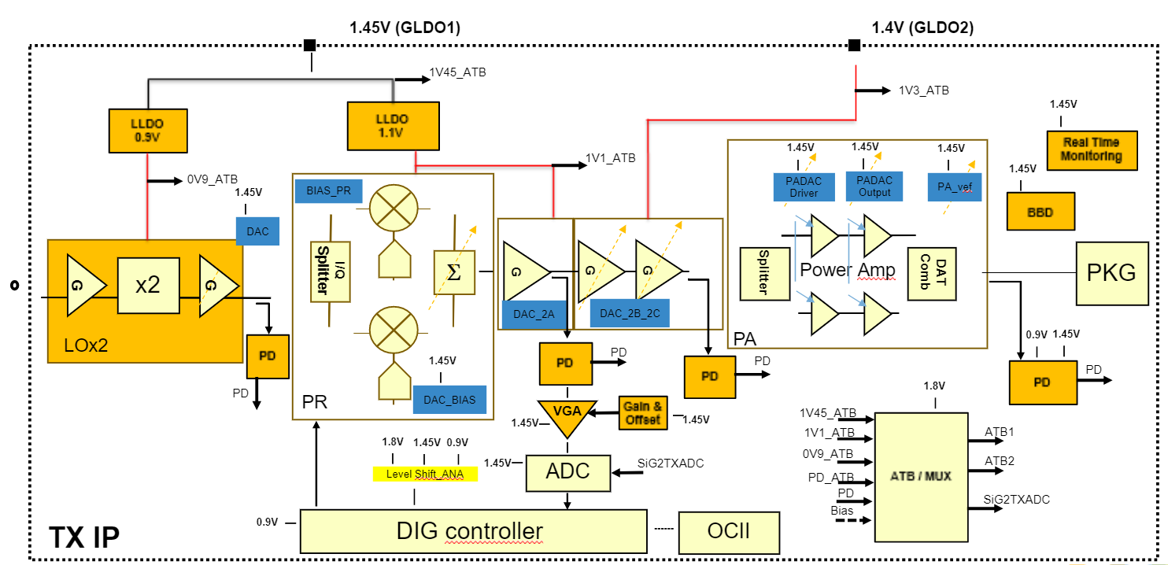

Figure 1: STRX TX

The TXBIST is a RF structure which is associated to 2 TXs modules. TXs are group per pair. The TXs PA output from 2 grouped TX is down-converted within TXBSIT as depicted “Figure 2: TXs and TXBIST”.

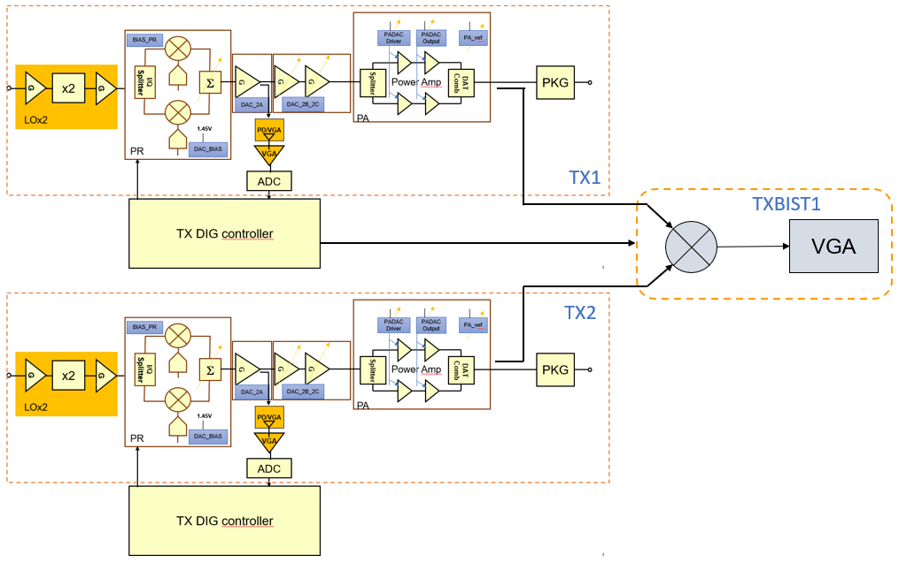

Figure 2: TXs and TXBIST

# Product variant

Tx can be configurated using OTP bits.

It shall be possible to enable/disable TX channels via OTP control. Each of the TX channel shall be controlled by 1 OTP bit.

It shall be possible to enable/disable the phase rotator via OPT control. This OTP bit disables the rotation of the phase and is common to all TX channels. In this case the DACs are controlled by an equivalent 0 degrees phase.

# TX Power mode

The TX Power sequence shall be initiated by the Timing Engine. Nevertheless it shall be possible to enable through SPI the TX and TXBIST modules.

The TXBIST power sequence shall only be controlled by SPI.

## Power up, down , stand by

* The TX power down mode shall be active when level shifters and LDOs are OFF
* Standby mode shall correspond to Level shifters ON and LDOs are ON
* The TX power up mode shall be active when Level shifters are On, LDOs ON and TX enabled

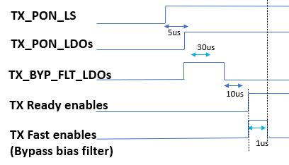

Figure 3:Power up sequence

# TX START up and TX Sequences

## READY State

The ready state is a standard configuration that shall be programmed by the user.

The TX is “ready” , waiting for chirping, calibrating or being used in safety mode.

The ready state shall be defined after Pon_ls, Pon_ldo and Byp_flt sequence by programming the bits defined in Table 1: Ready state SPI bits

Table 1: Ready state SPI bits

|  |  |  |  |
| --- | --- | --- | --- |
| **Delay [us]** | **Register name** | **Register field** | **Value (dec)** |
|  | PON | PON_TX_LS | 1 |
|  | TX_PR | FAST_SW_PR | 1 |
|  | TX_2B2C | FAST_SW_BUF | 1 |
|  | TX_PA | FAST_SW_PA | 1 |
|  | PX_POWER | ST1_C | d27 |
|  | PX_POWER | ST2_C | d27 |
|  | TX_BIST_CTRL | IBIAS_TRIM | d4 |
|  | TX_BIST_CTRL | VGA_CTRL | d1 |
|  | TX_2B2C | VCAS_TRIM_2B | 1 |
|  | TX_2B2C | VCAS_TRIM_2C | 1 |
|  | BBD_CTL | VREF_RECE | 0 |
|  | TXDIG_DFT | CLK_FREE_RUN | 1 |
| 5 after PON_TX_LS | PON | PON_LDO_LO | 1 |
| 5 after PON_TX_LS | PON | PON_LDO_PR | 1 |
| 5 after PON_TX_LS | PON | BP_FLT_LDO_LO | 1 |
| 5 after PON_TX_LS | PON | BP_FLT_LDO_PR | 1 |
| 35 after PON_TX_LS | PON | BP_FLT_LDO_LO | 0 |
| 35 after PON_TX_LS | PON | BP_FLT_LDO_PR | 0 |
| 45 after PON_TX_LS | TX_LO | EN_FAST_START_LOX2 | 1 |
| 45 after PON_TX_LS | TX_PR | FAST_EN_PR | 1 |
| 45 after PON_TX_LS | TX_2B2C | FAST_EN_BUF | 1 |
| 45 after PON_TX_LS | TX_PA | FAST_EN_PA | 1 |
| 45 after PON_TX_LS | TX_LO | EN_LOX2 | 1 |
| 45 after PON_TX_LS | TX_LO | EN_PPD_LOX2 | 1 |
| 45 after PON_TX_LS | TX_LO | EN_LOX2_BIAS | 1 |
| 45 after PON_TX_LS | TX_PR | EN_PR | 1 |
| 45 after PON_TX_LS | TX_PR | EN_PR_DAC | 1 |
| 45 after PON_TX_LS | TX_PR | EN_LBIAS_PR | 1 |
| 45 after PON_TX_LS | TX_PR | EN_BUF2A | 1 |
| 45 after PON_TX_LS | TX_PR | EN_DAC_BUF2A | 1 |
| 45 after PON_TX_LS | TX_PR | EN_PPD_BUF2A | 1 |
| 45 after PON_TX_LS | TX_2B2C | EN_BUF_2B | 1 |
| 45 after PON_TX_LS | TX_2B2C | EN_BUF_2C | 1 |
| 45 after PON_TX_LS | TX_2B2C | EN_DAC_BUF2B2C | 1 |
| 45 after PON_TX_LS | TX_2B2C | EN_PPD_BUF2C | 1 |
| 45 after PON_TX_LS | TX_PA | EN_PA_CORE | 1 |
| 45 after PON_TX_LS | TX_PA | EN_PA_DAC_ST1_C | 1 |
| 45 after PON_TX_LS | TX_PA | EN_PA_DAC_ST2_C | 1 |
| 45 after PON_TX_LS | TX_PA | EN_PA_DAC_VREF | 1 |
| 45 after PON_TX_LS | TX_PA | EN_PPD_PA | 1 |
| 46 after PON_TX_LS | TX_LO | EN_FAST_START_LOX2 | 0 |
| 46 after PON_TX_LS | TX_PR | FAST_EN_PR | 0 |
| 46 after PON_TX_LS | TX_2B2C | FAST_EN_BUF | 0 |
| 46 after PON_TX_LS | TX_PA | FAST_EN_PA | 0 |

## TX start up sequence to Chirping

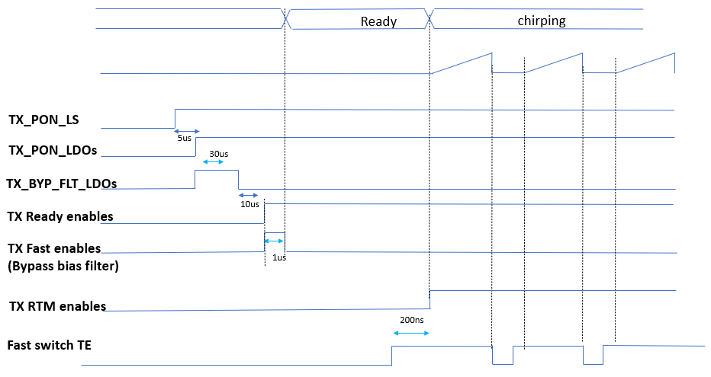

Figure 4:Start up sequence to Chirp

### TX start up sequence to calibration

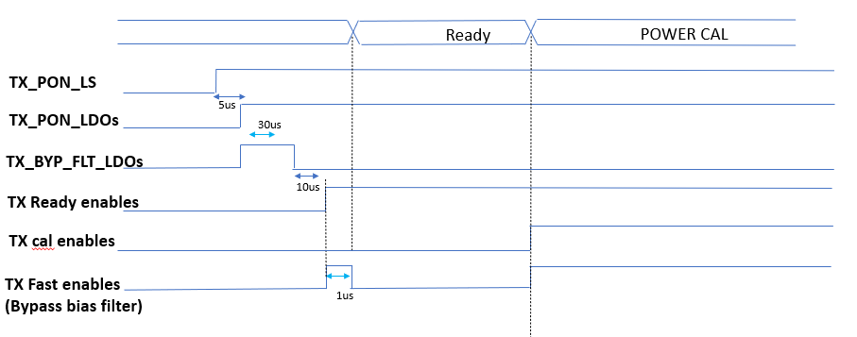

Figure 5: TX start up sequence to calibration

### TX start up sequence to safety

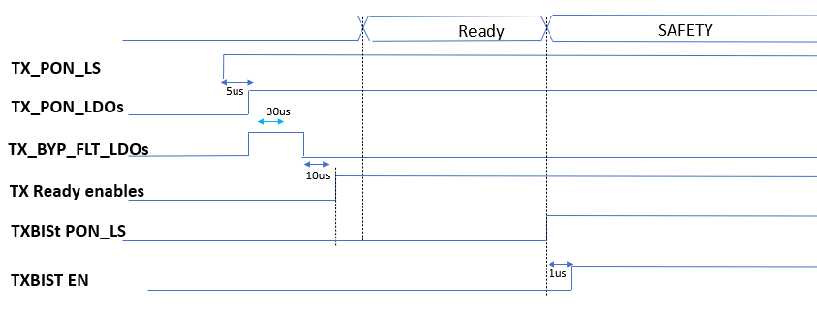

Figure 6: TX start up sequence to Safety

## TX enable control

TX has 2 types of enables.

Enables which are needed for application mode are controlled by a OR gate which input is either the tx_enable from the Timing engine or a dedicated SPI bit.

Other enables which are needed for other purpose such as calibration , safety , DFT only are managed only by SPI bit.

**( *RTL Update is needed in ES2 to align the ready state with the enable controlled by TE*)**

Table 2: TX enable

|  |  |  |  |  |
| --- | --- | --- | --- | --- |
| ***REGISTER NAME*** | ***FILED NAME*** | ***MODULE*** | ***MODE*** | ***CONTROLLED THROUGH*** |
| ***TX_ADC*** |  |  |  |  |
|  | POWER_ENABLE | TXADC | FUNC | SPI |
| ***PON_TXBIST*** |  |  |  |  |
|  | BIAS_EN | TXBIST | SAFETY | SPI |
|  | TEST_EN | TXBIST | SAFETY | SPI |
|  | VGA_EN | TXBIST | SAFETY | SPI |
|  | MIXER_CORE_EN | TXBIST | SAFETY | SPI |
| ***TX_LO*** |  |  |  |  |
|  | EN_LOX2 | TX | FUNC | TE OR SPI |
|  | EN_PPD_LOX2 | TX | FUNC | TE OR SPI |
|  | EN_FAST_START_LOX2 | TX | FUNC | TE OR SPI |
|  | EN_LOX2_BIAS | TX | FUNC | TE OR SPI |
| ***TX_PR*** |  |  |  |  |
|  | EN_PR | TX | FUNC | TE OR SPI |
|  | EN_PR_DAC | TX | FUNC | TE OR SPI |
|  | EN_LBIAS_PR | TX | FUNC | TE OR SPI |
|  | EN_BUF2A | TX | FUNC | TE OR SPI |
|  | EN_DAC_BUF2A | TX | FUNC | TE OR SPI |
|  | EN_PPD_BUF2A | TX | FUNC | TE OR SPI |
|  | EN_PPD_BUF2A_VGA | TX | FUNC | SPI |
|  | EN_VGA_PR | TX | FUNC | SPI |
|  | EN_VGA_DAC | TX | FUNC | SPI |
|  | EN_DAC_VGA_IBIAS | TX | FUNC | SPI |
|  | EN_VGA2_VBIAS_VCM | TX | FUNC | SPI |
|  | EN_VGA_DAC_OFST | TX | FUNC | SPI |
|  | FAST_EN_PR | TX | FUNC | TE OR SPI |
|  | FAST_SW_PR | TX | FUNC | TE OR SPI |
| ***TX_2B2C*** |  |  |  |  |
|  | EN_BUF_2B | TX | FUNC | TE OR SPI |
|  | EN_BUF_2C | TX | FUNC | TE OR SPI |
|  | EN_DAC_BUF2B2C | TX | FUNC | TE OR SPI |
|  | EN_PPD_BUF2C | TX | FUNC | TE OR SPI |
|  | FAST_EN_BUF | TX | FUNC | TE OR SPI |
|  | FAST_SW_BUF | TX | FUNC | TE OR SPI |
| ***TX_PA*** |  |  |  |  |
|  | EN_PA_CORE | TX | FUNC | TE OR SPI |
|  | EN_PA_DAC_ST1_C | TX | FUNC | TE OR SPI |
|  | EN_PA_DAC_ST2_C | TX | FUNC | TE OR SPI |
|  | EN_PA_DAC_VREF | TX | FUNC | TE OR SPI |
|  | EN_PPD_PA | TX | FUNC | TE OR SPI |
|  | EN_RTM_DAC | TX | SAFETY | SPI |
|  | EN_RTM_COMP | TX | SAFETY | SPI |
|  | EN_RTM_BUFX1 | TX | SAFETY | SPI |
|  | EN_RTM | TX | SAFETY | SPI |
|  | PPD_PAOUT_VGA_EN | TX | FUNC | SPI |
|  | FAST_EN_PA | TX | FUNC | TE OR SPI |
|  | FAST_SW_PA | TX | FUNC | TE OR SPI |
| ***BBD_CTL*** |  |  |  |  |
|  | EN | TX | SAFETY | SPI |
| ***BBD_DFT*** |  |  |  |  |
|  | EN_BALL_CURRENT | TX | SAFETY | SPI |
| ***ADC_DFT*** |  |  |  |  |
|  | PPD_BUF_EN | TX | DFT | SPI |
| ***TXBIST_CTRL*** |  |  |  |  |
|  | STLING_TIME_EN_N | TXBIST | DFT | SPI |
|  | STLING_TIME_EN_P | TXBIST | DFT | SPI |
| ***PRC_IF_TEST*** |  |  |  |  |
|  | TX_IF_EN | TX | DFT | SPI |
| ***PR_STLING_TIME*** |  |  |  |  |
|  | EN |  | DFT | SPI |
| ***ATB_CTL*** |  |  |  |  |
|  | ATB1_EN | TX/TXBIST | DFT | SPI |
|  | ATB2_EN | TX/TXBIST | DFT | SPI |
| ***VSTRESS*** |  |  |  |  |
|  | TX_HVST_EN | TX | DFT | SPI |
|  | TXBIST_HVST_EN | TXBIST | DFT | SPI |

# TX Calibration sequence

The following sequences are started from the “ Ready state” previously defined.

## LOX2 power calibration sequence

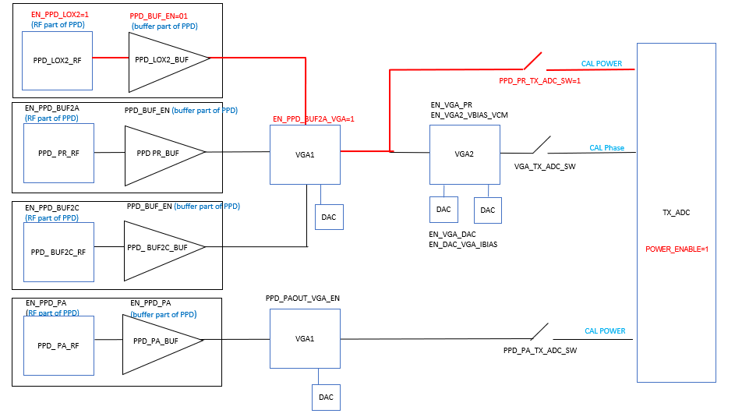

Figure 7: LOX2 power calibration sequence

The Calibration is done by default using the TX ADC.

Once in ready state, the following sequence shall be programmed

* EN_PPD_LOX2=1
* PPD_BUF_EN=b’01
* EN_PPD_BUF2A_VGA=1
* PPD_PR_TX_ADC_SW=1
* ADC : POWER_ENABLE=1

LOX2_DAC_CTRL SPI bit controls the LOX2 Power.

The TX ADC conversion shall be done be writing the ADC_CONV_FORCE SPI bit to 1 when ADC_CONV_SEL=1. It will generate a TXADC clock pulse.

## BUF2A Power Calibration sequence

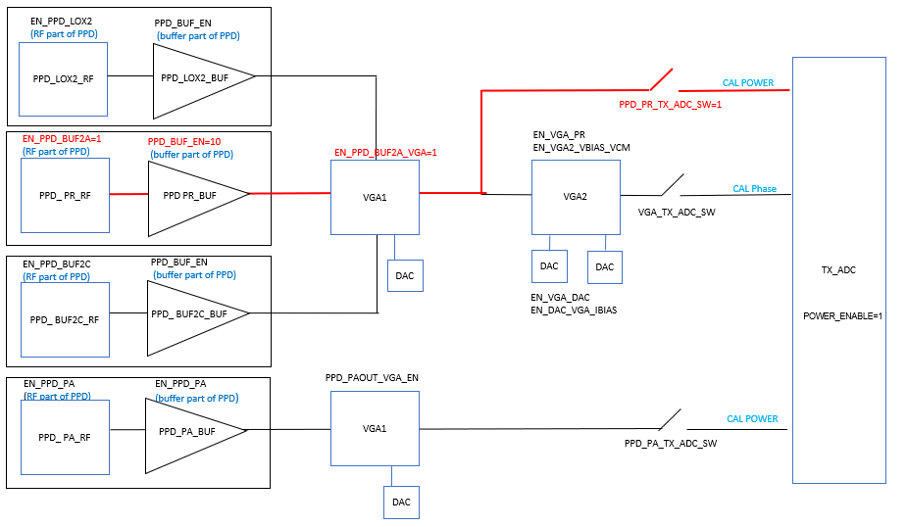

Figure 8:BUF2A power calibration sequence

The Calibration is done by default using the TX ADC.

Once in ready state, the following sequence shall be programmed

* EN_PPD_BUF2A=1
* PPD_BUF_EN=b’10
* EN_PPD_BUF2A_VGA=1
* PPD_PR_TX_ADC_SW=1
* ADC : POWER_ENABLE=1

BUF2A_DAC_CTRL bit controls the BUF2A Power.

The TX ADC conversion shall be done be writing the ADC_CONV_FORCE SPI bit to 1 when ADC_CONV_SEL=1. It will generate a TXADC clock pulse.

## BUF2B2C power calibration sequence

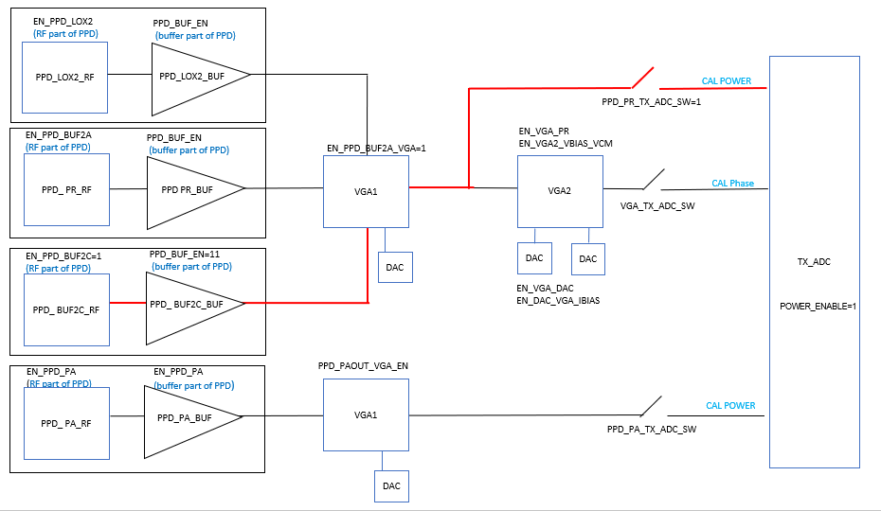

Figure 9: Buf2B2C power calibration sequence

The Calibration is done by default using the TX ADC.

Once in ready state, the following sequence shall be programmed

* EN_PPD_BUF2C=1
* PPD_BUF_EN=b’11
* EN_PPD_BUF2A_VGA=1
* PPD_PR_TX_ADC_SW=1
* ADC : POWER_ENABLE=1

BUF2B2C_DAC_CT bit controls the BUF2B2C Power.

The TX ADC conversion shall be done be writing the ADC_CONV_FORCE SPI bit to 1 when ADC_CONV_SEL=1. It will generate a TXADC clock pulse.

## PA power calibration sequence

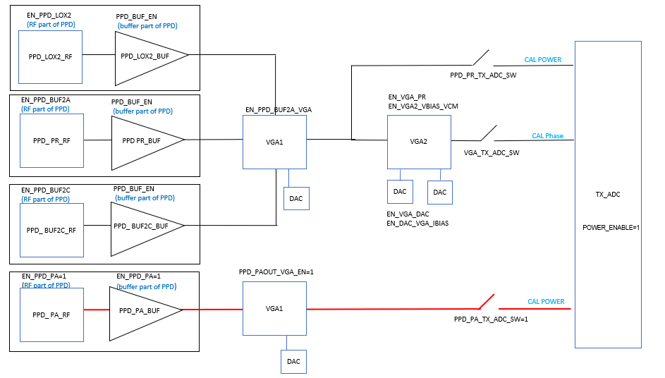

Figure 10:PA power calibration sequence

The Calibration is done by default using the TX ADC.

Once in ready state, the following sequence shall be programmed

* EN_PPD_PA=1
* PPD_PAOUT_VGA_EN=1
* PPD_PA_TX_ADC_SW=1
* ADC : POWER_ENABLE=1

SPI Bits, PROG_OUT_GLD1V3 and SETDC_BG_GLD1V3 bit controls the BUF2B2C Power.

The TX ADC conversion shall be done be writing the ADC_CONV_FORCE SPI bit to 1 when ADC_CONV_SEL=1. It will generate a TX ADC clock pulse.

## PR phase calibration sequence

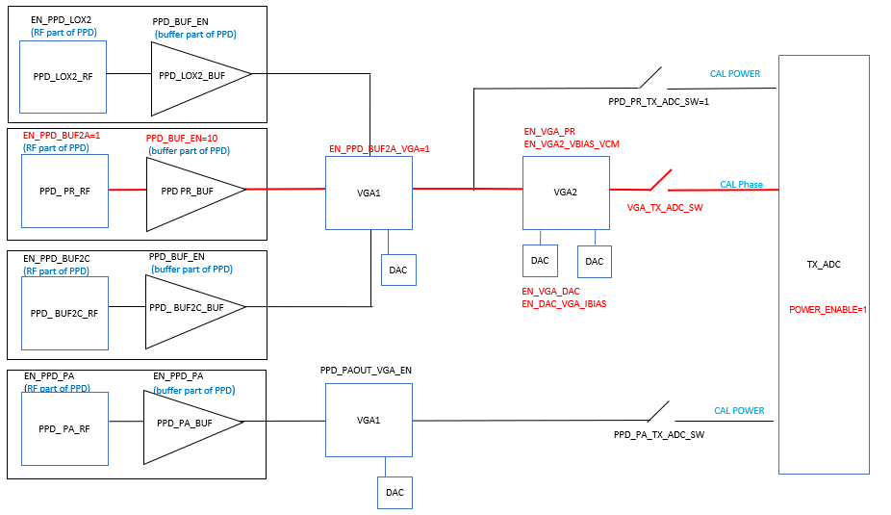

Figure 11: PR phase calibration sequence

The Calibration is done by default using the TX ADC.

Once in ready state, the following sequence shall be programmed

* EN_PPD_BUF2A=1
* PPD_PAOUT_VGA_EN=b’10
* EN_PPD_BUF2A_VGA=1
* EN_VGA_PR=1
* EN_VGA2_VBIAS_VCM=1
* EN_VGA_DAC=1
* EN_DAC_VGA_IBIAS=1
* VGA_TX_ADC_SW=1
* ADC : POWER_ENABLE=1

The Phase rotator phase calibration is a hardware autonomous mechanism. No need to control the phase and the ADC clock.

# Safety sequence

## Real time power monitoring

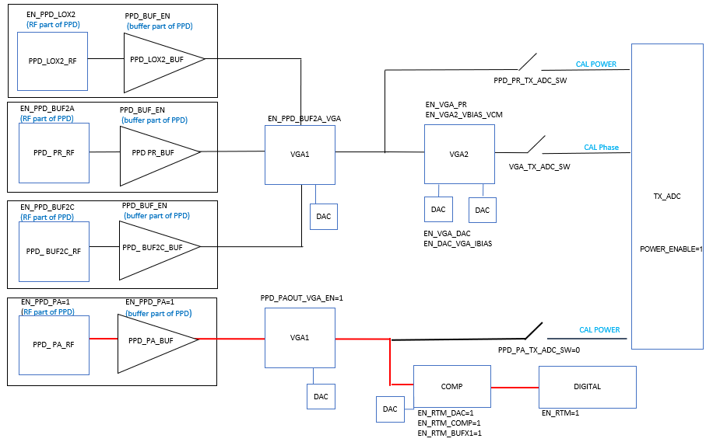

Figure 12:Real time Monitoring Safety sequence

The RTM safety mechanism does not used ADC.

Once in ready state, the following sequence shall be programmed

* EN_PPD_PA=1
* PPD_PAOUT_VGA_EN=b’10
* EN_RTM_DAC=1
* EN_RTM_COMP=1
* EN_RTM_BUFX1=1
* EN_RTM=1

## TXBIST

The sequence is described in chapter “TX start up sequence to safety” . The TXBIST enable bits are:

* BIAS_EN
* VGA_EN_
* MIXER_CORE_EN

# Clock and reset

Clock and reset are managed through 2 internal TXDIG module.

CTRL_TOP provides to the TX functional TOP a 40MHz clock and a reset. The detail of CTRL_TOP shall be defined in a separate document.

Only 1 reset is used in the TX functional Top.

Clk40_tx_cal_clk drives the phase rotator calibration digital module .

Clk40_tx_cal_clk is disabled when SPI bit power_down =1 or when otp_tx_pr_disable=1 or when otp_tx_disable=1

The clock is active when enable_TX and PR_CAL_RUN=1 indicating the calibration is running. clk_free_run SPI bit allows to bypass the enable_tx and pr_cal_run

Clk40_tx_prc_clk drives the phase rotator controller digital module .

Clk40_tx_cal_clk is disabled when SPI bit power_down =1 or when otp_tx_pr_disable=1 or when otp_tx_disable=1.

The clock is active when enable_tx from the Timing engine or clk_free_running =1

Clk40_tx_clk drives the safety and DFT. The clock is enabled when enable_tx=1 or clk_free_run =1

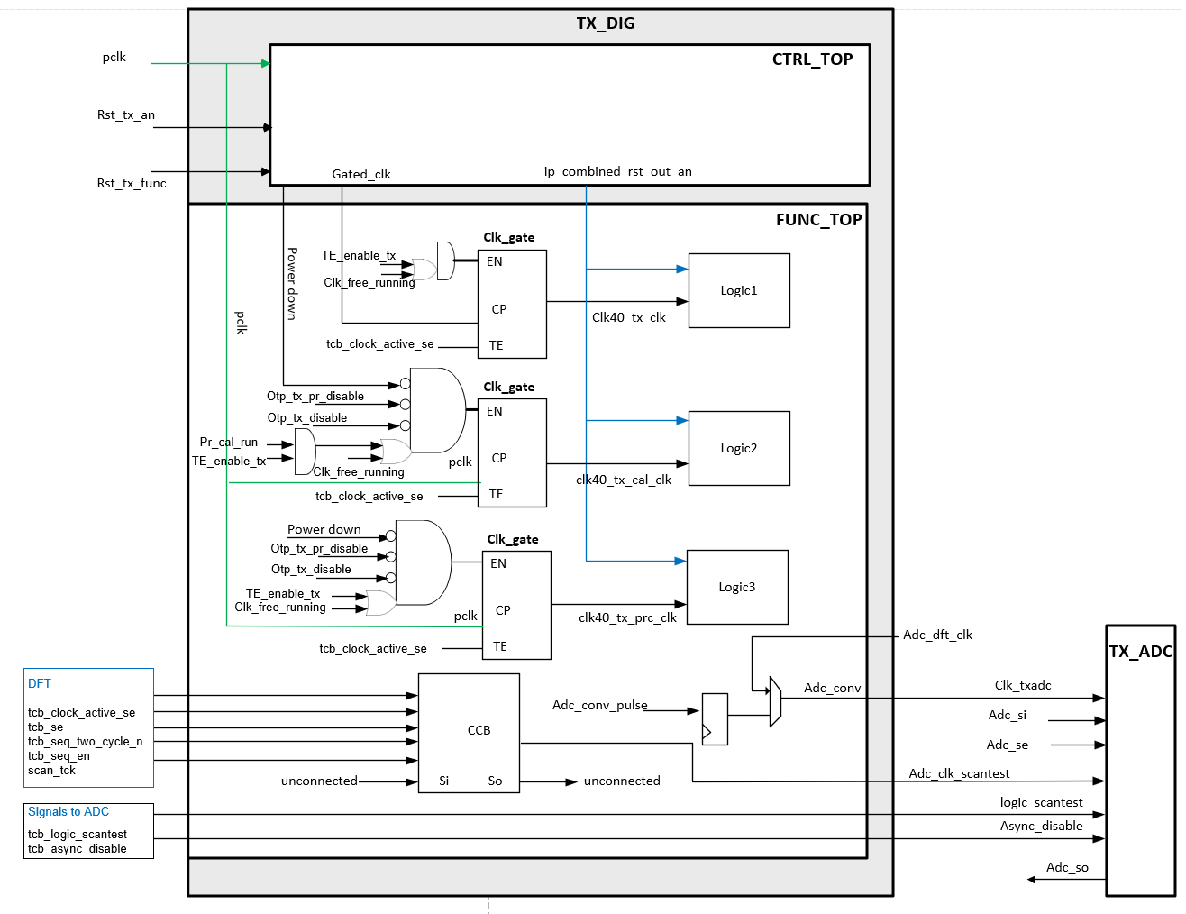

Figure 13: Clock and reset

# TX mode of operations

TXDIG has 4 modes of operations . Modes are selected through enable bits programming, as depicted in chapter” TX START up and READY Sequences”.

**Ready state**: The TX is ready to enter in one of the modes, calibration, safety ,application mode(chirping)

1. **Phase rotator calibration mode**: The Phase rotator is calibrated and self-compensated.
2. **Power calibration mode**: the TX power is calibrated.
3. **Safety mode**: safety mechanisms guaranty the behavior of the transmitter.
4. **Chirping mode**: Phase is transmitted from the timing engine to the phase rotator.

Tx Phase calibration is driven by an internal FSM. The chirping mode , the safety mode and the power calibration mode shall be managed by SPI.

The TX phase calibration internal FSM is detailed in chapter “PR phase Calibration FSM states”.

# TX application mode (chirping)

The application mode corresponds to the IDLE state of the internal TXDIG FSM.

The main functionality of the TXDIG is to translate the 7 bits phase from the timing engine to 256 unitary weighted bit input of the TX I and Q phase rotator DACs. The translation is done through a Cordic algorithm and a thermometer encoder.

The Phase rotator controller is driven by the LO on one side and 2 DACs which are respectively controlling the I and Q baseband DACs inputs on the other side. Those I and Q baseband inputs can be described by A*cos(phase+phase_init) and A*sin(phase+phase_init) respectively for the I and Q path.

The phase is dynamically change versus the time while the phase_init is a fixed value. The phase init can be used to adjust the phase offset between TX channels.

## Tx phase

During the application mode, the phase is a 7 bits signal from the Timing Engine module. The rotation in degree shall be defined by  TE_phase_code[6:0]*360/2^7 where TE_phase_code is a SPI bits within Timing Engine digital module.

A debug mode exists where the phase is directly driven by a register d_force_te_phase in the TX. The phase d_force_te_phase is a 7 bits SPI word that apply the phase at CORDIC input when SPI bit d_force_te_phase_sel =1

The rotation in degree shall be defined with d_force_te_phase[6:0]*360/2^7.

Table 3: Phase binary

|  |  |  |
| --- | --- | --- |
| phase ⁰ | Phase decimal | Phase binary |
| 0 | 0 | 0000000 |
| 45 | 16 | 0010000 |
| 90 | 32 | 0100000 |
| 135 | 48 | 0110000 |
| 180 | 64 | 1000000 |
| 225 | 80 | 1010000 |
| 270 | 96 | 1100000 |
| 315 | 112 | 1110000 |

A thermometer encoder shall convert signed bits to unary binary code to control PR DACs. The thermometer encoder input shall be thermin_i and thermin_q respectively for I and Q path. Both thermin_i and themin_q shall be 9 signed bit format

case thermin_i or thermin_q > or = 128 the output shall be clamp to 256 ‘1’ unary bits  
case thermin_i or thermin_q = 127 the output shall be 255 consecutive bits at ‘1’ , 1bit @ ‘0’  
case thermin_i or thermin_q = 126 the output shall be 254 consecutive bits at ‘1’ , 2 consecutives bit @ ‘0’  
case thermin_i or thermin_q = 125 the output shall be 253 consecutive bits at ‘1’ , 3 consecutives bit @ ‘0’  
.  
case thermin_i or thermin_q = -126 the output shall be 2 consecutive bits at ‘1’ , 254 consecutives bit @ ‘0’  
case thermin_i or thermin_q = -127 the output shall be 1 bits at ‘1’ , 255 consecutives bit @ ‘0’  
case thermin_i or thermin_q = -128 the output shall be 0 bits at ‘1’ , 256 consecutives bit @ ‘0’

all intermediate code (from 124 to -125) shall follow the same rules "

## TX phase init

The TX phase init shall be programmable using SPI bit d_phi_init_ci and d_phi_init_cq respectively for I and Q path.

## TX gain

The TX power gain shall be programmed through several bits.

LOX2 Gain shall be programmable through LOX2_DAC_CTRL SPI bits.

BUF2A Gain shall be programmable through BUF2A_DAC_CTRL SPI bits.

BUF2B2C gain shall be programmable through BUF2B2C_DAC_CT SPI bits.

PA gain shall be programmable through PROG_OUT_GLD1V3(coarse 5b), SETDC_BG_GLD1V3(fine 4) SPI bits.

The PR gain shall also be controlled through the baseband signal on PRDAC. GAIN_INIT which is 13-bit SPI that controls the amplitude of PR DAC input signal. By default the gain is programmed 0.2dB below the DAC saturation.

## TX profile

TX is using 9 profiles.

TXDIG profiles are managed by the TXDIG register bits:

Table 4: TX profile content

|  |  |  |
| --- | --- | --- |
| LOX2_DAC_CTRL |  | LO POWER: DAC control of the LOX2(buf1B) (PR input) |
| ST1_C |  | PA POWER :DAC current control PA first stage |
| ST2_C |  | PA POWER :DAC current control PA second stage |
| ST1_V |  | PA POWER :DAC voltage control PA first stage |
| ST2_V |  | PA POWER :DAC voltage control PA second stage |
| DAC_SFTY_LEVEL |  | PA_SAFETY:DAC control for safety level settings |
|  |  |  |

It has to be notified that the PA power is driven by the GLDO profile bits

# Phase rotator calibration

## Introduction

The goal of the calibration is to ensure that the phase rotator has +-2.8 degrees phase rotation accuracy .

The calibration shall be done through an autonomous mode or through a software mode. The autonomous mode shall be initiated through the pr_cal_start signal coming from TE or SPI or OCII. In case of SW calibration, no start is needed, and steps of the calibration shall be individually done through SPI access.

## Block diagram

The calibration is a closed loop starting at the phase rotator output including the first buffer(BUF2A). A peak power detector measures the amplitude of the RF signal, which is then amplified through 2 VGAs, then fed to the TXADC. The second VGA is calibrated using 2 DACs, to optimize the signal according to the ADC Full-scale . the TXDIG is closing the loop by applying digital compensation to improve the phase rotator performance .

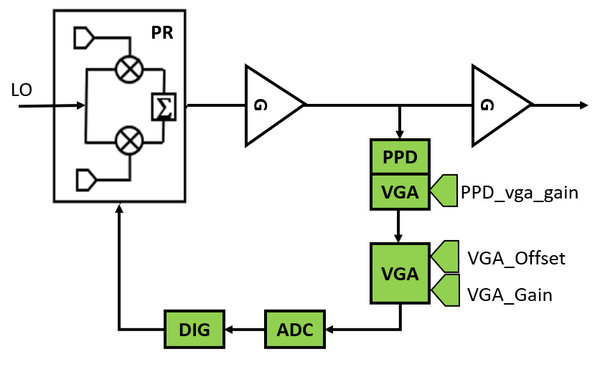

Figure 14:PR calibration block diagram

PPD_VGA is used for phase rotator calibration and also for other measurement such as TX power calibration. During Phase rotator calibration the PPD_VGA gain is controlled by SPI bit VGA_PPD_PHASE. Outside from the PR calibration, the PPD_VGA gain is controlled by SPI bit VGA_PPD_POWER. The PPD VGA gain shall be forced through VGA_PPD_GAIN_FORCE when VGA_PPD_GAIN_FORCE_SEL=1

The second VGA shall be tunable in Gain and offset. The second VGA shall only be used during the Phase rotator calibration.

The offset of the second VGA shall be defined during the PR autonomous calibration. The offset shall nevertheless be force by SPI bits VGA_OFFSET_FORCE when VGA_OFFSET_FORCE_SEL=1.

The gain of the second VGA shall be updated along the Phase rotator calibration. When in VGA_INIT state the gain shall be controlled by VGA_INIT_VGA_GAIN. The gain shall be updated autonomously in VGA_Gain state. The gain shall nevertheless be forced by SPI bits VGA_GAIN_FORCE when VGA_GAIN_FORCE_SEL=1.

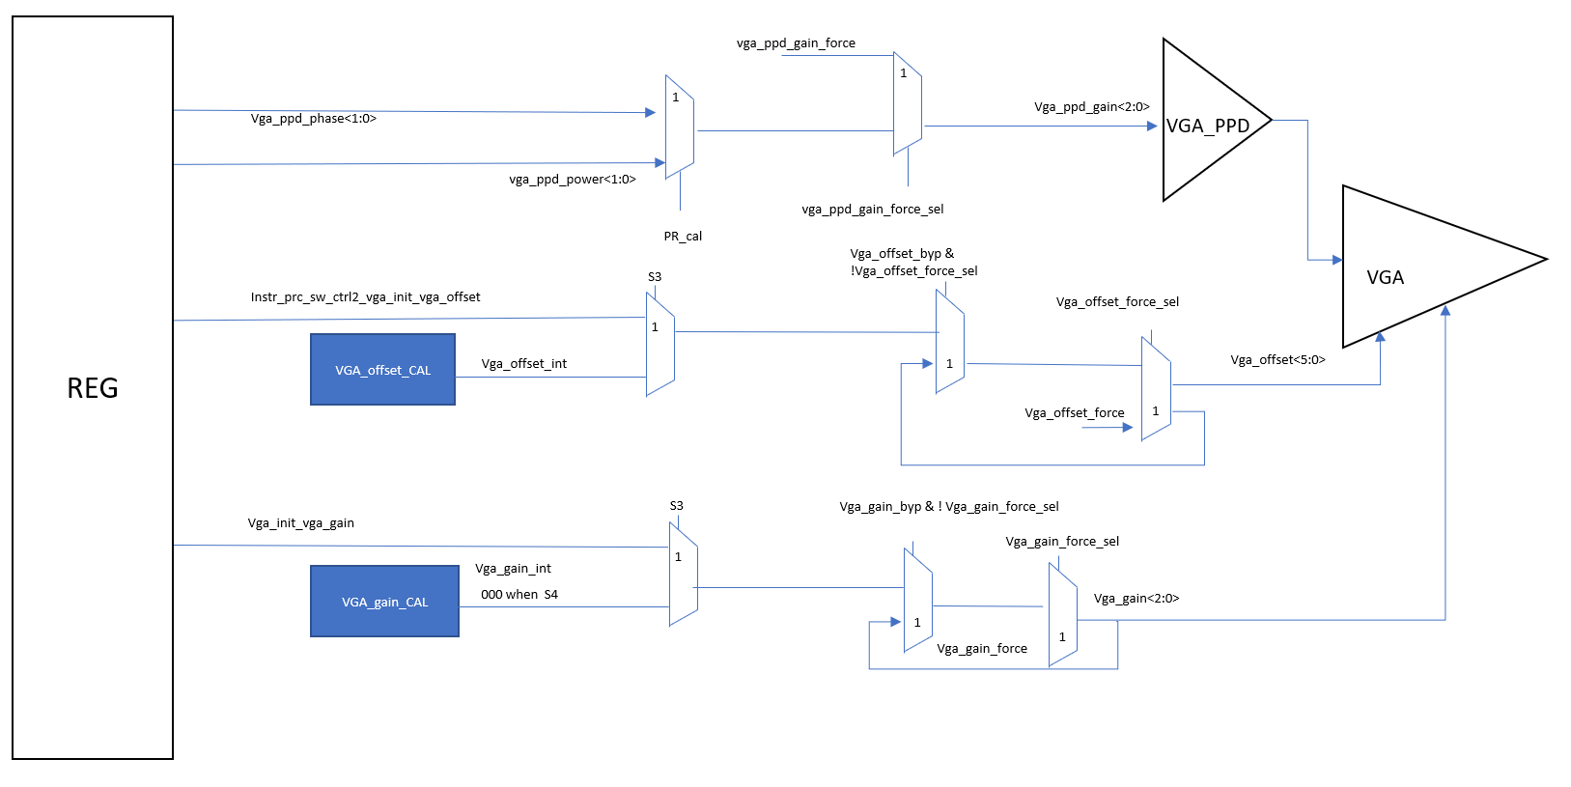

Figure 15:VGA control on PR calibration path

## PR phase Calibration FSM states

The Phase rotator calibration is driven by an internal FSM. The calibration needs 10 states to work in an optimized way. Each of the state can be bypassed. In case the state is bypassed and in case this is a calibration state (providing calibration results), the result of the calibration is unchanged unless it is forced.

The calibration starts when the timing engine activates the start_pr_cal signal. The start of the calibration can also be done through SPI and OCI. The calibration Start is managed by SPI start_cal_force when SPI bit starts_cal_force_sel=1.

At the end of the calibration a signal end_pr_cal indicates to the timing engine than the calibration is over.

A SPI bit “pr_cal_run” indicates that the calibration is in progress.

Figure 16: PR calibration FSM

### Start_CAL FSM state

#### Overview

This state allows to power up the analog module before running the calibration. Some of the analog and RF module may need some extra time to wake up. This time is programmable using SPI bit “analog_startup_timer”

Analog_startup_timer shall be programmed by step of 25ns

This value such as the ADC timing values shall be defined with the support of the laboratory engineers.

#### State bypass

There Is no bypass for this state, in case no need to use this timer to power up analog, it is recommended to program the “analog_startup_timer” to its minimum value.

#### State duration

The state duration shall be 25ns*(Analog_startup_timer+2)

### ADC_AVE FSM state

#### Overview

ADC_AVE is a state of the FSM during which a calibration is done .

ADC averaging consists in determining the number of ADC measurement "cal_out_rd" needed to get an accurate ADC measurement.

The averaging is needed to decrease the noise contribution of the RF chain.

The result of the calibration is reported with cal_out_rd SPI register.

The result of the calibration shall be 1, 2, 4, 8 or 16 which indicates the number of needed ADC measurements.

Other states of the FSM related to the phase rotator calibration shall perform "av_cal_out_rd" number of ADC measurement each time a measurement is needed.

By default, "ADC_AVE" state is bypassed to avoid variation in the calibration time along the radar process. The default value is 8, indicating that 8 ADC successive measurement are needed to average properly the measurement result.

The state is bypass to guaranty a constant time of the full calibration

#### Calibration forced result

The calibration result shall be forced when SPI bit av_force_sel=1 .

When av_force_sel=1 the result of the calibration is programmed thought SPI register av_calout_force

#### State bypass

This calibration shall be bypassed when SPI bit byp_ppd_averaging=1.by default the state is bypass

When the calibration is bypassed the result of the calibration is unchanged compare to what it was before entering the "ADC_AVE" state under the condition that the calibration is not forced.

#### State duration

When not bypassed ,the state duration shall

Duration=(timer_cdic_conv_ready+2)*25 +(timer_adc_cycle+1)*16*25+300

When bypassed the state duration shall be 25ns

### VGA_INIT FSM state

#### Overview

"VGA_INIT” is a state of the FSM during which 16 phases codes are swept, and ADC output are processed. VGA_INIT is a state during which 3 parameters are defined:

* vga_phi_code_rd used in next VGA_OFFSET state
* vga_phi_code_max_rd used in next VGA_OFFSET state
* vga_phi_code_min_rd used in next VGA_OFFSET state

When the state machine is stop at the end of VGA_INIT state the 16 ADC outputs shall be accessible using SPI read bit ppd_meas1, ppd_meas2, ppd_meas3, … ppd_meas16.

vga_phi_code_rd shall correspond to 1 of the 16-phase code that have been swept

vga_phi_code_rd shall correspond to the phase code that give the ADC value the closest to the mid ripple during VGA_INIT

vga_phi_code_min_rd shall correspond to 1 of the 16-phase code that have been swept

vga_phi_code_min_rd shall correspond to the phase code that give the ADC min value during VGA_INIT state

vga_phi_code_max_rd shall correspond to 1 of the 16 phase code that have been swept

vga_phi_code_max_rd shall correspond to the phase code that give the ADC max value during VGA_INIT state

ripple_min_rd and ripple_max_rd shall give the ADC output corresponding respectively to vga_phi_code_min_rd and vga_phi_code_max_rd

vga_init_vga_offset SPI bits shall control the offset of the DAC of the 2nd VGA during VGA_INIT state

vga_init_vga_gain SPI bits shall control the gain of the DAC of the 2nd VGA during VGA_INIT state

vga_ppd_phase SPI bits shall control the gain of the VGA_PPD during VGA_init state

vga_init_vga_offset , vga_init_vga_gain , vga_ppd_phase shall be programmed so that information of the ripple is meaningful at ADC output during VGA_INIT state. Default values have been defined based on simulations. Nevertheless, depending on the impairments and PVT variation of the analog part it may happens that those value have to be tuned.

analysis of the ripple during VGA_INIT state shall be done by stopping the FSM in VGA_INIT and analyzing the 16 ADC measurements through the SPI bits PPD_MEAS1 to PPD_MEAS16.

#### Calibration forced result

vga_offset_cal_phi_code shall be overwritten by SPI bit vga_offset_cal_phi_code_force when SPI bit vga_offset_cal_phi_code_sel shall be set to 1. The applied phase on CORDIC shall be (vga_offset_cal_phi_code_force*2^10)*360/2^16 degrees.

#### State bypass

The state shall be bypass when SPI bit byp_vga_init=1

#### State duration

When not bypassed ,the state duration shall

Duration=((timer_cdic_conv_ready+2)*25 +(timer_adc_cycle+1)*calout_rd*25 +675)+((timer_cdic_conv_ready+1)*25 +(timer_adc_cycle+1)* calout_rd *25+675)*15

When bypassed the state duration shall be 25ns

### VGA_Offset FSM state

#### Overview

“VGA_offset_cal” is a state of the FSM during which a calibration is done . Aim of the calibration is to find optimized offset settings of the second VGA (pr_vga_offset interface signal) so that the ADC is used in an efficient way.

Once the vga_offset calibration is over a second action shall done during VGA_OFFSET state. it consists in determining the phase code vga_gain_cal_phi_code that shall be used during next state VGA_GAIN state.

Result of the calibration shall be stored in vga_offset_rd .

At the end of the “vga_offset_cal” state, the ADC measurement is stored within SPI status bit meas_vga_offset_rd.

The meas_vga_offset_rd measurement shall be close to ADC mid value of 1023 LSB at the end of the “vga_offset_cal” state.

During "VGA_offset_cal" shall also be determined the phase (vga_gain_cal_phi_code) that shall be used during "vga_gain_cal" FSM state.

Vga_gain_cal_phi_code shall be readable through vga_gain_cal_phi_code_rd SPI bit

Vga_gain_cal_phi_code shall be one of the 16 phases code used during the vga_init state calibration

Vga_gain_cal_phi_code shall be computed during vga_offset_cal state using results vga_phi_code_max_rd and vga_phi_code_min_rd from VGA_GAIN_INIT state.

Vga_gain_cal_phi_code  shall be vga_phi_code_min_rd  if   adc_output(vga_phi_code_min_rd)<  [2047- adc_output(vga_phi_code_max_rd)]  otherwise vga_gain_cal_phi_code shall be vga_phi_code_max_rd

#### Calibration forced result

vga_gain_cal_phi_code shall be overwritten by SPI bit vga_gain_cal_phi_code_force when SPI bit vga_gain_cal_phi_code_sel shall be set to 1. The applied phase on CORDIC shall be (vga_gain_cal_phi_code_force*2^10)*360/2^16 degrees.

vga_offset calibration result shall be overwritten by SPI bit vga_offset_force when SPI bit

#### State bypass

The calibration shall be bypassed when SPI bit byp_vga_offset=1

If VGA_OFFSET is bypassed, VGA_GAIN must be bypassed as well (there is no mechanism to choose via registers if upper or lower threshold will be selected for calibration).

#### State duration

The "VGA_offset" calibration duration shall be constant.

When not bypassed ,the state duration shall

Duration=((timer_cdic_conv_ready+2)*25 +(timer_adc_cycle+1)* calout_rd *25 +300)+((timer_cdic_conv_ready+1)*25 +(timer_adc_cycle+1)* calout_rd *25+300)*8

### VGA_Gain FSM state

#### Overview

“VGA_gain_cal” is a state of the FSM during which a calibration is done. Aim of the calibration is to find optimized Gain settings of the VGA (vga_gain_ctrl) so that the ADC is used in an efficient way.

The intend of the calibration is to set the output of the ADC within a defined range using information from vga_gain_cal_phi_code_ripple_max and vga_gain_cal_phi_code_ripple_min from VGA_OFFSET state. The range is defined by SPI bit Vga_gain_min_th, Vga_gain_max_th

Result of the calibration shall be stored in vga_gain_rd.

The VGA gain shall amplify the corresponding PPD output to values close to the ADC full-scale

Vga_gain_min_th SPI bit shall define the ADC output low limit for the VGA gain calibration

Vga_gain_max_th SPI bit shall define the ADC output high limit for the VGA gain calibration

Vga_gain_max_th shall be programmed greater than Vga_gain_min_th

In case ripple_min_rd  < (2047-ripple_max_rd) the gain of the calibration shall be higher as possible and adc output shall exceed vga_gain_min_th

In case ripple_min_rd  >= (2047-ripple_max_rd) the gain of the calibration shall be higher as possible but adc output shall  not exceed vga_gain_max_th

#### Calibration forced result

The result of the VGA calibration shall be overwritten by the vga_gain_force SPI register when the vga_gain_force_sel SPI bit is '1'.

#### State bypass

The state shall be bypassed when SPI bit byp_vga_gain=1

#### State duration

When not bypassed, the state duration shall

Duration=((timer_cdic_conv_ready+2)*25 +(timer_adc_cycle+1)*calout_rd*25 +300)+((timer_cdic_conv_ready+1)*25 +(timer_adc_cycle+1)*calout_rd*25+300)*3"

When bypassed the state duration shall be 25ns

### PR_OFFSET_CAL FSM state

#### Overview

PR_offset_cal” is a state of the FSM during which a calibration is done . Aim of the calibration is to compensate the offset between I and Q path . Offset may come from the DAC , mixers, branch line coupler …The compensation is digitally applied at the DAC inputs.

A mechanism has been added to avoid the saturation of the DACs .

In case the sum of the offset compensation and CORDIC output do not belong to [-128: 128] LSB , the gain of the CORDIC shall be automatically decrease so that the adder output adder_out_i and adder_out_q shall always belong to [-128:128] LSB"

Result of the calibration are stored in SPI register offset_cal_ioffset_code_rd, offset_cal_qoffset_code_rd , offset_cal_Igain_code_rd, offset_cal_Igain_code_rd

.

#### Calibration forced result

result of the calibration, offset_cal_Ioffset_code shall be overwritten by the offset_Ioffset_code _force SPI register when the PPD_offset _force_sel SPI bit is '1'

result of the calibration, offset_cal_Igain_code shall be overwritten by the offset_Igain_code_force SPI register when the PPD_offset _force_sel SPI bit is '1'

result of the calibration offset_cal_Qoffset_code shall be overwritten by the offset_Qoffset_code_force SPI register when the PPD_offset _force_sel SPI bit is '1'.

result of the calibration offset_cal_Igain_code shall be overwritten by the offset_Igain_code _force SPI register when the PPD_offset _force_sel SPI bit is '1'.

OCAL_PPD0_RD, OCAL_PPD90_RD, OCAL_PPD180_RD, OCAL_PPD270_RD SPI bit shall be used to observe the convergence of the binary search. At the end of the Offset calibration OCAL_PPD0_RD shall be close to OCAL_PPD180_RD while OCAL_PPD90_RD shall be close to OCAL_PPD270_RD

#### State bypass

The state shall be bypass when SPI bit byp_pr_offset

#### State duration

"When not bypassed ,the state duration shall

Duration=((timer_cdic_conv_ready+2)*25 +(timer_adc_cycle+1)*calout_rd*25 +300)+((timer_cdic_conv_ready+1)*25 +(timer_adc_cycle+1)*calout_rd*25+300)*27"

When bypassed the state duration shall be 25ns

### GPATH_SEL FSM state

#### Overview

“GPATH_SEL “ is a state of the FSM during which a calibration is done. The goal is to determine which of I and Q path has the highest gain and will be used for gain compensation.

The calibration output hall be stored in gpath_sel_rd

When gpath_sel_rd ="01" , the phase and gain imbalance of the I path shall be compensated.

When gpath_sel_rd="10" the phase and gain imbalance of the Q path shall be compensated.

If the RF Phase Rotator Gain imbalance (ratio Q/I) is > 0 the gain compensation shall be applied on Q during the PR_GAIN_CAL.

If the RF Phase Rotator Gain imbalance (ratio Q/I) is < 0 the gain compensation shall be applied on I during the PR_GAIN_CAL.

PPD measurement when phase is 0 and 90 degrees shall be respectively read back with SPI bit gpath_sel_ppd0_rd, gpath_sel_ppd90_rd

#### Calibration forced result

Result of the calibration shall be overwritten by gpath_sel_force SPI bits when gpath_sel_force_sel = 1

#### State bypass

The state shall be bypassed when SPI bit byp_gpath_sel=1

#### State duration

When not bypassed ,the state duration shall

Duration=((timer_cdic_conv_ready+2)*25 +(timer_adc_cycle+1)*calout_rd*25 +300)+((timer_cdic_conv_ready+1)*25 +(timer_adc_cycle+1)*calout_rd*25+300)*1

When bypassed the state duration shall be 25ns

### PR_GAIN_CAL FSM state

#### Overview

PR_gain_cal is a state of the FSM during which a calibration is done . Aim of the calibrations is to compensate the gain imbalance between I and Q path. Gain imbalance may comes from the DAC or PR.

Result of the calibration shall be stored in gain_comp_i_rd and gain_comp_q_rd which are respectively the compensation gain of the I and Q path

For better efficiency of the calibration , the binary search shall start using a programmable gain value. This value shall be defined by SPI bit Gain_cal_init . The default value is h'1770 corresponding to -2.7dB of the fullscale.

#### Calibration forced result

The d_gain_comp_i  shall be overwritten by the gain_comp_force_i  SPI register when the force_gain_comp_i_sel  SPI bit is '1'.

The d_gain_comp_q shall be overwritten by the gain_comp_force_q SPI register when the force_gain_comp_q_sel SPI bit is '1'.

#### State bypass

The state shall be bypass when SPI bit byp_pr_gain=1

#### State duration

"When not bypassed ,the state duration shall

Duration=((timer_cdic_conv_ready+2)*25 +(timer_adc_cycle+1)* calout_rd *25 +300)+((timer_cdic_conv_ready+1)*25 +(timer_adc_cycle+1)* calout_rd *25+300)*14"

When bypassed the state duration shall be 25ns

### PR PHASE IMBALANCE CAL FSM state

#### Overview

PR_phase_cal is a state of the FSM during which a calibration is done . Aim of the calibrations is to compensate the phase imbalance between I and Q path. Phase imbalance may come from the DAC or PR.

Result of the calibration shall be stored in phase_comp_i_rd and phase_comp_q_rd SPI register which value shall be added respectively to the phase of the I and Q path.

The path to be compensated shall be defined by SPI bit phase_branch_sel . By default the Q path shall be compensated in phase.

#### Calibration forced result

The phase_comp_i_rd shall be overwritten by the phase_comp_force_I SPI register when the phase_comp_i_sel SPI bit is '1'

The phase_comp_q_rd shall be overwritten by the phase_comp_force_q SPI register when the phase_comp_q_sel SPI bit is '1'.

#### State bypass

The state shall be bypassed when SPI bit byp_pr_phase=1

#### State duration

When not bypassed ,the state duration shall

Duration=((timer_cdic_conv_ready+2)*25 +(timer_adc_cycle+1)*calout_rd*25 +300)+((timer_cdic_conv_ready+1)*25 +(timer_adc_cycle+1)*calout_rd*25+300)*15

When bypassed the state duration shall be 25ns

### END_CAL

End_cal state is a state where the signal end_pr_cal is generated. This signal indicate to the timing engine than the overall calibration is over.

#### State duration

The state is 75ns.

## Automatic calibration

The self-autonomous calibration is initiated when start_pr_cal signal is 1.

Start_pr_cal is initiated by:

* The Timing engine
* Through SPI: set start_cal_force to 1 when SPI bit start_cal_force_sel=1
* Through OCI.

## Manual calibration

The manual calibration shall be performed in IDLE mode of the Local TX FSM.

A manual calibration shall be exercised by forcing the Offset , Gain imbalance , Phase imbalance compensation and the Phase rotator DAC inputs.

### Phase rotator DACs input force

The DACs inputs shall be controlled by either forcing the thermometer encoder inputs or more easily by forcing the CORDIC input.

CORDIC has 3 input parameter, phase(phi_code_i/q), phase_init(d_phi_init_i/q), gain(d_gain_i/q) which all can be forced.

CORDIC_I output is cdic_out_i signal

Cordic output shall be described by cdic_out_i = [d_gain_i / 2^6]*cos( ( phi_code_i+ d_phi_init_i)*2*pi/2^16) whatever the state of the FSM is.

CORDIC_Q output is cdic_out_q signal.

Cordic output shall be described by cdic_out_q = [d_gain_q / 2^6]*sin( ( phi_code_q+ d_phi_init_q)*2*pi/2^16) whatever the state of the FSM is.

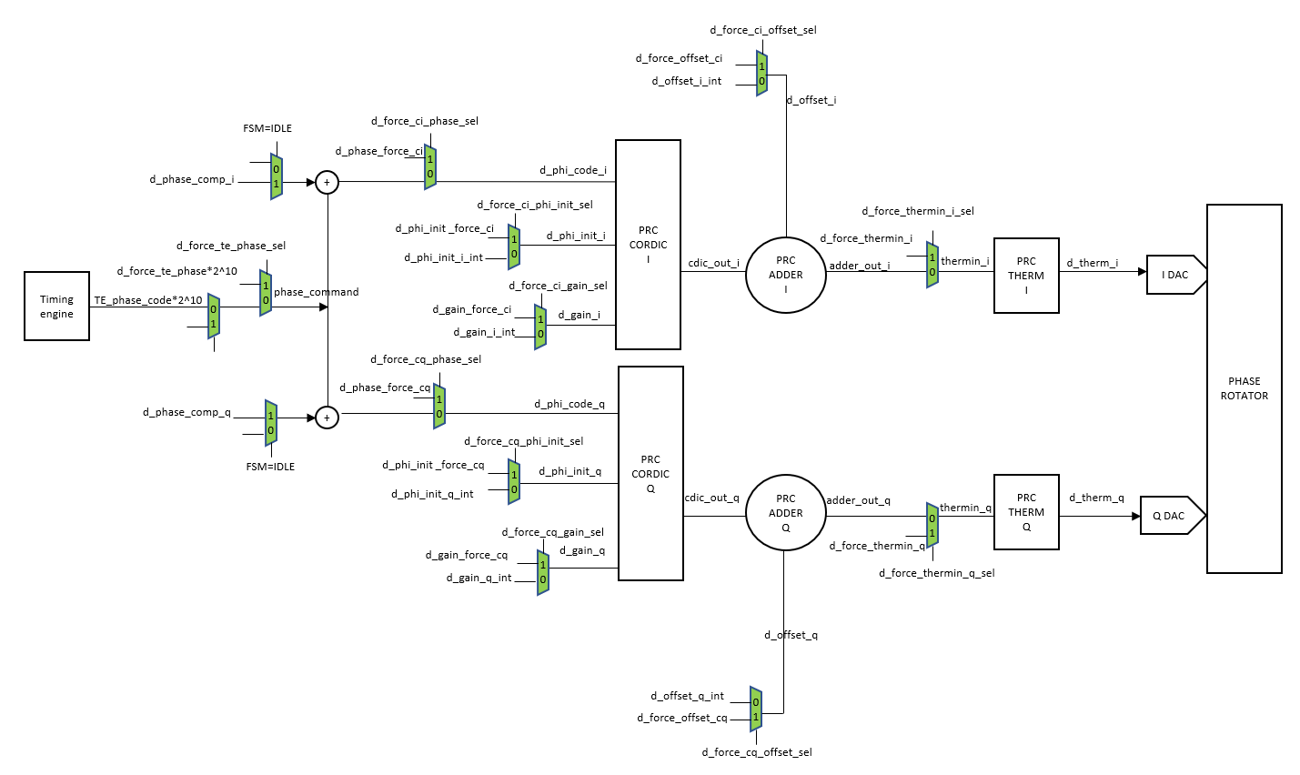d_gain_i/q, phi_code_i/q, d_phi_init_i/q shall be forced through SPI as described on diagram.

Figure 17: TXDIG forced signals

### Compensation force

All compensation results shall be forced by SPI bits . Description of the forced compensation has been described in chapter 8.3.2.2 , 8.3.3.2, 8.3.4.2, 8.3.5.2, 8.3.6.2, 8.3.7.2, 8.3.8.2, 8.3.9.2

## Calibration time

The Phase rotator calibration time shall be programmable.

SPI bit analog_startup shall define the time to power up analog module in case they are not.

SPI bit timer_cdic_conv_ready shall define the time need to pass the phase through the digital

SPI bit timer_adc_cycle shall define the clock period of the measurement.(so also the ADC clock period)

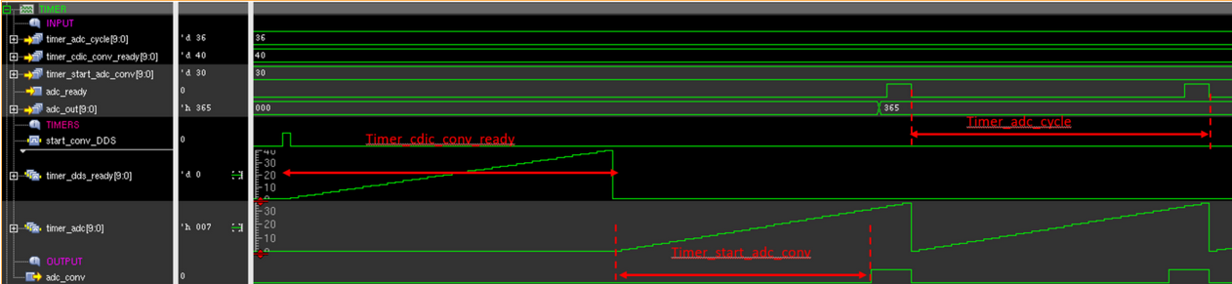

Figure 18: Calibration time parameter

The calibration time shall be defined using the document [STRX_calibration_time](https://www.collabnet.nxp.com/sf/go/doc500060?nav=1&pagenum=1&pagesize=15)

A detailed description of the calibration time per state of the FSM is described in the FSM chapter.

# TX PA Power control

Control of the TX power is done through profile registers. Registers are located in [GDLO digital reg](https://www.collabnet.nxp.com/sf/go/doc437493?nav=1&pagenum=1&pagesize=15)ister map and [TX digital register map](https://www.collabnet.nxp.com/sf/docman/do/viewDocument/projects.smarttrx/docman.root.es0.011_ic_architecture_design_and_i.non_fdo_documents.rfe.ip_rtl_dev_automation.reg_map_xls_for_all_ips/doc437607?_message=1600332092308) .

Chapter 2.7.4 of the [GLDO digital design](https://www.collabnet.nxp.com/sf/go/doc486548) documentation details the GLDO profiles bits and bypass mechanism.

Table 5: TX PA power control registers

|  |  |  |
| --- | --- | --- |
| **Interface analog name** | **DIG SPI** | **Digital module** |
| From GLDO dig | PROG_OUT_GLD1V3<4:0> | GLDO profile |
| From GLDO dig | SETDC_BG_GLD1V3<3:0> | GLDO profile |
| d_dac_stage1_ctrl<4:0> | instr_power_st1_c | TX profile |
| d_dac_stage2_ctrl<4:0> | instr_power_st2_c | TX profile |

The GDLO profile (PROG_OUT_GLD1V3, SETDC_BG_GLD1V3) can be used for changing the TX power from chirp-to-chirp in combination with a chirp interval timing which allows for settling of the GLDO2.

This profile can also be used for changing the TX power from frame to frame with a frame interval timing which allows for settling of the GLDO2.

It is important to make use of the bypass switch for the Low-noise filter so that the settling time is in the order of 50us instead of 2.5ms.

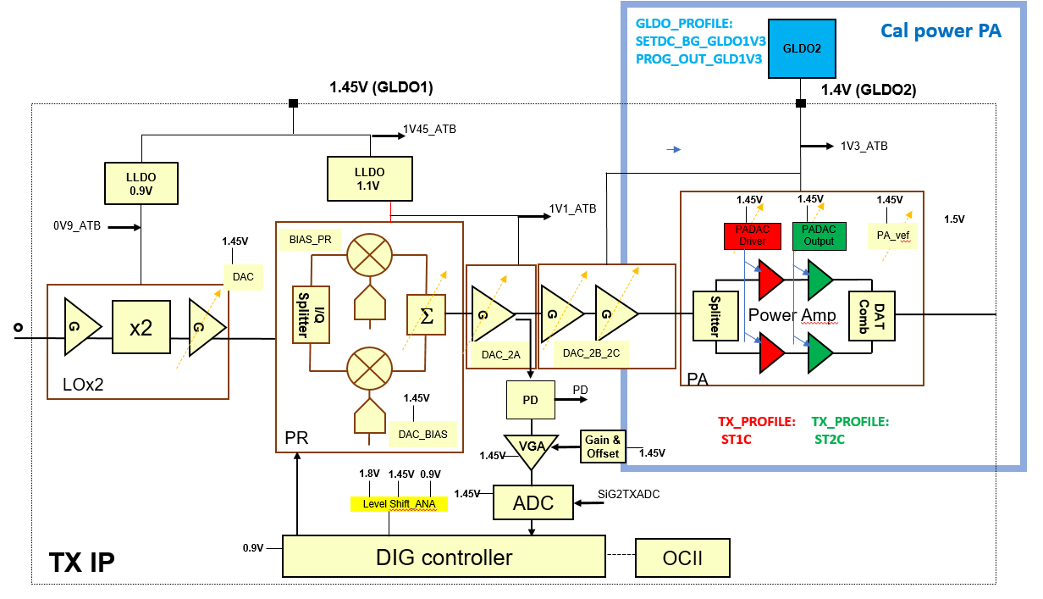

Figure 19: TX PA control in TX

By default, the 4 TX PA power settings are identical. Nevertheless, an option exists to fine tune the PA power per individual TX channel over a small range using the PA-DAC and the worst case situation would be that a different PA-DAC setting is needed for different power levels. TX profile (st1_c, st2_c) shall be used to individually fine tune the PA power

It has to be notified that cascode control st1_v, st2_v from TX profile are no longer used.

# TX safety

Safety of the TX is managed through software during IDLE state of the TX FSM

## Real time monitoring

### RTM description

This safety mechanism shall be done inside TX hardware.

A Realtime power monitoring is implemented in the transmitter to fulfill the safety requirement at system level. The error flag is sent to the inner safety monitor. The architecture is a mixed architecture with on analog side a power detector a VGA, a 6 bits reference voltage DAC to set the safety threshold and a comparator and with on digital side a mechanism to post process the comparator output. The post processing of the comparator output is done by a FIR. The latch is implemented in the digital . The FIR shall average the noise from the PPD/VGA and is acting as deglitcher.

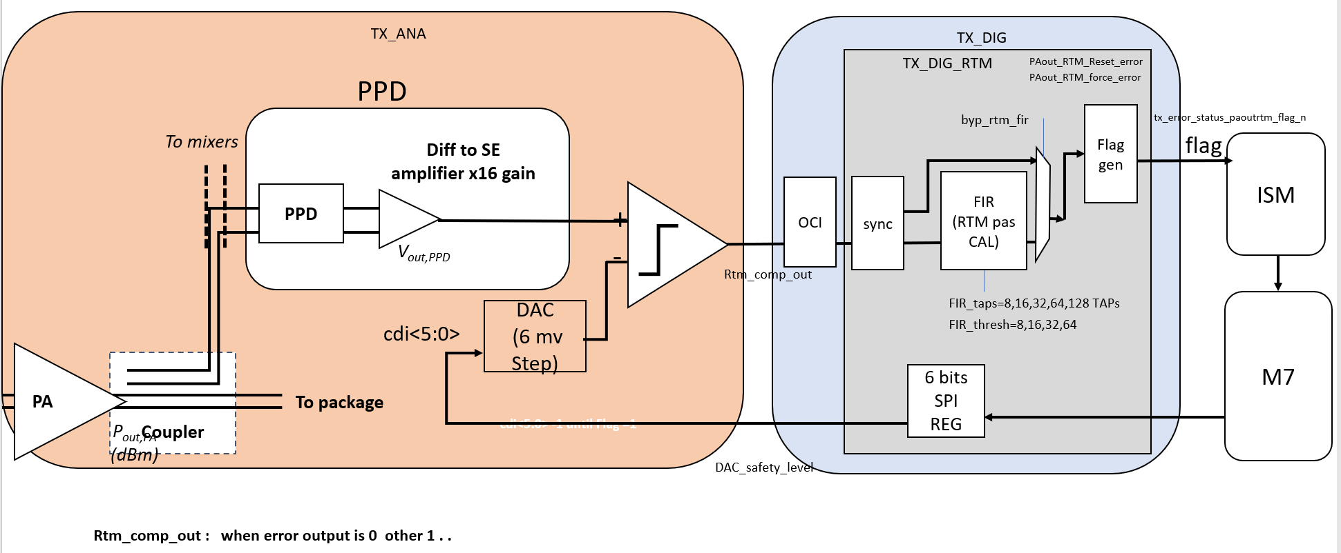

Figure 20: Real time monitoring block diagram

FIR_TAPS shall be programmable and shall define the number of comparator outputs (sampled at 40MHz) that shall be summed for Flag generation.

FIR_THRESH shall be programmable and shall defined the threshold for safety flag generation.

TX_DIG_RTM module shall be a TX_DIG submodule

Aim of the TX_DIG_RTM shall be to process the data coming from the analog comparator .

The comparator shall compare the output of the PPD_VGA with a reference. A SW calibration is needed to define the reference of the comparator.

The reference/threshold shall be calibrated by SW prior to start the safety mechanism .

**Threshold calibration:**

• The threshold is calibrated in SW.

• THE FIR shall be bypassed byp_fir=1

• PA shall be programmed 3dB lower than expected power.

• DAC current shall be set by SW to its max value and decrease until comparator output toggle.

**Flag generation:**

The digital safety mechanism (post process of the comparator output) shall be enabled through EN_RTM SPI bit.

The analog signal d_realtime_mon_error is the comparator output and shall be resampled on a 40Mhz clock in TXDIG.

The FIR inside the safety mechanism shall be bypassed by settings byp_fir=1

When byp_fir=1 the comparator output is not averaged.

When byp_fir=1 the latency time between the analog comparator output d_realtime_mon_error and tx_paout_rtm_error_flag_n shall have a minimum value between 0 and 1 clock cycles

When byp_fir=0 the latency time between the analog comparator output d_realtime_mon_error and tx_paout_rtm_error_flag_n shall have a minimum value between (FIR_TAPS+FIR_THRESH) and (FIR_TAPS+FIR_THRESH+1) clock cycles

The FIR output shall be the sum of the N successive FIR input bits where N is defined by the FIR_TAPs

The TX PAout RTM safety DAC shall be controlled by SPI bit DAC_sfty_level

A flag tx_paout_rtm_error_flag_n shall be asserted ( tx_paout_rtm_error_flag_n=0) when the sum of FIR_TAPS comparator outputs shall be greater or equal to FIR_thresh programmed value after a defined latency time.

The Paout RTM flag tx_paout_rtm_error_flag_n shall be reported in PAOUT_RTM_ERR_FLAG SPI bit

The Paout RTM flag shall be send to the ISM.

### RTM Mask

Register MASK_ISM_FORCE_ERROR/ BBD_ERR masks the force_error generated by the SW towards the ISM.

Register MASK_ISM_RESET_ERROR/BBD_ERR masks the reset_error generated by the SW towards the ISM

Register MASK_ISM_ERROR_FLAG/BBD_ERR masks the flag which are not forwarded to the ISM

### RTM FIT

The PA output force error shall not force the safety flag directly. the PA output force error signal shall force the threshold of the analog comparator to its highest value. The power shall be then below this threshold and then a flag shall be generated in the analog module

The PA output reset error shall force the flag and also the level of the threshold of the analog comparator to its lower value to be sure the flag is not re-asserted automatically

The force and reset of the PA output power safety mechanism is depicted Figure 14: RTM FIT sequence.

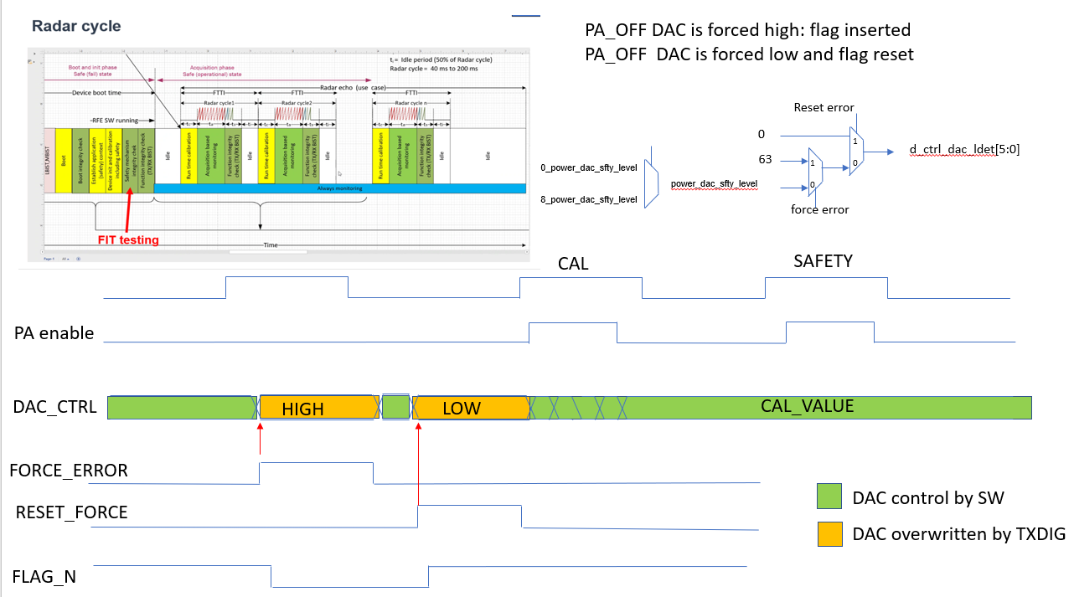

Figure 21: RTM FIT sequence

FUSA related SPI bits within register mask_ism_force_error, mask_ism_reset_error, mask_ism_error_flag, test_force_error, test_reset_error, error_status and associated mechanism shall follow requirement from the CTRL_TOP module

Force_error, reset error shall operate as described in the CTRL_TOP generic module

 In case the TE is not driving the TX through Tx_enable during FIT, CLK_free running clock has to be set to 1

## Ball break detector

This safety mechanism shall be done inside TX hardware.

### BBD description

A ball break detector is implemented in the transmitter to fulfill the safety requirement at system level.

The BBD is used for safety purpose in order to check the state of the solder ball contacting the package and the PCB. Correct operation of the BBD requires that the antenna at PCB side should shorted to ground through quarter-wavelength stub. The BBD is composed with two comparators, current sources and control logic. The current sources push a DC current on both differential paths of the TX (RF_P & RF_N) to reach the ground of the quarter-wavelength stub passing through a balun implemented in the package to convert the differential signal from the TX output to a single ended at antenna reference plane. During its flowing, the DC current will interact with the ball giving dropped voltage whose value is depending on the state of the solder ball. This value is then compared using the two compactors, the positive input of each comparator being connected to a given RF path (RF_P or RF_N). The negative input of the comparators is driven by a reference voltage generated internally by the BBD. The output of the comparators is combined through the logic control to provide the output flag of the BBD. When the solder ball is broken the flag will be low logic state, whereas, for normal operation the flag still at high state. The flag is latched internally by the logic control; therefore, a reset signal could be applied to the BBD in order to erase the former state.

Figure 22: ball break detector

The error flag is sent to the inner safety monitor.

A SPI bit BBD_err_flag shall be asserted ( bbd_error_flag_n=0) when ball break is happening.

### BBD Mask

Register MASK_ISM_FORCE_ERROR/ BBD_ERR masks the force_error generated by the SW towards the ISM.

Register MASK_ISM_RESET_ERROR/BBD_ERR masks the reset_error generated by the SW towards the ISM

Register MASK_ISM_ERROR_FLAG/BBD_ERR masks the flag and that shall not be forwarded to the ISM

### BBD FIT

Fault injection test shall be introduced in the safety BBD mechanism by activating SPI bit TEST_FORCE_ERROR/ BBD_ERR_FORCE. When BBD_ERR_FORCE=1,

The principle of the fault injection is to create a real fault inside the BBD. By setting SPI bit bbd_err_force=1, the positive input of both comparators becomes higher than the negative input (driven by the reference voltage), therefore, the comparator output is high leading to flag the BBD output (low logic state).

## CRC REGISTER

### CRC REGISTER description

Those safety mechanism shall be done inside TX hardware.

CRC Register safety check guaranty the content of the register along the time. It prevents from a bit flip by example.

A CRC reference code is generated using the internal TXDIG CRC engine at reset and each time a new SPI write is done. When CRC_CHECK_TR_CTL=1, TXDIG CRC engine is generating a second code which is compared to the reference code.

A safety flag is asserted when the reference value is different from the newly calculated value indicating a flip of one or several bits.

The flag is located in SPI register ERROR_STATUS/CRC_ERR_FLAG

### CRC Mask

Register MASK_ISM_FORCE_ERROR/ CRC_ERR masks the force_error generated by the SW towards the ISM.

Register MASK_ISM_RESET_ERROR/CRC_ERR masks the reset_error generated by the SW towards the ISM

Register MASK_ISM_ERROR_FLAG/CRC_ERR masks the flag and that shall not be forwarded to the ISM

## CRC MISO

### CRC MISO description

CRC MISO safety check guaranty the write SPI communication protocol. M7 is generating a CRC reference code which is send to through the SPI communication to TXDIG. TXDIG decode the SPI protocol and compute a CRC code using its internal CRC engine.

A safety flag is asserted when the reference value is different from the newly calculated value indicating a wrong transmission of the data through the SP write.

The flag is located in SPI register ERROR_STATUS/MISO_CRC_ERR.

### CRC MISO MASK

Register MASK_ISM_FORCE_ERROR/ MISO_CRC_ERR masks the force_error generated by the SW towards the ISM.

Register MASK_ISM_RESET_ERROR/MISO_CRC_ERR masks the reset_error generated by the SW towards the ISM.

Register MASK_ISM_ERROR_FLAG/MIOS_CRC_ERR masks the flag and that shall not be forwarded to the ISM.

## CRC MOSI

### CRC MISO description

CRC MISO safety check guaranty the read SPI communication protocol. TXDIG is generating a CRC reference code which is send to through the SPI communication to M7. M7 decodes the SPI protocol and compute a CRC code using its internal CRC engine.

A safety flag is asserted when the reference value is different from the newly calculated value indicating a wrong transmission of the data through the SP write.

The flag is located in SPI register ERROR_STATUS/MOSI_CRC_ERR

### CRC MISO MASK

Register MASK_ISM_FORCE_ERROR/ MOSI_CRC_ERR masks the force_error generated by the SW towards the ISM.

Register MASK_ISM_RESET_ERROR/MOSI_CRC_ERR masks the reset_error generated by the SW towards the ISM.

Register MASK_ISM_ERROR_FLAG/MOSI_CRC_ERR masks the flag and that shall not be forwarded to the ISM.

## TX INL/DNL

### TX INL description

This safety mechanism shall be done through SW programming.

TX phase step measurement is used to perform INL and DNL.

The TX phase step measurement is done using a second TX and the TXBIST .

The principle is described in the TXBIST Architecture specification.

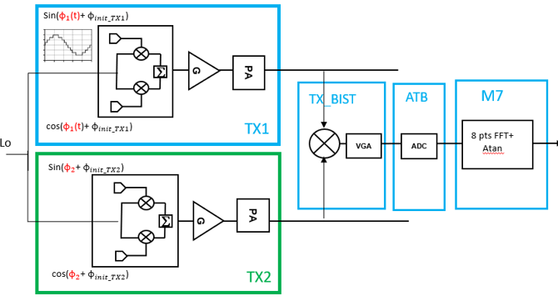

Figure 23:TX INL/DNL

TX and TXBIST module shall be enabled using SPI registers described in the TX register map document.

8 phase shall be programmed on the TX under test . As example = .

For each of those 8 phases programmed on the TX under test , N phases shall be programmed on the second TX with as constraint to describe a periodic sinewave at the Cordic output. As example, whenN=8, = so that cos(

8 FFT and post processing shall provide 8 phases measurement in M7. Those Phase shall be used to compute INL and DNL according to the below equations :

The DNL shall be defined as : DNL = [(PhaseD+1- PhaseD)-Phasedelta_IDEAL ] where PhaseD is the measurement of the phase.

The INL shall be defined as : INL=max [(PhaseD+1- Phaseideal)]

Both TX phase shall be programmed through SPI bit d_force_te_phase when SPI bit d_force_te_phase_sel=1.

Phase_in_degrees= d_force_te_phase*360/2^7

The post processing is done in M7 which assert a flag in case the phase step is higher than a define M7 threshold.

### TX INL MASK

No mask in the TX digital has the flag is managed through SW.

### TX INL FIT

The safety mechanism is measuring 8 output phases corresponding to 8 TX digital input phase= . Each of the 8 inputs phases are passed through a CORDIC algorithm. The CORDIC algorithm has 3 inputs. The phase (, the gain(G) and a phase init ( ). The output of the CORDIC shall be G*cos(

A Fault injection shall be introduced by corrupting one of the phase_init. By default the phase init is defined by 16 SPI bit d_phi_init_ci and d_phi_init_cq all zeros. Introducing a phase init of +45 degrees on one of the 8 measurement shall inject an error.

The phase init in degrees= d_phi_init_ci/q[15:0]*360/2*16.

## TX to TX delta phase variation (TXBIST)

This safety mechanism shall be done through SW programming.

### TX to TX delta variation description

The “TX to TX delta phase variation ” safety mechanism measures the variation of the phase init between 2 TX. If the delta phase variation is higher than a defined threshold, a flag is asserted in M7.

The design under test are the 2 TXs .

The measurement mechanism is composed by the TX BIST module, the ATB ADC and post processing in the ARM7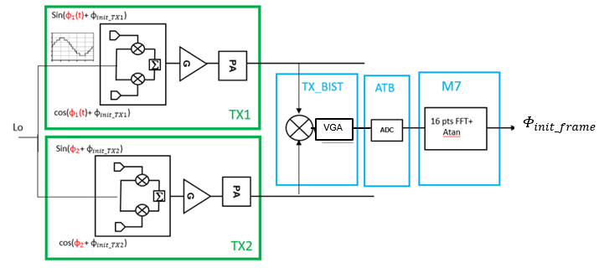

Figure 24:Tx to TX delta phase variation block diagram

Both TX phase shall be programmed through SPI bit d_force_te_phase when SPI bit d_force_te_phase_sel=1.

Phase_in_degrees= d_force_te_phase*360/2^7

The first TX is used to generate the IF. In the context of safety, the IF is described using 16 phase = . The FFT shall be done using the same number of points.

The fix phase of the second TX shall be selected in the range [0:360]º

phase init Timeframe is computed at the end of each frame in M7

The reference phase Ministered is the initial measurement of instream. This value is store and used as reference.

The delta phase is defined as the difference between timeframe computed at the end of each radar frame and the reference phase Minatare .

The delta phase variation is defined as the variation of delta phase over Radar cycle.

Delta_phase_var= var ( Φinit_frame- Φinit_ref)

### TX to TX delta variation Mask

No mask in the TX digital has the flag is managed through SW.

### TX to TX delta variation FIT

The safety mechanism is measuring the variation of the phase init from TX to TX over Radar frames.

Each of the TX has CORDIC algorithm with 3 inputs parameters. The phase (, the gain(G) and a phase init ( ). The output of the CORDIC shall be G*cos(

A Fault injection shall be introduced by corrupting one of the TX phase init between 2 radar frames. By default the phase init is defined by 16 SPI bit d_phi_init_ci and d_phi_init_cq all zeros.

The phase init in degrees= d_phi_init_ci/q[15:0]*360/2*16.

# TX & TXBIST ADC communication

TX and TXBIST module communicate with the internal TX_ADC and also the ATB1/ADC and ATB2/ADC.

Connection from TX/TXBIST to ADCs shall be controlled through SPI as depicted Figure 25: TX/TXBIST communication with ADCs

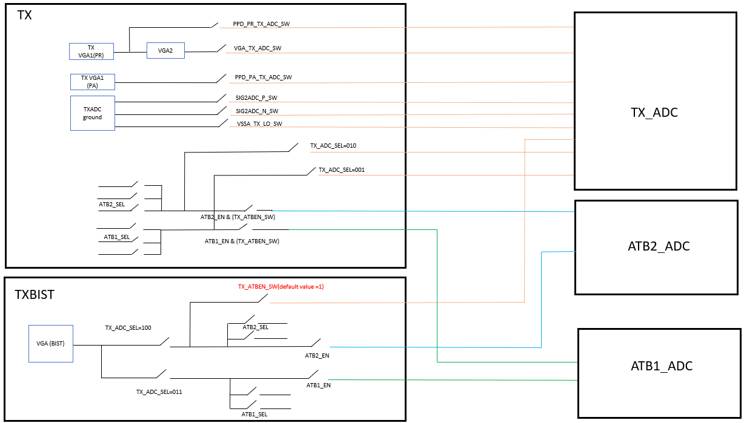

Figure 25: TX/TXBIST communication with ADCs

Note: Be careful with ES1. The Way TXBIST is communicating with ADCs may corrupt the die. When TX_ATBEN_SW=1, please be careful with how is programmed TX_ADC_SEL . This weakness shall be corrected in ES2.

#### TXADC SETTING for Phase rotator calibration

The TXDIG shall control the TX ADC clock internally. The clock do not need to be activated through SPI for the TX Phase calibration. Nevertheless some settings need to be defined .

The TXDIG shall generate a conversion pulse to the TXADC during the Phase rotator calibration. The ADC shall answer a 11bits data and an adc_ready signal

The adc_conversion pulse shall be fully programmable. Period shall be programmable through SPI bit timer_adc_cycle and duty cycle shall be programmable through SPI bit timer_start_adc_conv. Programming step is 25ns.

Timer_start_adc_conv shall be lower than timer_adc_cyle

Timer_start_adc_conv shall be the low state of the pulse.

SPI bit timer_adc_cycle shall be programmed in the range [10:800]

SPI bit timer timer_start_adc_conv shall be programmed < timer_adc_cycle

timer_adc_cycle- timer_start_adc_conv shall be programmed > 8 (200ns)

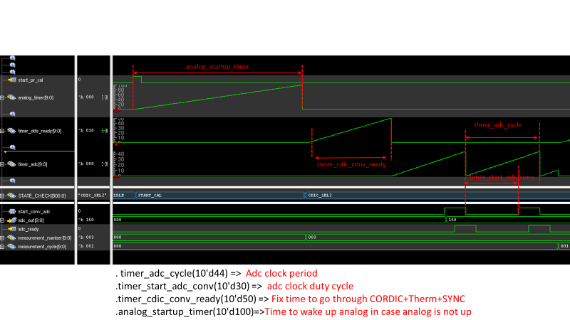timer_adc_cycle, timer_start_adc_conv, timer_cdic_conv_ready, analog_startup_timer optimum values shall be defined in lab.

Figure 26: TX ADC period and duty cycle

#### TXADC setting for other feature than PR calibration

When TX (except for autonomous phase calibration as described : TXADC SETTING for Phase rotator calibration) needs to access the TXADC , the ADC clock conversion need to be controlled through SPI.

TXADC conversion shall be initiated by SPI or OCI when outside the phase rotator calibration. The conversion shall happen when SPI bit ADC_CONV_FORCE=1 under the condition than SPI bit ADC_CONV_SEL=1. ADC_CONV_FORCE SPI bit shall remain high 200ns and shall be auto cleared.

#### TXADC setting for TXBIST.

When TXBIST needs to access the TXADC , the ADC clock conversion need to be controlled through SPI.

TXADC conversion shall be initiated by SPI or OCI when outside the phase rotator calibration. The conversion shall happen when SPI bit ADC_CONV_FORCE=1 under the condition than SPI bit ADC_CONV_SEL=1. ADC_CONV_FORCE SPI bit shall remain high 200ns and shall be auto cleared.

#### TXADC Timeout flag

A flag shall be asserted when the ADC shall not generate the expected “ready_signal”

The flag can be observed through SPI register

When the register read back value is 1, an ADC conversion has given wrong result.

# DFT

## PR DAC linearity

The PRDACs in the TX consist of 256 elements of which each can produce a unity amount of current.

This “PR DAC linearity” feature allows for measuring this current per DAC element. Actually two currents must be measured per element, the P-channel current and N-channel current. The currents can be measured by driving the PR DAC with a special control pattern. To that end, the TX Dig can generate 2x256 patterns under the control of the registers:

Table 6: DAC linearity register

|  |  |
| --- | --- |
| Register name | Function |
| PRC_DFT_ DAC_TESTMODE | 0: Normal operation, PR DAC linearity disabled  1: PR DAC linearity enabled |
| PRC_DFT_ DAC_TESTMODE_INVERTED | 0: allow measuring P-channel currents  1: allow measuring N-channel currents |
| PRC_THERM_SW_D_FORCE_THERMIN_I | 9 bit signed number, allows for measuring the current of the DAC_I elements i=0…255=n+127 by programming the value n = -127…128. |
| PRC_THERM_SW_D_FORCE_THERMIN_Q | 9 bit signed number, allows for measuring the current of the DAC_Q elements i=0…255=n+127 by programming the value n = -127…128. |

See also <https://www.collabnet.nxp.com/sf/go/artf782421>.

### P-channel current measurement-test

PRC_DFT_ DAC_TESTMODE = 1

PRC_DFT_ DAC_TESTMODE_INVERTED = 0

PRC_THERM_SW_D_FORCE_THERMIN_I/Q = -127 … 128

For the P-channel current measurement test, the control of the PR DAC shall be a 1-hot encoded value like: “0001000…000”. So, 255 zeros and only 1 bit asserted. The asserted bit is defined by the programmed value in PRC_THERM_SW_D_FORCE_THERMIN_I/Q. The programmed value n asserts the control bit of DAC element i = n + 127.

Verification should check that the P-channel current of all DAC elements can be measured as described.

### N-channel current measurement-test

PRC_DFT_ DAC_TESTMODE = 1

PRC_DFT_ DAC_TESTMODE_INVERTED = 1

PRC_THERM_SW_D_FORCE_THERMIN_I/Q = -127 … 128

For the N-channel current measurement test, the control of the PR DAC shall be an inverted 1-hot encoded value like: “1110111…111”. So, 255 one and only 1 bit de-asserted. The asserted bit is defined by the programmed value in PRC_THERM_SW_D_FORCE_THERMIN_I/Q. The programmed value n, de-asserts the control bit of DAC element i = n + 127.

Verification should check that the N-channel current of all DAC elements can be measured as described.

### Disabled DFT linearity test

PRC_DFT_ DAC_TESTMODE = 0

PRC_DFT_ DAC_TESTMODE_INVERTED = Don’t Care

PRC_THERM_SW_D_FORCE_THERMIN_I/Q = Don’t Care

Verification should check that the registers PRC_DFT_ DAC_TESTMODE_INVERTED and PRC_THERM_SW_D_FORCE_THERMIN_I/Q are don’t care in case the DFT linearity test is disabled.

## PR settling time

The waveforms in Figure 20: Phase rotator settling time, illustrate the principle of the measurement. The corresponding register are given in Table 6: PR settling time registers.

Table 7: PR settling time registers

|  |  |  |
| --- | --- | --- |
| Register | R/W | Description |
| PR_STLING_TIME_EN | RW | 0: Disabled  1: Enabled |
| PR_STLING_STAT_TIME_RD | R | 7 bits settling-time read-out value, 25ns resolution |
| TXBIST_CTRL_STLING_TIME_EN_N | RW | enable TXBIST out to TXBIST settling time comparator n input |
| TXBIST_CTRL_STLING_TIME_EN_P | RW | enable TXBIST out to TXBIST settling time comparator p input |
| TX_PA_EN_RTM | RW | enable RTM |

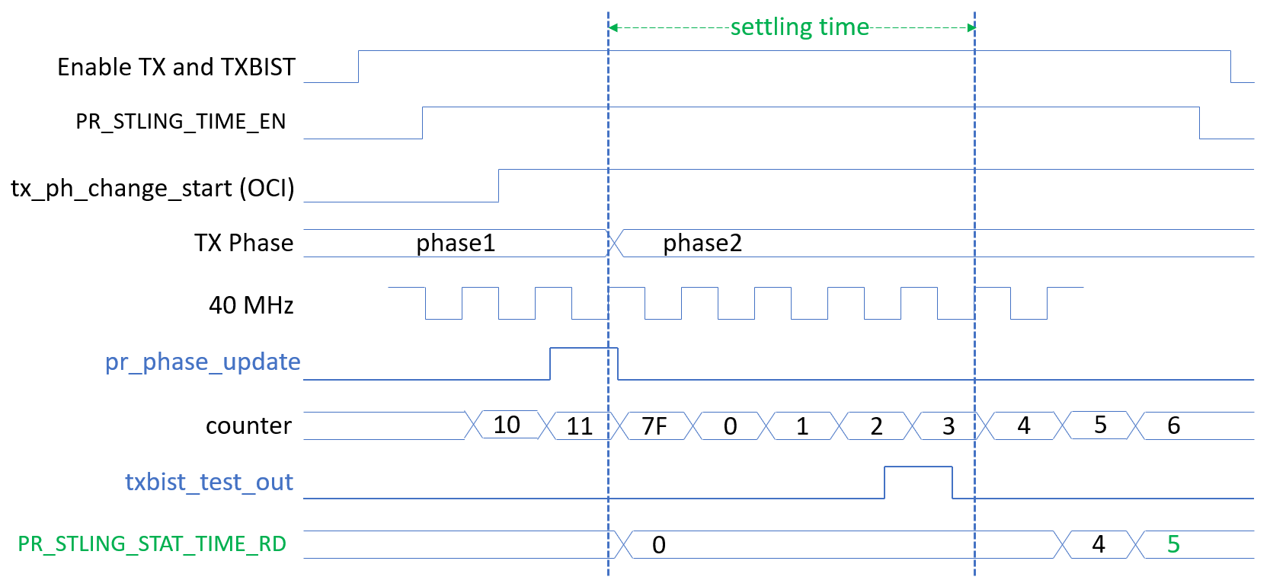The measurement reports the time from a phase-rotator change, as defined by an up transition of pr_phase_update, to the last transition of comparator output txbist_test_out.

Figure 27: Phase rotator settling time

Measurement procedure

* TX2 phase will be chosen arbitrary (at 0 degrees for example). TX1 is under test.
* TX1 phase1 at 45° after the phase where the TXBIST VGA output voltage is minimum.
* TX1 phase2 will be TX1 phase1 + 90°

Figure 28: PR settling time measurement procedure

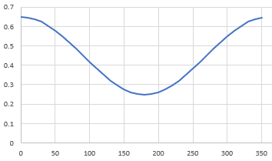

TXBIST VGA output voltage

TX1 phase

Phi1

Phi for min voltage

+45

Phi2

+90

IT shall be possible to select the N or P path of the comparator output

When TXBIST_CTRL_STLING_TIME_EN_N=1 txbist_test_out shall be the N path output of the comparator

When TXBIST_CTRL_STLING_TIME_EN_P=1 txbist_test_out shall be the P path output of the comparator

To perform a measurement, the TX, TXBIST and the tx_pr_settling_time module must be enabled. The latter is done by setting register PR_STLING_TIME_EN.

The settling time is measured by a counter that is clocked at 40MHz. Hence the resolution of the measurement time is 25ns. Once finished, the measurement time is stored in register PR_STLING_STAT_TIME_RD. The value in this register is copy of the counter at every detection of a transition on txbist_test_out.

At the start of the measurement, namely at rising transition of pr_phase_update, both the counter and register PR_STLING_STAT_TIME_RD are reset to 0xFF and 0x00 respectively.

When the module is disabled (PR_STLING_TIME_EN = 0), both the counter and PR_STLING_STAT_TIME_RD are kept constant.

The counter has a width of 7 bits, so a settling time up to 128*25ns = 3.2us can be measured.

Note that register TX_PA_EN_RTM shall be programmed to ‘0’, otherwise txbist_test_out gets disconnected.

The circuit for detecting transitions on txbist_test_out is given in Figure 23:PR settling time: Transition detection cases

This circuit can detect transitions and pulses that are asynchronous to the 40MHz clock. To that end, two flip-flops are present which respectively detect the presence of a “high” level and/or a “low” level during the present clock cycle. In case such conditions are being detected, the signals det_high and det_low will get asserted correspondingly.

Based on these signals, a (rising and falling) transition is being detected in the block called “Det. Logic”. This block can detect a transition in three situations as depicted in Figure 23:PR settling time: Transition detection cases.

In this situation both a high and low level have been seen during the current clock cycle

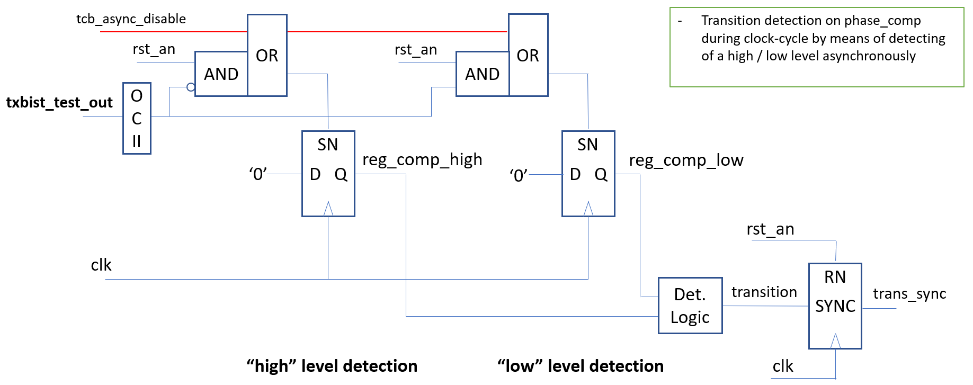

Figure 29: PR settling time transition detection

1. In this situation, a low level has been seen during the current clock cycle and a high level during the past clock cycle
2. In this situation, a high level has been seen during the current clock cycle and a low level during the past clock cycle
3. In this situation, a high level has been seen during the current clock cycle and a low level during the past clock cycle

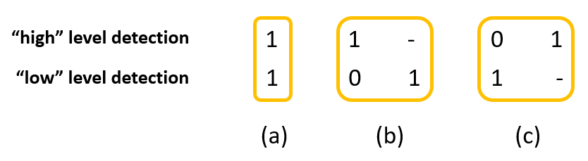

Figure 30:PR settling time: Transition detection cases

In this way, also a transition of txbist_test_out exactly at the rising clock edge is being detected.Figure 24:PR settling time: Transition detection example, illustrates two of the three possible detection cases (namely a, and c).

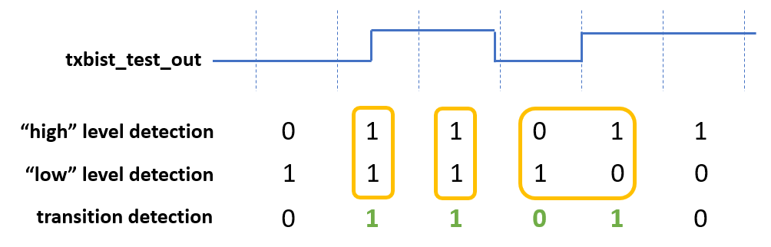

Figure 31:PR settling time: Transition detection example

The transition detection module is fully combinatorial. To use the result by the clocked state machine of the module, the output signal must be synchronized to the 40 MHz clock which is done by a synchronizer, resulting in the signal trans_sync.

For the purpose of DFT, the asynchronous reset signals of the two level detection flip-flops can be blocked by signal tcb_async_disable.

The comparator output signal txbist_test_out is passed through a OCII slice in cluster 43. By doing so:

1. Isolation is realized during Scan-test
2. Allows testing of the paths from txbist_test_out through the logic towards the receiving registers
3. No need for dedicated DFT observation logic at the interface of the tx_pr_settling_time module for testing the path from analog IP towards the digital IP

## IF generation (UPN)

A phase ramp shall be generated at the cordic input when SPI bit tx_if_en =1

The step of the ramp is defined by tx_if_phaseinc. Tx_if_phaseinc is a 12 bits SPI register

" The phase ramp shall be converted to sinewave signal at CORDIC output

Cordic I output (cdic_out_i) shall frequency of f0=40e6*tx_if_phaseinc*16/2^16 "

"The phase ramp shall be converted to sinewave signal at CORDIC output

Cordic Q output (cdic_out_q) shall frequency of f0=40e6*tx_if_phaseinc*16/2^16 "

CORDIC_I and CORDIC_Q output shall be in quadrature

CORDIC_I and CORDIC_Q output signal shall have both a SNDR>30dB in a [0-20MHz] bandwidth with f0 in [100K,10MHz]

## FSM STOP

"The FSM shall be stopped at the end of a state by setting to '1' it’s corresponding stop bit.

(in this case, end of the state means that the operations are over, but the end signal has not been asserted)

The stop shall be asserted prior to the start of the calibration .

This stop shall be used to read back the latest ADC measurement of the completed state.

Once the analysis/debug are done, the stop signal shall be de-asserted, which will unlock the end signal of the state and will move the FSM to next state"

The state machine shall restart by writing the SPI stop bit back to 0.

It has to be notified that the first ADC sample output after the restart may be corrupted.

NOTE: If state is stopped by setting a corresponding stop bit and if FSM is resumed by clearing that bit before expected state duration time is completed, FSM will resume, but results for that state will be incorrect/incomplete and not usable for following states

STOP_START_CAL stops in the FSM in “start_cal” state.

STOP_ADC_AVE stops in the FSM in “adc_ave” state.

STOP_VGA_INIT stops in the FSM in “vga_init” state

STOP_VGA_OFFSET_CAL stops in the FSM in “vga_offset_cal” state.

STOP_VGA_GAIN_CAL stops in the FSM in “vga_gain_cal” state.

STOP_PR_OFFSET_CAL stops in the FSM in “pr_offset_cal” state.

STOP_GPATH_SEL stops in the FSM in “gpath_sel” state.

STOP_PR_GAIN_CAL stops in the FSM in “pr_gain_cal” state.

STOP_PR_PHASE_CAL stops in the FSM in “pr_phase_cal” state.

STOP_END_CAL stops in the FSM in “end_cal” state.

## ADC measurement in FSM state

When stop signal is asserted in a state of the FSM, SPI bits ppd_meas1, ppd_meas2, ppd_meas3, ppd_meas4, ppd_meas5,ppd_meas6, ppdmeas7, ppd_meas8, ppd_meas9, ppd_meas10, ppd_meas11, ppd_meas12, ppd_meas13, ppd_meas14, ppd_meas15, ppd_meas16 shall store the 16 first ADC measurement of the current state."

## GPIO

the TX digital controller shall provide signals through TX debug[7:0] interface signal going to GPIO interface

"the following signals are connected to the GPIO

tx_debug[0]=tx_fast_sw;

tx_debug[1]=tx_fast_en ;

tx_debug[2]=tx_en; is the output of a OR gate on which inputs are all the enable of the TX

tx_debug[3]=pr_phase_update; indicating that the phase of the PR has been updated

tx_debug[4]=pr_cal_run ; indicating the calibration is running

tx_debug[5]=txbist_test_out ; txbist_test_out is the output of the TXBIST comparator

tx_debug[6]= tx_comp_out; tx_comp_out is the output of the comparator used for real time PA output power measurement

tx_debug[7]= instr_error_status_bbd_err_flag_n . instr_error_status_bbd_err_flag_n is the signal from RF ball break detector module"

PR settling time shall be the time difference between the pr_phase_update and txbist_test_out