**APPLICATION RELEASE AUTOMATION**

**Continuous Integration, Continuous Delivery,Continuous Deployment**

Continuous Integration is a core technique where everyone commits every day and code is integrated early and often. This improves frequency and reduces difficulty

Continuous Delivery (CD) stems from Continuous Integration (CI), where as per business needs, quality software is deployed frequently and predictably to Production in an automated fashion.

Continuous deployment is the next step of continuous delivery: Every change that passes the automated tests is deployed to production automatically.

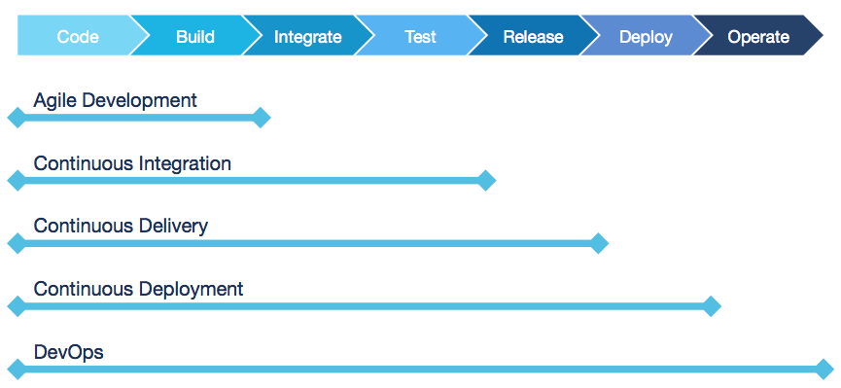

**Continuous Integration Workflow**

