**Database Structure**

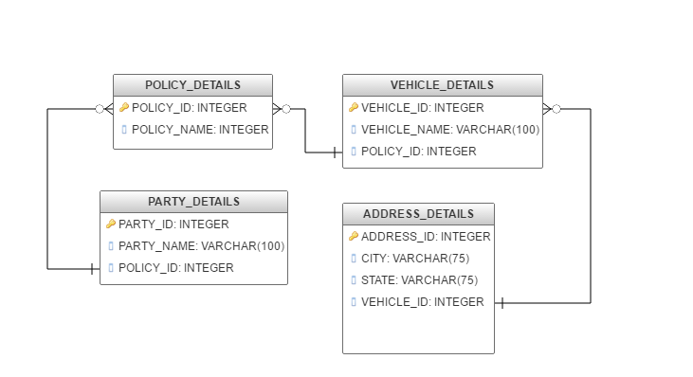

**Entity Structure**

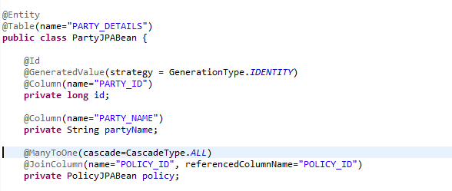

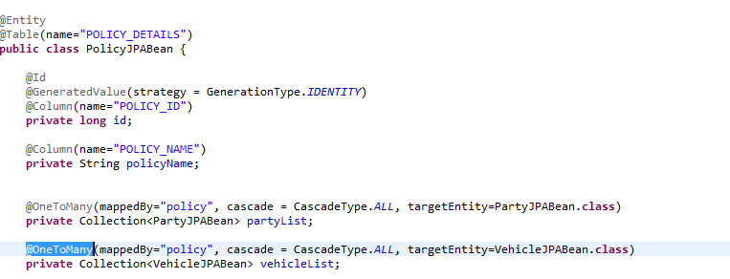

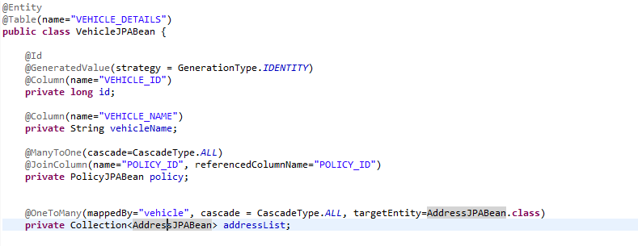

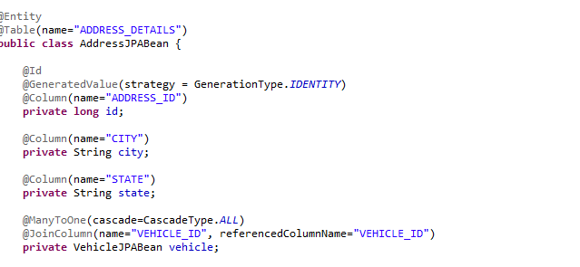

**Difference between FetchTypes**

* Modified PolicyJPABean and VehicleJPABean
* Added FetchType.LAZY
* Only One query triggered : SELECT POLICY_ID, POLICY_NAME FROM POLICY_DETAILS WHERE (POLICY_NAME = ?)
* Only Policy details loaded in memory

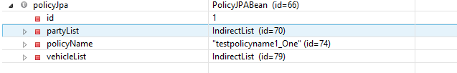

* Modified to FetchType.EAGER
* All queries triggered while fetching policy details
* Queries triggered:

SELECT POLICY_ID, POLICY_NAME FROM POLICY_DETAILS WHERE (POLICY_NAME = ?)

SELECT PARTY_ID, PARTY_NAME, POLICY_ID FROM PARTY_DETAILS WHERE (POLICY_ID = ?)

SELECT VEHICLE_ID, VEHICLE_NAME, POLICY_ID FROM VEHICLE_DETAILS WHERE (POLICY_ID = ?

SELECT ADDRESS_ID, CITY, STATE, VEHICLE_ID FROM ADDRESS_DETAILS WHERE (VEHICLE_ID =?

SELECT ADDRESS_ID, CITY, STATE, VEHICLE_ID FROM ADDRESS_DETAILS WHERE (VEHICLE_ID =?

* All details loaded in memory

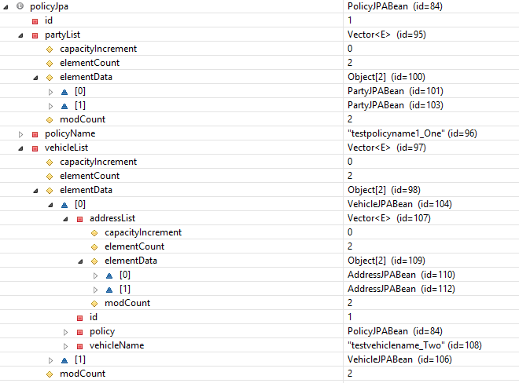

**Remove** **Operations**

* For Removing the relationship between the entities.
* 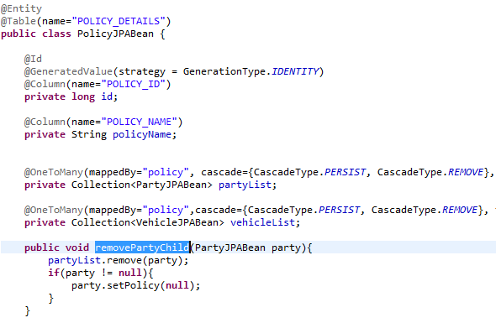
* Will remove the relation ship between the parent and child entities
* Below queries are triggered

SELECT POLICY_ID, POLICY_NAME FROM POLICY_DETAILS WHERE (POLICY_NAME = ?)

SELECT PARTY_ID, PARTY_NAME, POLICY_ID FROM PARTY_DETAILS WHERE (POLICY_ID = ?)

UPDATE PARTY_DETAILS SET POLICY_ID = ? WHERE (PARTY_ID = ?)

* With orphanRemoval=true, the child record will be deleted

