Prerequisites
Before attempting to create a Maven project in Eclipse, ensure that Eclipse is configured with the following:
- An m2eclipse plugin compatible with Maven 3.3 or higher.
- A JDK 1.8 or higher.(This is for ide. ex: eclipse)
- IDE: Eclipse Kepler Service Release 1
- apache-maven-3.3.9
Java installation process:
- Download and install JDK 1.8
- Click Start, then Control Panel, then System.
- Click Advanced, then Environment Variables.
- Add the location of the bin folder of the JDK installation for the PATH variable in System Variables. The following is a typical value for the PATH variable:
- C:\Program Files\Java\ JDK 1.8\bin
Maven installation process:
- Download apache-maven-3.3.9.zip and unzip it.
- Click Start, then Control Panel, then System.
- Click Advanced, then Environment Variables.
- Add the location of the bin folder of the Maven installation for the PATH variable in System Variables. The following is a typical value for the PATH variable:
- C:\Program Files\apache-maven-3.3.9\bin
Steps for Import maven project in Eclipse:
From the File menu, select Import.
1. The Select screen opens.

2. Expand Maven and select Existing Maven Projects.
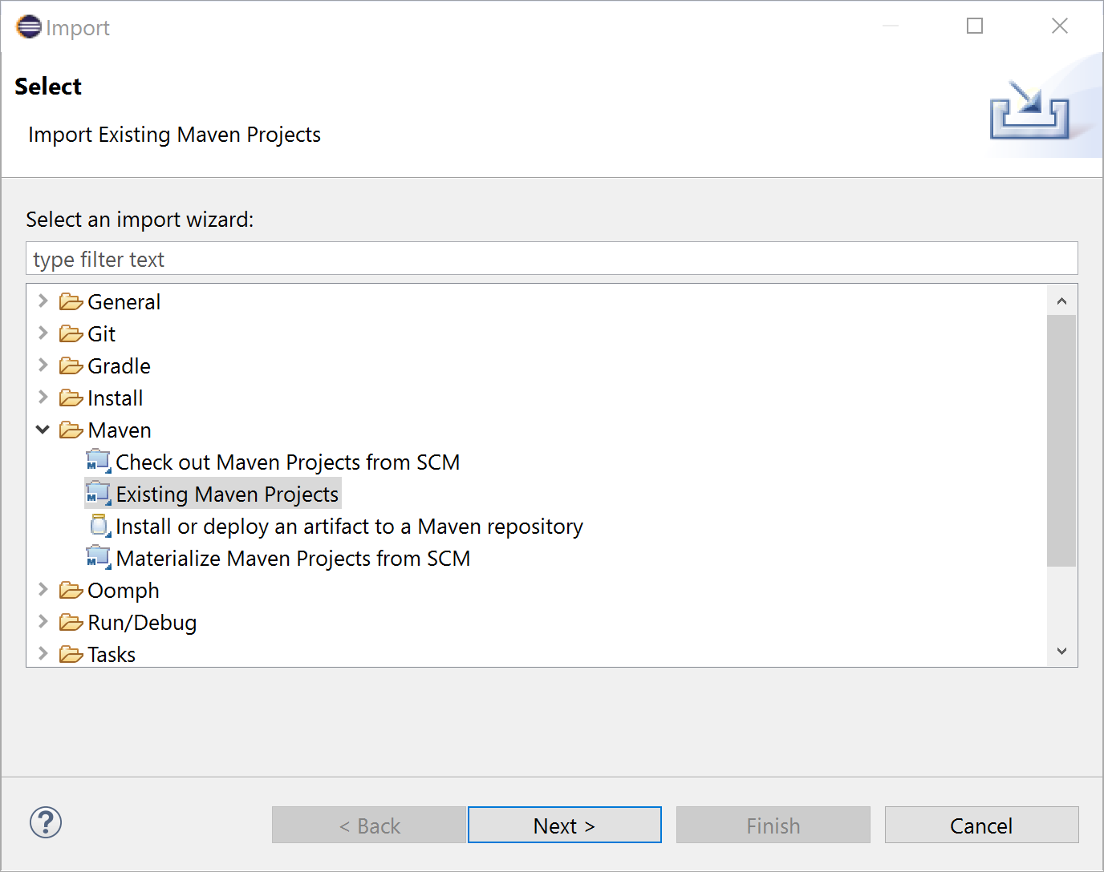

3. Click Next.

4. For Root Directory, click Browse and select the top-level project folder.

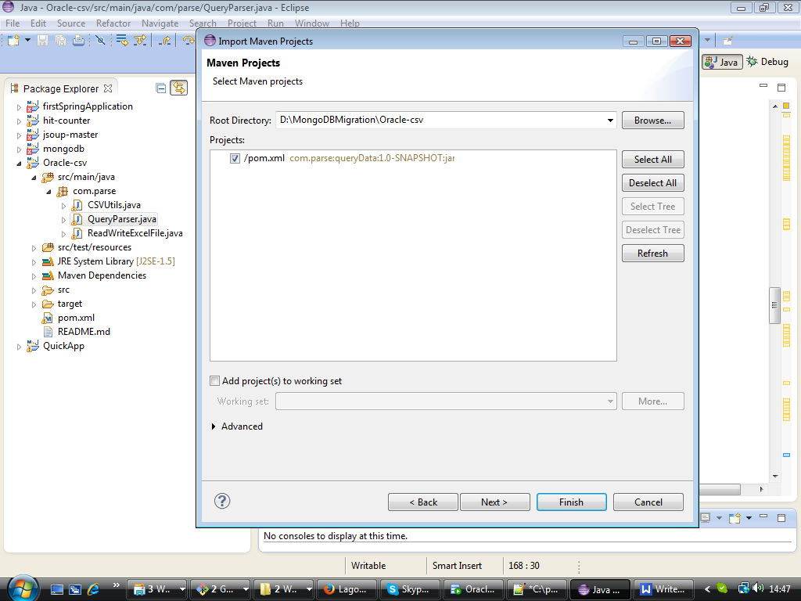

- Complete project structure for development:

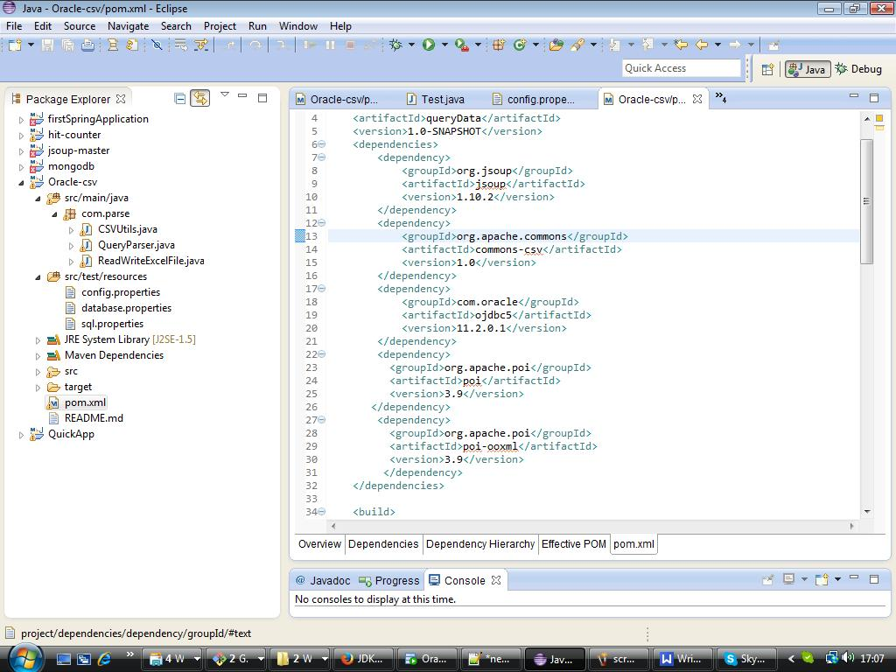

Following required jar for project development:
- commons-csv
- ojdbc5
- Poi
- poi-ooxml

For more details please check pom.xml.

5. Select the JRE tab and make sure it is pointing at a JRE associated with a jdk1.5.0_20.
Windows->Preferences->Java->Installed JRE-> Select jdk1.5.0_20

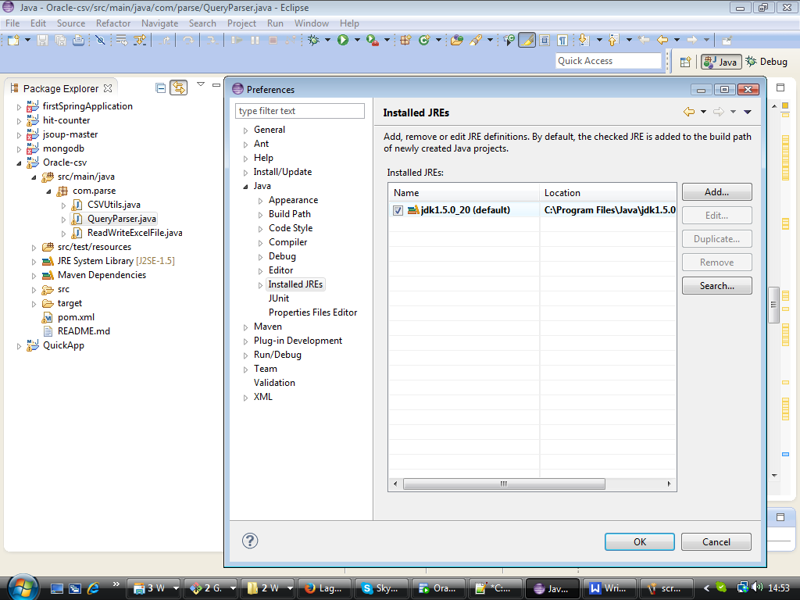

6. Right click on pom.xml and click on Run as->Maven Install->Jar file will create in target folder.
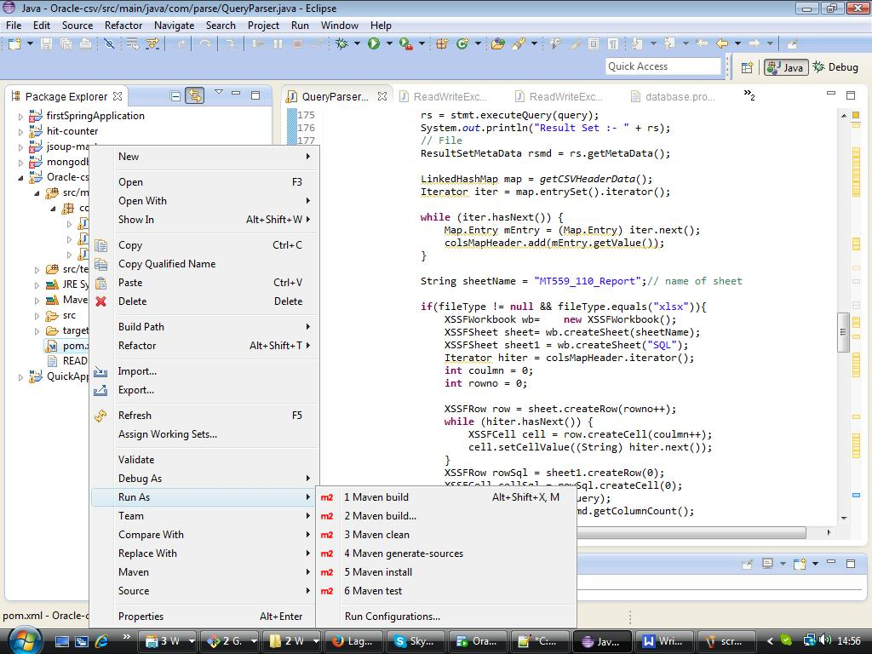

7. Download ojdbc5.jar file and run following command:
mvn install:install-file -Dfile=C:\properties\ojdbc5.jar -DgroupId=com.oracle -DartifactId=ojdbc5 -Dversion=11.2.0.1 -Dpackaging=jar
After running this command we can declare in pom.xml
<dependency>
<groupId>com.oracle</groupId>
<artifactId>ojdbc5</artifactId>
<version>11.2.0.1</version>
</dependency>

8. Steps for runnig jar file from command prompt:
Prerequisites:
JDK jdk1.5.0_20 should set in classpath.
Maven should set in classpath.

Command:
Mvn clean install (for generating jar file(queryData.jar) in target folder)
java -jar queryData.jar C:\\properties\\database.properties

- After successful jar execution. Report will generate on given location in side config.properties.
- Query should be in sql.properties file
- Database connection should be in database.properties file.
- File type should be stored in config.properties file.

