**1. Prerequisites:**

Before attempting to create a Maven project in Eclipse, ensure that Eclipse is configured with the following:

* An m2eclipse plugin compatible with Maven 3.3 or higher.
* A JDK 1.8 or higher.(This is for ide. ex: eclipse)
* IDE: Eclipse Kepler Service Release 1
* apache-maven-3.3.9
* postgres

**2. Java installation process:**

* Download and install jdk1.5.0_20
* Click Start, then Control Panel, then System.
* Click Advanced, then Environment Variables.
* Add the location of the bin folder of the JDK installation for the PATH variable in System Variables. The following is a typical value for the PATH variable:
* C:\Program Files\Java\jdk1.5.0_20\bin

**3. Maven installation process:**

* Download apache-maven-3.3.9.zip and unzip it.
* Click Start, then Control Panel, then System.
* Click Advanced, then Environment Variables.
* Add the location of the bin folder of the Maven installation for the PATH variable in System Variables. The following is a typical value for the PATH variable:
* C:\Program Files\apache-maven-3.3.9\bin

**4. Steps for Import maven project in Eclipse:**

From the File menu, select Import.

1. The Select screen opens.

2. Expand Maven and select Existing Maven Projects.

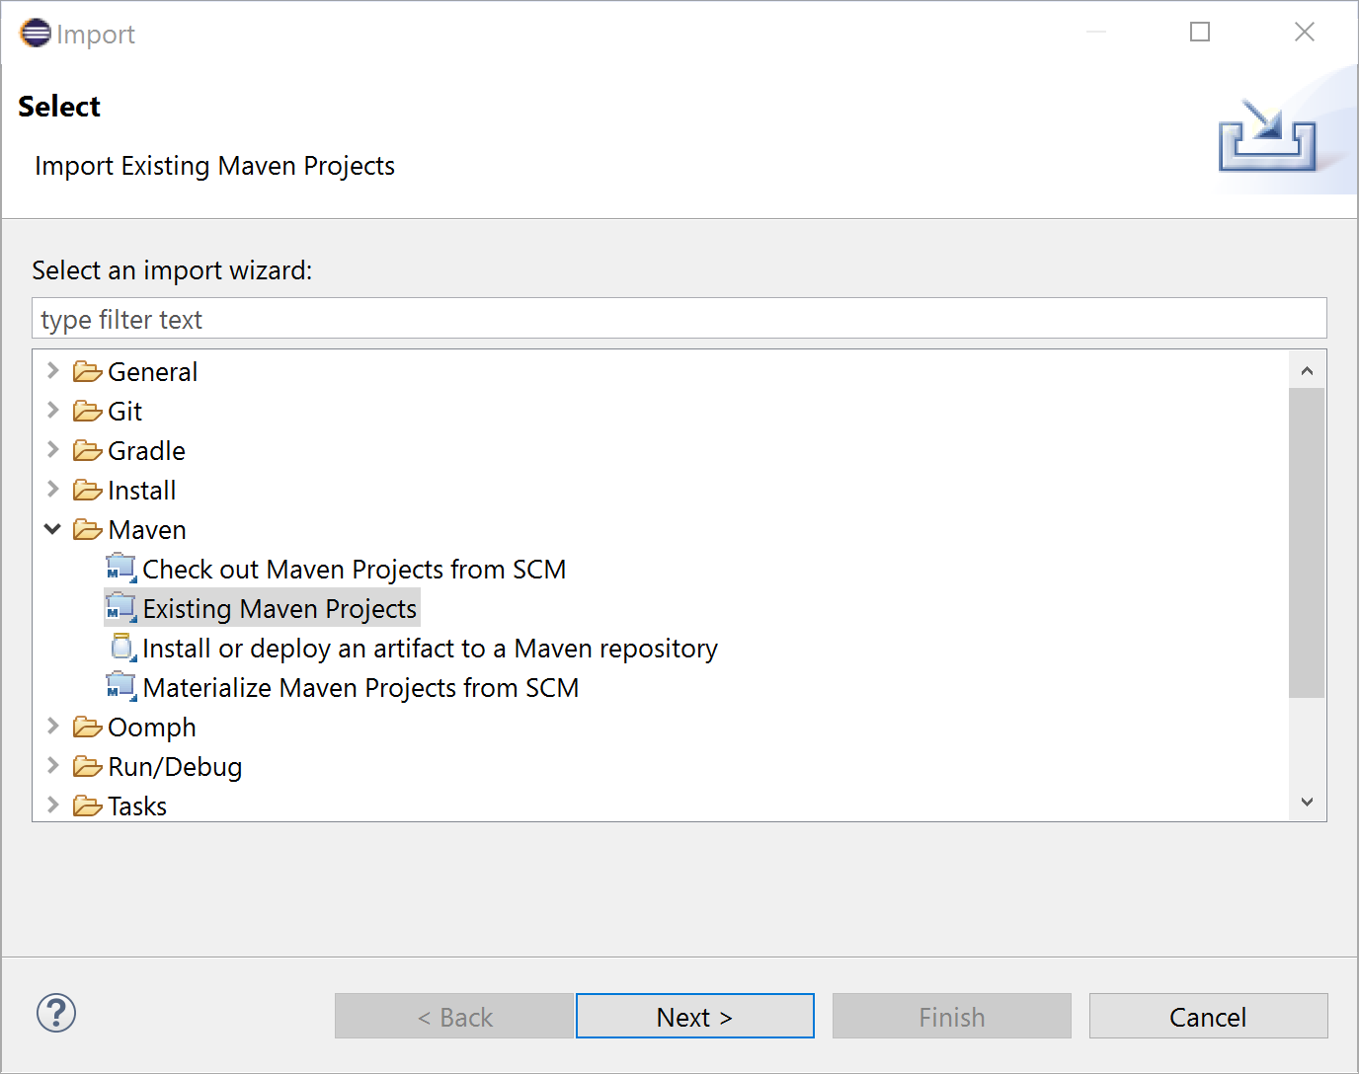

3. Click Next.

1. Complete project structure for development: