CI/CD pipeline for .NET Core with the Azure DevOps Project

The **Azure DevOps Project** simplifies the initial configuration of a continuous integration (CI) and continuous delivery (CD) pipeline for your .NET core or ASP.NET applications

**What’s covered here**

* Create ASP .NET Core Web Application
* Add xUnit Test Project
* Add Azure Web App
* Create new Azure DevOps project
* Configure **Azure DevOps Project** CI/CD pipelines.
* Commit the code changes and execute CI/CD
* Test Deployed Application.

Create ASP .NET Core Web Application

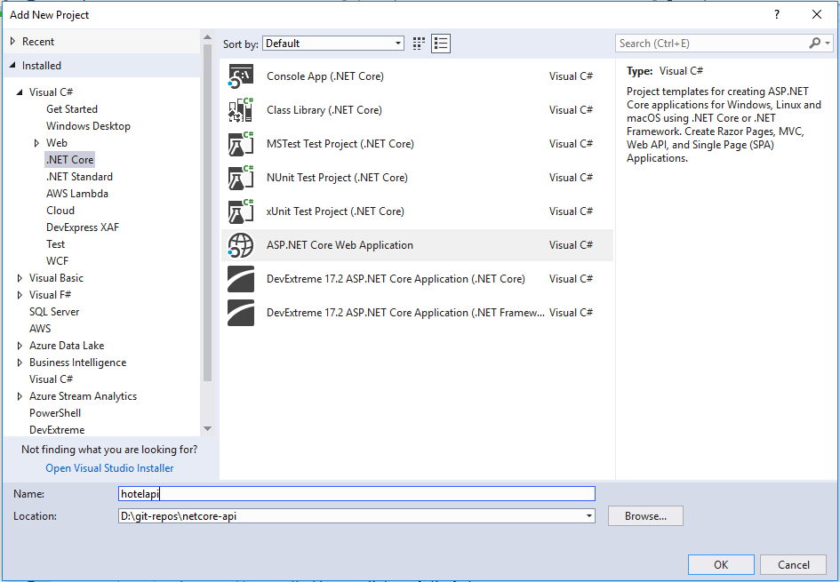

Add a xUnit Test Project to solution.

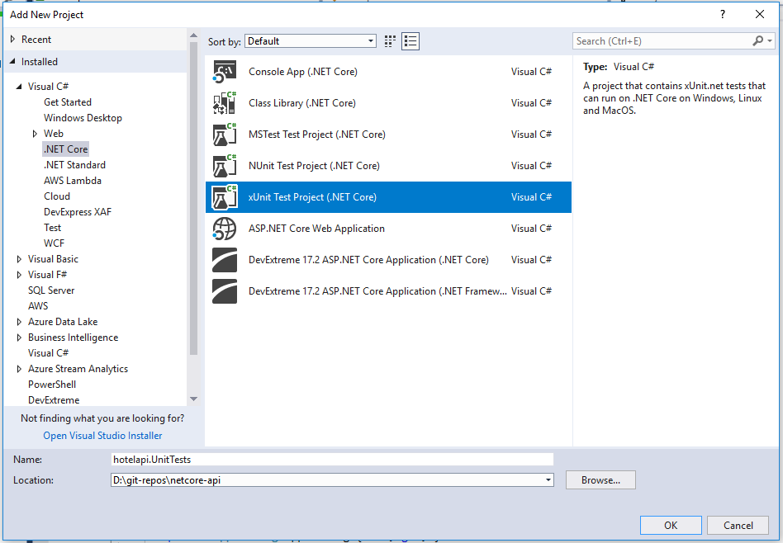

Add Azure Web App

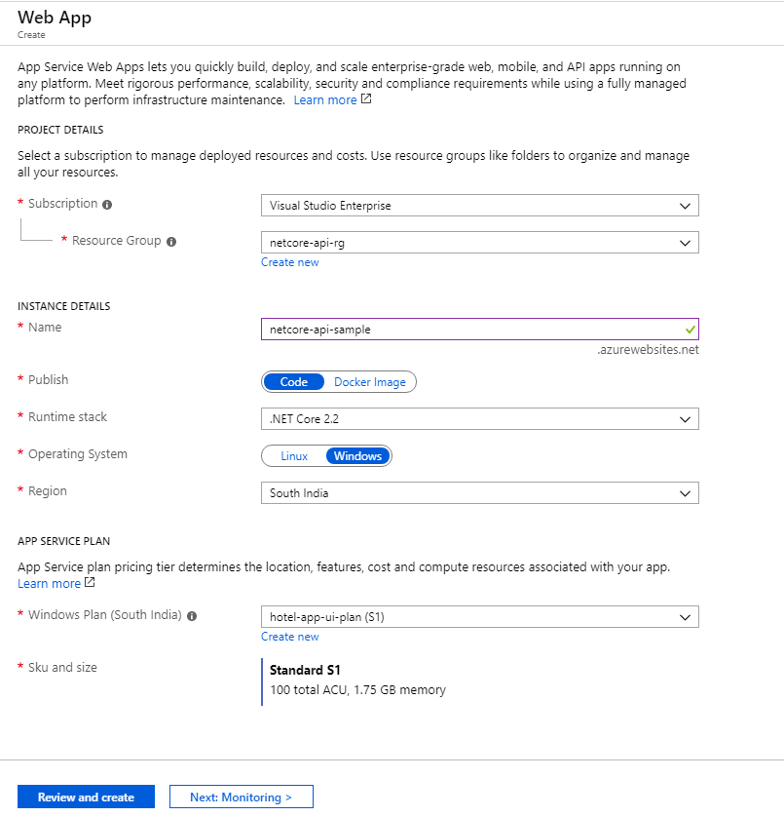

Create New Azure DevOps project.

Create Azuere devOps project in your Organization as below -

<https://dev.azure.com/ManavSoft/>

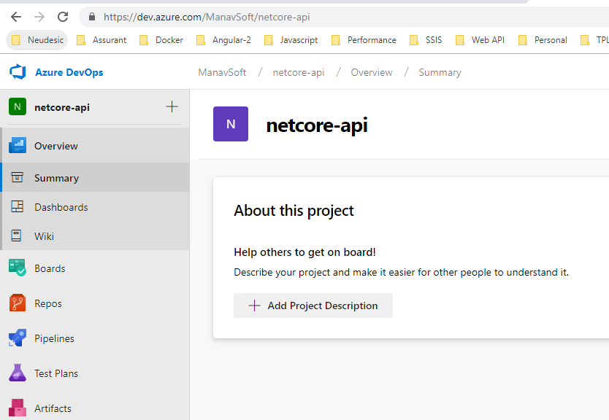

Configure CI/CD Pipeline:

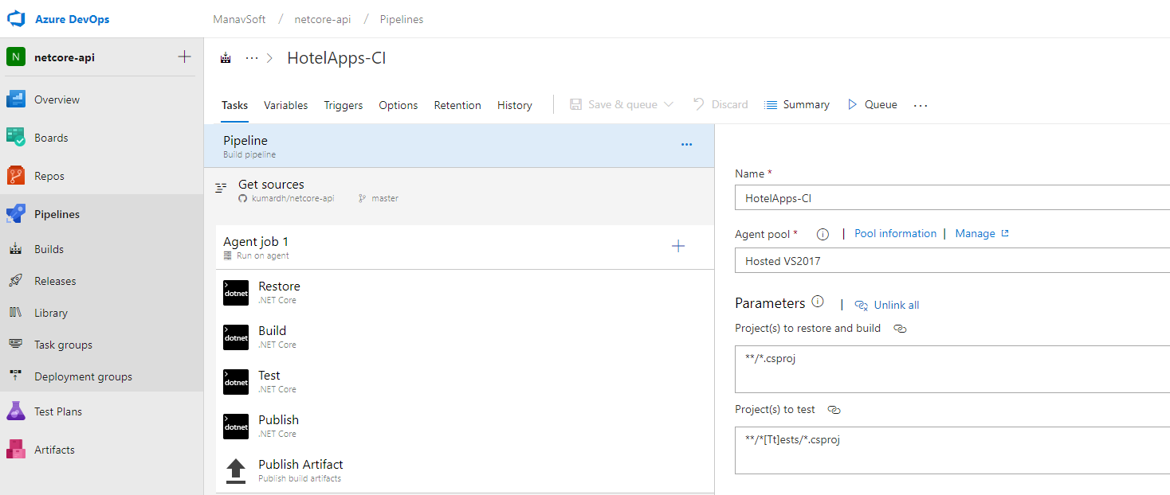

Select Repository

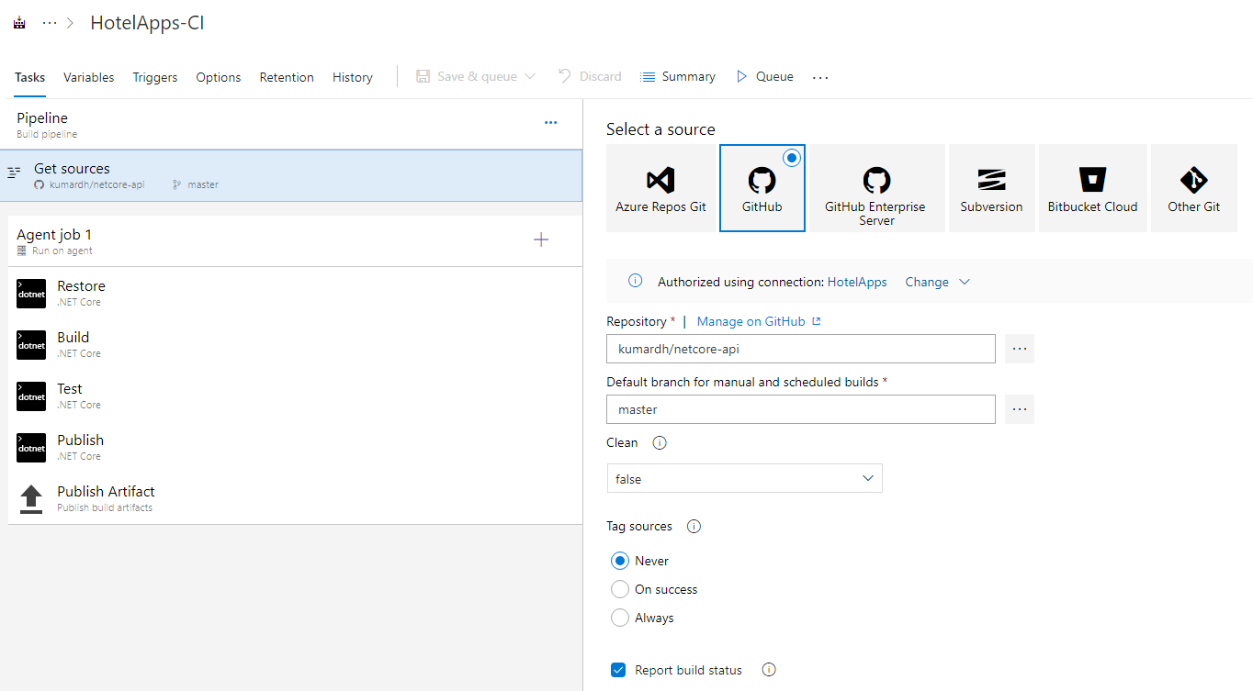

Configure Agent job

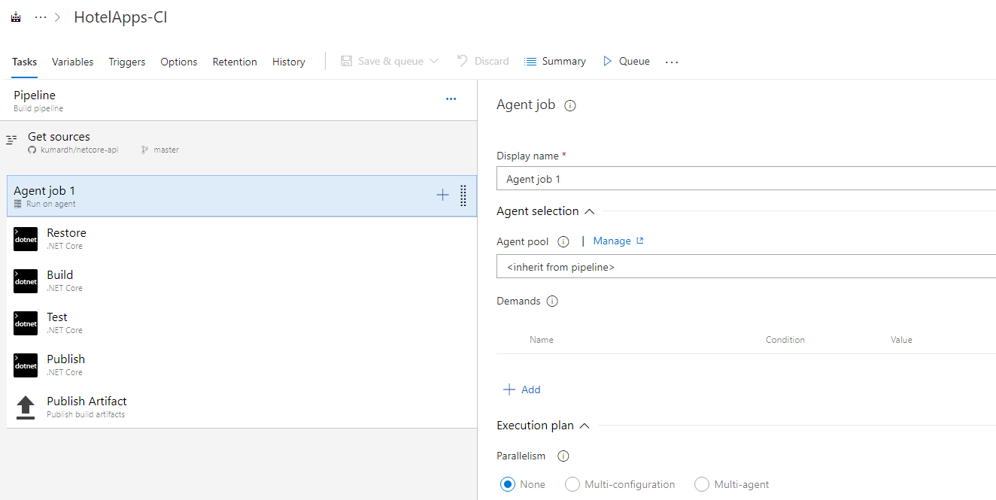

Add Restore task

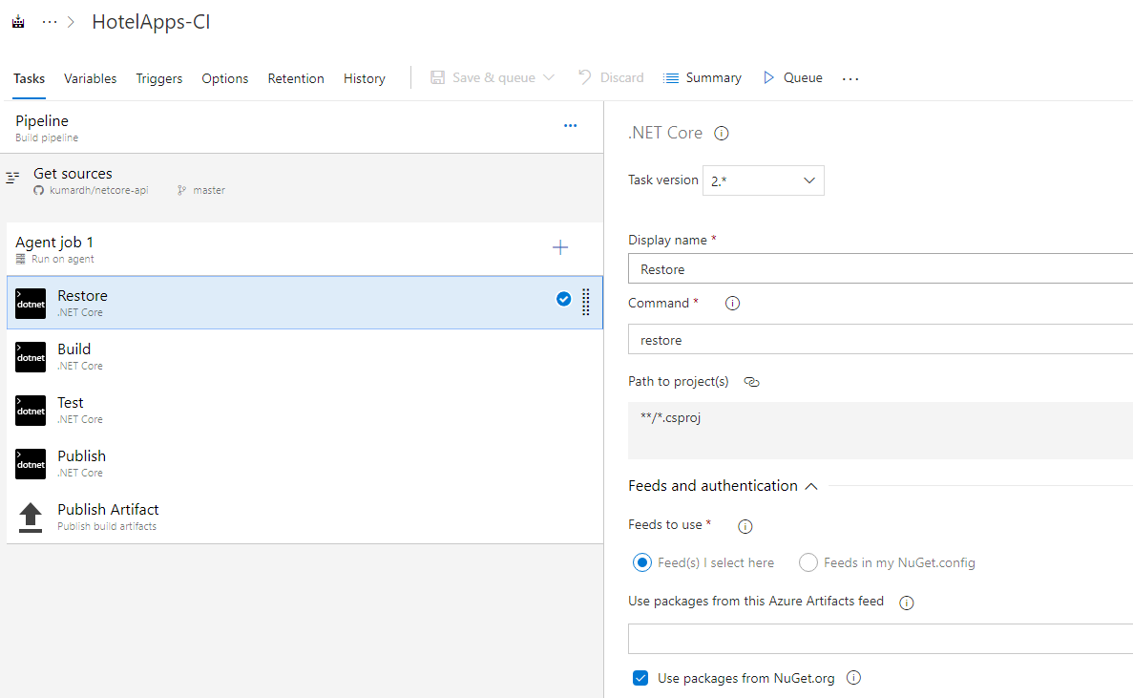

Add Build task

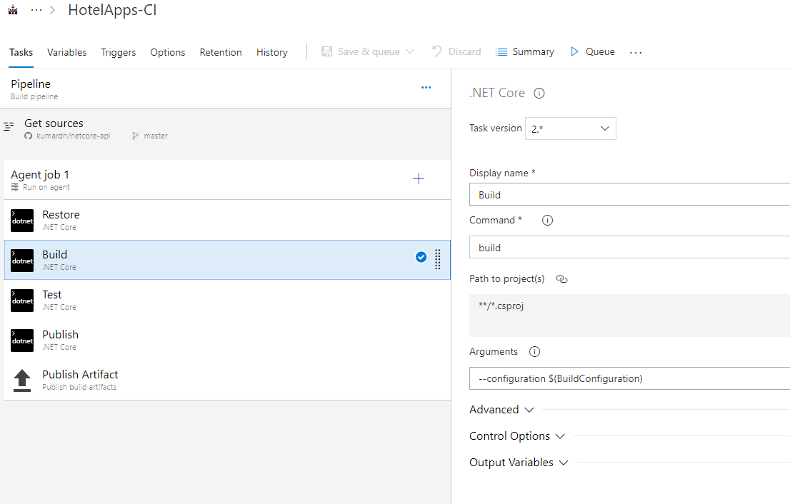

Add Test task

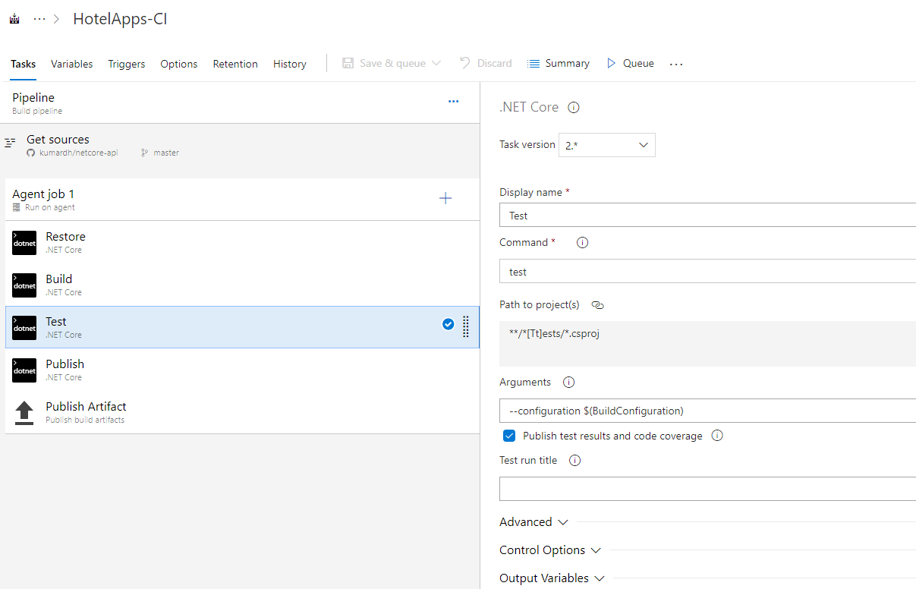

Add Publish task

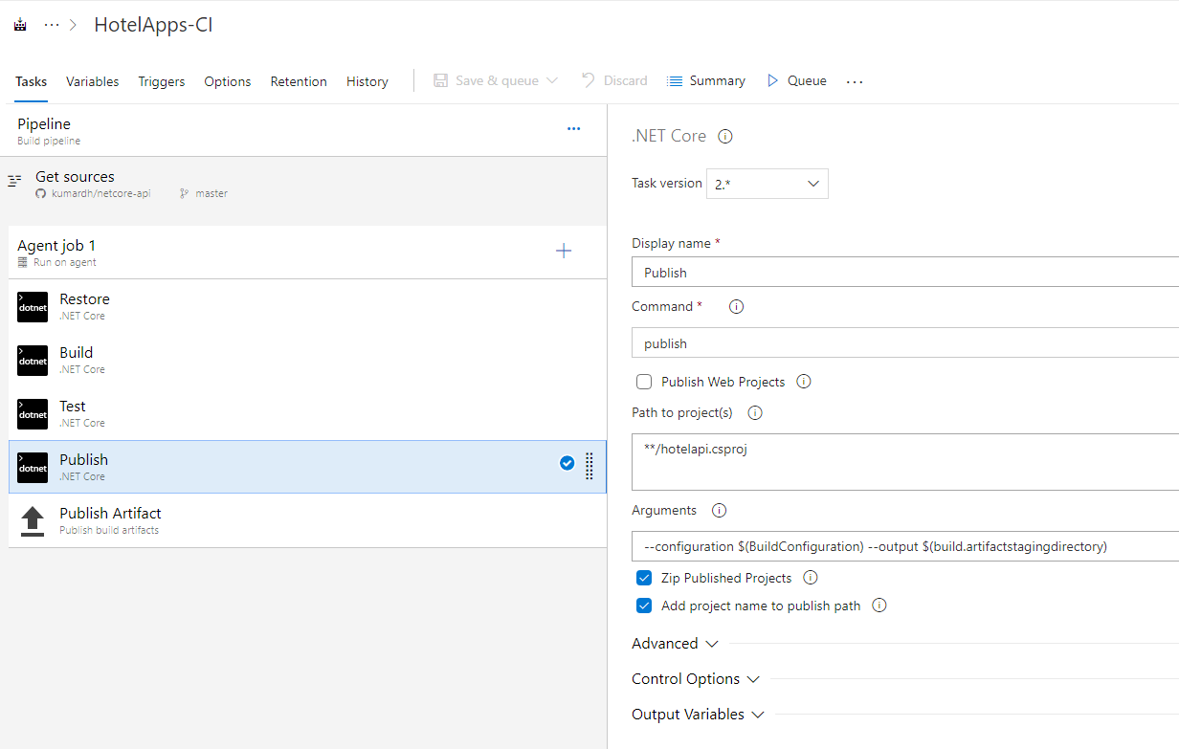

Publish Artifact

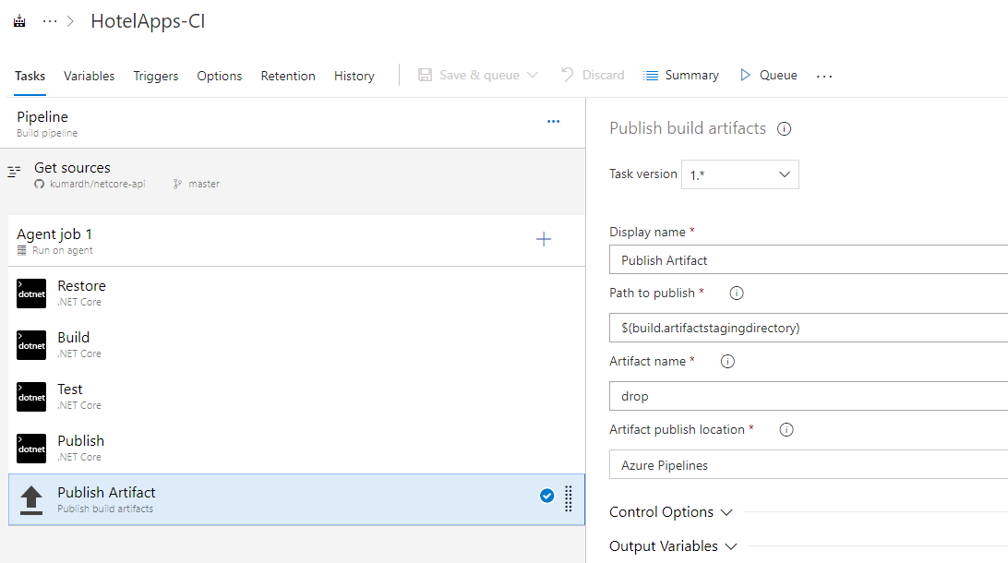

Release

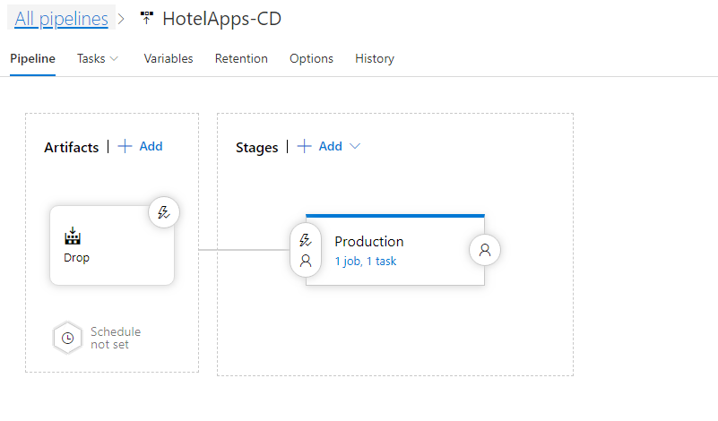

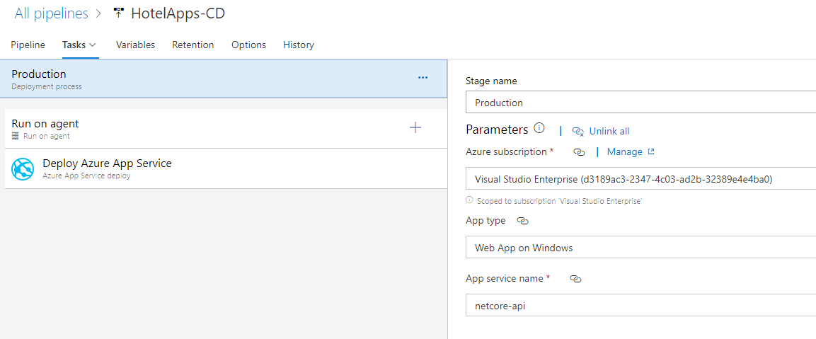

Deploy Azure App

