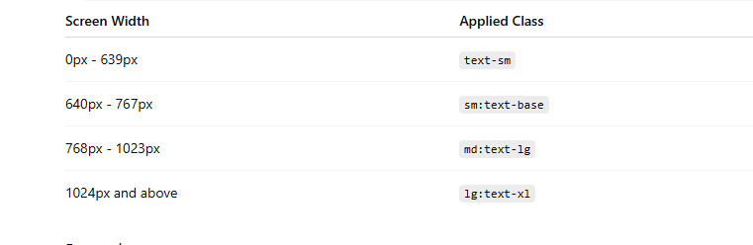

<div> <nav class="flex justify-between items-center bg-orange-900 rounded-b-2xl flex-wrap max-w-7xl mx-auto px-4 py-4 sm:px-6 lg:px-8 lg:bg-blue-400 relative"> <h1 class="text-2xl text-amber-100 font-bold">M.DharunKumar</h1> <button id="menu-btn" class="md:hidden text-amber-100 text-3xl focus:outline-none hover:text-orange-400 transition-colors"> <i class="bi bi-list"></i> </button> <div id="menu" class="hidden w-full md:flex md:w-auto md:items-center mt-4 md:mt-0"> <ul class="flex flex-col md:flex-row gap-4 w-full md:w-auto"> <a href="./Aboutme.html"><li class="text-amber-100 font-bold transition-all duration-300 ease-in hover:bg-orange-400 h-8 p-0.5 pl-2 w-[100px] rounded-[10px] cursor-pointer hover:scale-110 [box-shadow:_4px_4px_4px_rgba(253,230,137,0.7)] text-center md:text-left">About me</li></a> <a href="./Skills.html"><li class="text-amber-100 font-bold transition-all duration-300 ease-in hover:bg-orange-400 h-8 p-0.5 pl-2 w-[100px] rounded-[10px] cursor-pointer hover:scale-110 [box-shadow:_4px_4px_4px_rgba(253,230,137,0.7)] text-center md:text-left">Skills</li></a> <a href="./Projects.html"><li class="text-amber-100 font-bold transition-all duration-300 ease-in hover:bg-orange-400 h-8 p-0.5 pl-2 w-[100px] rounded-[10px] cursor-pointer hover:scale-110 [box-shadow:_4px_4px_4px_rgba(253,230,137,0.7)] text-center md:text-left">Projects</li></a> <a href="./Contactme.html"><li class="text-amber-100 font-bold transition-all duration-300 ease-in hover:bg-orange-400 h-8 p-0.5 pl-2 w-[100px] rounded-[10px] cursor-pointer hover:scale-110 [box-shadow:_4px_4px_4px_rgba(253,230,137,0.7)] text-center md:text-left">Contact Me</li></a> <div class="flex gap-4 justify-center md:justify-start mt-2 md:mt-0"> <a href="https://www.linkedin.com/in/techdharunkumar/" target="_blank"><li class="transition-all duration-300 ease-in hover:scale-110 list-none"><i class="bi bi-linkedin text-amber-100 font-bold transition-all duration-300 ease-in relative top-1.5 hover:bg-orange-400 h-8 p-0.5 pl-2 pr-2 w-[40px] rounded-[10px] cursor-pointer [box-shadow:_4px_4px_4px_rgba(253,230,137,0.7)]"></i></li></a> <a href="mailto:kumardharun607@gmail.com"><li class="transition-all duration-300 ease-in hover:scale-110 list-none"><i class="bi bi-envelope-fill text-amber-100 font-bold hover:bg-orange-400 h-8 p-0.5 pl-2 pr-2 w-[40px] rounded-[10px] cursor-pointer relative top-1.5 [box-shadow:_4px_4px_4px_rgba(253,230,137,0.7)]"></i></li></a> </div> </ul> </div> </nav>

What is menu.classList.toggle('hidden')?
menu.classList.toggle('hidden');
This line adds the hidden class if it is not present and removes the hidden class if it is present.
Think of it as an ON/OFF switch.

Before Clicking
HTML:
<div id="menu" class="hidden">
Menu Content
</div>
Tailwind's hidden class means:
display: none;
So the menu is invisible.

First Click
menu.classList.toggle('hidden');
Since hidden already exists, toggle() removes it.
Result:
<div id="menu">
Menu Content
</div>
Now the menu becomes visible.

Second Click
menu.classList.toggle('hidden');
Since hidden does not exist, toggle() adds it back.
Result:
<div id="menu" class="hidden">
Menu Content
</div>
Menu becomes hidden again.

Visual Flow
Initial
-------
class="hidden"
Menu Hidden

Click 1
-------
toggle('hidden')
↓
class=""
Menu Visible

Click 2
-------
toggle('hidden')
↓
class="hidden"
Menu Hidden

Click 3
-------
toggle('hidden')
↓
class=""
Menu Visible

Equivalent Code Without toggle()
if (menu.classList.contains('hidden')) {
menu.classList.remove('hidden');
} else {
menu.classList.add('hidden');
}
toggle() does the same thing in one line.

Other Useful classList Methods

Add a class
menu.classList.add('hidden');
Result:
<div class="hidden">
Always hides the menu.

Remove a class
menu.classList.remove('hidden');
Result:
<div>
Always shows the menu.

Check if a class exists
menu.classList.contains('hidden');
Returns:
true
or
false

Why Use toggle() in a Navbar?
For a mobile menu, every click should alternate between:
Click 1 → Open Menu
Click 2 → Close Menu
Click 3 → Open Menu
Click 4 → Close Menu
toggle() is perfect for this behavior because it automatically switches between the two states without writing an if...else block.

