CSS
- TYPES of CSS

1)Inline CSS
2)Internal CSS
3)External CSS

- Selectors
1. Simple Selector
2. Combinator Selector
3. Pseudo Class Selector
4. Pseudo Element Selector
5. Attribute Selector

Simple Selector

▪ TagName ▪ Id Name (#) ▪ Class Name (.) ▪ Universal (*) ▪ Grouping (,)
These are CSS selectors used to select HTML elements and apply styles 👇

🔹 1️⃣ Tag Name Selector
Explanation: Selects elements using the HTML tag name.
✅ Example:
p {
color: red;
}
👉 Applies style to all <p> tags
<p>Hello</p>
<p>World</p>

🔹 2️⃣ Id Selector (#)
Explanation: Selects an element using a unique id.
👉 One id = one element.
✅ Example:
#title {
color: blue;
}
<h1 id="title">Welcome</h1>

🔹 3️⃣ Class Selector (.)
Explanation: Selects elements using class name.
👉 One class can be used for many elements.
✅ Example:
.box {
background-color: yellow;
}
<p class="box">Text 1</p>
<p class="box">Text 2</p>

🔹 4️⃣ Universal Selector (*)
Explanation: Selects all elements in the webpage.
✅ Example:
* {
margin: 0;
padding: 0;
}
👉 Applies style to every element

🔹 5️⃣ Grouping Selector (,)
Explanation: Applies same style to multiple selectors together.
✅ Example:
h1, p, div {
color: green;
}
<h1>Heading</h1>
<p>Paragraph</p>
<div>Box</div>

Combinator Selector

These are CSS selectors used to select elements based on parent–child relationship

1. Descendent Selector ( )
2. Direct Child Selector (>)

These are CSS selectors used to select elements based on parent–child relationship 👇

🔹 1️⃣ Descendant Selector (space)
Explanation:
Selects all child elements inside a parent, even if they are deeply nested (child, grandchild, etc.).
👉 Syntax:
parent child {
property: value;
}
✅ Example:
div p {
color: red;
}
<div>
<p>This will be red</p>
<section>
<p>This also will be red</p>
</section>
</div>
✔ Both <p> tags are selected because they are inside <div>.

🔹 2️⃣ Direct Child Selector (>)
Explanation:
Selects only immediate (direct) children of a parent element.
👉 Syntax:
parent > child {
property: value;
}
✅ Example:
div > p {
color: blue;
}
<div>
<p>This will be blue</p>
<section>
<p>This will NOT be blue</p>
</section>
</div>
✔ Only the direct child <p> is selected.

🔄 Difference (Simple)
Selector | Meaning
div p | All <p> inside <div>
div > p | Only direct child <p> of <div>

Adjacent sibling

These are CSS sibling selectors — used to select elements based on same parent (side-by-side elements) 👇
⚠️ Small correction first:
- General sibling selector = ~
- Adjacent sibling selector = +
(> is direct child selector — not sibling)

🔹 1️⃣ General Sibling Selector ~
Explanation:
Selects all sibling elements that come after a specified element and share the same parent.
👉 Syntax:
element1 ~ element2 {
property: value;
}
✅ Example:
h2 ~ p {
color: red;
}
<div>
<h2>Heading</h2>
<p>Paragraph 1</p>
<p>Paragraph 2</p>
<section>
<p>Paragraph 3</p>
</section>
</div>
👉 Result:
- Paragraph 1 → styled
- Paragraph 2 → styled
- Paragraph 3 → NOT styled (not same parent)

🔹 2️⃣ Adjacent Sibling Selector +
Explanation:
Selects only the first immediate sibling that comes right after an element.
👉 Syntax:
element1 + element2 {
property: value;
}
✅ Example:
h2 + p {
color: blue;
}
<div>
<h2>Heading</h2>
<p>Paragraph 1</p>
<p>Paragraph 2</p>
</div>
👉 Result:
- Paragraph 1 → styled
- Paragraph 2 → NOT styled

🔄 Difference
Selector | Symbol | Meaning
General Sibling | ~ | All following siblings
Adjacent Sibling | + | Only next immediate sibling

Pseudo Class Selector

✅ What is Pseudo-Class Selector?
A pseudo-class selector is used to style an element based on its state or position, like when the mouse is over it, when it is clicked, or its order in a list.
👉 Syntax:
selector:pseudo-class {
property: value;
}

🔹 1️⃣ :hover
Explanation:
Applies style when the mouse pointer is placed over an element.
✅ Example:
a:hover {
color: red;
}
<a href="#">Move mouse here</a>
👉 When you move the mouse over the link → color becomes red.

🔹 2️⃣ :active
Explanation:
Applies style when the element is being clicked (pressed).
✅ Example:
button:active {
background-color: green;
}
<button>Click Me</button>
👉 When you press the button → background becomes green.

🔹 3️⃣ :nth-child()
Explanation:
Selects elements based on their position number inside a parent.
✅ Example:
li:nth-child(2) {
color: blue;
}
<ul>
<li>Item 1</li>
<li>Item 2</li>
<li>Item 3</li>
</ul>
👉 Only Item 2 will be blue.

🧠 Quick Summary
Pseudo Class | Meaning
:hover | Mouse over element
:active | While clicking element
:nth-child(n) | Select element by position

Pseudo Element Selector

✅ What is Pseudo-Element Selector?
A pseudo-element selector is used to style specific parts of an element, like the first letter, first line, or to insert content before/after an element.
👉 Syntax:
selector::pseudo-element {
property: value;
}

🔹 1️⃣ ::before
Explanation:
Inserts content before the element’s actual content.
✅ Example:
p::before {
content: "👉 ";
color: red;
}
<p>Hello World</p>
👉 Output shows 👉 before the text.

🔹 2️⃣ ::after
Explanation:
Inserts content after the element’s content.
✅ Example:
p::after {
content: " ✔";
color: green;
}
<p>Completed Task</p>
👉 Output shows ✔ after the text.

🔹 3️⃣ ::first-letter
Explanation:
Styles only the first letter of text.
✅ Example:
p::first-letter {
font-size: 30px;
color: blue;
}
<p>This is a paragraph</p>
👉 Only first letter becomes big and blue.

🔹 4️⃣ ::first-line
Explanation:
Styles only the first line of a paragraph.
✅ Example:
p::first-line {
color: red;
font-weight: bold;
}
<p>This is a long paragraph text used to demonstrate first line styling in CSS.</p>
👉 Only first line text will be styled.

🧠 Quick Summary
Pseudo Element | Purpose
::before | Add content before element
::after | Add content after element
::first-letter | Style first letter
::first-line | Style first line

Attribute Selector

✅ What is Attribute Selector?
An attribute selector selects HTML elements based on their attributes or attribute values.

🔹 1️⃣ [attr] Selector
Explanation:
Selects all elements that contain a specific attribute, no matter the value.
👉 Syntax:
[attribute] {
property: value;
}
✅ Example:
[title] {
color: red;
}
<p title="info">Paragraph 1</p>
<p>Paragraph 2</p>
👉 Result:
- Paragraph 1 → styled
- Paragraph 2 → NOT styled (no title attribute)

🔹 2️⃣ [attr=value] Selector
Explanation:
Selects elements whose attribute has a specific value.
👉 Syntax:
[attribute="value"] {
property: value;
}
✅ Example:
input[type="text"] {
border: 2px solid blue;
}
<input type="text">
<input type="password">
👉 Result:
- text input → styled
- password input → NOT styled

🧠 Quick Summary
Selector | Meaning
[attr] | Element contains attribute
[attr=value] | Attribute has specific value

Box Model

Definition:

- The CSS box model represents the structure of an element in terms of its content, padding, border, and margin.

Components of the Box Model:

1. Content:
- The actual content of the element, such as text, images, or other media.
- Example: width and height properties define the size of the content area.

2. Padding:
- The space between the content and the border.
- Example: padding: 20px; (applies padding equally to all sides).

3. Border:
- A line surrounding the padding (if any) and the content.
- Can be styled with different widths, colors, and styles.
- Example: border: 1px solid black; (sets a 1px solid black border).

4. Margin:
- The space outside the border, separating the element from adjacent elements.
- Example: margin: 10px; (applies margin equally to all sides).

Box-Sizing Property:

- box-sizing:
- Defines how the total width and height of an element are calculated.
- content-box (default): width and height include only the content.
- border-box: width and height include content, padding, and border.
- Example: box-sizing: border-box;.

box-shadow: 2px 3px 5px black;
Border Property

Definition:

- The border property in CSS is used to define the border around an element.

Key Border Properties:

1. border-width:

- Specifies the thickness of the border.

2. border-style:

- Specifies the style or type of the border.
- Common styles include:

- none, solid, dashed, dotted, double

3. border-color:

- Specifies the color of the border.

4. border-radius:

- Rounds the corners of the border, creating a curved effect.

5. border (Shorthand):

- Combines border-width, border-style, and border-color into a single property.
- Syntax: border: [width] [style] [color];
- Example:
css
border: 2px solid black;

Display property

The `display` property in CSS specifies the display behavior (the type of rendering box) of an element.
It determines how an element is rendered on the web page.
Feature | Block Level Element | Inline Element | Inline-Block Element
Starts on new line | ✅ Yes | ❌ No | ❌ No
Takes full width | ✅ Full width by default | ❌ Only content width | ❌ Only content width
Can set width & height | ✅ Yes | ❌ No | ✅ Yes
Margin & Padding | ✅ All sides work | ⚠️ Top/Bottom limited | ✅ All sides work
Layout behavior | Vertical stacking | Horizontal flow | Horizontal with size control

🧱Block Level Elements — Examples
👉 Always start on new line & take full width.

Common Examples
- <div>
- <p>
- <h1> to <h6>
- <section>
- <article>
- <header>
- <footer>
- <nav>
- <ul>, <ol>, <li>
- <table>
- <form>
- <main>
- <aside>

✅ Are all formatting tags inline elements?
👉 Most HTML formatting tags are inline elements, but don’t say “all” blindly — say “most formatting elements are inline.”

🧾 Common Formatting Tags (Inline Elements)
These usually stay in the same line and only affect text:
- <b> – bold
- <strong> – important text
- <i> – italic
- <em> – emphasized text
- <u> – underline
- <mark> – highlight
- <small> – smaller text
- <sup> – superscript
- <sub> – subscript
- <del> – deleted text
- <ins> – inserted text
- <code> – code text
- <span> – inline container
👉 All behave like inline elements.

⚠️ Small Note (exam clarity)
- Formatting tags = mostly inline ✔
- But not every inline element is a formatting tag
Example: <a>, <label> → inline but not formatting.

✅ Elements that commonly behave like inline-block
- <button>
- <input>
- <img>
- <select>
- <textarea>
- <label>
- <iframe>
<textarea> is an HTML form element that creates a multi-line text input box where users can type long messages or paragraphs.

✅ Example Code
<textarea rows="4" cols="30">
Enter your message here...
</textarea>

🖥️ Output (how it looks in browser)
+------------------------------+
| Enter your message here... |
| |
| |
| |
+------------------------------+

Display:none

Space will not occupied in your web page

Element not rendered

Visibility:Hidden

Space will occupied

Element rendering but not visible

- **Creating Layouts**: Use `flex` or `grid` for modern, responsive layouts.

OVERFLOW

The overflow property in CSS controls what happens when content is bigger than its container.

🔹 Syntax
overflow: value;

Value | Purpose | What happens
visible (default) | Shows content outside the box | Content will overflow and be visible outside the container
hidden | Hides extra content | Overflow content is clipped and not visible
scroll | Adds scrollbars always | Scrollbar appears even if content does not overflow
auto | Adds scrollbars only when needed | Scrollbar appears only if content overflows
clip | Clips content without scroll | Similar to hidden but no scrolling mechanism at all

🔹 Example
div{
width: 200px;
height: 100px;
border: 2px solid black;
overflow: auto;
}

🔥 Simple Memory Trick
👉 V H S A C
Visible – show outside
Hidden – cut content
Scroll – scrollbar always
Auto – scrollbar if needed
Clip – cut, no scroll
HORIZONTAL OVERFLOW
Property | Use
overflow-x: scroll; | Always horizontal scroll
overflow-x: auto; | Scroll when needed

HIDE SCROLL BAR
Property | Browser | Purpose
scrollbar-width: none; | Firefox | Hides scrollbar
-ms-overflow-style: none; | IE / old Edge | Hides scrollbar
::-webkit-scrollbar { display:none; } | Chrome, Safari, new Edge | Hides scrollbar

TEXT PROPERTY
Property | Values | Purpose
text-align | left, right, center, justify, start, end | Aligns text horizontally inside a container
text-decoration | none, underline, overline, line-through | Adds or removes text decoration
text-transform | uppercase, lowercase, capitalize, none | Changes the case of text
text-indent | length (px, em, %) | Adds space to the first line of a paragraph
letter-spacing | normal, length | Controls space between characters
word-spacing | normal, length | Controls space between words
line-height | normal, number, length, % | Controls space between lines
white-space | normal, nowrap, pre, pre-line, pre-wrap, break-spaces | Controls text wrapping and line breaks
text-shadow | h-shadow v-shadow blur color, none | Adds shadow to text
text-overflow | clip, ellipsis | Controls how hidden overflow text is displayed

🎯 Purpose of text-overflow: ellipsis;
text-overflow: ellipsis; is used to show three dots (...) when text is too long to fit inside a container.
👉 It indicates: “More text is available but hidden.”

FLEX

Definition:

- Flexbox is a CSS layout model that allows you to design a flexible and responsive layout structure without using positioning.

1. display: flex;: - Defines a flex container, enabling flex context for all its direct children.
Example: display: flex;

2. flex-direction:

- Specifies the direction of the flex items in the flex container.
- Values: - row: Default, items arranged horizontally (left to right).
- row-reverse: Items arranged horizontally (right to left).
- column: Items arranged vertically (top to bottom).
- column-reverse: Items arranged vertically (bottom to top).

- Example: flex-direction: row;.

3. flex-wrap:
Here are clear examples for flex-wrap values 🎯

🔹 1️⃣ flex-wrap: nowrap; (Default)
👉 All items stay in one single row (even if they overflow)
<div class="container nowrap">
<div class="box">1</div>
<div class="box">2</div>
<div class="box">3</div>
<div class="box">4</div>
<div class="box">5</div>
</div>
.container{
display: flex;
width: 300px;
border: 2px solid black;
}

.box{
width: 100px;
height: 100px;
background: orange;
margin: 5px;
}

.nowrap{
flex-wrap: nowrap;
}
🧾 Result:
All boxes in one row → overflow happens.

🔹 2️⃣ flex-wrap: wrap;
👉 Items move to next line (top → bottom)
.wrap{
flex-wrap: wrap;
}
🧾 Result:
1 2 3
4 5
✔ New row created when space is not enough.

🔹 3️⃣ flex-wrap: wrap-reverse;
👉 Items move to next line (bottom → top)
.wrap-reverse{
flex-wrap: wrap-reverse;
}
🧾 Result:
4 5
1 2 3
✔ Wrapping happens in reverse vertical direction
gap | length | Space between flex items

row-gap | length | Space between rows

column-gap | length | Space between columns

TRANSITION

The transition property in CSS is used to make smooth animation between two states of an element instead of changing styles instantly.

.inner > .card:hover{
background-color: cadetblue;

/* transform: translate(-200px,0); */
/* transform: translate(-100px,-100px); */

/* transform: translateX(-200px); */
/* transform: translateY(100px); */

/* transform: rotate(360deg); */

/* transform: scale(1.5); */

transform: skew(180deg);
}

EXAMPLE VALUES FOR TRANSFORM

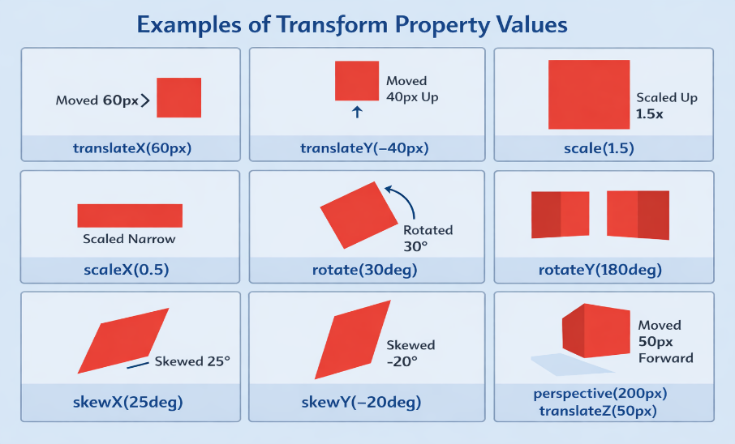
transform: translate(50px, 100px);

<!DOCTYPE html>
<html>
<head>
<style>
.parent{
perspective: 300px;
margin:100px;
}

.box{
width:120px;
height:120px;
background:tomato;
transform: rotateY(50deg);
transition:1s;
}

.box:hover{
transform: rotateY(0deg);
}
</style>
</head>
<body>

<div class="parent">
<div class="box"></div>
</div>

</body>
</html>

🧠 Interview Point
✅ perspective → applied on parent
✅ transform: perspective() → applied on element

.inner > .card{
height: 200px;
width: 200px;
background-color: yellow;

/* transition: all 3s linear 1s; */

transition-property: all;
transition-duration: 3s;
transition-timing-function: ease-in;
transition-delay: 1s;

}
Property | Possible Values | Purpose
transition-property | all, none, opacity, width, transform, etc. | Specifies which CSS property will animate
transition-duration | time → 0.5s, 1s, 200ms | Defines how long the transition takes
transition-timing-function | ease, linear, ease-in, ease-out, ease-in-out, cubic-bezier() | Controls speed curve
transition-delay | time → 0s, 1s | Wait time before animation starts

Value | Effect
ease | slow → fast → slow (default)
linear | same speed
ease-in | slow start
ease-out | slow end
ease-in-out | slow start & end
cubic-bezier(n,n,n,n) | custom speed curve

Background property

Here is the CSS Background Properties in table format with
✅ Possible values + ✅ Purpose — perfect for exams & interviews. 🔥

🎯 CSS Background Properties
Property | Possible Values | Purpose
background-color | color name, hex, rgb(), rgba(), hsl() | Sets the background color
background-image | url("img.jpg"), none, linear-gradient(), radial-gradient() | Sets one or more background images
background-repeat | repeat, no-repeat, repeat-x, repeat-y, space, round | Controls image repetition
background-position | left, right, top, bottom, center, %, px | Sets starting position of background image
background-size | auto, cover, contain, length, % | Defines size of background image
background-attachment | scroll, fixed, local | Controls scrolling behavior of background
background-clip | border-box, padding-box, content-box, text | Defines painting area of background
background-origin | border-box, padding-box, content-box | Defines positioning area of background
background-blend-mode | multiply, screen, overlay, darken, lighten, etc. | Blends background image with color
background (shorthand) | color image position / size repeat attachment origin clip | Sets all background properties in one line

🧠

Color → Image → Repeat → Position / Size → Attachment → Origin → Clip

Most Important for Interview
⭐ background-color
⭐ background-image
⭐ background-repeat
⭐ background-position
⭐ background-size
⭐ background (shorthand)

🎯 Example
.box{
background-color: lightblue;
background-image: url("img.jpg");
background-repeat: no-repeat;
background-position: center;
background-size: cover;
}

🔥 Shorthand Example
background: url("img.jpg") no-repeat center / cover;

🎯 Real-Time Use Cases
Property | Used For
background-size: cover | Full page hero section
background-attachment: fixed | Parallax effect
background-repeat: no-repeat | Single image display
background-position: center | Centered image

🧠 Quick Memory Trick
👉 Color → Image → Position → Size → Repeat → Attachment
Animation

✅ How to give animation in CSS
To apply animation you need 2 things:
1️⃣ Define the animation using @keyframes
2️⃣ Apply it to an element using animation properties

🔹 Step 1: Create animation
@keyframes myAnimation {
from {
transform: translateX(0);
}
to {
transform: translateX(200px);
}
}
or
@keyframes myAnimation {
0% { opacity: 0; }
50% { opacity: 0.5; }
100% { opacity: 1; }
}
Property | Possible Values | Purpose
animation-name | none, keyframename | Specifies which @keyframes to apply
animation-duration | time → 1s, 500ms | How long one animation cycle takes
animation-timing-function | ease, linear, ease-in, ease-out, ease-in-out, cubic-bezier() | Speed curve of animation
animation-delay | time → 0s, 2s, -1s | Wait before animation starts
animation-iteration-count | number, infinite | How many times animation runs
animation-direction | normal, reverse, alternate, alternate-reverse | Animation playing direction
animation-fill-mode | none, forwards, backwards, both | Style applied before/after animation
animation-play-state | running, paused | Start or pause animation

ANIMATION DIRECTION

Value | Purpose
normal | start → end
reverse | end → start
alternate | forward → backward
alternate-reverse | backward → forward

animation: name duration timing-function delay iteration-count direction fill-mode play-state;

MEDIA QUERY
Your media query:
@media (min-width:500px) and (max-width:800px) {
footer > h1{
color: green;
}
}

✅ What condition is given here?
This rule will apply ONLY WHEN the screen width is between 500px and 800px.

✔ Condition in simple words:
🟢 Screen width ≥ 500px
AND
🟢 Screen width ≤ 800px

⭐ All possible media query conditions (for exams)

🔹 Width & Height
min-width
max-width
min-height
max-height

🔹 Orientation
@media (orientation: portrait) TO MENTION AS MOBILE HEIGHT>WIDTH
@media (orientation: landscape) TO MENTION AS LAPTOP HEIGHT<WIDTH

🔹 Device type
@media screen
@media print
@media all

They tell the browser where the CSS should be applied.
@media screen
@media print
@media all

✅ 1️⃣ @media screen
👉 Used for mobile, laptop, tablet, desktop screens

Example
@media screen {
body{
background: lightblue;
}
}
📌 This CSS works only on screens (not while printing).

🎯 With condition
@media screen and (max-width:600px){
body{
background: pink;
}
}
✔ Applied only on small screens

✅ 2️⃣ @media print
👉 Used when the user prints the webpage
🖨 Very useful for:
- hiding buttons
- removing navigation bar
- changing text color to black
- showing only important content

Example
@media print{
body{
background: white;
color: black;
}

button{
display: none;
}
}
📌 Buttons will not appear in print

🖨 Real-time example
nav{
background: black;
color: white;
}

@media print{
nav{
display:none;
}
}
👉 Navbar visible on screen
👉 Hidden in print

✅ 3️⃣ @media all
👉 Default for all devices
- screen
- print
- speech

Example
@media all{
h1{
color: green;
}
}
📌 Works everywhere
💡 Usually we don’t write this because CSS is already for all by default.

🔥 Complete Example
/* Screen only */
@media screen{
h1{
color: blue;
}
}

/* Print only */
@media print{
h1{
color: black;
}
}

/* All devices */
@media all{
body{
font-family: Arial;
}
}

🔹 Resolution
@media (min-resolution: 2dppx)

The resolution media feature is used to apply CSS based on the pixel density of the device (how sharp the screen is).
It is mainly used for:
🖥 Retina displays
📱 High-density mobile screens
🖨 High-quality print

✅ Syntax
@media (resolution: value) { }
@media (min-resolution: value) { }
@media (max-resolution: value) { }

📏 Units used in resolution
Unit | Meaning
dpi | dots per inch
dppx | dots per pixel
dpcm | dots per centimeter
💡 Most modern projects use dppx

🎯 Common value for Retina screens
@media (min-resolution: 2dppx)
👉 Targets high-density screens

✅ Example 1 – Change text for HD screens
@media (min-resolution: 2dppx){
h1{
color: red;
}
}
✔ Works on Retina / high-quality displays

✅ Example 2 – Load high-quality image
.logo{
background-image: url("normal.png");
}

@media (min-resolution: 2dppx){
.logo{
background-image: url("hd.png");
}
}

🔹 Combining conditions
and
or (comma ,)
not
only

🎯 “How do you make a web page responsive using HTML & CSS?”

✅ 1️⃣ Use the viewport meta tag (HTML)
This tells the browser how to control layout on mobile.
<meta name="viewport" content="width=device-width, initial-scale=1.0">
📌 Without this → mobile layout will be zoomed out ❌

✅ 2️⃣ Use Flexible Layouts

✔ Flexbox
.container{
display: flex;
flex-wrap: wrap;
}

✔ CSS Grid
.container{
display: grid;
grid-template-columns: repeat(auto-fit, minmax(250px, 1fr));
}
👉 Layout automatically adjusts to screen size 😍

✅ 3️⃣ Use Media Queries
@media (max-width:768px){
.container{
flex-direction: column;
}
}
Used to:
- change layout
- resize text
- hide/show elements

✅ 4️⃣ Use Relative Units (Not fixed units)
❌ Avoid:
width: 500px;
✅ Use:
width: 100%;
font-size: 2rem;
padding: 5%;
Units used:
- %
- em
- rem
- vw
- vh

✅ 5️⃣ Make Images Responsive
img{
max-width:100%;
height:auto;
}
Image will never overflow.

✅ 6️⃣ Use Responsive Typography
h1{
font-size: clamp(1.5rem, 4vw, 3rem);
}
Text scales automatically.

✅ 7️⃣ Mobile-first approach (Best practice ⭐)
/* Mobile styles first */

.container{
flex-direction: column;
}

/* Larger screens */

@media (min-width:768px){
.container{
flex-direction: row;
}
}

🧠 Interview Bonus Points 💥
Say this line:
🗣 “I use mobile-first design with Flexbox/Grid, media queries, fluid units, and responsive images to adapt layout for different screen sizes.

OBJECTFIT

🎯 object-fit and object-position (Interview + Exam ready)
These properties are used with:
<img>
<video>
to control how the media fits inside its container.

✅ object-fit

🔹 Syntax
object-fit: value;

🎯 Possible values
Value | Meaning
fill | Default. Stretches to fill the container (may distort)
contain | Fits inside container without cropping (keeps aspect ratio)
cover | Fills the container and crops extra (keeps aspect ratio)
none | Original size (no resize)
scale-down | Smaller of none or contain

🔥 Visual behaviour

fill
📦 Image is stretched
❌ Aspect ratio not maintained

contain
✔ Full image visible
📌 Empty space may appear

cover ⭐ (Most used)
✔ No empty space
✔ Aspect ratio maintained
❌ Image may be cropped

none
Image keeps original size.

scale-down
Chooses:
- none OR
- contain
👉 whichever is smaller.

✅ object-position
Used to control image alignment inside the container

🔹 Syntax
object-position: value;

🎯 Possible values

1️⃣ Keyword values
Value | Meaning
top | top center
bottom | bottom center
left | left center
right | right center
center | center (default)

2️⃣ Two-value positions
object-position: right top;
object-position: left bottom;
object-position: center top;

3️⃣ Length values
object-position: 20px 40px;
👉 x-axis y-axis

4️⃣ Percentage values
object-position: 50% 50%;
object-position: 100% 0%;
.container{
width: 300px;
height: 300px;
border: 2px solid black;
}

.container img{
width: 100%;
height: 100%;
object-fit: cover; /* ✅ Apply here */
}

grid

# 🧩 1️⃣ Grid Container Properties

(Used on the parent)

## 🔹 display

css
display: grid; -----The container act as a block level element---
display: inline-grid; -----The container act as a inline level element---

➡ Turns element into a grid container.

---

## 🔹 grid-template-columns

Defines *number & width of columns*

css
grid-template-columns: 200px 1fr 1fr;
grid-template-columns: repeat(3, 1fr);

---

## 🔹 grid-template-rows

Defines *row height*

css
grid-template-rows: 100px auto 1fr;

---

## 🔹 gap (very important ⭐)

Space between rows & columns

css
gap: 20px;
row-gap: 10px;
column-gap: 30px;

---

## 🔹 justify-content

Aligns *whole grid horizontally*

Values:

start | end | center | space-between | space-around | space-evenly

---

## 🔹 align-content

Aligns *whole grid vertically*

Same values as justify-content

---

## 🔹 place-content ✅ (shortcut)

css
place-content: center space-between;

---

## 🔹 justify-items

Align items *inside each cell (horizontal)*

Values:

start | end | center | stretch

---

## 🔹 align-items

Align items *inside each cell (vertical)*

---

## 🔹 place-items ✅ (shortcut)

css
place-items: center;

---

## 🔹 grid-template-areas ⭐ (Very important for layout)

Used for *page structure*

css
grid-template-areas:
"header header"
"sidebar content"
"footer footer";

---

# 🧩 2️⃣ Grid Item Properties

(Used on the child)

## 🔹 grid-column

css
grid-column: 1 / 3;
grid-column: span 2;

---

## 🔹 grid-row

css
grid-row: 1 / 3;

---

## 🔹 grid-area ⭐

Used for:

* positioning
* naming layout

css
grid-area: header;

---

## 🔹 justify-self

Align *single item horizontally*

---

## 🔹 align-self

Align *single item vertically*

---

## 🔹 place-self (shortcut)

css
place-self: center;

---

# 🧩 3️⃣ Special Functions / Units ⭐ (Frequently Asked in Interviews)

## 🔹 fr unit

css
1fr 2fr

Flexible space.

---

## 🔹 repeat()

css
repeat(3, 1fr)

---

## 🔹 minmax()

css
minmax(200px, 1fr)

---

## 🔹 auto-fit / auto-fill (for responsive grid)

css
repeat(auto-fit, minmax(250px, 1fr))

🎯 5. POSITION PROPERTY
position:
Values:
- static(default all the elements position is static)
- relative(suppose if you give top or left means the element move from current position only)
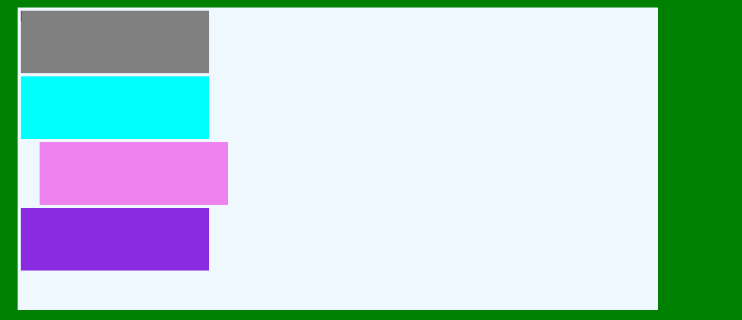
*{
margin: 0%;
padding: 0%;
box-sizing: border-box;
}
.outer{
height: 200vh;
background-color: green;
display:flex ;
justify-content: center;
align-items: center;

}
.inner{
height: 75vh;
width: 75vw;
background-color: aliceblue;
position: relative;

}
.box{
height: 100px;
width: 300px;
margin: 5px;

}
#box1{
background-color: gray;
/* position: relative;
z-index: 5; */
}
#box2{
background-color: aqua;
}
#box3{
background-color: violet;
position: relative;
left: 30px;
/* position: sticky;

top: 400px;
z-index: 3; */
}
#box4{
background-color: blueviolet;
/* z-index: 10; */
/* position: relative; */
}

HERE BOX ONE AND TWO BOTH TEMPLATE ARE SAME OR DIFFERENT(TEMPLATE:RELATIVE,ABSOLUTE)
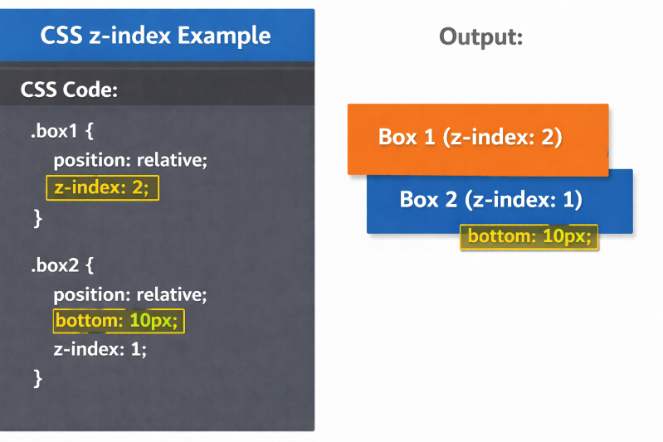
- absolute(once you give absolute means if you give top left ,then element move away from the your webpage border
- 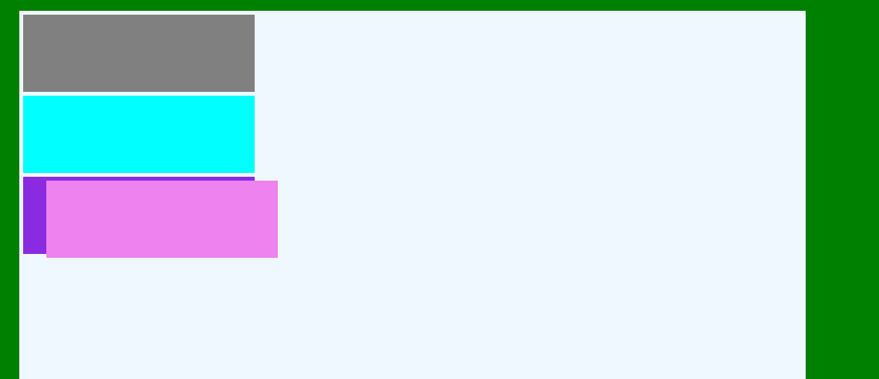
*{
margin: 0%;
padding: 0%;
box-sizing: border-box;
}
.outer{
height: 200vh;
background-color: green;
display:flex ;
justify-content: center;
align-items: center;

}
.inner{
height: 75vh;
width: 75vw;
background-color: aliceblue;
position: relative;

}
.box{
height: 100px;
width: 300px;
margin: 5px;

}
#box1{
background-color: gray;
/* position: relative;
z-index: 5; */
}
#box2{
background-color: aqua;
}
#box3{
background-color: violet;
position: absolute;
left: 30px;
/* position: sticky;

top: 400px;
z-index: 3; */
}
#box4{
background-color: blueviolet;
/* z-index: 10; */
/* position: relative; */
}

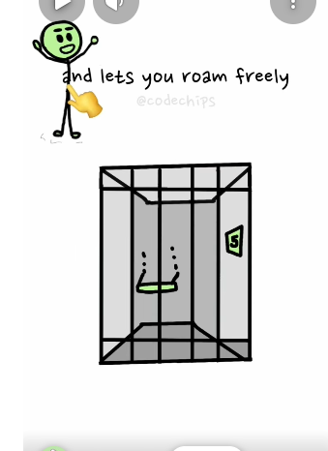
Here theif is absolute so it come out from cell if give top left means theif will move from surrounding space of cell
If cell is relative then theif is absolute means the cell will be open also but he will any where move only within a cell(here I will give position to theif means he can move from cell wall to another position)
If cell is static(default) theif is relative means the cell is locked but the theif move from current position to another position
- fixed(the element position fixed at current position even thought scroll also)
- sticky(if any element position is sticky and top:20px once the element is reached 20px from top means then after the element should be fixed at this position
Here are clear CSS notes for
✅ position
✅ z-index
✅ why we use position
Perfect for interview + revision.

📌 CSS POSITION – Complete Notes

🔹 Why we use position?
By default HTML elements follow normal document flow (top → bottom).
We use position to:
- Move elements anywhere on the page
- Create overlapping layouts
- Place items inside a container
- Build navbar, dropdown, tooltip, modal, sticky header
- Control layout in advanced UI

🔹 position values

1️⃣ position: static (default)
- Normal flow
- top right bottom left ❌ NOT WORK
- z-index ❌ NOT WORK
box {
position: static;
}

2️⃣ position: relative
- Moves relative to its original position
- Space is still reserved
- Enables top right bottom left
- Enables z-index
.box {
position: relative;
top: 20px;
left: 30px;
}
🧠 Interview line:
👉 Moves from its own original location.

3️⃣ position: absolute
- Moves relative to nearest positioned parent
- Removed from normal flow ❌
- No space is kept
.parent {
position: relative;
}

.child {
position: absolute;
top: 0;
right: 0;
}
🧠 Interview line:
👉 Positioned inside a positioned parent.

4️⃣ position: fixed
- Relative to viewport
- Does NOT move on scroll
.header {
position: fixed;
top: 0;
}
📌 Used for:
- Sticky navbar
- Floating button

5️⃣ position: sticky
- Works like relative + fixed
- Sticks when scrolling
.nav {
position: sticky;
top: 0;
}

🔹 top, right, bottom, left
These work only when position is:
✅ relative
✅ absolute
✅ fixed
✅ sticky
They move element from that direction.

📌 Z-INDEX NOTES

🔹 Why z-index?
Controls stacking order (front/back) when elements overlap.
🧠 Like layers in Photoshop.

🔹 Rules of z-index

1️⃣ Works only on positioned elements
position: relative | absolute | fixed | sticky;

2️⃣ Higher value → comes to front
z-index: 10; /* front */
z-index: 1; /* back */

3️⃣ Default value
z-index: auto;

🔹 Example
.box1{
position: relative;
z-index: 2;
}

.box2{
position: relative;
z-index: 1;
}
✅ box1 will be on top.

📌 POSITION vs Z-INDEX CONNECTION
Without position:
z-index ❌ NOT WORK
With position:
z-index ✅ WORK

📌 Real-time use cases

✅ relative
- Small adjustments
- Parent for absolute child

✅ absolute
- Tooltip
- Dropdown
- Badge on image

✅ fixed
- WhatsApp floating button
- Fixed navbar

✅ sticky
- Sticky header
- Sticky sidebar

🎯 INTERVIEW QUICK SUMMARY

What is position?
Property used to control how an element is placed on the page.

Why we use it?
To:
- Move elements
- Overlap elements
- Create advanced layouts

What is z-index?
Controls stacking order of positioned elements.

Key rule:
👉 z-index works only when position is not static.

⭐To place an element exactly at the center using CSS position, you have a few standard methods.

✅ Method 1 — position: absolute + transform (Most used)
.parent {
position: relative;
height: 100vh;
}
.child {
position: absolute;
top: 50%;
left: 50%;
transform: translate(-50%, -50%);
}

🔹 Why this works
- top: 50% → moves element halfway from top
- left: 50% → moves element halfway from left
- transform: translate(-50%, -50%) → pulls it back by half of its own size

Want next?
I can give you:
- 🔥 Position + z-index visual diagrams
- 🎯 10 interview questions with answers
- 🧠 Real-world layout examples
Just say: “give interview questions” or “give real-time examples”.

🔹 Feature | 🔸 Flexbox | 🔸 Grid
Layout type | One-dimensional | Two-dimensional
Direction | Row or Column | Row and Column together
Main purpose | Align items in a single line | Create full page/layout structure
Axis control | Works on main axis & cross axis | Works on rows & columns
Item placement | Items flow automatically | Items can be placed anywhere
Content size handling | Content-based | Track-based (row/column size)
Wrapping | Uses flex-wrap | No need (grid handles automatically)
Alignment | Good for component alignment | Perfect for page layout alignment
Layering (overlap) | Difficult | Easy using grid-area
Gap support | Yes (gap) | Yes (gap)
Responsive design | Simple layouts | Complex responsive layouts
Control over both dimensions | ❌ No | ✅ Yes
Example use | Navbar, buttons, card row | Full website layout

🔹 Feature | 🔸 Absolute Units | 🔸 Relative Units
Definition | Fixed size units | Size depends on parent or screen
Responsiveness | ❌ Not responsive | ✅ Responsive
Based on | Physical measurement | Parent element / root / viewport
Flexibility | Fixed | Flexible
Scaling | Does NOT change | Changes dynamically
Best for | Print layout, borders | Responsive design
Accessibility | ❌ Poor | ✅ Good
Common usage | Exact size needed | Modern web design

🎯 1. CSS TYPES & SYNTAX

✔️ Types of CSS
- Inline → inside HTML tag
- Internal → inside <style>
- External → .css file

✔️ Basic Syntax
selector {
property: value;
}

🎯 2. CSS SELECTORS

✔️ Basic Selectors
p {} /* element */
.class {} /* class */
#id {} /* id */
* {} /* universal */
h1,h2 {} /* group */

✔️ Attribute Selector
input[type="text"]
Values:
- text
- password
- email
- number

✔️ Pseudo Classes
:hover
:active
:focus
:first-child
:last-child

✔️ Pseudo Elements
::before
::after
::first-letter
::first-line

🎯 3. BOX MODEL
Properties & Values:

✔️ width / height
- px
- %
- auto
- vw
- vh

✔️ margin
- px
- %
- auto
margin: 10px;
margin: 10px 20px;

✔️ padding
- px
- %
- em

✔️ border
border: 1px solid black;
border-style values:
- solid
- dotted
- dashed
- double
- groove
- none

🎯 4. DISPLAY PROPERTY
display:
Possible Values:
- block
- inline
- inline-block
- flex
- grid
- none
- contents

🎯 5. POSITION PROPERTY
position:
Values:
- static
- relative
- absolute
- fixed
- sticky
Additional properties:
top
bottom
left
right
Values:
- px
- %
- auto

🎯 6. FLEXBOX
display:flex;

Container Properties

flex-direction
- row
- column
- row-reverse
- column-reverse

justify-content
- flex-start
- flex-end
- center
- space-between
- space-around
- space-evenly

align-items
- stretch
- center
- flex-start
- flex-end
- baseline

flex-wrap
- nowrap
- wrap
- wrap-reverse

🎯 7. GRID
display:grid;
Properties:

grid-template-columns
- auto
- px
- %
- fr
Example:
grid-template-columns: 1fr 1fr;

gap
- px
- %

🎯 8. TEXT & FONT

font-family
- Arial
- Verdana
- sans-serif
- serif
- monospace

font-weight
- normal
- bold
- lighter
- bolder
- 100–900

text-align
- left
- right
- center
- justify

text-decoration
- none
- underline
- overline
- line-through

🎯 9. COLORS & BACKGROUND

color values
- red
- #ff0000
- rgb()
- rgba()
- hsl()

background properties

background-repeat
- no-repeat
- repeat
- repeat-x
- repeat-y

background-size
- cover
- contain
- auto

background-position
- center
- top
- bottom
- left
- right

🎯 10. RESPONSIVE DESIGN

Media Query
@media screen and (max-width:600px)
Units:
- %
- vw
- vh
- rem
- em

🎯 11. ADVANCED CSS

z-index
- auto
- number

overflow
- hidden
- scroll
- auto
- visible

transition
transition: all 0.3s ease;
Values:
- linear
- ease
- ease-in
- ease-out
- ease-in-out

transform
- rotate()
- scale()
- translate()
- skew()

animation
- animation-name
- animation-duration
- animation-delay
- animation-iteration-count

🧾 SUPER IMPORTANT EXAM PROPERTIES (Top 20)
- display
- position
- margin
- padding
- border
- flex-direction
- justify-content
- align-items
- grid-template-columns
- font-size
- font-weight
- text-align
- background-color
- color
- overflow
- z-index
- transition
- transform
- width
- height

If you want 😄 I can also make:
✅ 📘 Complete CSS Notes PDF (very useful for exams)
✅ 🧠 100 CSS Interview Questions with Answers
✅ 🔥 CSS Roadmap (Beginner → Advanced → Job Ready)
✅ 💻 Real Project-Based CSS Topics (what companies expect)
Just tell 👍.
Points
Cursor:pointer

