Part-3
- Exception
a)Define & RealTime example
b)Types of Exception and explain
c)Exception handling
d)Explain try,catch –rules,finally
e)throw

  - Define
  - Syntax
  - Note
f)throws
  - Define
  - Note
  - Syntax
  - Rules
g)Difference between Throw and Throws
h)Difference b/w final, finally ,finalize
i)Throwabletype of object ref.printStackTrace()
j)Object Propagation
k)Unchecked Exception propagation
l)Custom Exception
  - Define
  - We can create custom exception for both checked and unchecked
Feature | List | Set
Type | Interface | Interface
Package | java.util | java.util
Duplicates | ✅ Allowed | ❌ Not allowed
Order | ✅ Maintains insertion order | ❌ No order (except LinkedHashSet, TreeSet)
Indexing | ✅ Supports index | ❌ No index
Access | get(index) | No direct access
Sorting | ✅ Can be sorted | ❌ Cannot be sorted directly
Null elements | ✅ Multiple nulls (ArrayList) | ❌ Only one null (HashSet)
Performance | Good for search by index | Good for uniqueness
Iterator | ListIterator + Iterator | Only Iterator
Implementations | ArrayList, LinkedList, Vector | HashSet, LinkedHashSet, TreeSet

Feature | ArrayList | LinkedList | Vector | Stack
Data structure | Resizable array | Doubly linked list | Resizable array | LIFO (Vector)
Thread-safe | ❌ | ❌ | ✅ | ✅
Access by index | O(1) | O(n) | O(1) | O(1)
Insert/delete middle | O(n) | O(1) | O(n) | O(n)
Implements | List | List, Deque | List | Vector
Legacy | ❌ | ❌ | ✅ | ✅
Use case | Fast search | Frequent insertion/deletion | Thread-safe array | LIFO operations

Feature/Aspect | ArrayList | LinkedList | Vector | Stack
Underlying Data Structure | Dynamic array | Doubly linked list | Dynamic array | Extends Vector (dynamic array)
Implements Interfaces | List, RandomAccess, Cloneable, Serializable | List, Deque, Cloneable, Serializable | List, RandomAccess, Cloneable, Serializable | List, RandomAccess, Cloneable, Serializable
Insertion/Deletion | Slow (except at end, O(1) amortized) | Fast (O(1) at start or end, O(n) for index access) | Slow (like ArrayList) | Same as Vector (slow in middle)
Access by Index | Fast (O(1)) | Slow (O(n)) | Fast (O(1)) | Fast (O(1))
Thread Safety | Not synchronized | Not synchronized | Synchronized (thread-safe) | Synchronized (thread-safe)
Usage | General-purpose list, frequent access | Frequent insert/delete, queue/deque operations | Legacy code, thread-safe list | LIFO operations (push/pop)
Memory Overhead | Low | Higher (due to node pointers) | Low | Low (inherits Vector overhead)
Performance | Fast for random access | Fast for insertion/deletion | Slightly slower due to synchronization | Same as Vector

Feature/Aspect | HashSet | LinkedHashSet | TreeSet
Underlying Data Structure | Hash table | Hash table + doubly linked list | Red-Black tree (balanced binary search tree)
Implements Interfaces | Set, Cloneable, Serializable | Set, Cloneable, Serializable | Set, NavigableSet, SortedSet, Cloneable, Serializable
Order of Elements | No order (unordered) | Insertion order | Sorted (natural order or via Comparator)
Allows Null | Yes (only one null) | Yes (only one null) | No
Performance (Add/Remove/Contains) | O(1) average | O(1) average | O(log n)
Iteration Order | Unpredictable | Predictable (insertion order) | Sorted order
Memory Overhead | Low | Slightly higher (due to linked list) | Higher (tree structure)
Thread Safety | Not synchronized | Not synchronized | Not synchronized
Usage | Fast operations without order | Maintain insertion order | Maintain sorted order

Feature/Aspect | HashMap | LinkedHashMap | TreeMap
Underlying Data Structure | Hash table | Hash table + doubly linked list | Red-Black tree (balanced binary search tree)
Implements Interfaces | Map, Cloneable, Serializable | Map, Cloneable, Serializable | Map, NavigableMap, SortedMap, Cloneable, Serializable
Order of Entries | No order (unordered) | Insertion order | Sorted order (natural or via Comparator)
Allows Null | Yes (1 null key, multiple null values) | Yes (1 null key, multiple null values) | No null keys, allows multiple null values
Performance (Put/Get/Remove) | O(1) average | O(1) average | O(log n)
Iteration Order | Unpredictable | Predictable (insertion order) | Sorted order
Memory Overhead | Low | Slightly higher (due to linked list) | Higher (tree structure)
Thread Safety | Not synchronized | Not synchronized | Not synchronized
Usage | Fast key-value operations without order | Maintain insertion order | Maintain sorted keys; range queries

Feature / Aspect | Set | Map
Type | Collection of elements | Collection of key–value pairs
Package | java.util | java.util
Extends / Interface | Extends Collection | Does NOT extend Collection
Data Storage | Stores only values | Stores key → value pairs
Duplicates | ❌ Does not allow duplicate elements | ❌ Does not allow duplicate keys (values can be duplicate)
Null Allowed | Depends on implementation (e.g., HashSet allows one null) | Depends on implementation (e.g., HashMap allows one null key, multiple null values)
Access Mechanism | Access via iteration only | Access via keys using get(key)
Index-Based Access | ❌ No indexing, no get() method | ❌ No index, but key-based access
Order Maintenance | Depends on implementation (LinkedHashSet, TreeSet) | Depends on implementation (LinkedHashMap, TreeMap)
Common Implementations | HashSet, LinkedHashSet, TreeSet | HashMap, LinkedHashMap, TreeMap, Hashtable
Use Case | When you need unique elements only | When you need key–value mapping

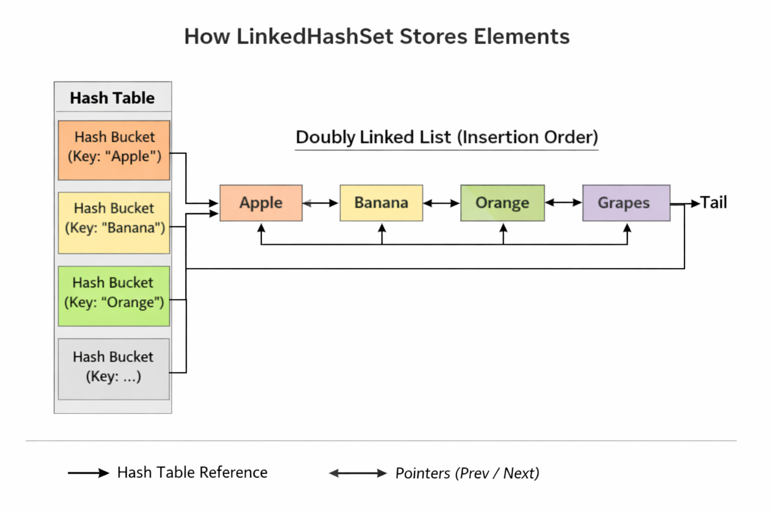
Feature | Comparable | Comparator
Package | java.lang | java.util
Type | Interface | Interface
Purpose | Defines natural/default ordering of objects | Defines custom or multiple sorting orders
Method | compareTo(Object o) | compare(Object o1, Object o2)
Number of methods | 1 | 1 (Functional Interface)
Changes required in class | Yes – class must implement Comparable | No – separate class or lambda
Override compareTo compare
BY USING LAMDA EXPRESSION:
Comparator<Student> c = new Comparator<Student>() {
@Override
public int compare(Student s1, Student s2) {
return s1.getId() - s2.getId();
}
};
Collections.sort(employeeList,
(e1, e2) -> e1.id - e2.id
);

