Task Description:
Create a dockerfile, docker-compose file which when executed must display your basic details in the website.
Docker Source Code has been update in the repository.
Docker Ps -a Status
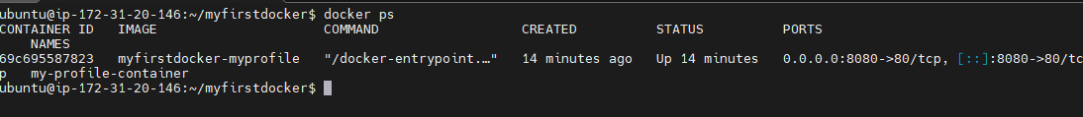
Docker Compose Command:
docker compose up --build -d – To build the docker
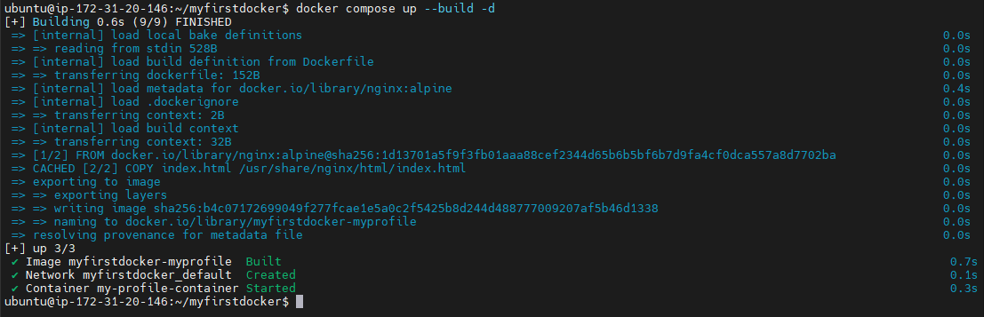
Docker Html Page Output:
