Task 3 Execution Command

EC2 Instance Launced:
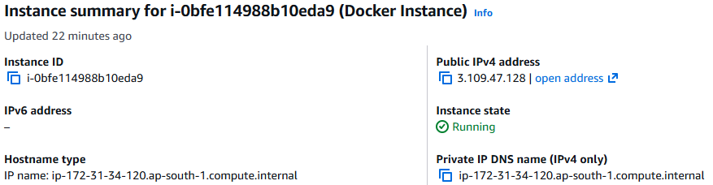

Docker & Docker Compose Installed Version:
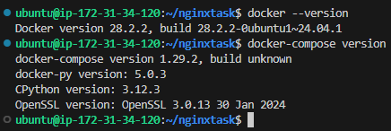

Docker file Info:
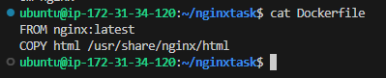
Docker-Compose.xml Code:
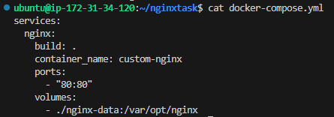

Docker-Compose Build Output:
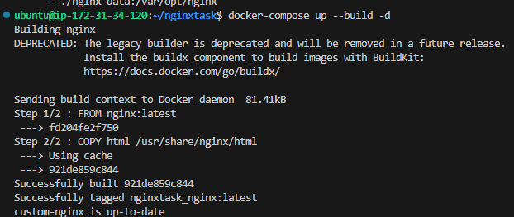
URL Output:
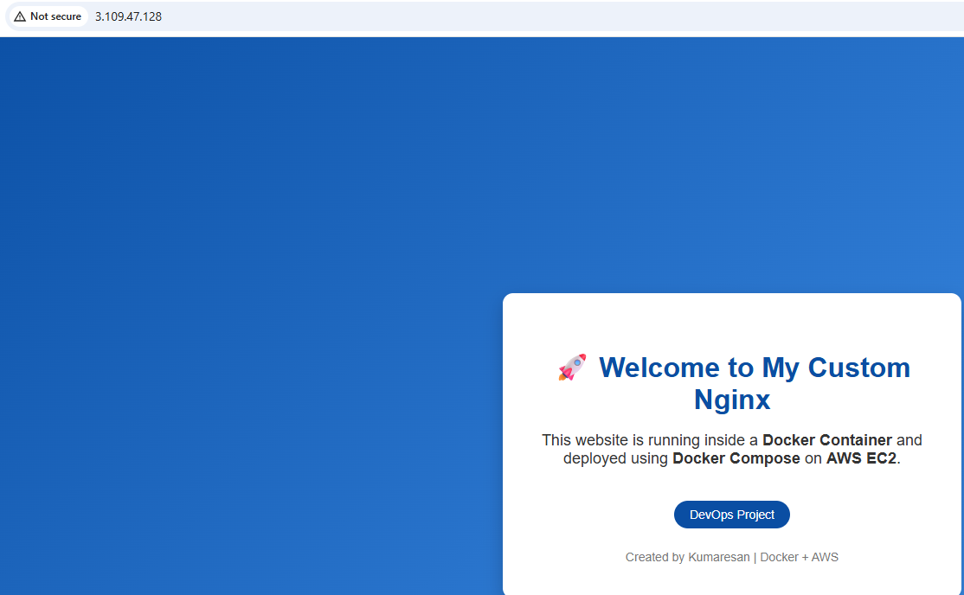

Docker LOG:
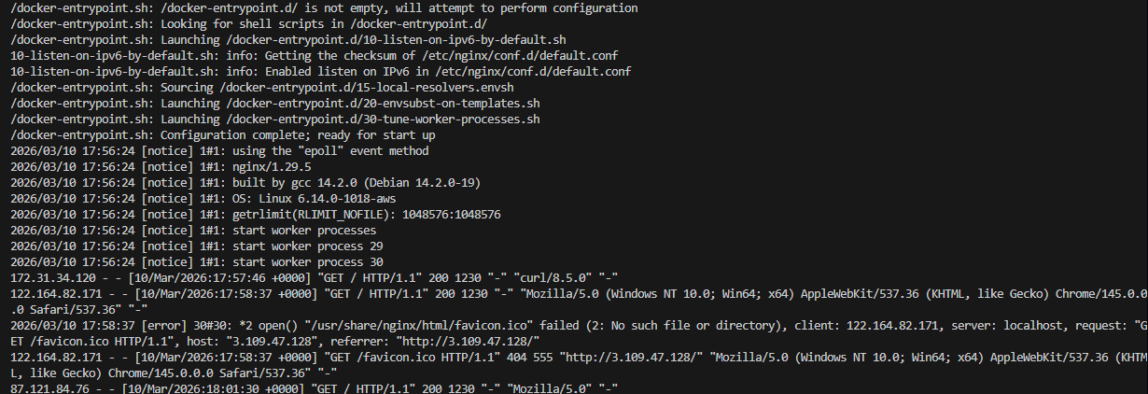
Docker Stats:
Docker Repositry Login:
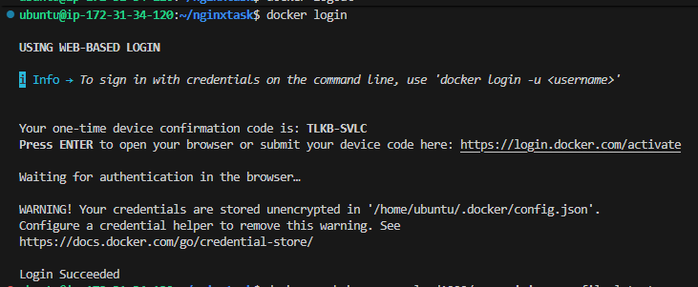
Converted the container to image and uploaded to docker Repositry:
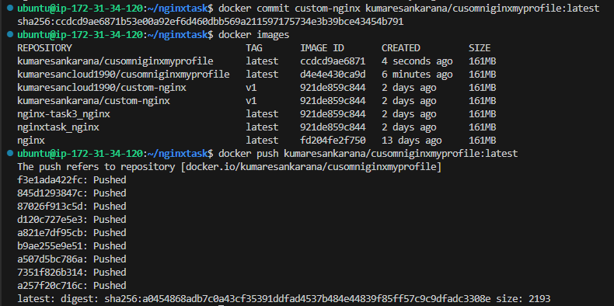
Repositry Page:
