Brainstorming – Idea Generation & Prioritization
Project: Auto Ticket Classification using ServiceNow Flow Designer

Problem Area
School IT tickets are often entered with inconsistent descriptions and require manual classification.

Brainstormed Ideas
- Automatic ticket classification from Short Description
- Automatic Category and Subcategory assignment
- Automated caller acknowledgement email
- Automatic assignment to support groups
- Dashboard and SLA tracking

Selected Idea
Auto Ticket Classification using ServiceNow Flow Designer was selected because it directly addresses repetitive manual classification using a maintainable no-code workflow.
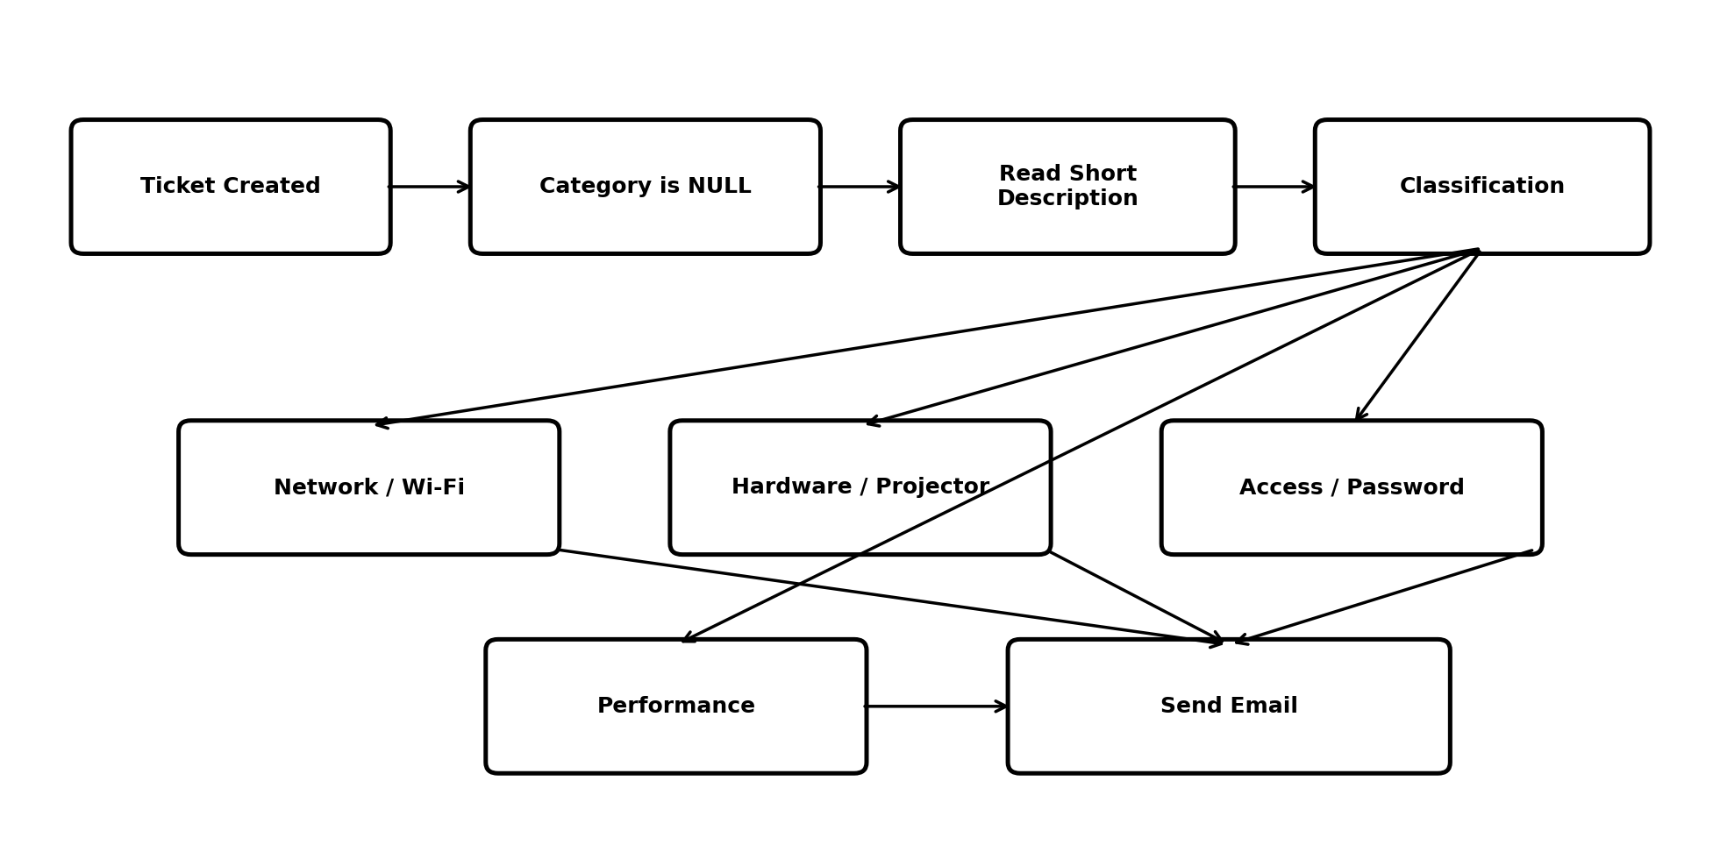
Figure 1: Proposed automated classification flow.

