Data Flow Diagrams and User Stories
Project: Auto Ticket Classification using ServiceNow Flow Designer

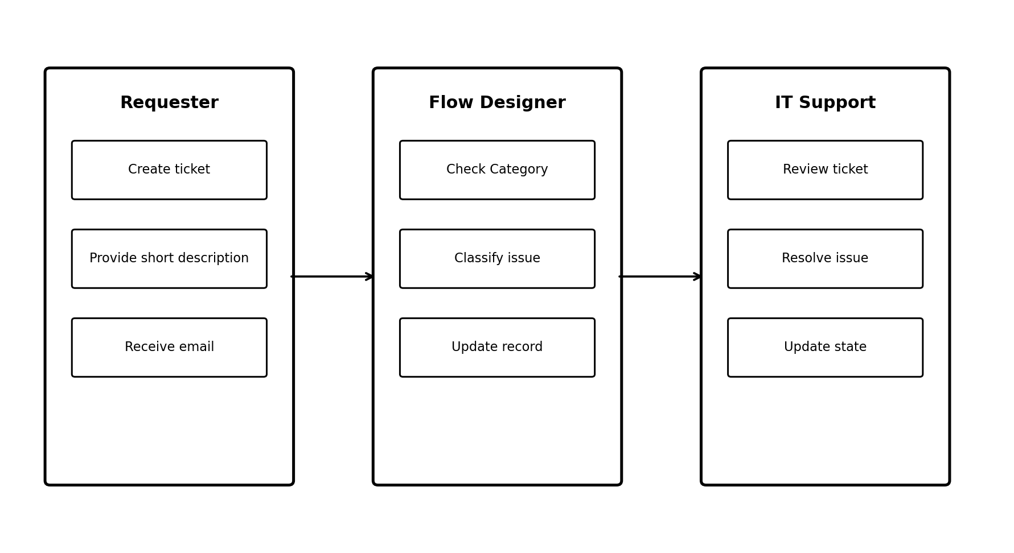
Figure 1: High-level user interaction and workflow.

User Stories
- As a requester, I want to create an IT ticket with a Short Description.
- As a requester, I want the system to classify my ticket automatically.
- As an IT support user, I want consistent Category and Subcategory values.
- As a requester, I want an email acknowledgement after submission.

Data Flow
Requester → Incident Workflow record → Flow Designer → Classification → Updated ticket → Email notification.

