Project Demonstration Checklist
Project: Auto Ticket Classification using ServiceNow Flow Designer

No. | Demonstration Item | Screenshot
1 | Flow name and Active status | Required
2 | Trigger: Created + Category NULL | Required
3 | Wi-Fi/Network classification | Required
4 | Projector/Hardware classification | Required
5 | Forgot Password classification | Required
6 | Performance classification | Required
7 | Send Email action | Required
8 | Created ticket | Required
9 | Updated Category/Subcategory | Required
10 | Email preview | Required
11 | Flow Test Run | Required

Recommended Demo Scenario
Create a ticket with Short Description 'WiFi not working in library'. Save/reload the record and show Network / Wi-Fi classification, followed by the acknowledgement email.
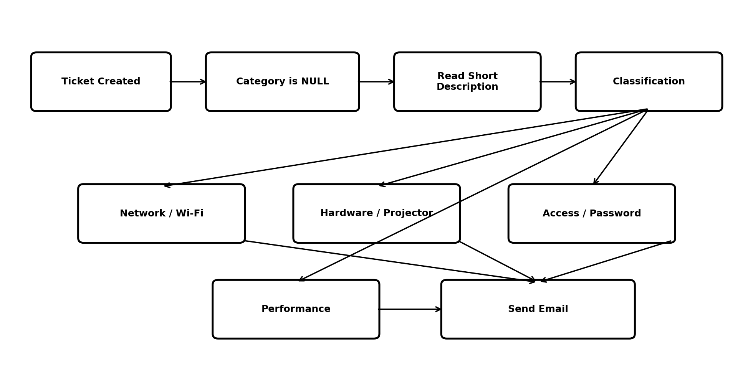
Figure 1: Classification flow to demonstrate.

