Final Report
Project: Auto Ticket Classification using ServiceNow Flow Designer

Abstract
This project implements an automated IT ticket classification solution using ServiceNow Flow Designer. The system reads the Short Description of a newly created Incident Workflow record, applies configured classification rules, updates Category and Subcategory, and sends an acknowledgement email.

Objectives
- Reduce manual classification effort
- Improve consistency of ticket data
- Automate caller acknowledgement
- Provide an extensible no-code design

System Flow
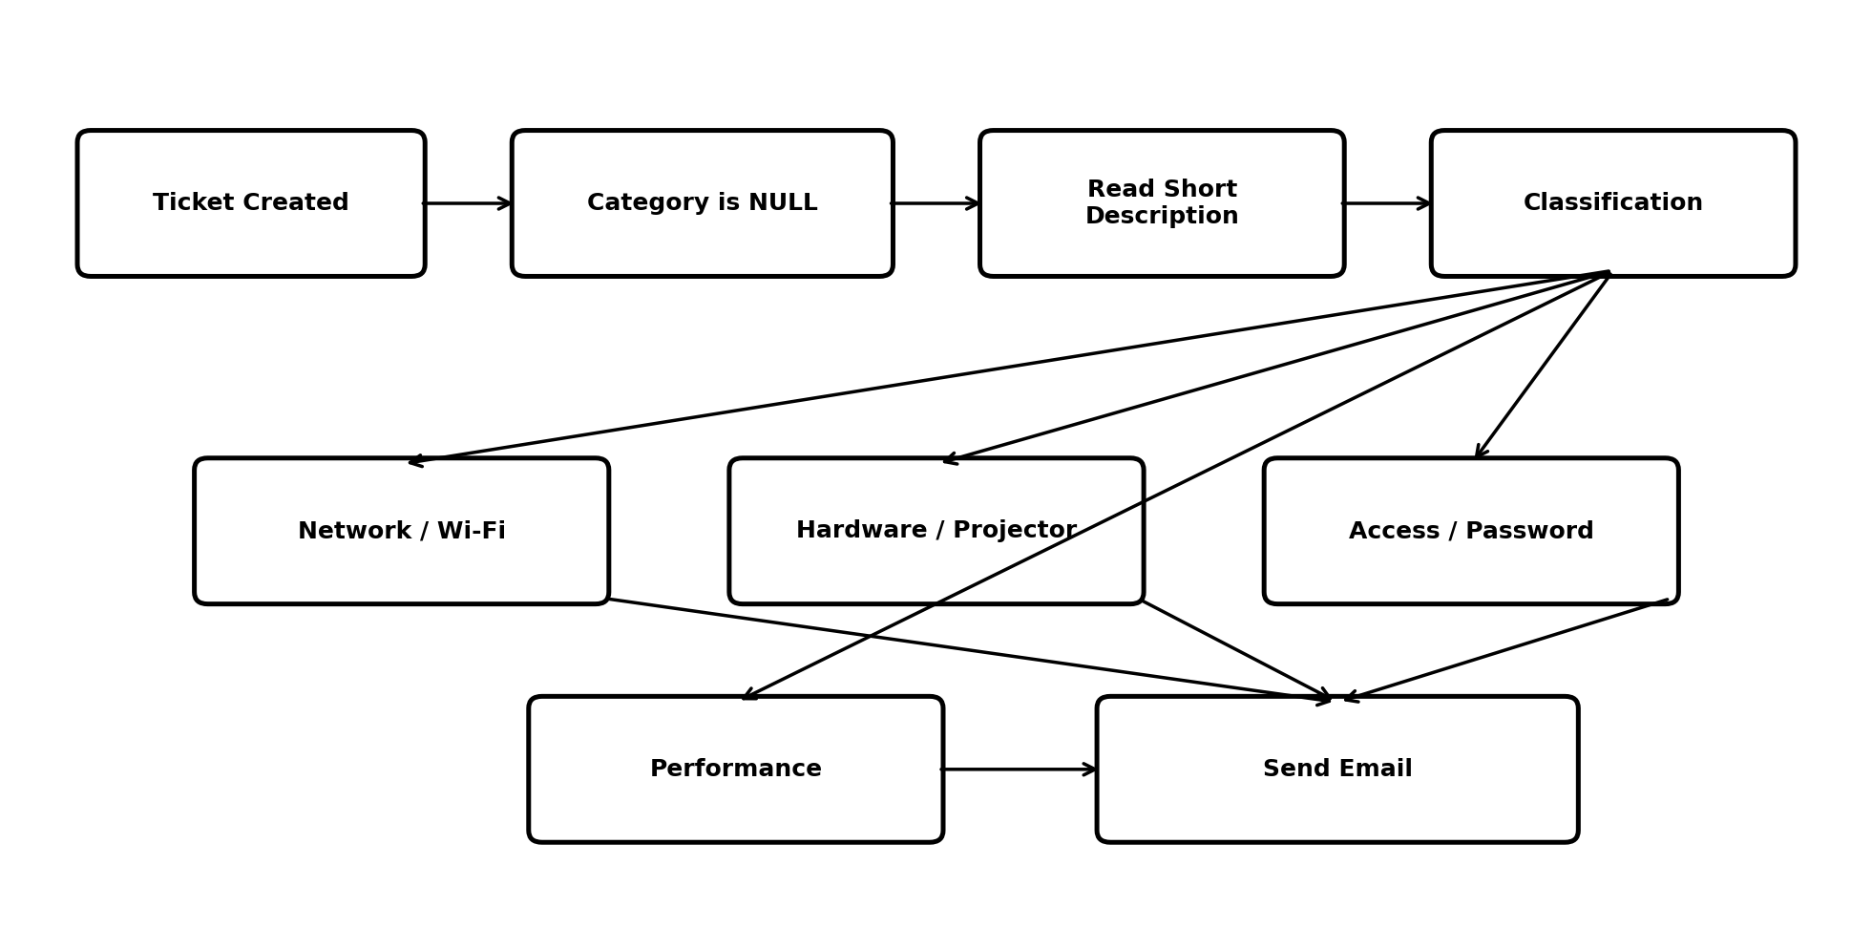
Figure 1: End-to-end system flow.

Conclusion
The project demonstrates how Flow Designer can automate a repeatable school IT helpdesk process without requiring complex scripting.

