Functional & Performance Testing
Project: Auto Ticket Classification using ServiceNow Flow Designer

Functional Testing
Area | Test
Trigger | Create record with Category NULL
Wi-Fi rule | Use WiFi/Network description
Projector rule | Use Projector description
Password rule | Use Forgot password description
Performance rule | Use performance/slow description
Email | Verify notification action

Performance/Operational Checks
- Flow completes without errors
- Classification occurs after record creation
- Email action completes
- Existing classified records are not unnecessarily reprocessed
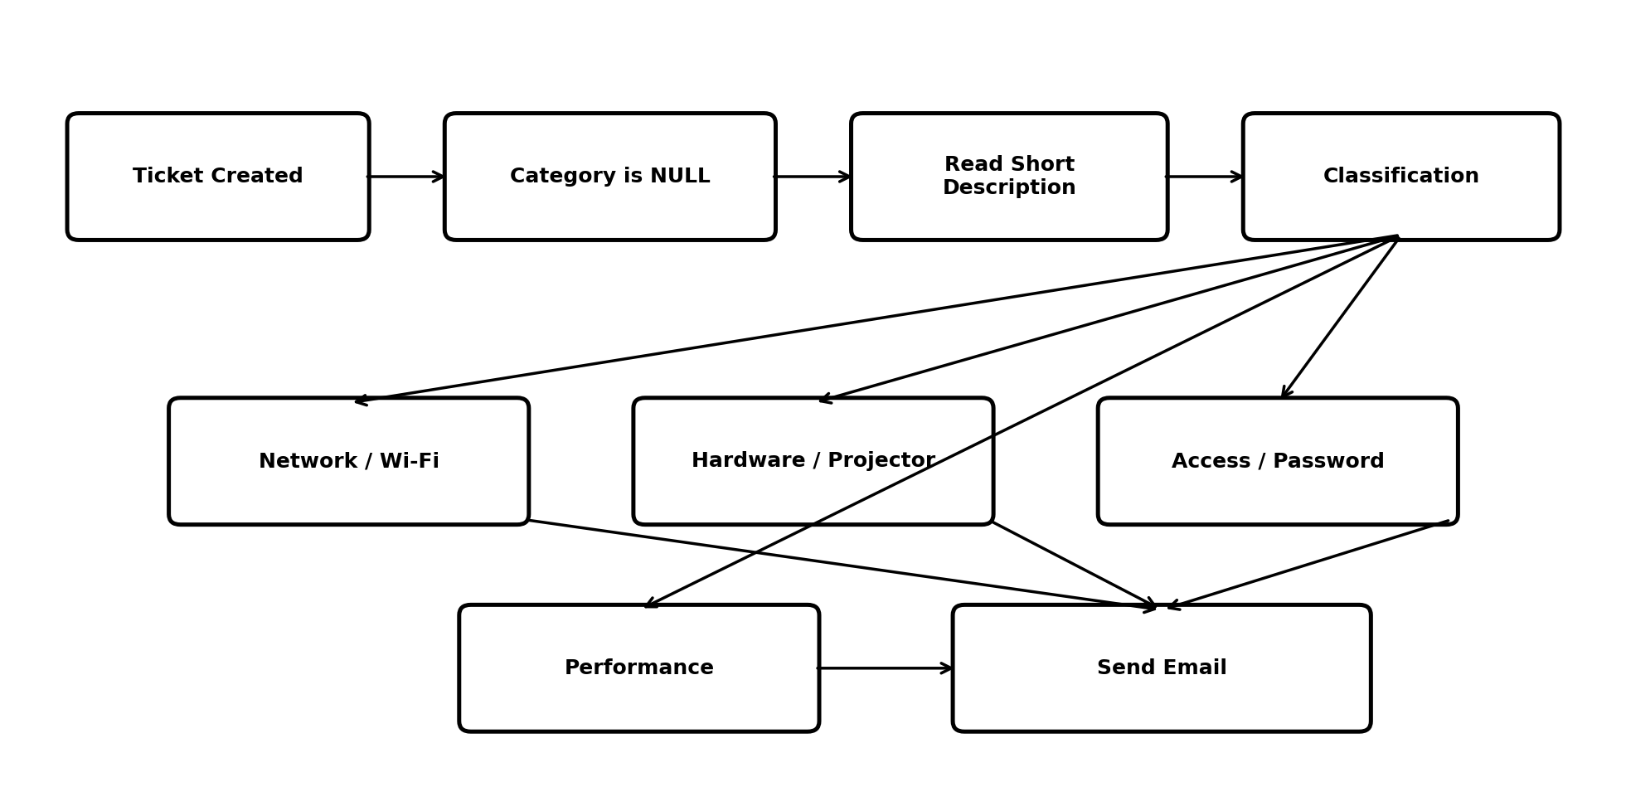
Figure 1: Workflow used for functional testing.

