Proposed Solution
Project: Auto Ticket Classification using ServiceNow Flow Designer

Solution Overview
Create an active ServiceNow Flow Designer flow named Auto Classify School IT Tickets. The flow starts when a new Incident Workflow record is created with Category empty, checks the Short Description, updates the classification, and sends an email.
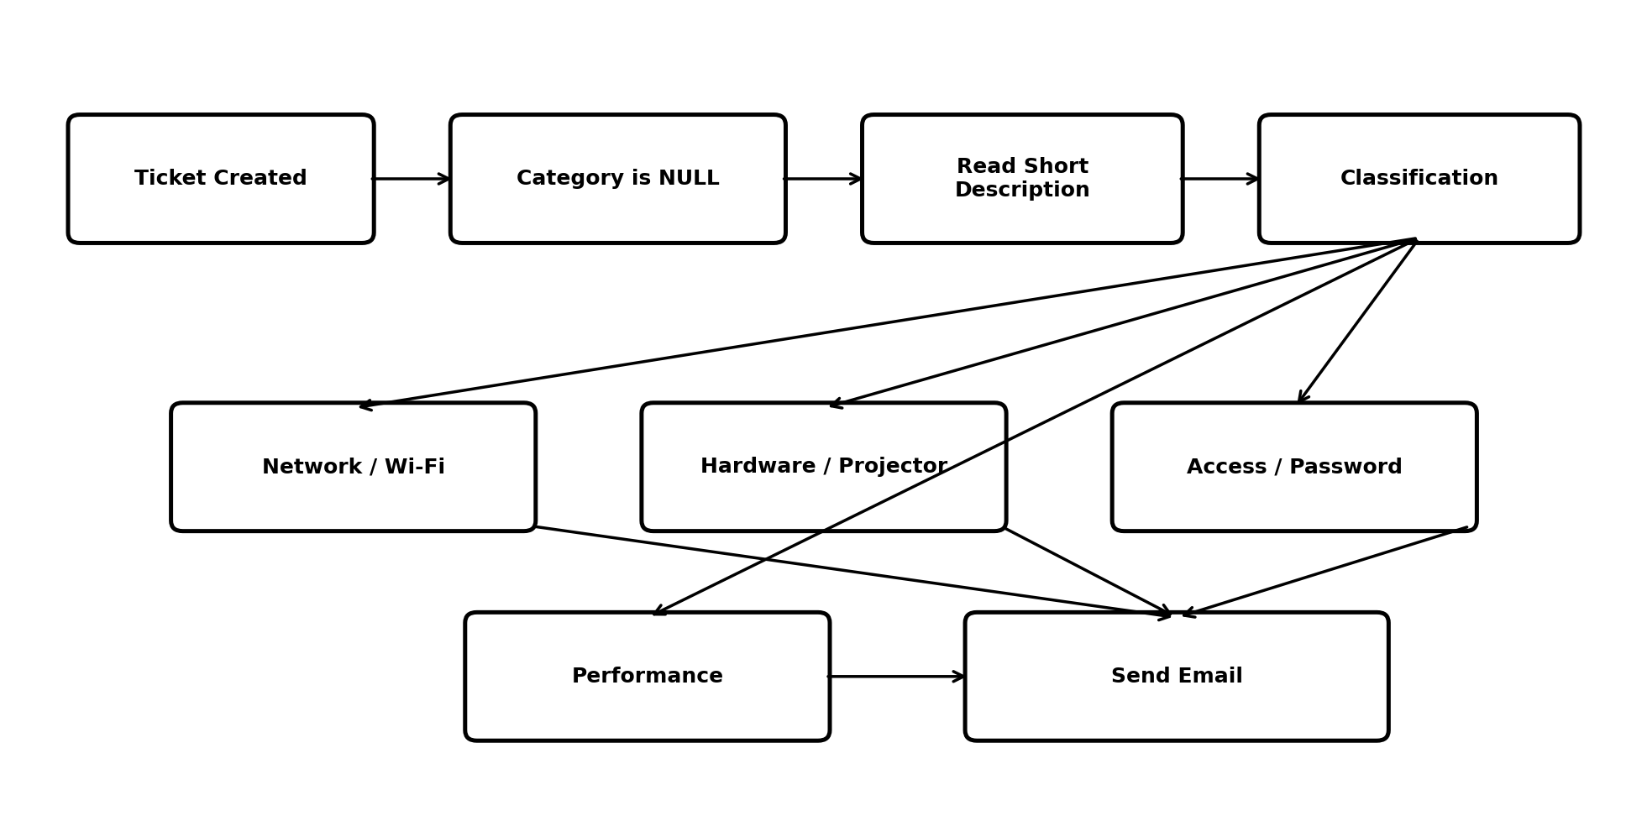
Figure 1: Proposed solution flow.

Classification Rules
Condition | Category | Subcategory
Wi-Fi / Network | Network | Wi-Fi
Projector | Hardware | Projector
Forgot password | Access | Forgot Password
Performance | Performance | Slow Computer

