Solution Architecture
Project: Auto Ticket Classification using ServiceNow Flow Designer

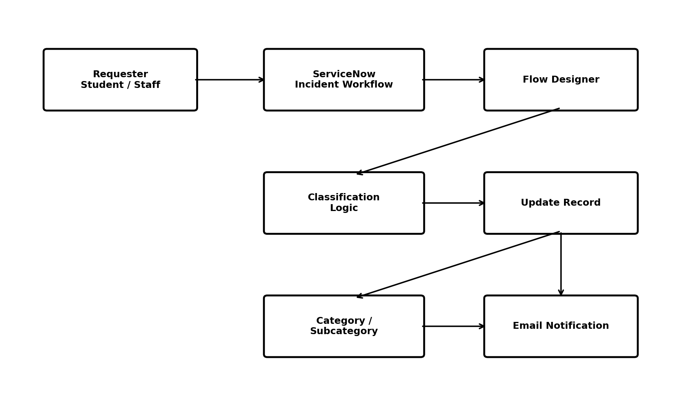
Figure 1: Solution architecture.

Architecture Components
- Requester interface / ticket form
- Incident Workflow data table
- Flow Designer trigger and conditions
- Update Record actions
- Email notification action

Control Point
The Category-is-NULL trigger condition prevents already classified records from being processed by the classification flow.

