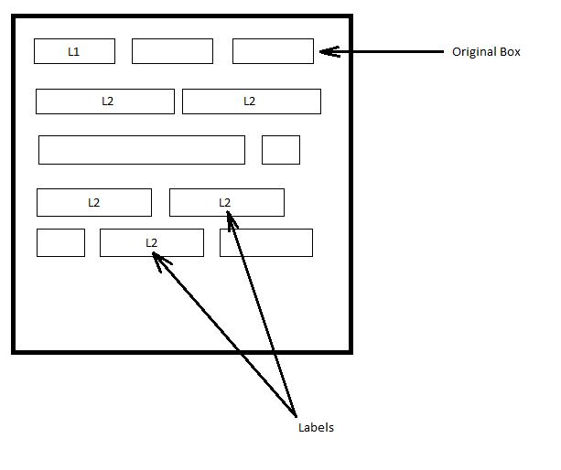

**Figure:** Given Image

**Given:** An Image with rectangular Boxes and labels associated to those Boxes. Index of every Box and its Coordinates.

**Problem Statement:** Group together Boxes by labels and Neighboring Criteria and return the Coordinates of the New Boxes formed.

** Any Programming Language acceptable.

**Input:** Index, Label and Coordinate of the Box(x0,y0,x1,y1) where (x0,y0) represents top-left corner and (x1,y1) represents bottom-right corner of box with origin at top-left corner of image. The inputs are not in any sequence.

CSV File in following format

Index,Label,x0,y0,x1,y1

1, L1, 5,10,15,20

2,L2,25,35,60,70

**Output:** Coordinates of the New Box

**E.g**.:

Index,Label,x0,y0,x1,y1

1, L1, 5,10,15,20

2,L2,25,35,60,70

**Neighboring Criteria:** Make a new Box that is 0.5 units away from the boundary of a selected original box for all the sides. Now if the original boxes intersect with this new box, we consider them as neighbors.

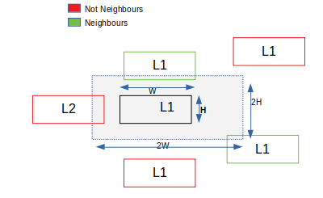

If label of the Neighbor Boxes matches within the newly formed Box we group them all together and re-calculate the new Box using the same method that we used in Neighboring Criteria (0.5 units away from extreme points among all the neighbor boxes).

**OUTPUT:**

