Create file named grade.txt and write following contents in it. ( grep , cut )

John Smith: A

Mary Johnson: B

Alex Rodriguez: C

Emily Wong: A

David Lee: B

James Johnson: A

Edwin Albert: B
And compose commands to perform following operations
- Count the number of students. ( wc )
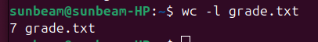

- List the students having grade A. ( grep )
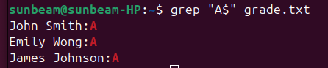

- List the students not having grade B. ( grep )
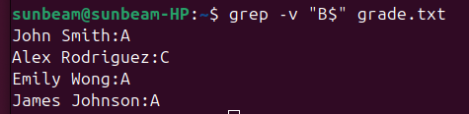

- Print the count of students not having grade C. ( grep )

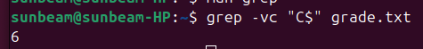

- List the student/students whose name starts with E & having grade B. ( grep )
- Show only Studetns first name & Last Name. ( cut )
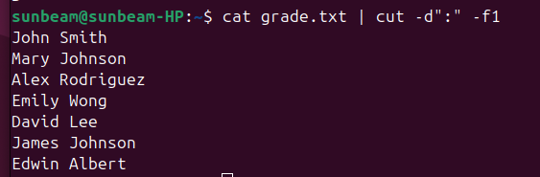
- Show only grades. ( cut )
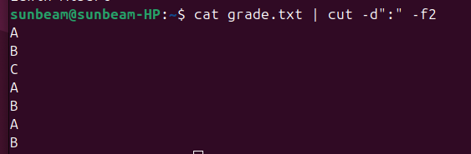
- Show only first name & grades. ( cut )
