14_Linux_assignment_XIV
Create new directory with the name 18oct and create three directories there. (dir1, dir2, dir3), also create four .txt files (1.txt, 2.txt, 3.txt, 4.txt) Using find command:
- List only directories from 18oct.
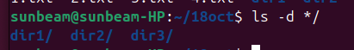

- List only files.
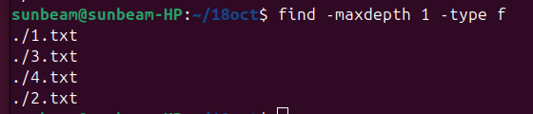
- Make 2.txt executable, now search the files having permission as rwxr-xr-x (755) from 18oct.
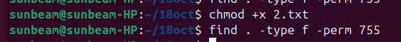
- Search the file 4.txt.
