Floating Point Representation
By Kumar Sai Reddy Guntaka

Introduction: Floating Point arithmetic is by far the most used way of approximating real number arithmetic for performing numerical calculations on modern computers. Each computer had a different arithmetic for long time: bases, significant and exponents’ sizes, formats, etc. Each company implemented its own model, and it hindered the portability between different equipment's until IEEE 754 standard appeared defining a single and universal standard. The floating-point arithmetic is clearly the most efficient way of representing real numbers in computers. Representing an infinite, continuous set (real numbers) with a finite set (machine numbers) is not an easy task: some compromises must be found between speed, accuracy, ease of use and implementation and memory cost. Floating Point Arithmetic represent a very good compromise for most numerical applications.

Fixed-point number systems: offer limited range and/or precision. Computations must be “scaled” to ensure that values remain representable and that they do not lose too much precision.

A typical floating-point representation format:
- The significand or number sign indicates a positive or negative floating-point number and is usually represented by a separate sign bit (signed-magnitude convention).
- The exponent sign, roughly speaking, indicates a large or small number and is usually embedded in the biased exponent. When the bias is a power of 2 (e.g., 128 with an 8-bit exponent), the exponent sign is the complement of its most-significant bit (MSB).
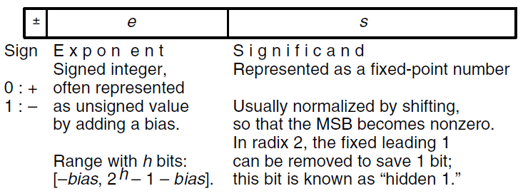

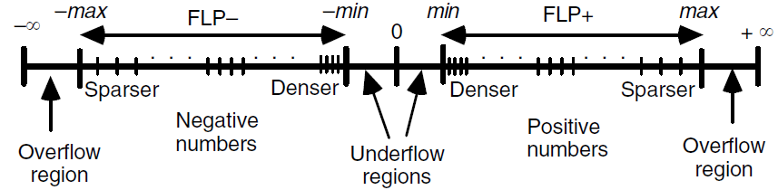

IEEE Single Precision Format:

IEEE Double Precision Format:
