SWIGGY SALES ANALYSIS
BUSINESS REQUIREMENTS DOCUMENT
Data Cleaning · Dimensional Modelling · KPI Development · Business Analysis

Table of Contents
Table of Contents 1
1 Data Cleaning & Validation 1
1.1 Null Check 1
1.2 Blank / Empty String Check 1
1.3 Duplicate Detection 1
1.4 Duplicate Removal 1
2 Dimensional Modelling (Star Schema) 1
2.1 Dimension Tables 1
2.2 Fact Table 1
2.3 ERD Diagram — Star Schema 1
3 KPI Development 1
4 Deep-Dive Business Analysis 1
4.1 Date-Based Analysis 1
4.2 Location-Based Analysis 1
4.3 Food Performance 1
4.4 Customer Spending Insights 1
4.5 Ratings Analysis 1

1 Data Cleaning & Validation
The raw table swiggy_data contains food delivery records across states, cities, restaurants, categories, and dishes. The first goal is to ensure data quality before any modelling or reporting work begins.

1.1 Null Check
Identify missing values in the following business-critical fields:
☐ State
☐ City
☐ Order_Date
☐ Restaurant_Name
☐ Location
☐ Category
☐ Dish_Name
☐ Price_INR
☐ Rating
☐ Rating_Count

1.2 Blank / Empty String Check
Detect fields containing blank (empty-string) values that may cause inaccurate analysis, distinct from true NULLs.

1.3 Duplicate Detection
Identify duplicate rows by grouping on all business-critical columns to confirm the scope and volume of duplication before remediation.

1.4 Duplicate Removal
Use ROW_NUMBER() partitioned over the business-critical columns to remove surplus duplicate rows while retaining exactly one clean copy for each unique order.

2 Dimensional Modelling (Star Schema)
Dimensional modelling organizes data so that analysis stays simple, consistent, and highly efficient. Rather than keeping all information in one large table, the Star Schema separates descriptive attributes into dimension tables and keeps all measurable values in a single, central fact table.
This structure reduces data duplication, improves clarity, and enables faster reporting, since queries access small, focused tables rather than scanning one bulky dataset. Most analytics and BI tools are optimized for star schemas, so this approach ensures smooth dashboard creation, accurate aggregations, and reliable insights — a clean, scalable, performance-optimized foundation for the analytical system.

2.1 Dimension Tables
Table | Description | Key Attributes
dim_date | Calendar dimension | date_id (PK), Full_Date, Year, Quarter, Month, Month_Name, Week
dim_location | Geographic dimension | location_id (PK), State, City, Location
dim_restaurant | Restaurant dimension | restaurant_id (PK), Restaurant_Name
dim_category | Cuisine / category dimension | category_id (PK), Category_Name
dim_dish | Dish dimension | dish_id (PK), Dish_Name

2.2 Fact Table
Table | Description | Key Attributes
fact_swiggy_orders | Central fact table | order_id (PK); date_id, location_id, restaurant_id, category_id, dish_id (FKs); Price_INR, Rating, Rating_Count
Load rule: populate each dimension with distinct values from the cleaned source, then load the fact table with all foreign keys fully resolved.

2.3 ERD Diagram — Star Schema
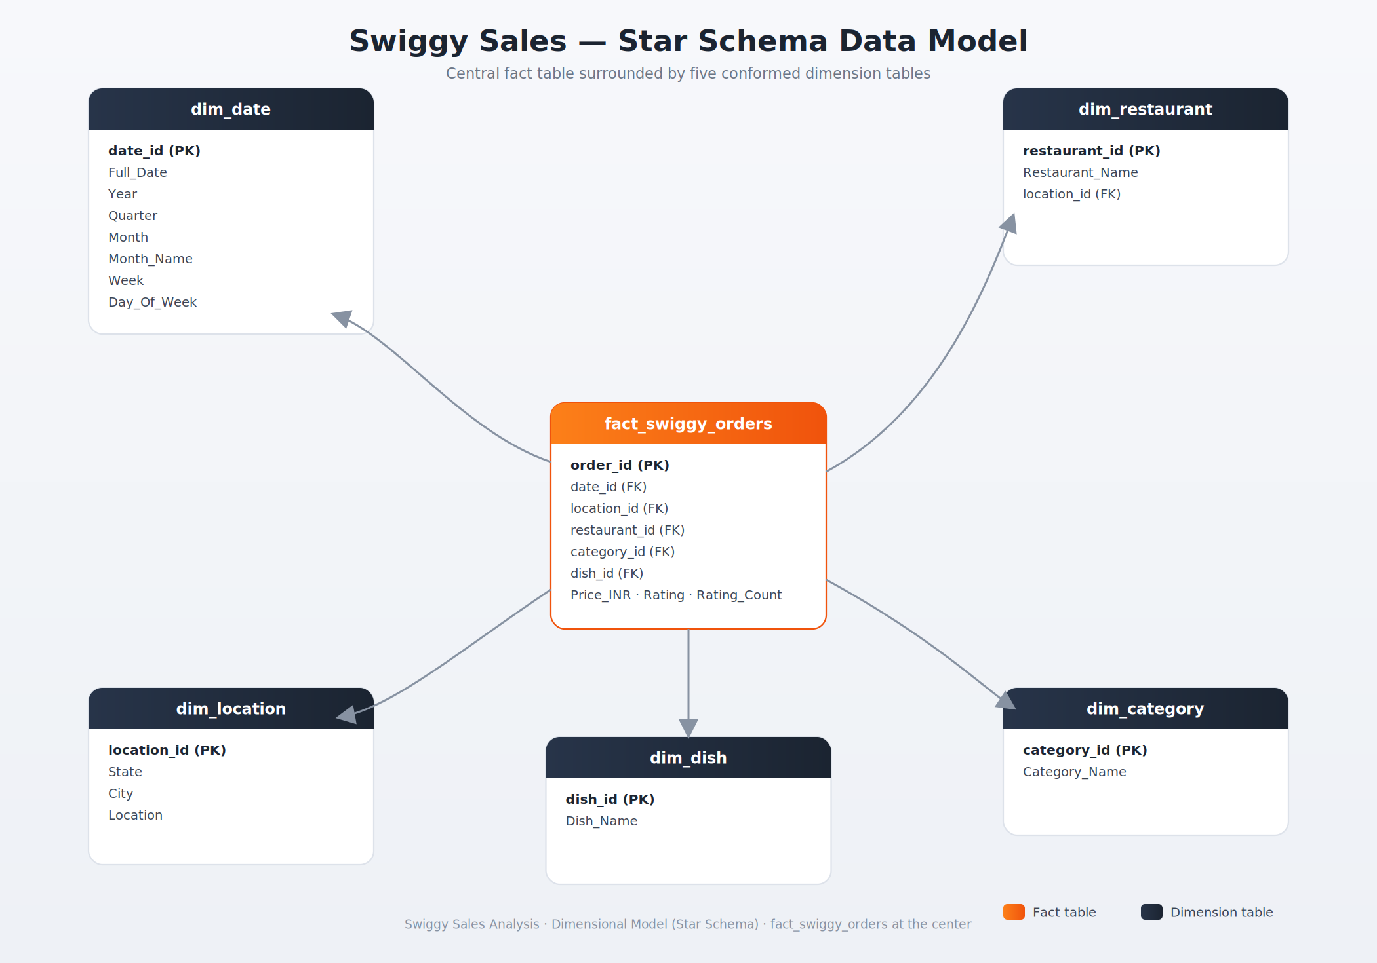
Figure 1 — Star schema for the Swiggy sales dataset: fact_swiggy_orders at the center with five conformed dimensions.

3 KPI Development
Once the schema is built, compute the following core performance indicators to establish a baseline view of business performance:
KPI | Definition
Total Orders | Count of all valid orders after cleaning and de-duplication
Total Revenue (INR Million) | Sum of order revenue in INR, expressed in millions
Average Dish Price | Mean price across all dishes / orders
Average Rating | Mean customer rating across all orders

4 Deep-Dive Business Analysis

4.1 Date-Based Analysis
- Monthly order trends
- Quarterly order trends
- Year-wise growth
- Day-of-week patterns

4.2 Location-Based Analysis
- Top 10 cities by order volume
- Revenue contribution by state

4.3 Food Performance
- Top 10 restaurants by orders
- Top categories (Indian, Chinese, etc.)
- Most ordered dishes
- Cuisine performance → Orders + Avg Rating

4.4 Customer Spending Insights
Customer spend buckets, with total order distribution across each range:
Spend Range (INR)
Under 100
100 – 199
200 – 299
300 – 499
500+

4.5 Ratings Analysis
Distribution of dish ratings from 1 to 5, to understand overall customer satisfaction and identify rating outliers.

