Analysis of Drag Coefficient Variation against Reynolds Number (Re) for Different Configuration

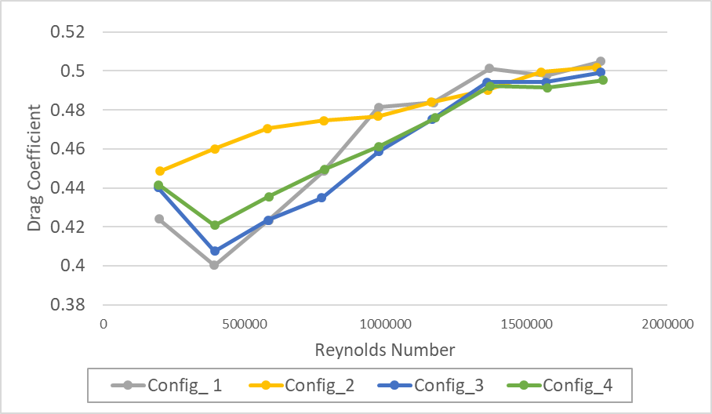Figure 1 Chart of Drag Coefficient

The drag coefficient variations with Reynolds number, which corresponds to various wind speeds (m/s) across four different configurations, is represented in this scatter line with marker chart. Comparing the effects of various wheel and cooling systems on aerodynamic drag.
The Four Configuration as follows:
- Closed Cooling System with Spoke Wheels
- Open Cooling System with Spoke Wheels
- Closed Cooling System with Disk Wheels
- Open Cooling System with Disk Wheels

Each configuration also shows different design choices that impacts airflow and drag coefficient. X-Axis which represents as Reynolds Number (Re). Re helps identify whether the airflow is Laminar or Turbulent. Not only that, it is also directly proportional to Wind Speed, which means that when wind speeds are high, Re will also results in high values. Y-Axis which represents as Drag Coefficient. It represents as the resistance an object experiences while moving via the air.

The following formula is used to determine the actual aerodynamic forces acting on the test model (F corrected):
F corrected = F total – F tare strut
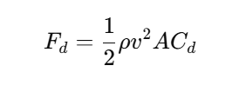
F corrected = (Drag Force – (0.27* (y= 0.0071x^2) + (0.0038x))) / 0.5*(Air Density) *(Speed)*(Speed)*(Frontal area of the model (0.042).

External factors, particularly the support system used to hold the test model, frequently affect the observed aerodynamic forces. A tare test is used to get accurate force measurements. The purpose of the tare test is to ensure that only the forces exerted on the test model are recorded by excluding the impact of the support system and other external factors on the aerodynamic force readings.

The Wind speed values which are associated with Re are 5,10,15,20,25,30,35,40, and 45 m/s (Not in specific value).

The figure 1 above shows that drag Coefficient is higher, indicates greater aerodynamics resistance which occur negatively affects speed. Drag Coefficient is proportional to the square of velocity, as indicated by the fact that it increases as Reynolds number increases.
Trend Analysis and Key Observations
Increasing Drag Coefficient with Re.
Drag Coefficient is proportional to velocity squared, according to aerodynamic principles, and it increases as Reynolds number (wind speed) increases. Drag Coefficient is minimal at slower speeds, but aerodynamic resistance increases when vehicle accelerates.
Impact of Cooling System in Cd (Open vs Closed)
The bar graph shows that the configurations with an open cooling system (Conf 2 & 4) have slightly higher drag force than closed cooling system (Conf 1 & 3). The results shown because open cooling system allow airflow through the engine bay by creating turbulence and aerodynamics resistance. The drag coefficient gap between open and closed cooling systems becomes higher at increasing wind speeds, indicating that open cooling plays a major role in increased drag at high speeds.

Impact of Wheel type (Spoked vs Disk Wheels)
Configurations with disk wheels (Conf 3 & 4) exhibit lower drag Coefficient compared to spoked wheels (Conf 1 & 2), specifically in high wind speeds.
The results shown because disk wheels reduce aerodynamic disturbances as they do not allow the air from flowing via the spokes, reducing turbulence. Disk wheels which offer a smooth surface and reducing aerodynamics resistance. On other hand, Spoked wheels allows air pass through which also create turbulence and higher aerodynamics drag.

Percentage differences in Key Observations
Configuration 3 (Most Aerodynamics). It has the lowest drag, containing as the baseline (0 % increase). Configuration 1 has moderately higher drag. It contains around 7 to 25% more drag than Configuration 3. Closed System benefits but affected by turbulence (Spoked wheels created).

Configuration 4 is better than spoked wheels but worse than closed cooling and which 5 to 25% more drag than configuration 3. Configuration 2 has the highest drag coefficient which 20 to 50 % more drag than Configuration 3 as the results of open cooling and spoked wheels contains the most turbulence, which lead to worst aerodynamics performance.

Conclusion
Configuration 3 (Closed Cooling & Disk Wheels) has the best aerodynamic performance (lowest drag coefficient), making it the most effective configuration for lowering aerodynamic resistance. A closed cooling system with disk wheels is the greatest choice for lowering resistance and enhancing vehicle efficiency if minimizing drag coefficient is the top concern.

Comparison Table with 4 Configurations.
Configuration | Cooling Type | Wheel Type | Drag Behaviour Comparison

Conf 1 | Closed | Spoked | Fall in between (Moderate). Closed System benefits but affected by turbulence (Spoked wheels created)

Conf 2 | Open | Spoked | Highest drag (due to both Open & Closed System air flow and wheel-induced turbulence)

Conf 3 | Closed | Disk | Lowest drag (smooth flow due to closed cooling and disk wheels) which also exhibits lowest drag force against Re.

Conf 4 | Open | Disk | A bit higher drag than Conf 3 (but still performs better than using spoked wheel)

