Analysis Of Lift Coefficient against Reynold’s Number (Re) for different configurations

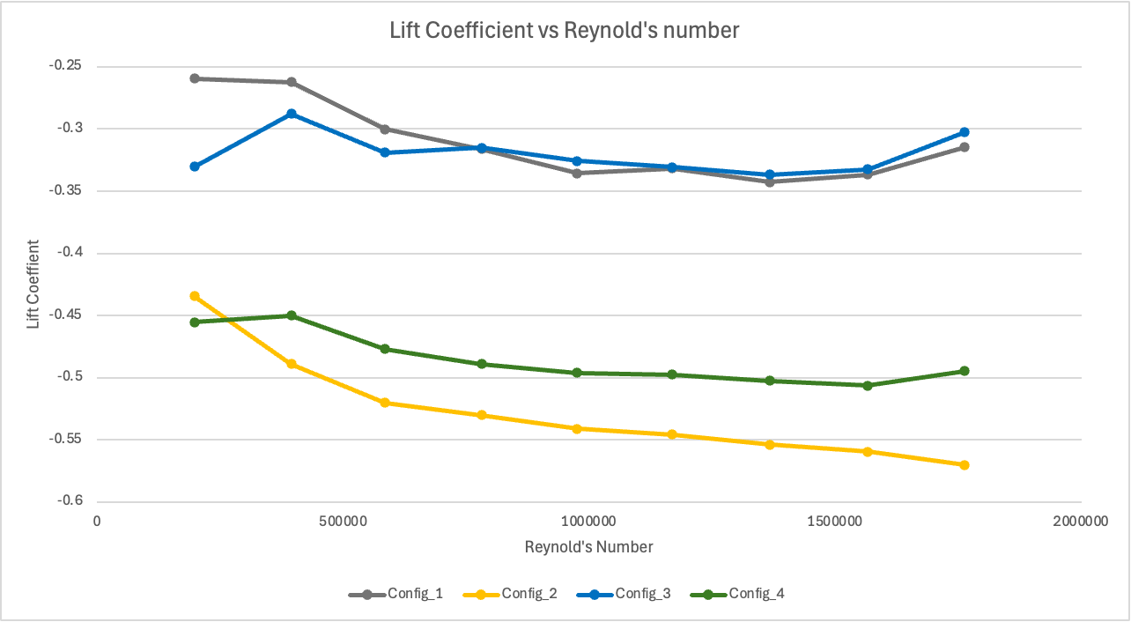

The Lift coefficient variations with Reynolds number, which corresponds to various wind speeds (m/s) across four different configurations, is represented in the graph above. Comparing the effects of various wheel and cooling systems on aerodynamic lift.

The Four Configuration as follows:

- Closed Cooling System with Spoke Wheels (Gray)
- Open Cooling System with Spoke Wheels (Yellow)
- Closed Cooling System with Disk Wheels (Blue)
- Open Cooling System with Disk Wheels (Green)

X and Y Axis Interpretation

X-Axis represents as Reynolds Number (Re). Re helps identify whether the airflow is Laminar or Turbulent. Not only that, it is also directly proportional to Wind Speed, which means that when wind speeds are high, Re will also results in high values. Y-Axis represents Lift Coefficient. It represents that how much lift can be generated from a certain velocity and density of the fluid.

The following formula is used to determine the actual aerodynamic forces acting on the test model:

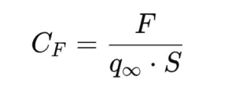

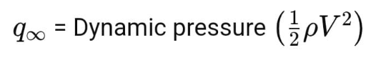
Here:
CF = Lift Coefficient
F = Measured Lift Force
S = Frontal Area of Car
ρ = Air Density
V = Wind speed

The Wind speed values which are associated with Re are 5,10,15,20,25,30,35,40, and 45 m/s (Not in specific value).

Trend Analysis for Every Configuration
Config_1 (Gray Line) - Value of lift coefficient starts at around -0.30 and declines gradually to around -0.32 at the higher Reynold’s number, it means this configuration has little fluctuation but is relatively stable with only a small decrease in lift coefficient. Due to less negative Lift Coefficient values, Config_1 does not yield a strong negative lift force, therefore it is less optimal.
Config_2 (Yellow Line) - Value of lift coefficient starts at around -0.45 and reduces consistently to around -0.55 at the higher Reynolds number, it means this configuration shows higher decrease in lift coefficient, and therefore it is more effective in generating negative lift force which makes it more efficient.
Config_3 (Blue Line) - Value of lift coefficient starts at around -0.35 but increases slightly to around -0.32, showing an unwanted trend. As Config_3 does not show a downward trend it makes this configuration worst of all of them because it generates positive lift force instead of negative lift force, which we do not want.
Config_4 (Green Line) - Value of lift coefficient starts at around -0.48 and decreases by a marginal amount to around -0.50, indicating a little bit improvement. It is similar in trend to Config_2 but with less Lift Coefficient drop meaning that it is not that much effective.

Conclusion

Aerodynamics is very critical in track-oriented cars where downforce must be optimized and lift minimized to enhance grip, stability, and overall performance. As our model is of a track-oriented car we would like configuration the most which has most negative lift force which is Config_2.
Config_2 (Yellow Line) – Most Negative Lift (Best Performance)
With around 22.22% decrease in Lift Coefficient, Config_2 produces the most negative lift force, making it the best-performing configuration.

Config_4 (Green Line) – Second Best
It is not as effective as Config_2 but still shows a downward trend (around 4.17%).

Config_1 (Gray) and Config_3 (Blue) - Least Effective
Config_1 remains stable (-6.67% decrease), indicating weaker downward force whereas Config_3 is the worst, as it increases by 8.57%, meaning it produces even less negative lift force over time.

Analysis Of Pitch Moment Coefficient against Reynold’s Number (Re) for different configurations

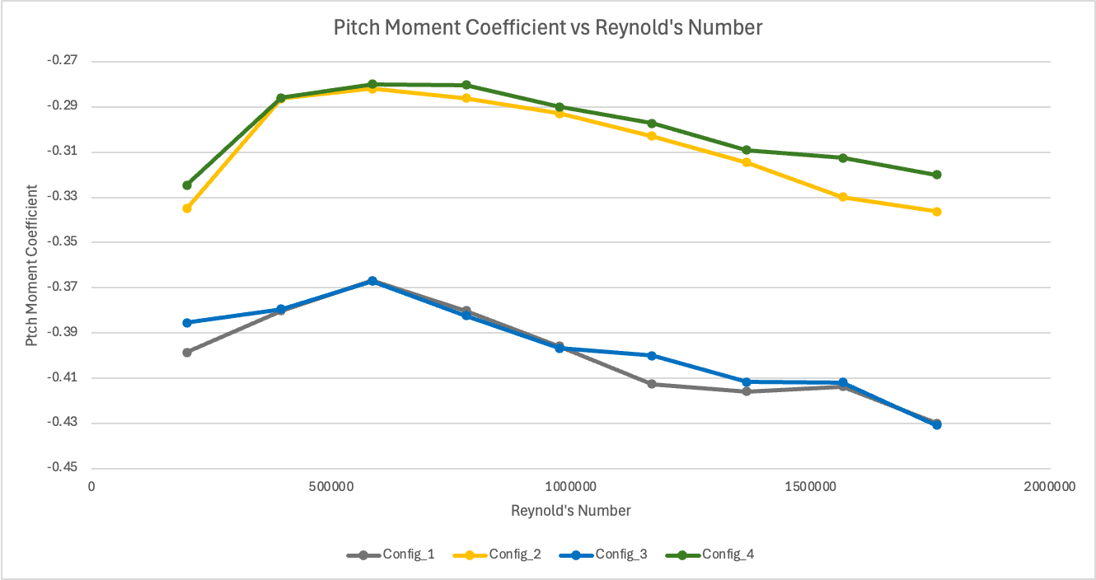

The Pitch Moment coefficient variations with Reynolds number, which corresponds to various wind speeds (m/s) across four different configurations, is represented in the graph above. Comparing the effects of various wheel and cooling systems on aerodynamic lift.

The Four Configuration as follows:

- Closed Cooling System with Spoke Wheels (Gray)
- Open Cooling System with Spoke Wheels (Yellow)
- Closed Cooling System with Disk Wheels (Blue)
- Open Cooling System with Disk Wheels (Green)

X and Y Axis Interpretation

X-Axis represents as Reynolds Number (Re). Re helps identify whether the airflow is Laminar or Turbulent. Not only that, it is also directly proportional to Wind Speed, which means that when wind speeds are high, Re will also results in high values. Y-Axis represents Pitch Moment Coefficient. It represents the tendency of a car to tilt forward (nose-down) or backward (nose-up) at high speeds due to aerodynamic forces.

The following formula is used to determine the actual aerodynamic forces acting on the test model:

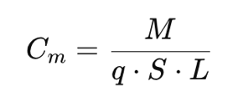

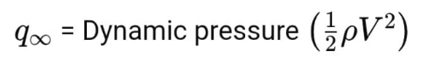
Here:
Cm = Pitch Moment Coefficient
M = Pitch Moment
S = Frontal Area of Car
ρ = Air Density
L = Wheelbase of Car

The Wind speed values which are associated with Re are 5,10,15,20,25,30,35,40, and 45 m/s (Not in specific value).

Trend Analysis for Every Configuration

Config_1 (Gray Line) - Value of pitch moment coefficient starts at approximately -0.41 and shows an initial gentle rise (less negative) before steadily decreasing with increasing Reynold’s Number. It gets more negative at higher speeds, indicating increased nose-down effect this means average aerodynamic stability with more nose-down effect at higher Reynolds numbers.
Config_2 (Yellow Line) - Value of pitch moment coefficient starts at approximately starts at –0.34, rising to a maximum at approximately -0.29 before gradually decreasing again. It has a general stable behaviour across Reynolds numbers with relatively smaller fluctuations. It has less aggressive aerodynamic response compared to Config_1 and Config_3.
Config_3 (Blue Line) - Value of pitch moment coefficient starts at around -0.40 and is similar in trend to Config_1 but with increasingly negative values at higher Reynolds numbers. This means that the configuration shows most aggressive aerodynamic response overall for nose-down moment, potentially having a bad effect on
Config_4 (Green Line) - Value of pitch moment coefficient starts at -0.33 and increases to approximately -0.29 before levelling out and then gradually decreasing. It illustrates the most reliable performance in view of variation of pitch moment coefficient and therefore has better aerodynamic balance when compared to other configurations.

Conclusion

For a track-oriented car, a slightly nose-down setup enhances front-end grip, improves high-speed stability, and optimizes aerodynamics. Since our model is of a track-oriented car, the most suitable configuration is Config_4, as it provides the best nose-down effect for balanced handling and efficiency among all the configurations.

Best Configuration: Config_4 (Green) (+9.09)
Config_4 has the maximum positive percentage change, which indicates least increase in nose-down moment for the range of Reynolds number.
It provides better stability and aerodynamic balance; thus it is most aerodynamically favourable configuration.
Second Best Configuration: Config_2 (Yellow) (+8.82%)
Config_2 has a positive percentage change, reflecting the reduction in nose-down moment and good stability. It is less stable than Config_4 but not aerodynamically inefficient.
Worst Configuration: Config_3 (Blue) (-7.5%)
Config_3 has the worst negative percentage change, which means that it becomes the most nose-down dominant at higher speeds.
This would make it unstable and hard to control, hence making it the worst configuration.
Second Worst Configuration: Config_1 (Gray) (-2.44%)
Config_1 also has a negative percentage change, but less extreme than Config_3. It continues to become nose-down with time but is comparatively stable than Config_3.

