Analysis of Roll Moment Coefficient against Yaw Angle for Different Configuration
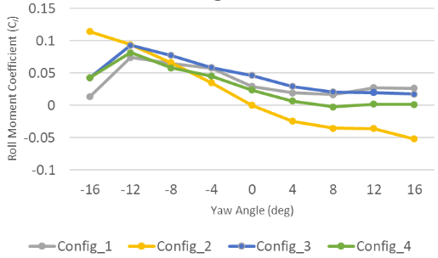Figure 1 Chart of Roll Moment Coefficient

This chart shows that the roll moment coefficient variation with yaw angle (in degrees) for four different configurations is represented in this scatter line with marker chart.
Comparing the effects of various wheel and cooling systems on under different yawing conditions.
The Four Configurations as follows
- Closed Cooling system with Spoke Wheels
- Open Cooling System with Spoke Wheels
- Closed Cooling System with Disk Wheels
- Open Cooling System with Disk Wheels

Each Configuration also shows different design choices that impact airflow and roll moment coefficient. A crucial aerodynamic component influencing vehicle stability is the roll moment coefficient, particularly in crosswind situations when yaw angles effect aerodynamic forces. Better aerodynamic stability is suggested by a more progressive decrease in Cl, while a greater positive Cl indicates a bigger rolling moment that may cause instability.

The Yaw Angle (degree) values which are associated with Roll Moment Coefficient are -16, -12, -8, -4,0,4,8,12,16 (degree).

Trend in Roll Moment Coefficient (CI)
When the yaw angle rises from negative to positive values, the roll moment coefficient (𝐶𝑙 C l) falls for all configurations. The maximum Cl values are seen at a yaw angle of -12°, after which the coefficient gradually decreases.
This pattern suggests that asymmetric airflow around the vehicle body and wheels produces a greater rolling moment at moderate negative yaw angles. The rolling moment decreases as the yaw angle rises, suggesting a change in aerodynamic balance that may be brought on by adjustments to the distribution of pressure and flow separation.

Impact of Cooling System (Open vs Closed Cooling)
Effect of Cooling System
Config_1 (Closed Cooling, Spoked wheels) and Config_3 (Closed Cooling, Disk Wheels) maintain relatively higher stability across yaw angles. When there are no open cooling channels, flow disturbances are probably reduced, which lessens aerodynamic imbalance in crosswind situations.
Config_2(Open Cooling, Spoked Wheels) has the greater initial Cl but experiences the perpendicular as the yaw angles increases. This shows that opening the cooling system stated additional aerodynamics disturbances, increasing the roll effect at lower yaw angles but decreasing stability at higher angles.
Config_4 (Open Cooling, Disk Wheels) tends similar trends to Confi_3 but with a slightly lower roll moment coefficient, state that open cooling negatively impacts roll stability, though the impact is pronounced distinct with disk wheels.
Effect of Wheels Design (Spoke vs Disk Wheels)
When opposed to vehicles with disk wheels, spoked wheel vehicles (Config_1 and Config_2) typically have higher starting Cl values. This is probably because the spokes and airflow interact, causing further aerodynamic disruptions.
Disk wheels (Config_3 and Config_4) help to reduce rolling effects, particularly at higher yaw angles, by lowering and stabilizing Vl. This implies that by reducing turbulent airflow surrounding the wheels, disk wheels improve aerodynamic stability.

Key Observations from percentage differences
Out of all the configurations, Config_3 (Closed Cooling + Disk Wheels) shows the best stability, according to the analysis. Compared to Config_1, it exhibits the lowest initial roll moment coefficient (𝐶𝑙 C l) at 90%, suggesting fewer aerodynamic disturbances from its design. It also has the least drop in Cl (-30%), which guarantees more reliable aerodynamic performance at various yaw angles. This makes it the most aerodynamically efficient and stable design, with the highest total stability at 95%.

Conversely, the least stable configuration is Config_2 (Open Cooling + Spoked Wheels). It has the highest initial Cl (110%) but experiences the steepest decline (-70%) because to its open cooling system and spoked wheels, resulting in the lowest stability at 50%.

Closed cooling configurations (Config_1 & Config_3) have better stability at various yaw angles since they see a lesser drop in Cl. Aerodynamic behavior is also greatly influenced by wheel design. Compared to spoked wheels, disk wheels offer a 10–20% boost in stability.

Conclusion
The vehicle's roll moment coefficient is greatly influenced by the wheel design and cooling system selection. A closed cooling system with disk wheels (Config_3) seems to be the greatest choice for the finest aerodynamic stability.

