PIZZA_SALES ANALYSIS USING SQL QUERIES

**KPI REQUIREMENTS:**

1. **Total_Revenue:**



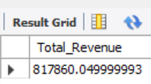

1. **Average Order Value:**



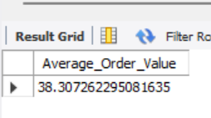

1. **Total_Pizza_Sold:**



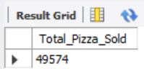

1. Total_orders:



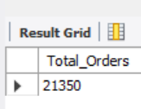

1. **Average_pizza_per_order:**



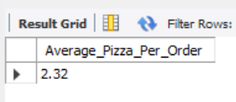

**CHART ANALYSIS:**

1. **Daily trend for Total orders (Total orders by day of week)**

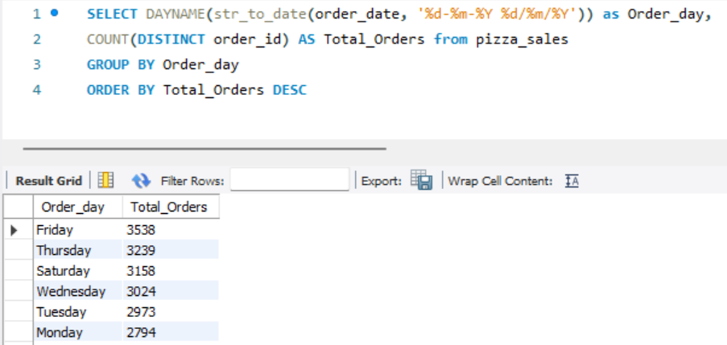

1. **Monthly trend for total orders (Total orders by month)**

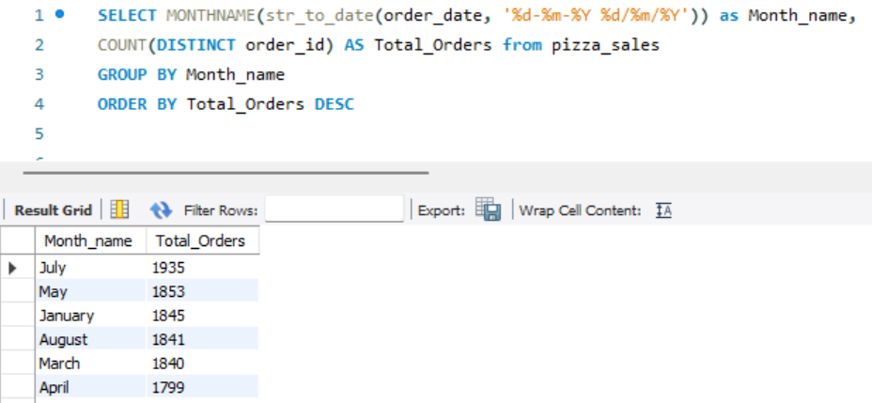

1. **Percentage of sales by pizza category**

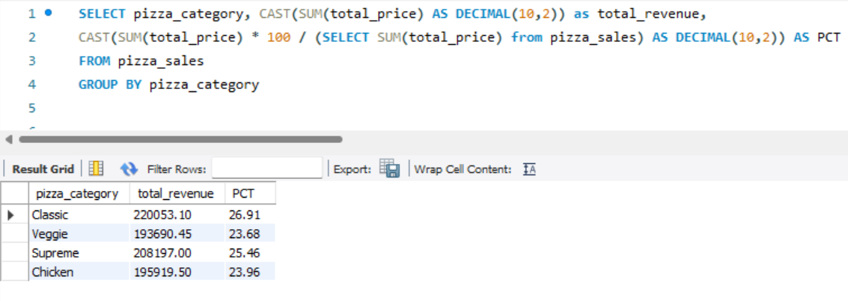

1. **Percentage of highest sales by pizza size**

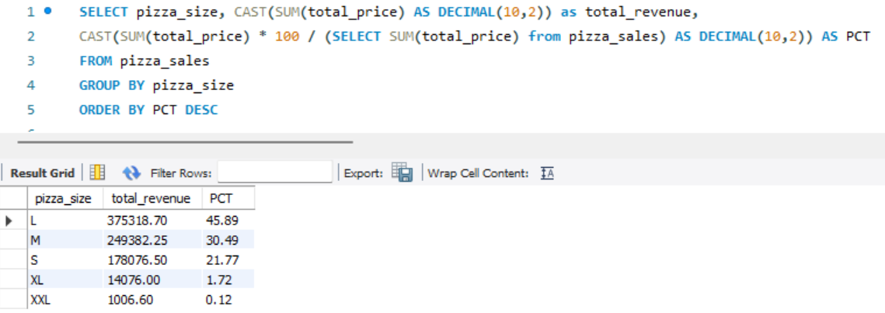

1. **Top 5 best seller pizza by revenue, total quantity and total orders**

**Top 5 Pizza by Revenue:**

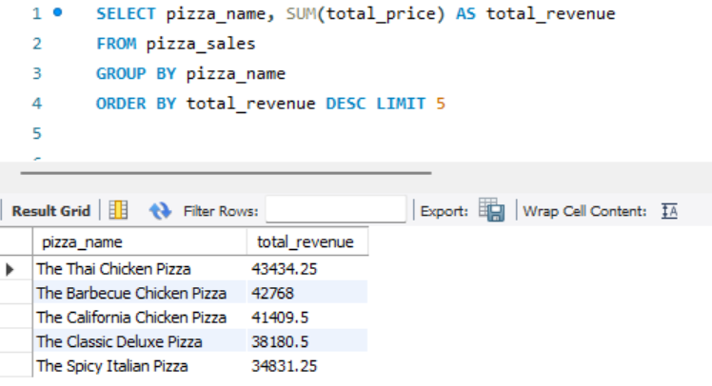

**Bottom 5 Pizza by Revenue:**

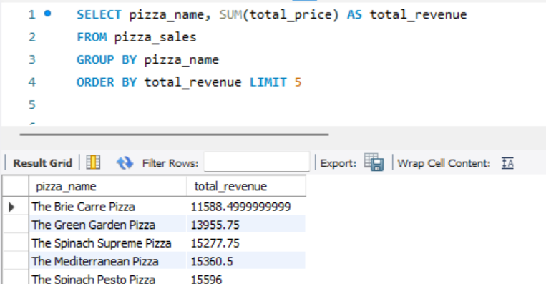

**Top 5 Pizza by Quantity:**

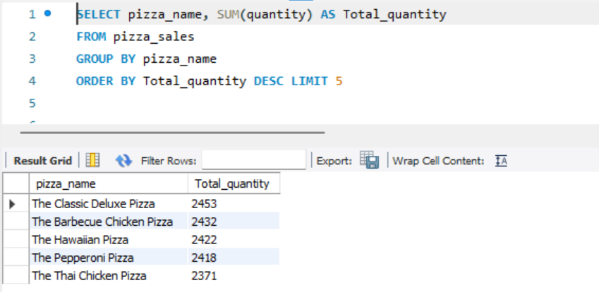

**Bottom 5 Pizza by Quantity:**

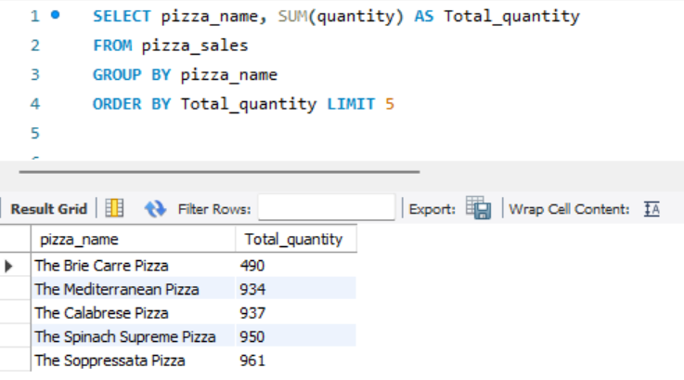

**Top 5 Pizza by Total orders:**

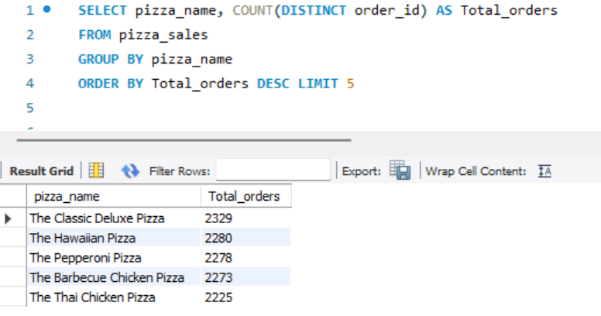

**Bottom 5 Pizza by Total orders:**

