**7PAM2000 APPLIED DATA SCIENCE 1**

**ASSIGNMENT 1: VISUALIZATION**

**STUDENT NAME: KUMARI DUVVARI**

**STUDENT ID:22097941**

**GIT HUB LINK:[** **https://github.com/kumari55/ADS1-Assignment.git]**

# Table of Contents

Introduction 3

Data Source 3

Environment 3

Visualizations: Line Plots 4

Visualization 2: Fertility Rate Comparison (2020): Bar Chart 5

Visualization 3: Scatter Plot - Fertility Rate vs. Fertility Rate (2021) 6

Visualization 4: Fertility Rate Proportion (2021)- Pie Chart 7

Conclusion 7

Recommendations 8

# Introduction

The results and insights gained from visualizing fertility rate statistics for particular nations are presented in this study. The goal of the analysis is to give us a comparative perspective on fertility rates so that we may make informed decisions.

# Data Source

The following link provides the data used for this analysis: <https://data.worldbank.org/indicator/SP.DYN.TFRT.IN?cid=GPD_11>

# Environment

We are using Spyder for running the scripts.

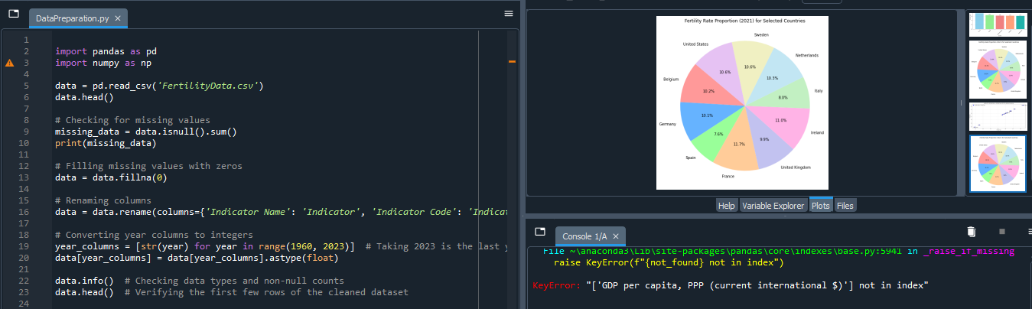

# Visualizations: Line Plots

***Visualization 1: Fertility Rate Comparison (1960-2022)***

The fertility rates of a few chosen nations are compared in this initial visualisation from 1960 to 2022. The United States, the Netherlands, Belgium, France, Germany, Ireland, and the United Kingdom are the nations included by this analysis. This contrast is shown in the line plot that follows.

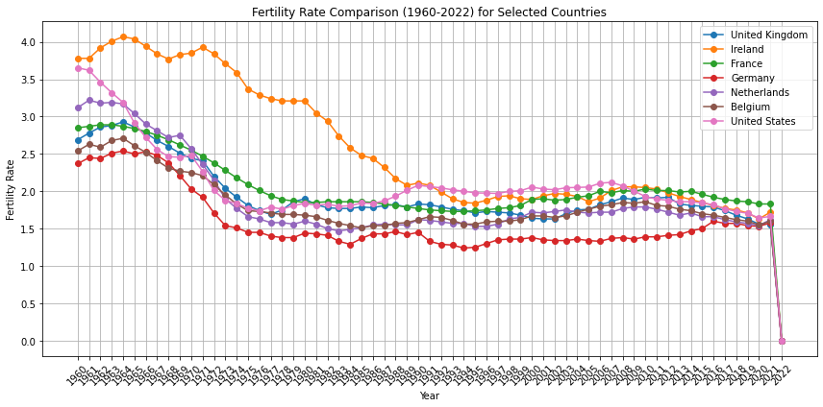

The trends in each country's fertility rate throughout the chosen period of time are graphically displayed in the chart. Among the noteworthy findings are the following:

• The fertility rate in the US has dramatically decreased over time.

• The fertility rate in France remained comparatively steady.

• There were various variations in Germany and the United Kingdom.

• The Netherlands and Belgium had continuously low fertility rates.

# Visualization 2: Fertility Rate Comparison (2020): Bar Chart

The second visualisation compares the fertility rates of the United Kingdom with those of its neighboring countries with an emphasis on the year 2020. The UK, Ireland, France, Germany, the Netherlands, and Belgium are among the participating nations. This contrast is shown in the bar chart that follows.

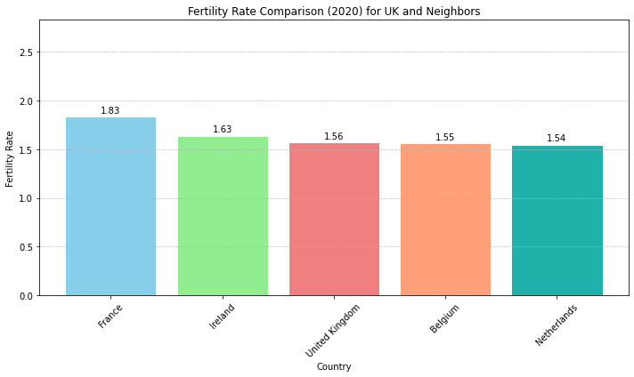

The following are the main conclusions to be drawn from this chart:

• Belgium and the Netherlands had lower fertility rates in 2020, with the United Kingdom, France, and the Netherlands falling in between.

• France had the highest fertility rate among the selected countries.

# Visualization 3: Scatter Plot - Fertility Rate vs. Fertility Rate (2021)

We examine the correlation between the fertility rates of the chosen nations in 2021 in the third visualisation. The link between fertility rates is shown in this scatter plot, which makes it possible to identify trends and anomalies.

The following are some important takeaways from this scatter plot:

• The fertility rate in the United States is comparatively lower than in other nations, making it stand out.

• There is a clear group of nations with comparable fertility rates, including Belgium, France, Germany, and the United Kingdom.

• Of this group, the United Kingdom had the highest fertility rate.

# Visualization 4: Fertility Rate Proportion (2021)- Pie Chart

In the last graphic, we show the percentage of the chosen countries' total fertility rates in 2021 using a pie chart. The contribution of each nation to the global fertility rate is displayed in this chart.

The following conclusions can be drawn from this pie chart:

• Ireland accounts for the greatest portion of the total fertility rate among the chosen nations in 2021; the UK and France also make substantial contributions.

• The Netherlands and Germany account for a lesser share of the global fertility rate.

# Conclusion

The graphics offer insightful information on the historical patterns in fertility rates for particular nations. Fertility rate variations, proportions, and shifts are visible to us, enabling us to draw well-informed conclusions. We can see patterns and trends in the data and gain a deeper understanding of it thanks to these visual aids.

# Recommendations

Examining the economic, social, and cultural variables that affect these nations' fertility rates could be a future line of inquiry. More statistical analyses or visualizations can shed more light on these dynamics.