**Online Complaints Management System - Documentation**

# Introduction

Project Title: Online Complaints Management System Team Members:

* + Veera Kumari Anantha
  + Rajakumari Chapala
  + Dasari Sahitya Lalitha Sri
  + Komarthi Arun Kumar

# Project Overview

Purpose:

To develop a platform where users can file complaints online and track their status while administrators manage and resolve them efficiently.

Features:

* User and Admin login
* Complaint filing and listing
* Status updates
* Secure authentication using JWT
* Role-based access control
* REST API communication

# Architecture

Frontend:

Built using React.js with React Router and Axios. Styled with Bootstrap/CSS.

Backend:

Developed with Node.js and Express.js handling authentication, complaint management APIs.

Database:

MongoDB used via Mongoose to store user and complaint data.

# Setup Instructions

Prerequisites:

* + Node.js
  + MongoDB
  + Git
  + Code Editor

Installation:

1. Clone the repo
2. Install backend & frontend dependencies
3. Setup .env for backend
4. Run npm start for both client and server

# Folder Structure

Client: client/ src/

components/ pages/ services/ App.js

Server: server/ controllers/ models/ routes/ middleware/ server.js

# Running the Application

Frontend:

$ cd client

$ npm start

Backend:

$ cd server

$ npm start

# API Documentation

POST /api/auth/register - Register user POST /api/auth/login - Login user

POST /api/complaints - Create complaint GET /api/complaints/my - User's complaints

GET /api/admin/complaints - All complaints (Admin) PUT /api/complaints/:id - Update status

DELETE /api/complaints/:id - Delete complaint

# Authentication

JWT is used for login token generation. Passwords are hashed using bcryptjs. Middleware restricts routes based on user roles.

# User Interface

Includes:

* + Login/Register Pages
  + User Dashboard
  + Admin Panel

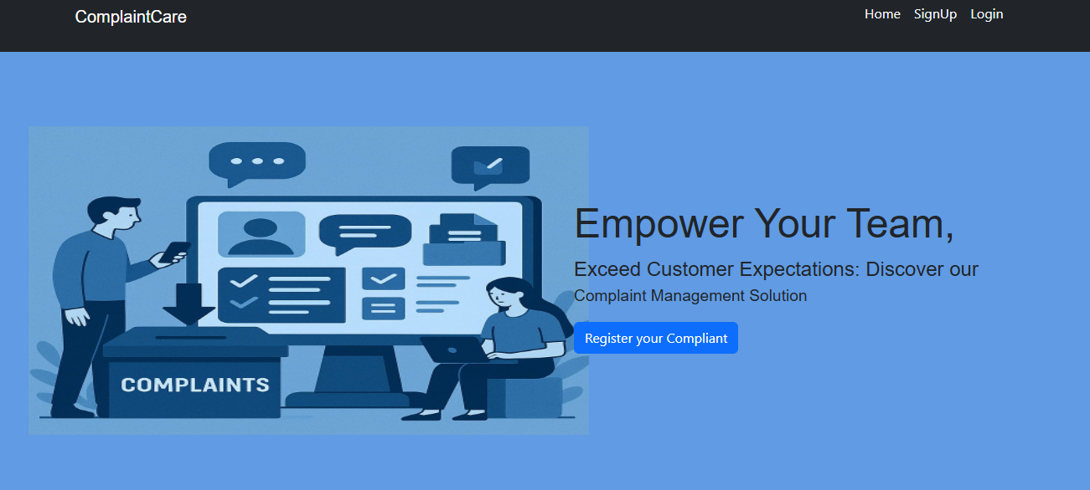

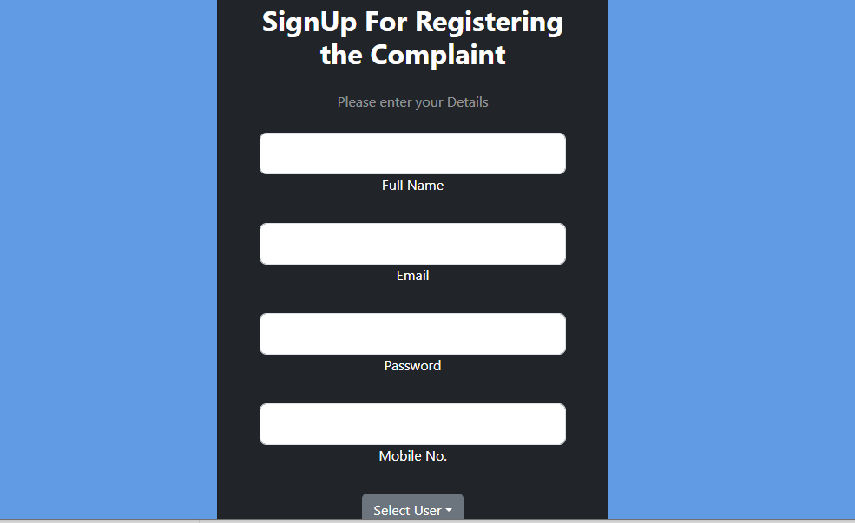

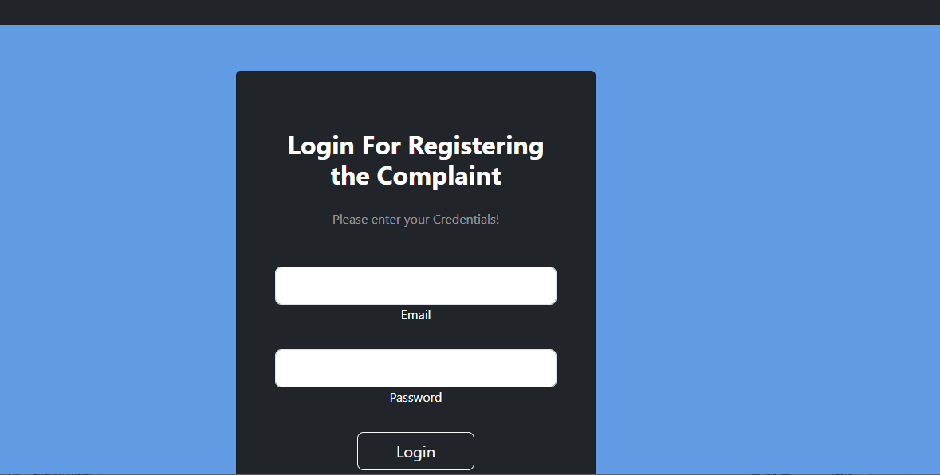

­­­­

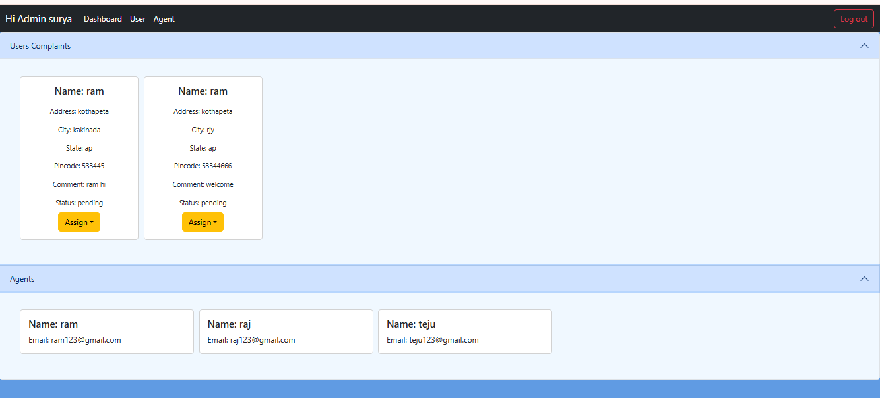

Testing

Manual testing using Postman for APIs.

Frontend tested via browser with edge case validation.

# Screenshots or Demo

https://drive.google.com/drive/folders/1fBe9q-XF33ZOjgAryo-i6CgUz2kD_Xbq

# Known Issues

* + No email notifications yet
  + No file upload support

# Future Enhancements

* + Add email/SMS notifications
  + Document uploads
  + Complaint categories and filters
  + Admin analytics
  + Mobile app with React Native