**Sales Analysis**

**----------------------------------------------------------------------------------------------------------------------------------------------------------------------------------------------------------------------------------------------------------------------------------------------------------------------------------------------------------------------------------------------------------------------------**

**1.Introduction**

This document offers a comprehensive overview of the Power BI Sales Analysis report for users who will be utilizing it. This documentation should be used as a guide for understanding the structure and functionality of the Power BI Sales Analysis report.

**2.Objective**

The objective of the Sales Analysis Report is to provide a comprehensive overview and evaluation of sales performance, trends, and key metrics within a specified timeframe. This analysis aims to offer valuable insights that can inform strategic decision-making, identify opportunities for growth, optimize sales processes, and enhance overall business performance.

Top of Form

Bottom of Form

**2.Purpose**

The goal of the Sales Analysis Report is to provide actionable insights into sales performance by analysing relevant data and metrics. This helps stakeholders, such as management, sales teams, and executives, to make informed decisions, identify strengths and weaknesses in sales strategies, optimize resource allocation, forecast future sales trends, and ultimately drive business growth and profitability.

**3.Data Dictionary**

**Customer**

* **CustomerID**: Unique identifier for each customer.
* **CompanyName**: Name of the customer's company.
* **ContactName**: Name of the primary contact at the company.
* **ContactTitle**: Title of the primary contact (e.g., Manager, CEO).
* **Address**: Street address of the customer.
* **City**: City where the customer is located.
* **Region**: Region or state where the customer is located.
* **PostalCode**: Postal code of the customer's location.
* **Country**: Country where the customer is located.
* **Phone**: Contact phone number for the customer.
* **Fax**: Fax number for the customer.

**Employee**

* **EmployeeID**: Unique identifier for each employee.
* **LastName**: Last name of the employee.
* **FirstName**: First name of the employee.
* **Title**: Job title of the employee.
* **TitleOfCourtesy**: Honorific title (e.g., Mr., Ms., Dr.).
* **BirthDate**: Date of birth of the employee.
* **HireDate**: Date when the employee was hired.
* **Address**: Street address of the employee.
* **City**: City where the employee is located.
* **Region**: Region or state where the employee is located.
* **PostalCode**: Postal code of the employee's location.
* **Country**: Country where the employee is located.
* **HomePhone**: Personal contact phone number for the employee.
* **Extension**: Extension number for the employee.
* **Photo**: Photo of the employee (could be a reference or path).
* **Notes**: Additional notes about the employee.
* **ReportsTo**: ID of the employee's supervisor (references EmployeeID).

**Order**

* **OrderID**: Unique identifier for each order.
* **CustomerID**: ID of the customer who placed the order (references Customer table).
* **EmployeeID**: ID of the employee who processed the order (references Employee table).
* **OrderDate**: Date when the order was placed.
* **RequiredDate**: Date when the order is required to be fulfilled.
* **ShippedDate**: Date when the order was shipped.
* **ShipVia**: ID of the shipping company used (references Shipper table).
* **Freight**: Cost of shipping.
* **ShipName**: Name of the recipient for shipping.
* **ShipAddress**: Address of the recipient for shipping.
* **ShipCity**: City of the recipient for shipping.
* **ShipRegion**: Region or state of the recipient for shipping.
* **ShipPostalCode**: Postal code of the recipient for shipping.
* **ShipCountry**: Country of the recipient for shipping.

**Product**

* **ProductID**: Unique identifier for each product.
* **ProductName**: Name of the product.
* **SupplierID**: ID of the supplier who provides the product (references Supplier table).
* **CategoryID**: ID of the category to which the product belongs (references Category table).
* **QuantityPerUnit**: Quantity of product per unit (e.g., "12 boxes").
* **UnitPrice**: Price per unit of the product.
* **UnitsInStock**: Number of units currently in stock.
* **UnitsOnOrder**: Number of units currently on order.
* **ReorderLevel**: Inventory level at which a new order should be placed.
* **Discontinued**: Flag indicating if the product is discontinued.

**Supplier**

* **SupplierID**: Unique identifier for each supplier.
* **CompanyName**: Name of the supplier's company.
* **ContactName**: Name of the primary contact at the supplier's company.
* **ContactTitle**: Title of the primary contact at the supplier's company.
* **Address**: Street address of the supplier.
* **City**: City where the supplier is located.
* **Region**: Region or state where the supplier is located.
* **PostalCode**: Postal code of the supplier's location.
* **Country**: Country where the supplier is located.
* **Phone**: Contact phone number for the supplier.
* **Fax**: Fax number for the supplier.
* **HomePage**: URL of the supplier's homepage (if available).

**Shipper**

* **ShipperID**: Unique identifier for each shipping company.
* **CompanyName**: Name of the shipping company.
* **Phone**: Contact phone number for the shipping company.

**4. Data Model**

The data model comprises several interconnected tables:

* Customers: CustomerID, CompanyName, ContactName, Address, City, Region, PostalCode, Country, Phone, Fax.
* Employees: EmployeeID, LastName, FirstName, Title, BirthDate, HireDate, Address, City, Region, PostalCode, Country, HomePhone, Extension, Photo, Notes, ReportsTo.
* Orders: OrderID, CustomerID, EmployeeID, OrderDate, RequiredDate, ShippedDate, ShipVia, Freight, ShipName, ShipAddress, ShipCity, ShipRegion, ShipPostalCode, ShipCountry.
* Products: ProductID, ProductName, SupplierID, CategoryID, QuantityPerUnit, UnitPrice, UnitsInStock, UnitsOnOrder, ReorderLevel, Discontinued.
* Suppliers: SupplierID, CompanyName, ContactName, Address, City, Region, PostalCode, Country, Phone, Fax, HomePage.
* Categories: CategoryID, CategoryName, Description.
* Shippers: ShipperID, CompanyName, Phone.

**5.Visualizations**

**5.1. Customer analysis**

**Maps:** Display the geographical distribution of customers using color intensity or bubble size to represent customer density.

**5.1. Customer acquisition rate**

Below line trends charts shows increasing trend of customer acquisition rate over the time.

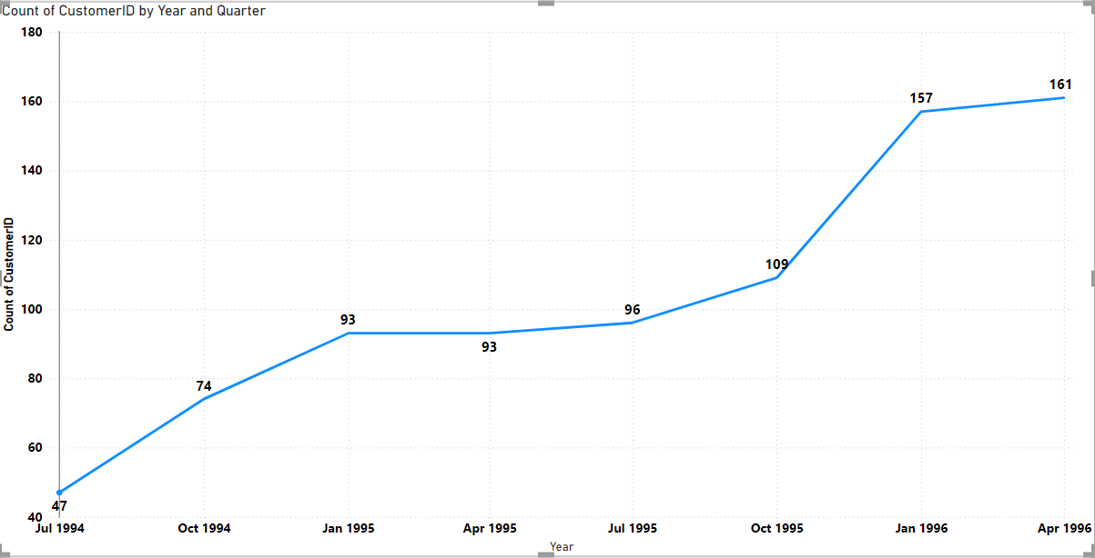

**6.Order**

**6.1. Order Volume trends**

Trend of Order volume over the time

**6.2. Distribution of Order Value**

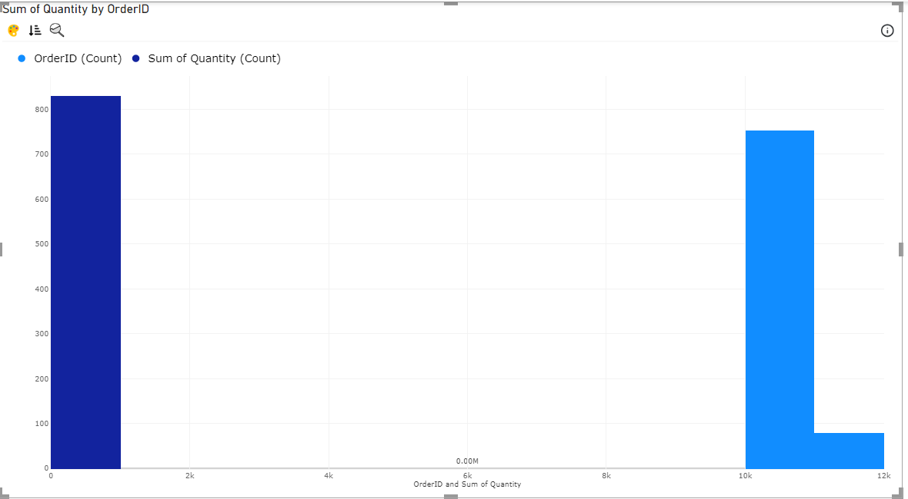

**6.3. Shipping duration (Avg) by OrderID**

**7. Employee Analysis**

**7.1.** Employee productivity vary across different job roles

**7.2 Employee Tenure**

**7.3 Employee Performance Ratings**

**8. Suppliers**

Geographical distribution of suppliers

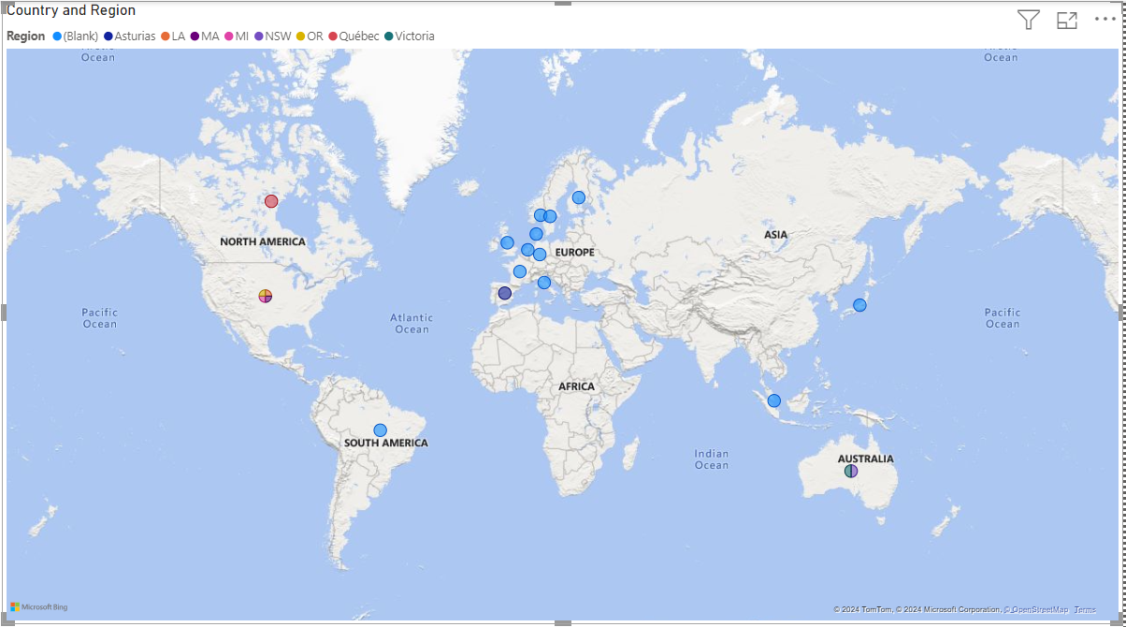

**9. Pricing structure of suppliers**

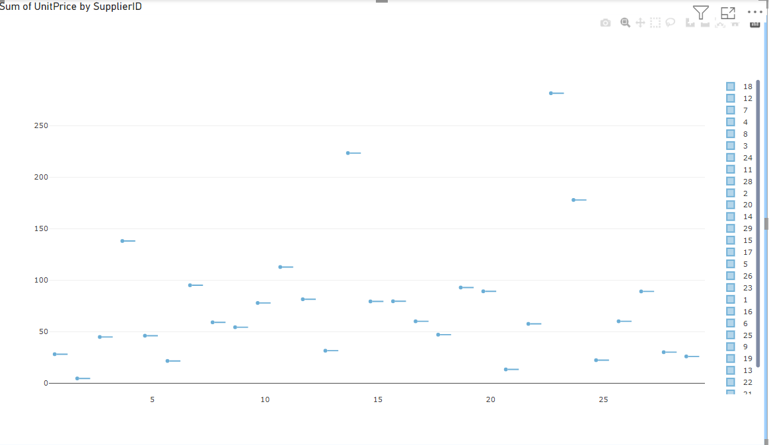

**10. Pricing distribution of Product**

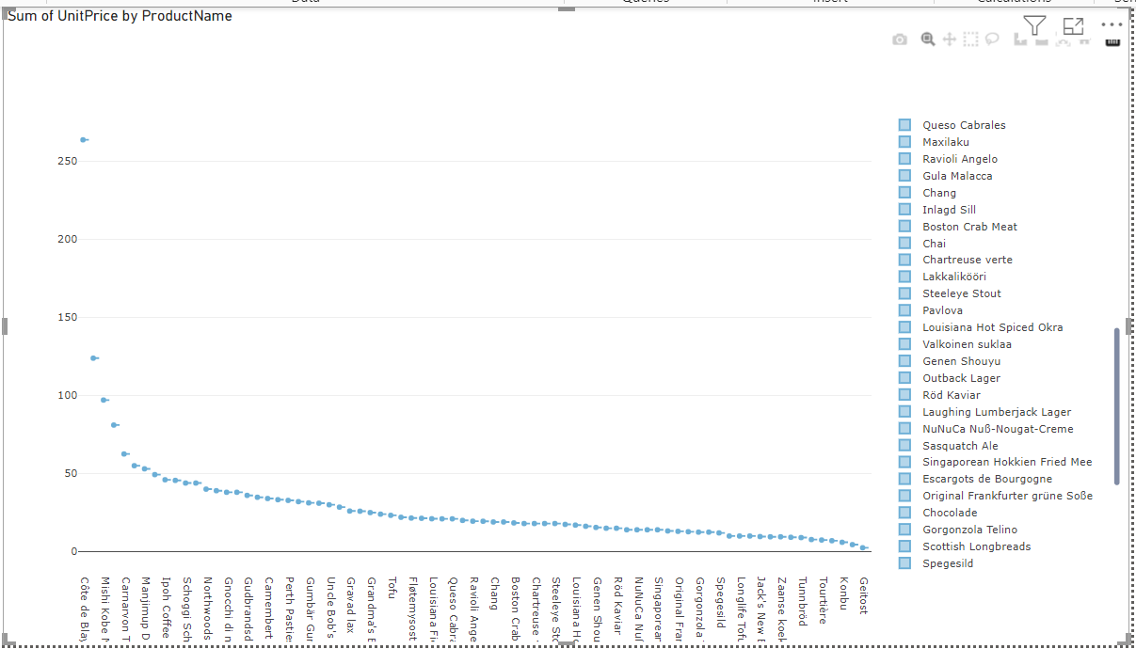

### 10. Conclusion

This Power BI Sales Analysis report is designed to provide actionable insights into sales performance, helping stakeholders make informed decisions. The report's interactive features and comprehensive data coverage ensure it meets the analytical needs of various users across the organization.