ENTITY FRAMEWORK CORE 8.0
LAB-1: Understanding ORM with a Retail Inventory System
Scenario: You’re building an inventory management system for a retail store. The store wants to track products, categories, and stock levels in a SQL Server database.
Objective: Understand what ORM is and how EF Core helps bridge the gap between C# objects and relational tables.
Steps:
- What is ORM?
  - Explain how ORM maps C# classes to database tables.
  - Benefits: Productivity, maintainability, and abstraction from SQL.
Object Relational Mapping (ORM) is a technique that maps C# classes (objects) to relational database tables. Instead of writing SQL queries manually, developers work with C# objects, and the ORM automatically generates the required SQL statements.

public class Product
{
public int ProductId { get; set; }
public string ProductName { get; set; } public decimal Price { get; set; }
}
Database Table
ProductId ProductName Price

1 | Laptop | 50000
2 | Mouse | 500
Benefits of ORM
- Productivity
  - Reduces the amount of SQL code developers need to write.
  - Speeds up development.
- Maintainability
  - Database changes can be managed through C# models.
  - Easier to update and maintain applications.

- Abstraction from SQL
  - Developers interact with objects instead of writing complex SQL queries.
  - Improves readability and reduces errors.
- EF Core vs EF Framework:
- EF Core is cross-platform, lightweight, and supports modern features like LINQ, async queries, and compiled queries.
- EF Framework (EF6) is Windows-only and more mature but less flexible.

EF Core EF Framework (EF6)

Cross-platform (Windows, Linux, macOS)
Windows only

Lightweight and modular Larger framework
Better performance Comparatively slower

Supports LINQ, async queries, compiled queries
Supports LINQ and async, but fewer modern optimizations

Actively developed Mainly maintenance updates

Suitable for modern .NET applications
- EF Core 8.0 Features:
  - JSON column mapping.
  - Improved performance with compiled models.
  - Interceptors and better bulk operations.
JSON Column Mapping
Best for older .NET Framework applications

Allows storing complex C# objects directly as JSON inside SQL Server columns. Example:
public class ProductDetails
{
public string Manufacturer { get; set; } public string Warranty { get; set; }
}

Improved Performance
    - Compiled models reduce startup time.
    - Faster query execution.
    - Better memory usage.
Interceptors
Interceptors allow developers to monitor or modify database operations. Examples:
    - Logging SQL queries
    - Auditing changes
    - Security checks
Better Bulk Operations
EF Core 8 provides improved support for:
    - Bulk insert
    - Bulk update
    - Bulk delete
- Create a .NET Console App:
dotnet new console -n RetailInventory cd RetailInventory
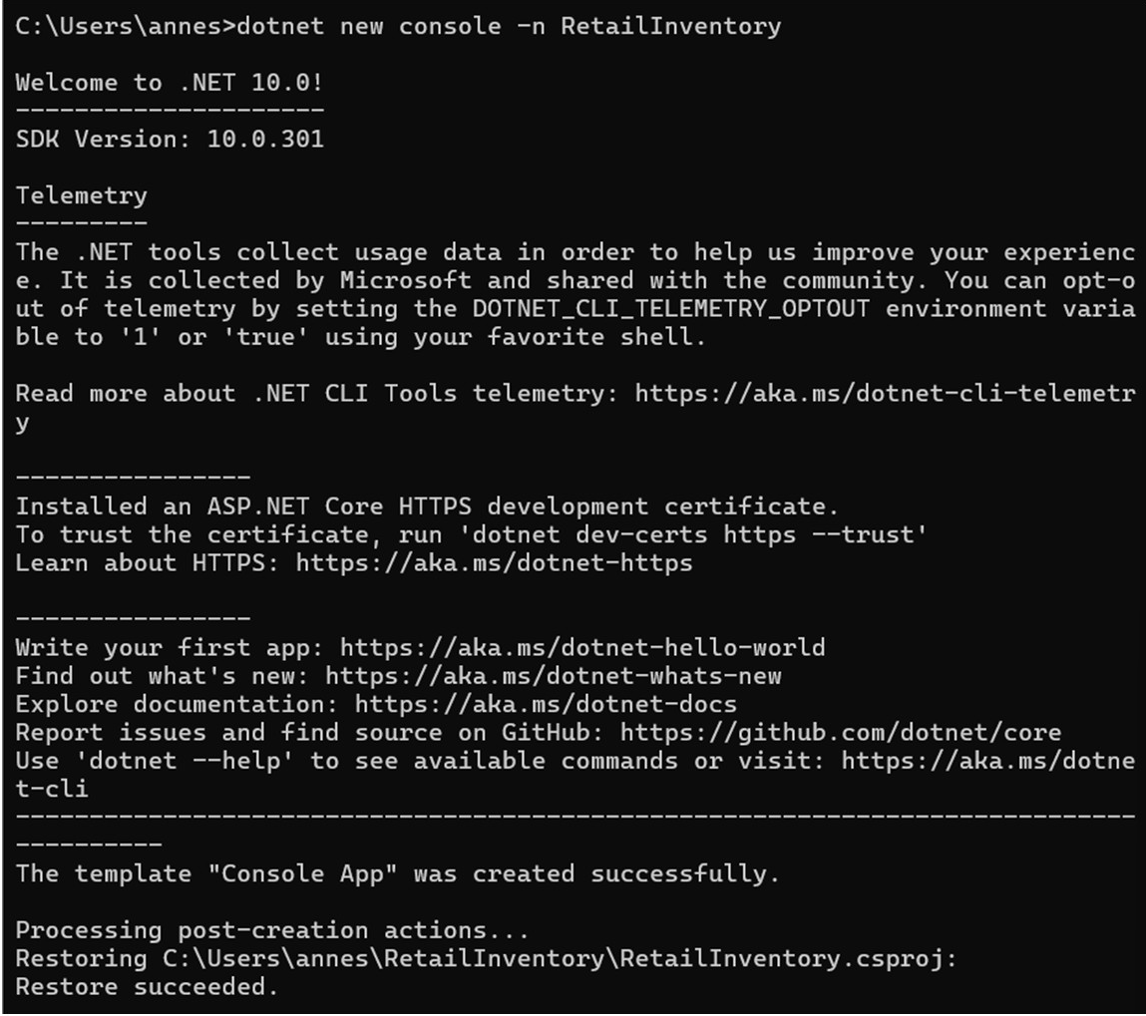

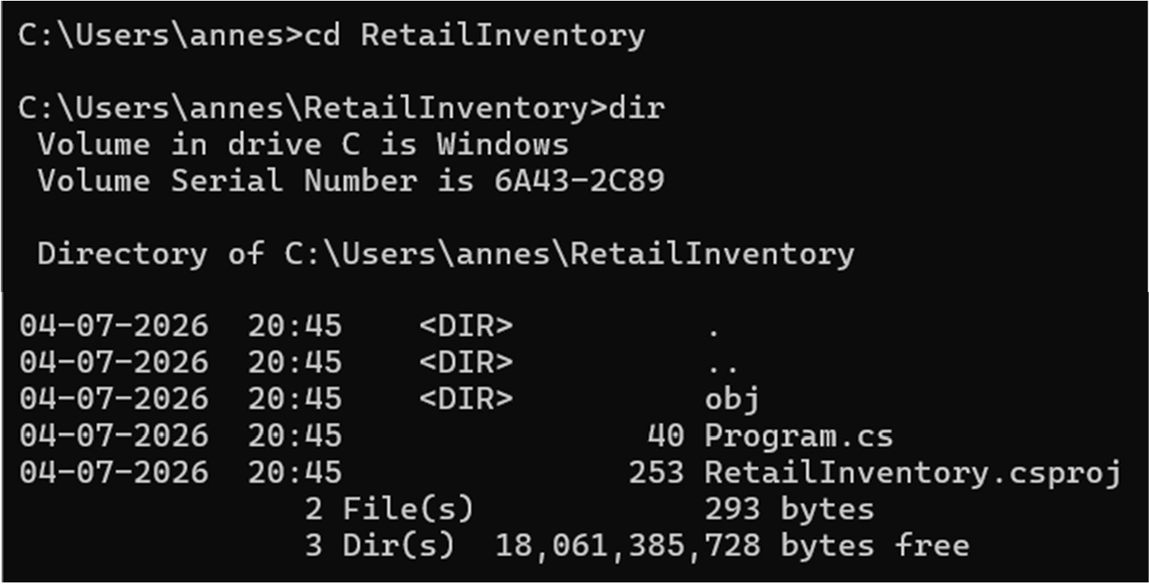

- Install EF Core Packages:
dotnet add package Microsoft.EntityFrameworkCore.SqlServer dotnet add package Microsoft.EntityFrameworkCore.Design
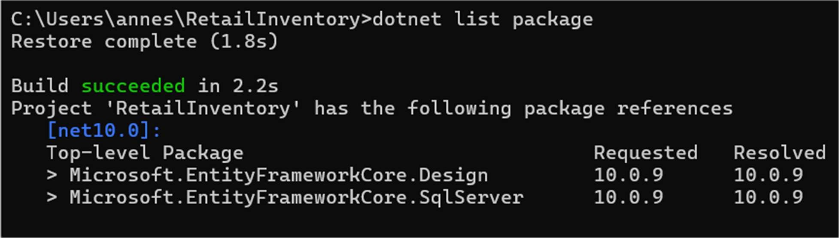

LAB- 2: Setting Up the Database Context for a Retail Store
Scenario: The retail store wants to store product and category data in SQL Server. Objective: Configure DbContext and connect to SQL Server.
Steps:
- Create Models:
public class Category { public int Id { get; set; }
public string Name { get; set; } public List Products { get; set; }
}

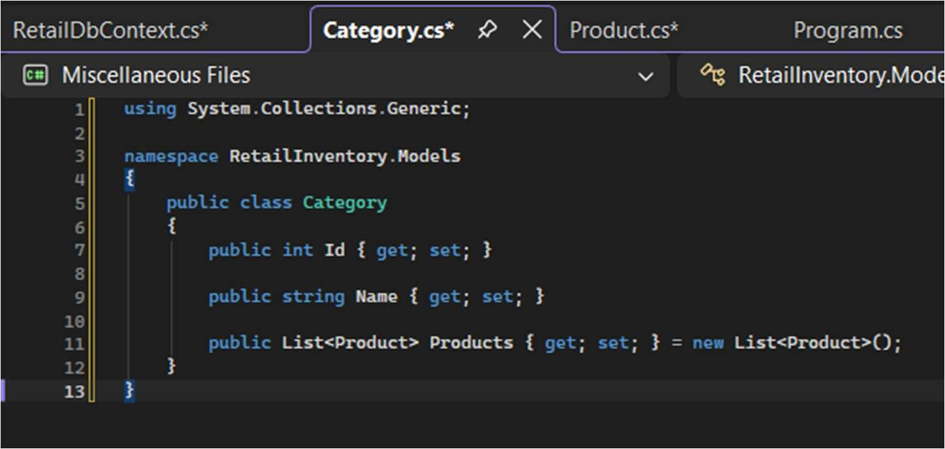

public class Product { public int Id { get; set; }
public string Name { get; set; } public decimal Price { get; set; } public int CategoryId { get; set; } public Category Category { get; set; }
}
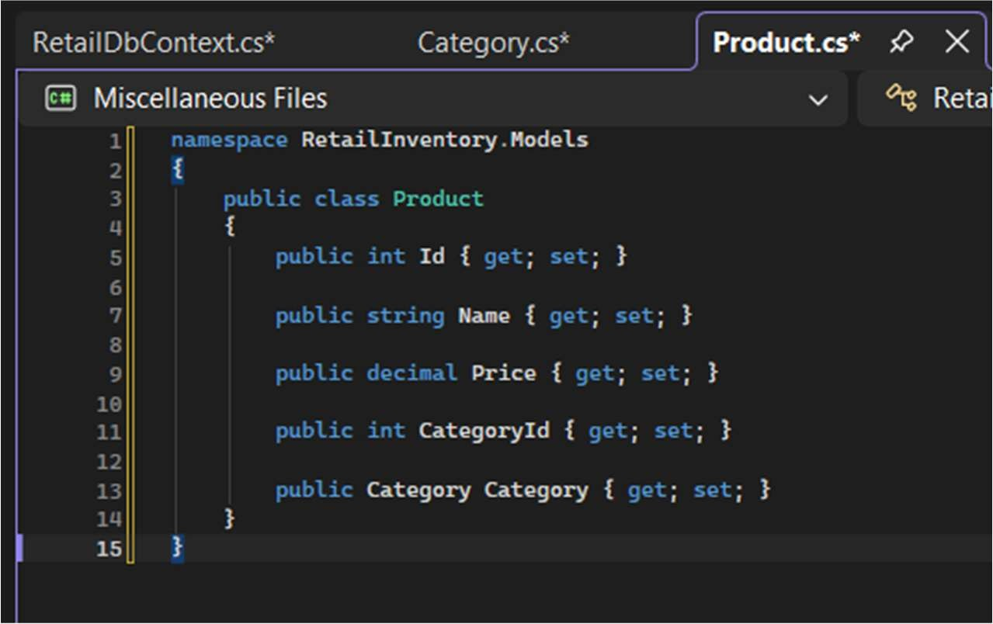

- Create AppDbContext:
public class AppDbContext : DbContext
{
public DbSet Products { get; set; } public DbSet Categories { get; set; }
protected override void OnConfiguring(DbContextOptionsBuilder optionsBuild er)
{
optionsBuilder.UseSqlServer("Your_Connection_String_Here");
}
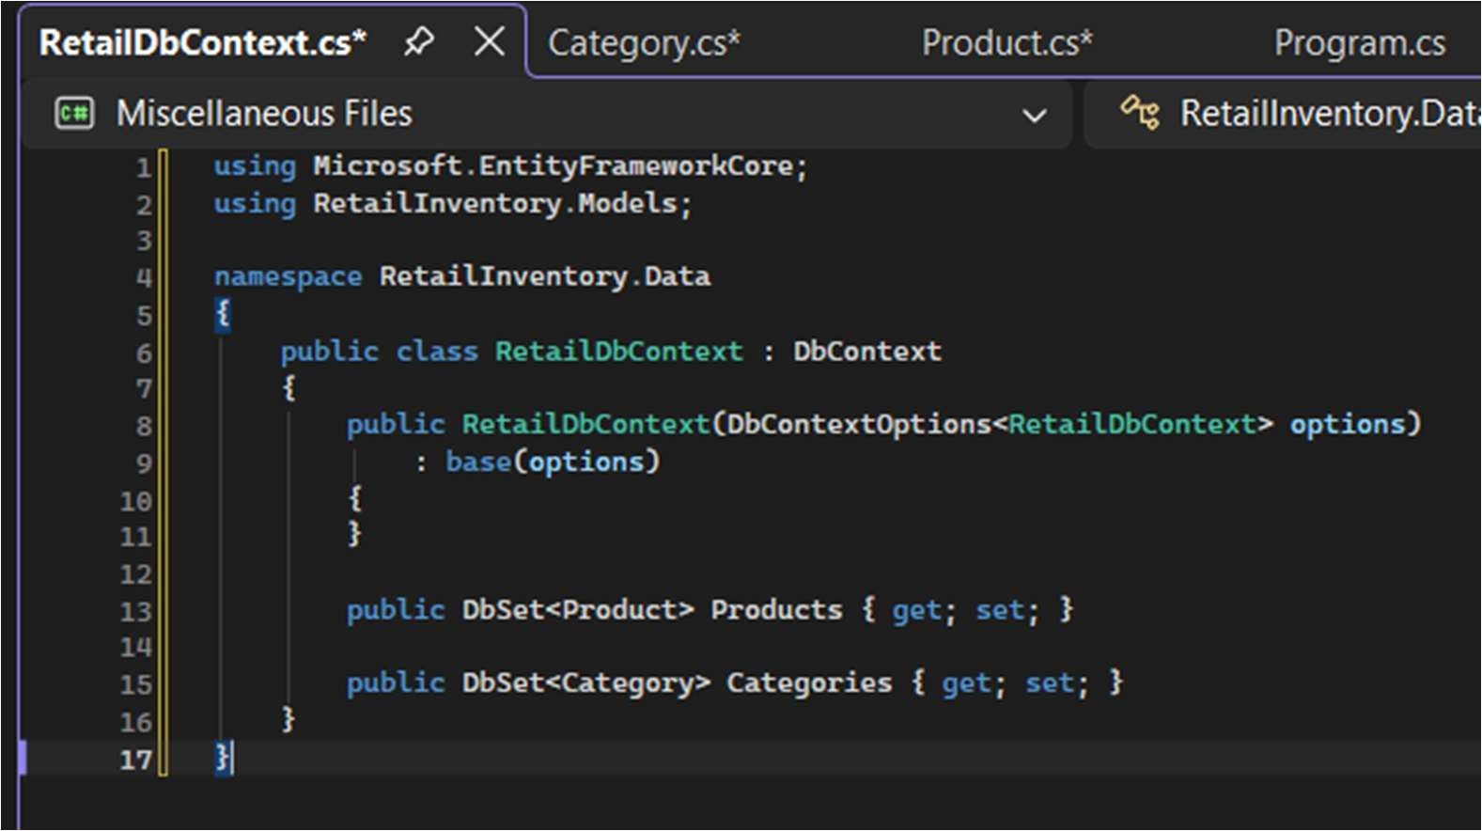

- Add Connection String in appsettings.json (optional for ASP.NET Core).
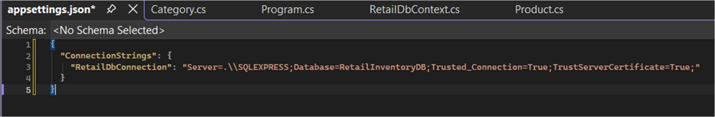

Lab 3: Using EF Core CLI to Create and Apply Migrations
Scenario: The retail store's database needs to be created based on the models you've defined. You’ll use EF Core CLI to generate and apply migrations.
Objective: Learn how to use EF Core CLI to manage database schema changes. Steps:
- Install EF Core CLI (if not already):
dotnet tool install --global dotnet-ef
- Create Initial Migration:
dotnet ef migrations add InitialCreate
This generates a Migrations folder with code that represents the schema.
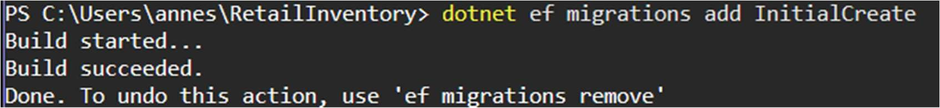
- Apply Migration to Create Database:
dotnet ef database update
- Verify in SQL Server: Open SQL Server Management Studio (SSMS) or Azure Data Studio and confirm that tables Products and Categories are created.
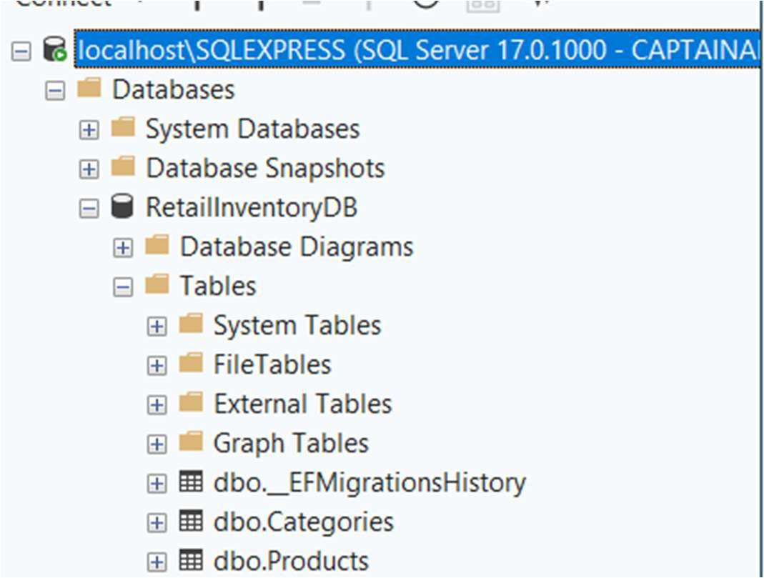

Lab 4: Inserting Initial Data into the Database
Scenario: The store manager wants to add initial product categories and products to the system.
Objective: Use EF Core to insert records using AddAsync and SaveChangesAsync. Steps:
- Insert Data in Program.cs:
using var context = new AppDbContext(); var electronics = new Category { Name = "Electronics" }; var groceries = new Category { Name = "Groceries" }; await context.Categories.AddRangeAsync(electronics, groceries); var product1 = new Product { Name = "Laptop", Price = 75000, Category = electro nics }; var product2 = new Product { Name = "Rice Bag", Price = 1200, Category = groceri es }; await context.Products.AddRangeAsync(product1, product2); await context.SaveChangesAsync();
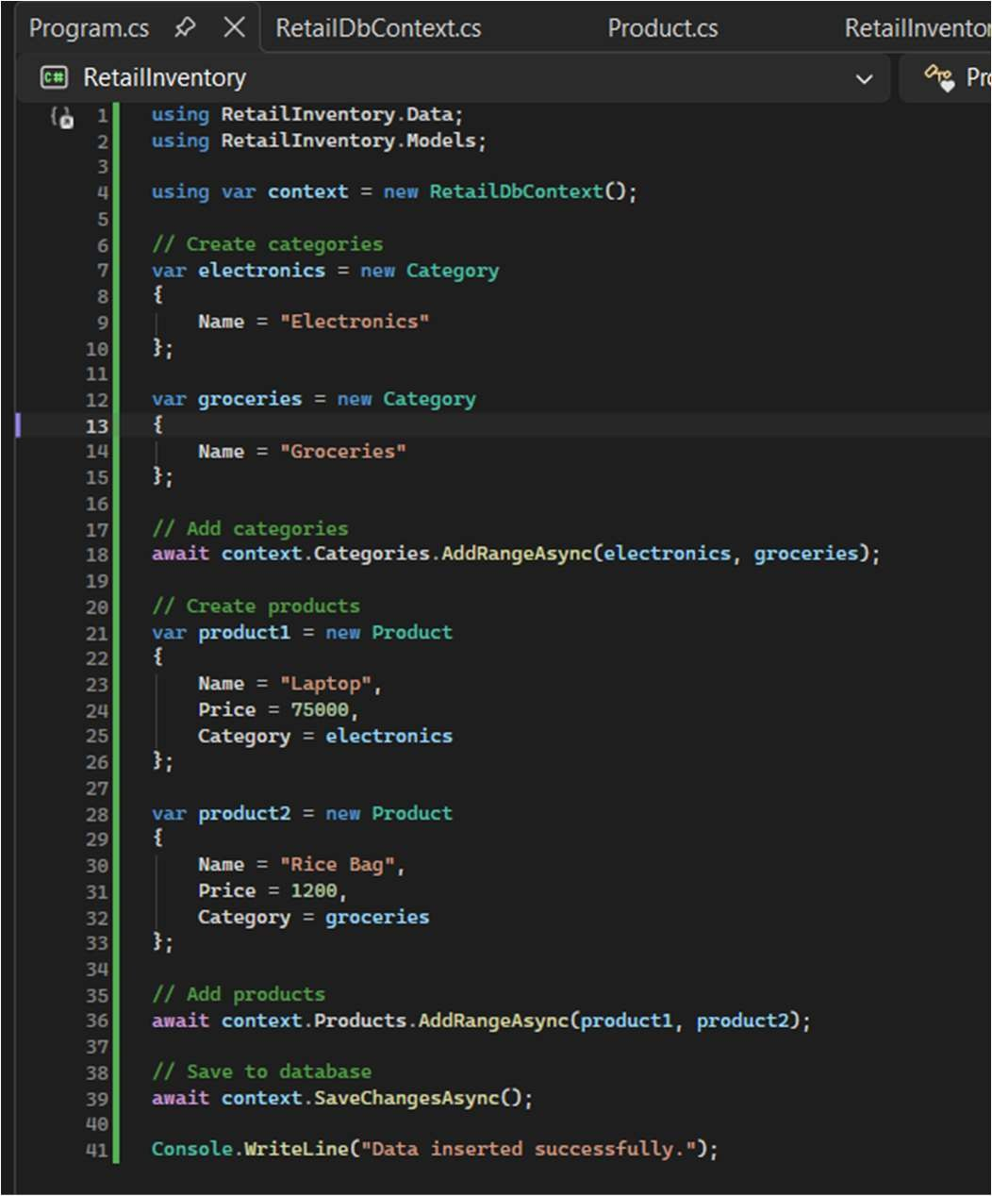
- Run the App:
dotnet run


- Verify in SQL Server: Check that the data is inserted correctly.
Products
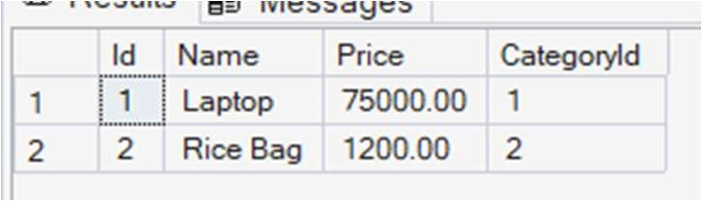
Category
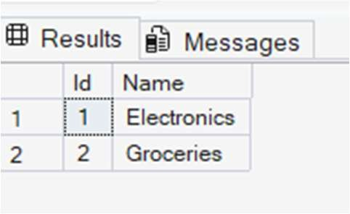

Lab 5: Retrieving Data from the Database
Scenario: The store wants to display product details on the dashboard. Objective: Use Find, FirstOrDefault, and ToListAsync to retrieve data. Steps: 1.
Retrieve All Products:
var products = await context.Products.ToListAsync(); foreach (var p in products) Console.WriteLine($"{p.Name} - ₹{p.Price}");
- Find by ID:
var product = await context.Products.FindAsync(1); Console.WriteLine($"Found:
{product?.Name}");
- FirstOrDefault with Condition:
var expensive = await context.Products.FirstOrDefaultAsync(p => p.Price > 5000 0); Console.WriteLine($"Expensive: {expensive?.Name}");
