MICROSERVICES

Hands-On Exercises: Authentication and Authorization in ASP.NET Core Web API Microservices
Question 1: Implement JWT Authentication in ASP.NET Core Web API
Scenario: You are building a microservice that requires secure login. You need to implement JWTbased authentication.
Steps: 1. Create a new ASP.NET Core Web API project.
- Add a `User` model and a login endpoint.
- Generate a JWT token upon successful login.
- Secure an endpoint using `[Authorize]`.
Solution Code: Install NuGet Packages: dotnet add package Microsoft.AspNetCore.Authentication.JwtBearer appsettings.json: { "Jwt": { "Key": "ThisIsASecretKeyForJwtToken", "Issuer": "MyAuthServer", "Audience": "MyApiUsers", "DurationInMinutes": 60 } } Program.cs: builder.Services.AddAuthentication("Bearer")
.AddJwtBearer("Bearer", options => { options.TokenValidationParameters = new TokenValidationParametersValidateIssuer = true, ValidateAudience = true, ValidateLifetime = true, ValidateIssuerSigningKey = true, ValidIssuer = builder.Configuration["Jwt:Issuer"], ValidAudience = builder.Configuration["Jwt:Audience"], IssuerSigningKey = new SymmetricSecurityKey(Encoding.UTF8.GetBytes(builder.Configuration["Jwt:Key"])) }; }); builder.Services.AddAuthorization(); AuthController.cs: [ApiController] [Route("api/[controller]")] public class AuthController : ControllerBase { [HttpPost("login")] public IActionResult Login([FromBody] LoginModel model) { if (IsValidUser(model)) { var token = GenerateJwtToken(model.Username); return Ok(new { Token = token }); } return Unauthorized(); } private string GenerateJwtToken(string username) { var claims = new[] { new Claim(ClaimTypes.Name, username) }; var key = new SymmetricSecurityKey(Encoding.UTF8.GetBytes("ThisIsASecretKeyForJwtToken")); var creds
= new SigningCredentials(key, SecurityAlgorithms.HmacSha256); var token = new JwtSecurityToken( issuer: "MyAuthServer", audience: "MyApiUsers", claims: claims, expires: DateTime.Now.AddMinutes(60), signingCredentials: creds); return new JwtSecurityTokenHandler().WriteToken(token); } }

Solution Explorer:
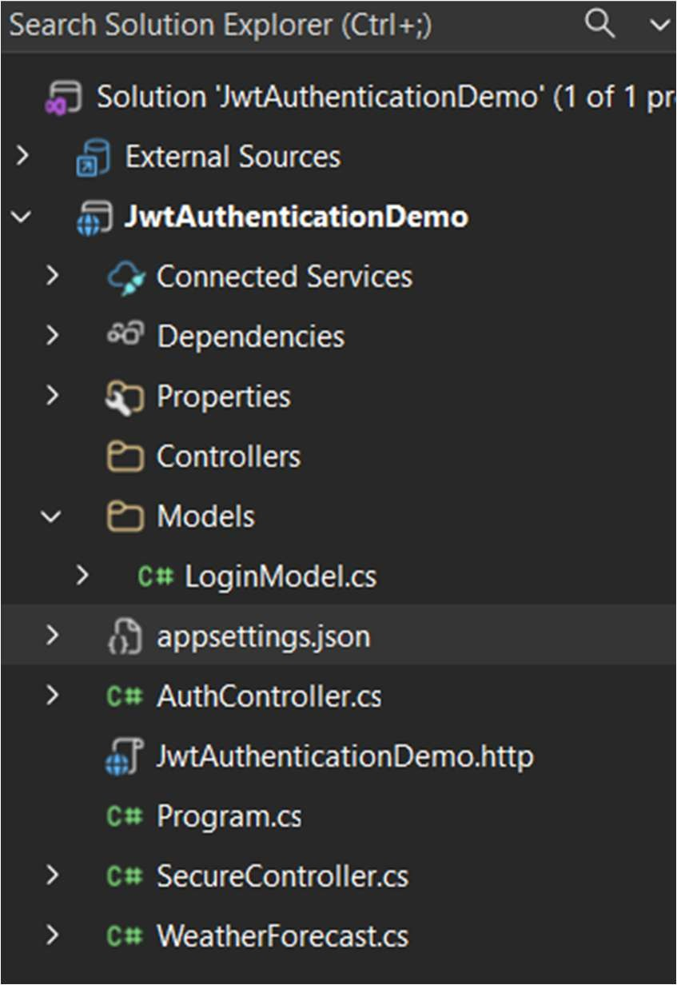

Installed JWT Authentication Package:
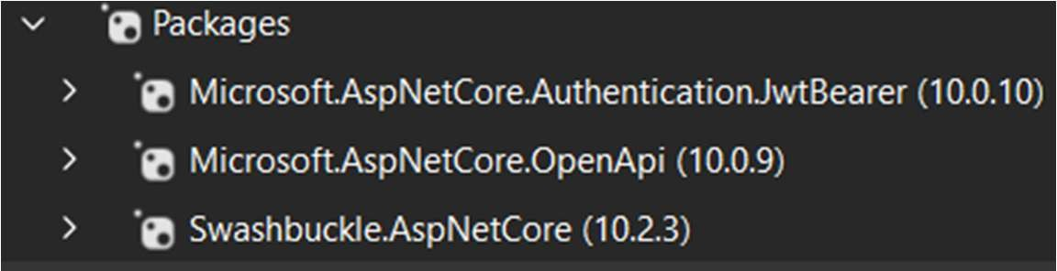
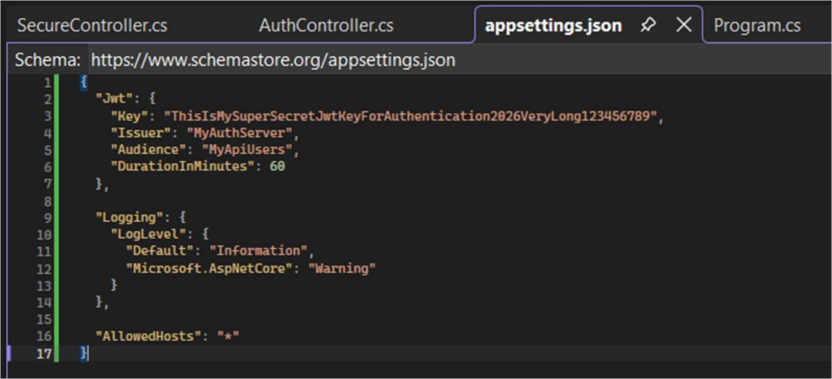

Program.cs
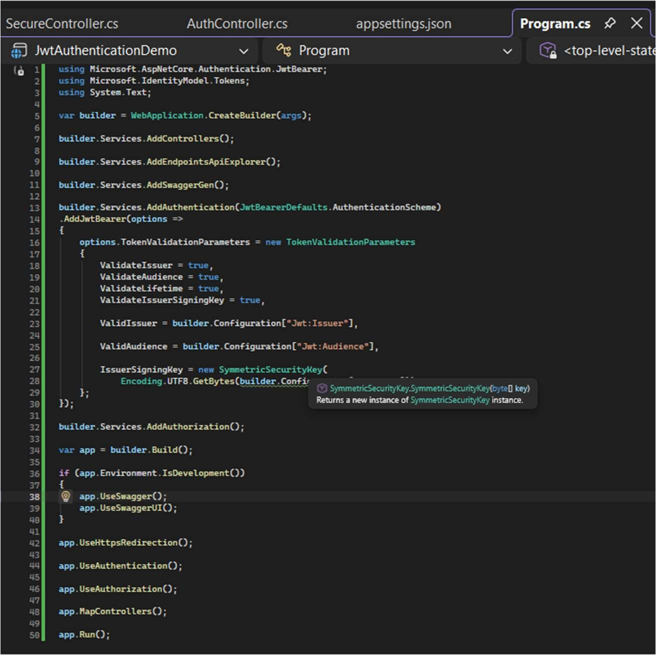

AuthController.cs
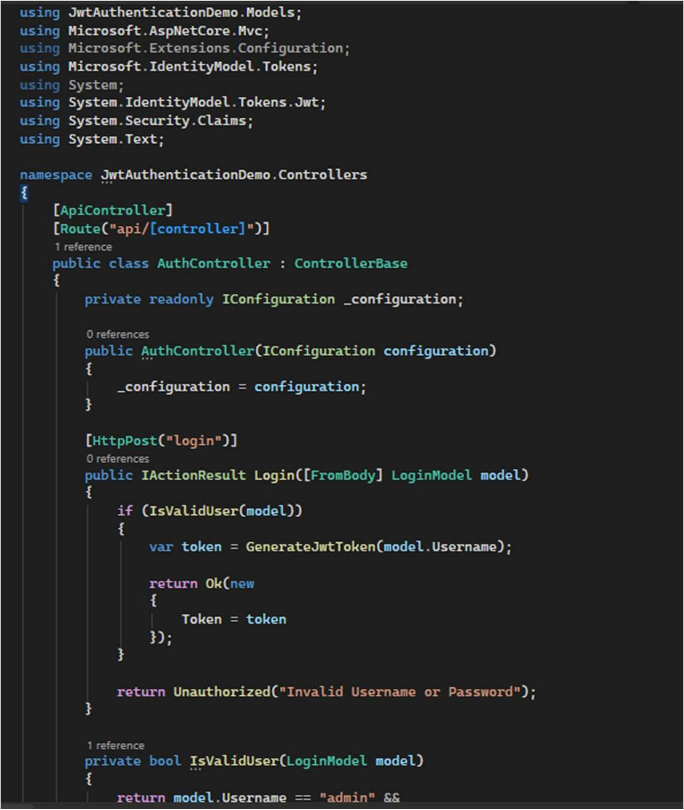

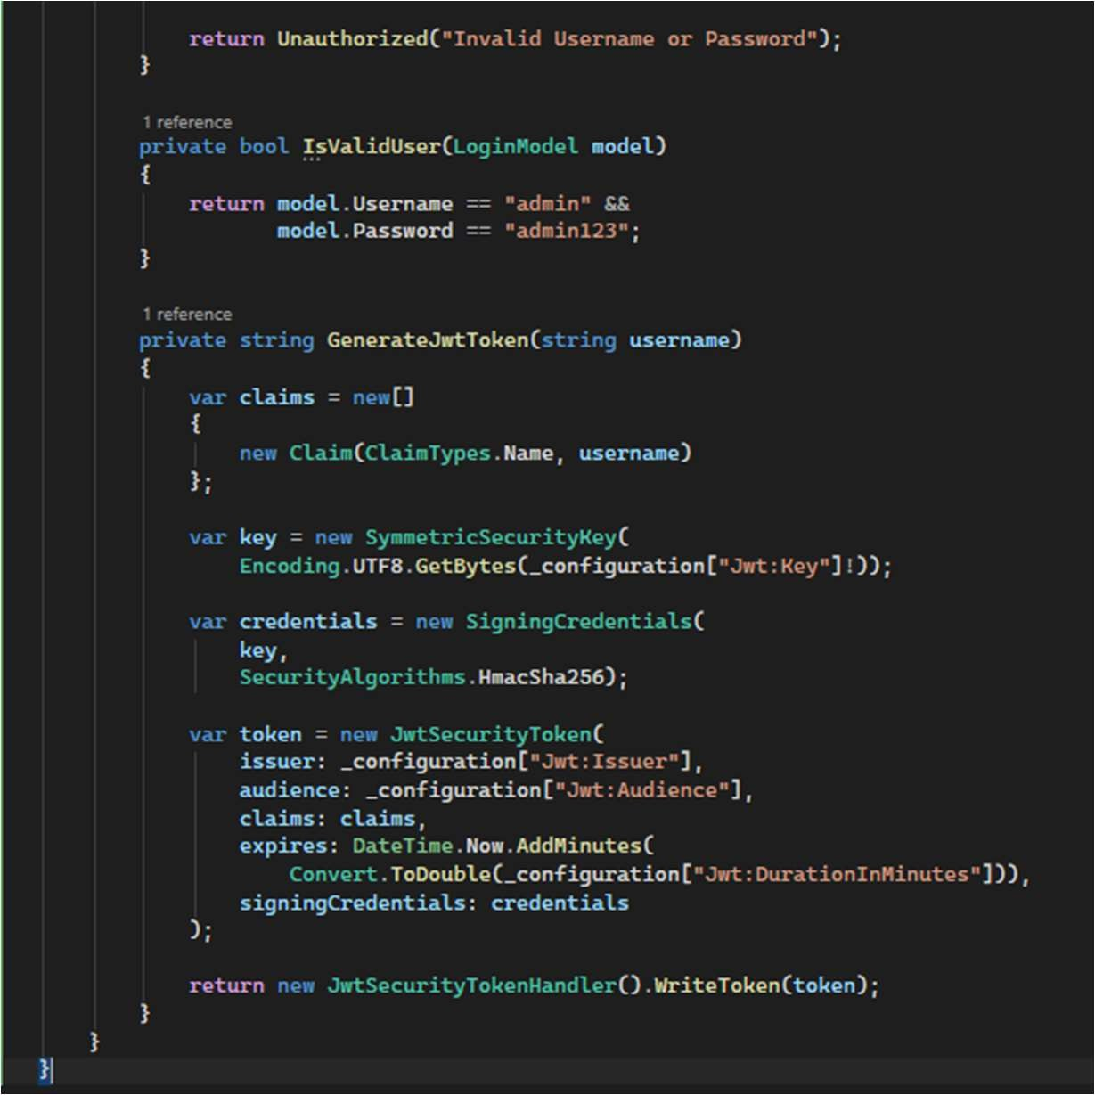

SecureController.cs
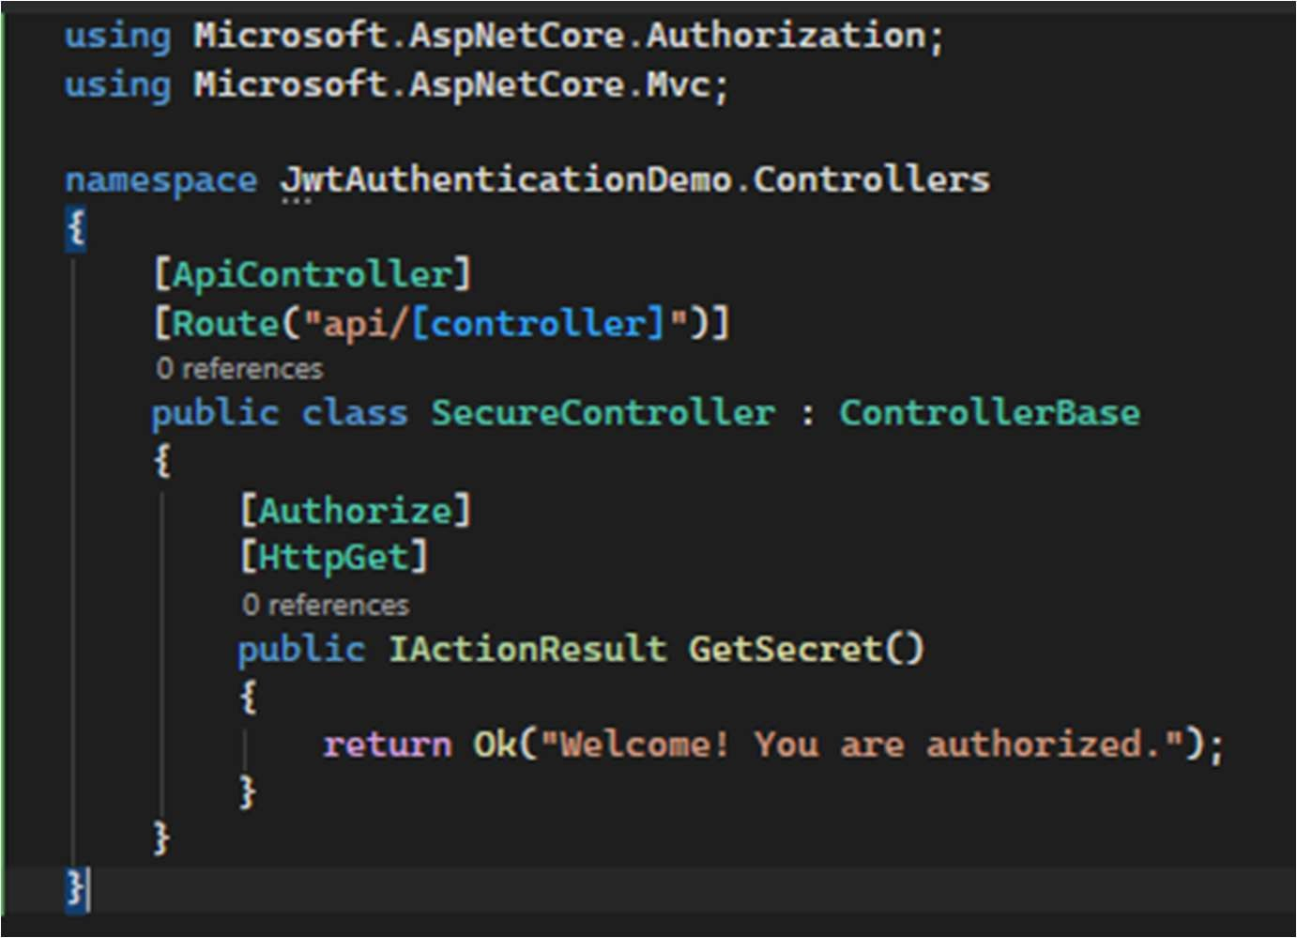

Login Request
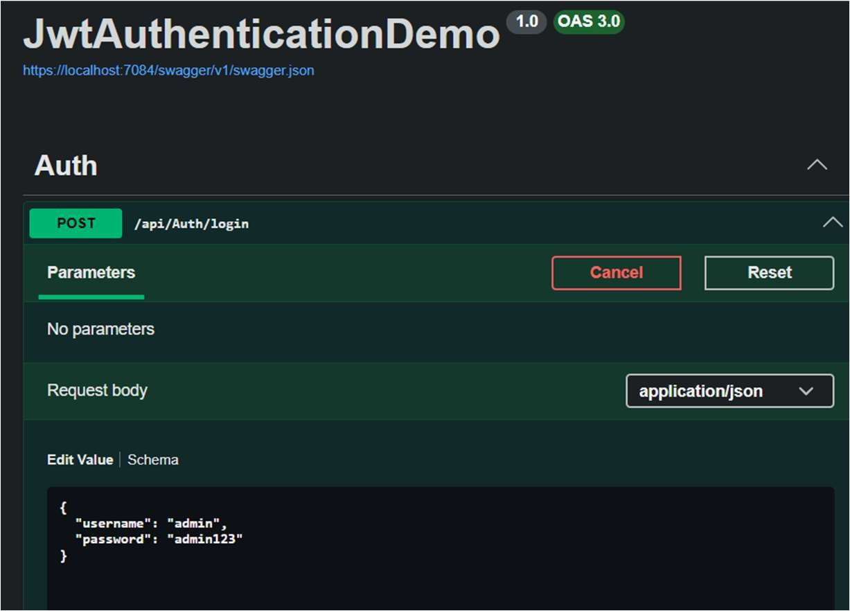

JWT Token Generated Successfully
