CHAPTER 1

INTRODUCTION
Today, Wireless Local Area Networks (WLANs) are an integral part of any modern organization offering quick, reliable and flexible network connectivity. WLANs enable employees to use wireless devices, like a tablet, a smartphone and a laptop, to gain access to organizational resources in various areas of the office, whereas wired networks do not. A properly designed WLAN provides the advantages of communication, more efficient work, and business applications like cloud computing, file sharing, video conferencing and online collaboration. With the growing adoption of digital technologies, the design of a secure and efficient wireless network has become more important.
Success of a WLAN relies on planning, network design and analysis of the site survey. Before putting wireless access points into place, the building layout, wall materials, user density, and sources of signal interference should be carefully considered. The design of a WLAN should ensure complete wireless coverage, reduce dead zones, maintain signal strength and ensure secure communication for everyone. It is, therefore, important to perform a wireless site survey as part of the process of designing a robust and scalable wireless network infrastructure.
This project is centered on the design of a WLAN infrastructure for a three floor office building, with approximately ten employees. The office has various functional spaces like the reception, working space, CEO office, conference room, IT support space, and administrative offices. For every level of the building there will be the need for effective wireless connectivity that provides the ability to communicate, enable smooth business operations and serve the needs of employees and visitors. The planned network features enterprise-class networking equipment such as managed switch, firewall and Wi-Fi 6 access points to offer high-speed, secure and centralized networking connectivity.
1.1 Objective

This project aims to design a secure, reliable and scalable Wireless Local Area Network (WLAN) for a three-floor office building to be deployed by performing a comprehensive wireless site survey, analyzing the office environment and designing an optimized wireless network infrastructure. The proposed design will ensure that all areas are covered and will reduce any potential interference with the wireless signal. The design will also ensure that high speeds and a stable wireless signal are provided for employees and visitors. The project also suggests the right networking equipment and software for enterprise use, which will help in efficient network management, robust security, and future expansion of the organization.
1.2 Background of the Study
Wireless networks are a critical component of the communication and collaboration infrastructure in modern organizations and critical for access to digital resources. As the number of wireless devices grows, it is important that organizations have a well-designed WLAN that provides consistent performance, secure connectivity and an adequate network capacity. Weak signal coverage, network congestion and decreased productivity can be caused by poor network planning.
This project aims to overcome these challenges by designing a WLAN system for a 3-floor building that consists of offices. It is designed based on a detailed site survey and should be in accordance with networking best practices to ensure reliable wireless coverage is attained throughout the building. The goal of the proposed solution is to enhance the performance of the network, make it easier to manage and ensure a scalable infrastructure that will support the business growth of the future.
1.3 Site Survey Methodology
A wireless survey was conducted to determine the best places to install wireless access points in the office. Building layout and room distribution, number of users, potential sources of signal interference, etc. were thoroughly reviewed. Before deployment, the wireless coverage and access point placement were simulated with the Visiwave tool. The results of the survey were used to design an optimized WLAN network design for full coverage, high signal strength and network efficiency throughout the three floors of the office building.

CHAPTER 2: ORGANIZATION OVERVIEW
2.1 Company Background
Aether Technologies Pvt. Ltd. is a medium-sized Information Technology (IT) company which specializes in software development, IT consulting, customer support, and digital solutions. The company will continue to provide innovative technology services, enabling enterprises to optimize their operations and enhance their digital capabilities.
It has a three-story office building, and currently has about 10 employees, such as software developers, help desk staff, administrators, and managers. Staff use cloud applications, emails, video conferencing and shared network resources to be effective in their daily work.
In order to accommodate these business activities, the company needs a secured, reliable, and high-speed Wireless Local Area Network (WLAN). The proposed WLAN will enable seamless wireless connectivity throughout all three floors for efficient communication, centralized WLAN management, and scalability for future organizational expansion.
2.2 Office Layout
The new office block is to be built over three floors, each of which will be used for a particular business use. The design is optimized for an efficient workflow, collaboration and stable wireless coverage.
The Ground Floor accommodates the Reception, Waiting Area, Meeting Room, Pantry, Washroom and Staircase, which are necessary for visitors and for daily operations.
The First Floor has the Development Office, HR Office, Finance Office, Manager Office, Washroom and Staircase, where the employees conduct administrative and software development work.
The Second Floor is made up of the Training Room, Conference Room, CEO Office, Server Room, IT Support Office, Washroom and Staircase. It is the floor that is used for all the executive management, staff training and IT operations.
Each floor has a Cisco Business CBW150AX Wi-Fi 6 Access Point located in the center of the floor, providing reliable coverage and a stable network performance across the building for seamless wireless connectivity.
2.3 User Requirements
The planned WLAN will be used for the networking needs of employees, management, IT administrators and visitors. Users need to be continuously connected to the Internet and the organizational resources to be able to do their day-to-day jobs efficiently.
The network should support:
- Wireless Internet connection with high speed.
- Ensure secure access to shared files and cloud services.
- Online meetings and video conferencing.
- Business communication or email.
- Wireless printing and file sharing.
- Provide guest internet access.
- Secure internet access for laptops, cellphones, tablets and desktop computers.
- Centralized management and monitoring of the network.
The network should also be scalable to support additional users and wireless devices in the future without significantly modifying the existing infrastructure.
The 2nd phase is called Site Survey and Existing Environment Analysis. The second phase is called Site Survey and Existing Environment Analysis.
A wireless site survey was performed to get a feel for the office set-up and to identify the best placement of wireless access points before designing the WLAN infrastructure. The survey included the physical structure of the building, room assignments, wall types, employee density, and estimated number of wireless devices per floor of the building.
The concrete blocks are mainly used for the construction of the office building, and they are covered with glass partitions in some parts of the building. Concrete walls will attenuate the wireless signal, but if the access points are carefully positioned, they will provide overall wireless coverage in the office. With each floor having about ten active users, a single central Wi-Fi 6 access point was deemed to ensure high-quality coverage.
Wireless Site Survey was conducted with the aid of software called Visiwave that was used to simulate the wireless coverage, measure its strength and find possible dead zones before the WLAN design was finalized.
2.5 Sources of Interference
There are a number of environmental factors that impact wireless signal performance in the office building. At the site survey, the following possible sources of interference were identified:
- Office rooms with concrete walls between.
- Some small signal reflections from glass partitions.
- Small signal reflections from glass partitions.
- Electrical assets like printers, computers and UPS.
- In the pantry there are microwave ovens.
- Wireless devices that are within range of the nearby wireless channels.
- Staff working around the office.
To reduce interference, each access point is located in the middle of the floor associated with it, providing an even signal distribution and less overlap of the wireless signal areas.4
Room Distribution by Floor
https://app.diagrams.net/#G1lrEwkJP93StFRMgvbfdpf8vUWKdd22wz#%7B%22pageId%22%3A%22oY7zFdODPbOIuXWXKstK%22%7D
Ground Floor
Room | Purpose
Waiting Area | Customer reception and visitor assistance
Meeting Room | Seating area for visitors before meetings
Pantry | Client meetings and discussions
Washroom | Staff refreshments and break area
Staircase | Staff and visitor restroom
Reception | Access to the first floor

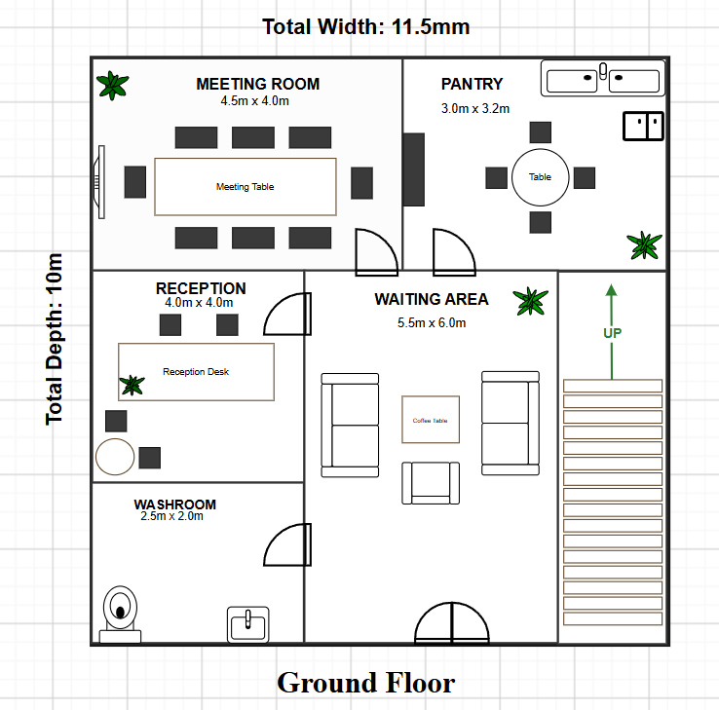

First Floor
Room | Purpose
Development Office | Workspace for software developers
HR Office | Human Resource department
Finance Office | Accounting and financial operations
Manager Office | Office for department manager
Washroom | Staff restroom
Staircase | Access between ground and second floor

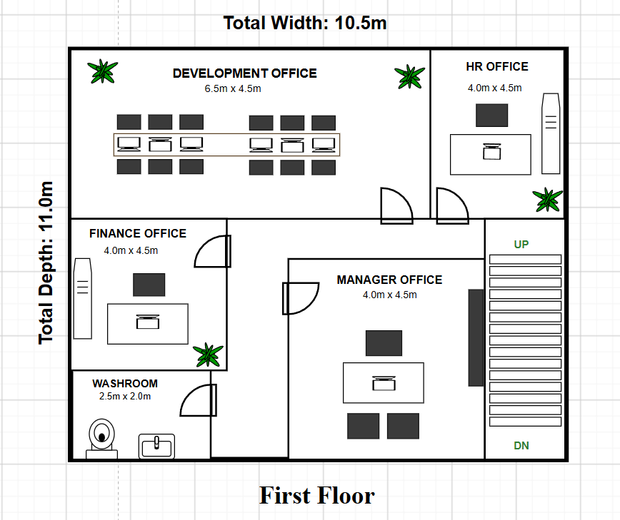

Second Floor
Room | Purpose
Training Room | Employee training sessions
Conference Room | Presentations and large meetings
CEO Office | Executive management office
Server Room | Network servers and IT infrastructure
IT Support Office | Technical support and network
Washroom | Staff restroom
Staircase | Access to lower floors

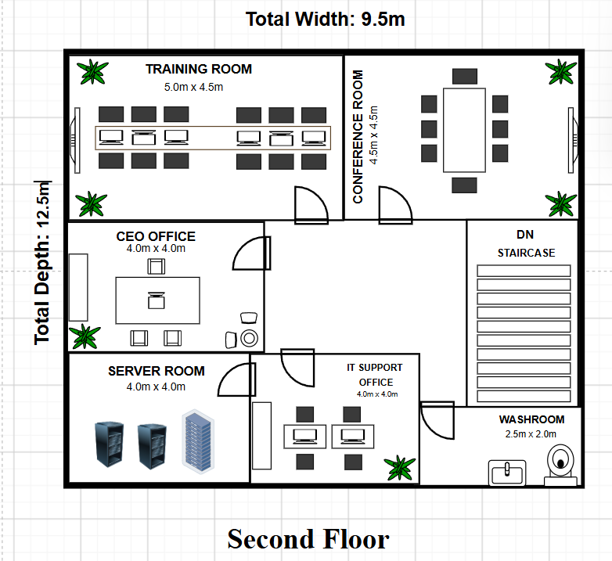

2.7 Site Survey by Floor
The wireless site survey results were confirmed by the wireless survey, which revealed a need for one Cisco Business CBW150AX Wi-Fi 6 Access Point located centrally on each floor for full wireless coverage. Visiwave simulations showed that placement of the desired access points leads to a strong signal in all workspaces, meeting rooms and executive offices with minimal dead zones and interference.
The survey has also confirmed that the proposed WLAN infrastructure can meet the requirements for the current number of staff members, and will allow for the addition of further access points if needed to meet future growth.

CHAPTER 3: PROPOSED WLAN INFRASTRUCTURE DESIGN
3.1 Proposed Network Design
The planned WLAN will guarantee wireless connectivity throughout the entire building in all three floor, network security, reliability and scalability. The network is based on enterprise grade networking equipment such as Huawei Echo Life HG8245H5 GPON ONT, Cisco Firepower 1010 Firewall, Cisco Business 350 Series Managed Switches and Cisco Business CBW150AX Wi-Fi 6 Access Points.
The Internet connection is provided via the ISP fiber network, and is converted to Ethernet by the GPON ONT. The traffic is then directed through the Cisco Firepower 1010 Firewall, which acts as a defense mechanism to the network, filtering traffic, blocking unauthorized access and enabling secure communication. The firewall is directly connected to a managed switch at each floor, which provides an efficient and central network architecture.
One Cisco Business CBW150AX Wi-Fi 6 Access Point is installed on each floor in the area where wireless signals need to be strong and spread across the floor evenly, to minimize signal interference. This solution offers secure connectivity for users, guests and network devices to support cloud applications, file sharing, video conferencing and other business activities.
The proposed WLAN is also scalable, and can accommodate other switches or access points as the organization grows.
3.2 Access Point Placement

3.3 Network Topology Diagram
The proposed WLAN architecture is a Star Topology that has the Cisco Firepower 1010 Firewall as the central gateway that interfaces all floor switches to the Internet. A Cisco Business 350 Series Managed Switch is used to provide network connectivity to the wired devices and Cisco Business CBW150AX Wi-Fi 6 Access Point on each floor.
This centralized design makes network troubleshooting, reliability and management easy. It also provides future scalability by permitting extra gadgets or access points to be added while not impacting the current structure.
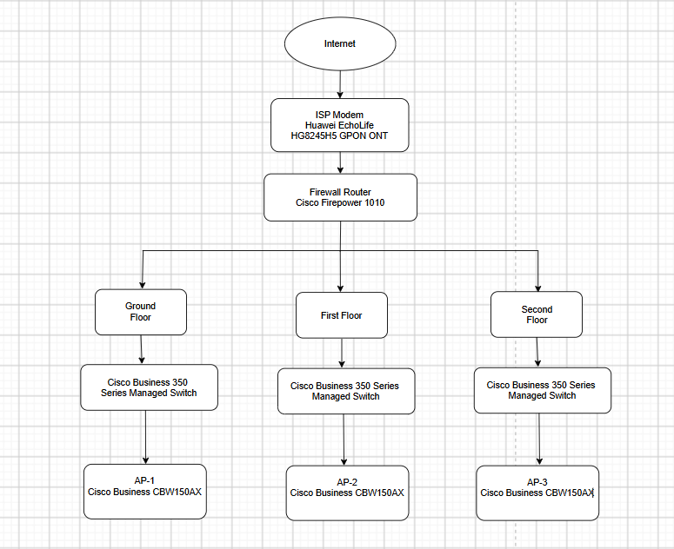
https://app.diagrams.net/#G1MMJP7xAlOxwnglNKWrQV7o2O5XeQYFN4#%7B%22pageId%22%3A%220%22%7D
3.4 IP Addressing Scheme

CHAPTER 4: HARDWARE AND SOFTWARE REQUIREMENTS

4.1 Hardware Requirements
Proposed WLAN will be based on enterprise-class network devices that provide reliable connectivity, efficient network management and secure communication in the three floors of the office building.
Hardware | Model | Purpose
Internet Connection | ISP Fiber Internet | Provides high-speed Internet connectivity to the office network.
ISP Modem | Huawei EchoLife HG8245H5 GPON ONT | Converts the fiber-optic signal into an Ethernet connection.
Firewall | Cisco Firepower 1010 | Protects the network by filtering traffic, preventing unauthorized access, and supporting VPN services.
Managed Switch | Cisco Business 350 Series Managed Switch | Connects wired devices and distributes network traffic efficiently on each floor.
Wireless Access Point | Cisco Business CBW150AX (Wi-Fi 6) | Provides high-speed wireless connectivity with improved coverage and performance.
Ethernet Cable | Cat6 | Connects networking devices while supporting high-speed data transmission and reducing electromagnetic interference.
Desktop Computers | Standard Office PCs | Used by employees for daily office tasks and software development.
Laptops | Business Laptops | Supports mobile work and wireless connectivity.
Network Printer | Multifunction Printer | Enables shared printing and document scanning across departments.
UPS | Uninterruptible Power Supply | Provides backup power to critical networking devices during power outages.

4.2 Software Requirements
The software applications used for network planning, implementation and documentation are as follows:
Software | Purpose
Windows 11 Pro | Operating system for office computers.
Visiwave | Used to perform wireless site surveys, analyze Wi-Fi coverage, optimize access point placement, and generate heat maps.
Draw.io (diagrams.net) | Creates floor plans and network topology diagrams.
Microsoft Word | Prepares and formats the project documentation.
Cisco Business Dashboard | Monitors and manages Cisco networking devices from a centralized interface.
Google Chrome | Accesses cloud services, documentation, and web-based management tools.

4.3 Hardware Justification
The hardware used was designed to ensure a secure, reliable and efficient WLAN for the three-floor office building. When it comes to Internet service, the Huawei EchoLife HG8245H5 GPON ONT provides a stable Internet service, and the Cisco Firepower 1010 Firewall keeps the network secure from unauthorized access and cyber-attacks. The Cisco Business 350 Series Managed Switch offers an efficient way to manage your network and to accommodate future growth. The Cisco Business CBW150AX Wi-Fi 6 Access Point provides high-speed wireless connectivity and robust coverage per each floor. Cat6A STP cables will also transmit data quickly and with little interruption, and the UPS will power up during a power outage.
4.4 Software Justification
The software chosen can be used to plan, manage and document the proposed WLAN. The Wi-Fi coverage was analyzed and the placement of the access points optimized using Visiwave. The network topology and floor plans have been created in the software Draw.io and the project report in the software Microsoft Word. Cisco Business Dashboard allows for centralized monitoring and management of devices, and a stable Windows 11 Pro with Google Chrome for use in daily office operations and to access web-based applications.

CHAPTER 5: MONITORING AND MAINTENANCE
5.1 Network Monitoring
To ensure the performance and availability of the proposed WLAN, network monitoring is a must. The Cisco Business Dashboard allows the IT support team to view real-time monitoring of connected devices, status of APs, bandwidth utilization, and network traffic. This allows administrators to easily spot network congestion, hardware failures or abnormal activity. By monitoring the network regularly, it is possible to ensure that all networking devices are working efficiently and performing as expected and the information can be used for future network planning and troubleshooting.
5.2 Preventive Maintenance
Preventive maintenance ensures that failures of network equipment and the network itself can be avoided and that equipment has a longer life. Switches, access points and firewall devices should be regularly tested to ensure their proper functioning. Periodic firmware and software updates should be done to enhance security and performance. Other cable and power connections need to be inspected for damage, and configuration files should be backed up periodically to make it easy to recover the system should a problem arise.
5.3 Security Considerations
Security to prevent unauthorized access to the WLAN is an important requirement. The proposed network is to passively filter network traffic and protect from cyber threats using the Cisco Firepower 1010 Firewall. Use of encryption of WiFi (WPA3), user and administrator passwords (changing regularly), and separate wireless networks for guests should be used to protect sensitive organizational data. The network's security is further enhanced by regular security updates and user access reviews.
5.4 Backup and Recovery
A backup and recovery plan provides a quick recovery of the network in event of hardware failure, accidental change of configuration, or security incidents. Regularly back-up and securely store network device configurations. Cloud Storage or external Backup devices should also be used to back up important organizational data. If there is a failure, these backups enable the organization to get back to business quickly and reduce disruption to their business.

CONCLUSION
This project aimed to create a secure, reliable and scalable Wireless Local Area Network (WLAN) in a 3-level office building. A wireless site survey was performed along with an analysis of the office layout, resulting in an efficient network infrastructure that enabled the organization to have seamless wireless connectivity throughout. All devices are enterprise-grade to deliver high performance, robust security and centralized network management.
The proposed WLAN will be used for the organization's daily business activities as well as software development, cloud-based apps, video conferencing, file sharing, and Internet connectivity. Placing wireless access points strategically helps ensure complete coverage and reduces interference and dead zones. Moreover, the adoption of cutting-edge networking technologies and routine monitoring practices boost network dependability, security, and maintainability.
In conclusion, the proposed WLAN design fulfills the current networking needs of Aether Technologies Pvt. Ltd. and can be easily expanded and adapted to accommodate future organizational growth. The project illustrates the value of network planning, site survey and selection of the right hardware and software for constructing an effective and secure wireless network environment.

